Part I – How are we here?
The question ‘why and how are we here’ has often unsettled people to this date, not only the decorated scientists and philosophers, but also the simplest of men and women who have treaded this earth. The answer generally specified to us, is that the human race is of comparatively recent origin, because if we had been around earlier, surely, we would have progressed in knowledge and technology even more? And this is in no matter false.
To give you a cosmological time scale that can hopefully be comprehended by average human being, let’s forget that the universe started 13.8 billion years ago but pretend that the universe started just ten years ago. Then by scaling all other values down, the Earth would have been created about 3 years ago and modern humans were not even alive till about 80 minutes ago. There was nothing that could think, behave and look like us until a few hours ago!
However, while all these bizarre but wonderful things occurred on Earth, such as evolution, it is important to note that the physical surroundings, topography and landscape change very little during a human’s life time. They were therefore thought to have been divine and to have been created at the same time as the Earth, in the beginning.

Part III – The Big Bang Model
In 1927, A certain Belgian physics professor and part-time priest by the name of Georges Lemaître, had a revolutionary idea. An idea that the universe began from a single point in spacetime. A point predicted by Einstein, and proven by Stephen Hawking and Roger Penrose to be called a singularity. A point of infinite density and when the universe was a very hot, dense super force, with no atoms, or quarks or form or structure. Just energy.
Right now, the prevailing theory of how the universe first came about is called the Big Bang theory, and actually, its name is highly contradictive to what it explains. When most think about a ‘bang’, an explosion is what comes to mind. Like a firework or a bomb. But in a period of rapid expansion and inflation. It swelled from a size smaller than a quark to its current state in less than a fraction of a second.

A timeline of the Universe’s beginning
At ‘Planck time’, the smallest theoretically observable unit of time, the super-force (a mixture of the four fundamental forces) first split into the force of gravity and the electronuclear force, and then a second splitting of the strong force from the electronuclear force. An hour after the universe was born, matter cooled as it spaced apart, and baryons (a type of hadron composed of three quarks) decayed into protons and neutrons, creating the first hydrogen nuclei. Even at this time, the universe was too hot for light to shine, as photons could not interact with the dense plasma ‘soup’ of free sub-atomic particles. Finally, nearly 380,000 years after the beginning, enough cooling meant helium and hydrogen nuclei were able to capture electrons, creating electrically stable atoms, and his phase is known as “recombination”, and the light released at this time, can still be detected today in the form of cosmic microwave background radiation.
It is important to understand that when the universe expanded, it wasn’t just matter that erupted, but also that the fabric of spacetime expanded itself, like when a balloon inflates, two points drawn on the surface appear to get further away from each other without actually physically moving apart.

What is the evidence for the Big Bang model?
‘Almost all astronomers agree on the theory of the Big Bang, but to call the concept merely a theory is to misjudge the overwhelming amount of evidence’. There are separate pieces of compelling evidence that support the Big Bang theory and the first was the extraordinary discovery that galaxies are moving away from us and each other.

Why was Hubble’s discovery so crucial?
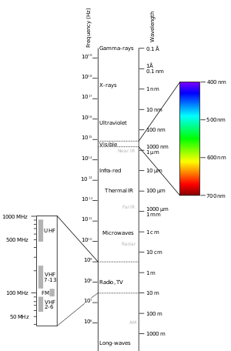
The Big Bang model was originally the product of Einstein’s theory of General Relativity, as applied to an expanding universe. However, at the time in 1917, the thought of the universe expanding seemed to be apocryphal. Consequently, Einstein derived the cosmological constant (see nomenclature) and added it to his equation. In turn, his equation now could be applied for a static universe. However, in 1929, Edwin Hubble announced that his observations of galaxies outside of the Milky Way showed that they were meticulously moving away from us, at a speed proportional to their displacement (distance away from us). In other words, galaxies further away from us receded at a greater velocity than those that were closer.
There were two fundamental and key breakthroughs prior to Hubble which allowed for his own. The first was the period-luminosity scale developed by Henrietta Leavitt, which enabled one to accurately calculate the distance to variable stars from Earth, and the other was when Vesto Slipher who was investigating spiral nebulae, discovered that these objects emit visible light, which can be separated into component colors on a spectrum, but if the light source was moving away, these lines shifted toward red, signifying that the body was moving rapidly away from the observer.
Figure 6 - Electromagnetic spectrum
As light get’s red shifted, it’s wavelength increases.

Increasing wavelength
So, by observing variable stars from his telescope at the top of Mt Wilson, and by using red-shift calculations, and distance measurements, he was able conclude that the speed of recession is proportional to distance, and this is called Hubble’s Law.
Hubble expressed his law as an equation where:
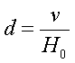
d = distance
v = velocity
H₀ = Hubble’s constant.
The ratio of distance to redshift was 170 km/s per light year of distance, and this is now called Hubble’s constant. To find out velocity in the equation, we use the formula:
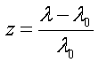
λ₀ = true wavelength
λ = measured wavelength shift
z = redshift
And then utilize the following equation:
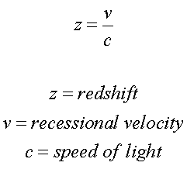
c = speed of light
v = velocity of object
z = redshift
Edwin Hubble had transformed modern astronomy with his discovery, because it confirmed the universe began from a single point. His theory confirmed distant galaxies were speeding away from each other, so reverse the clock back 13.8 billion years, and the galaxies will come closer and closer until it reaches one single point in space. Like the balloon analogy; if we deflate our inflated balloon with two points, the two points will keep coming closer and closer to each other. In the end, General Relativity did in fact predict the universe was expanding, resulting in a very happy Einstein.

How does Cosmic Microwave Background Radiation prove the Big Bang?
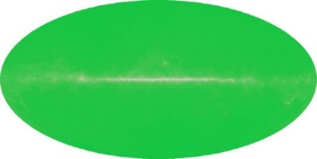
The second piece of evidence came in the late 1960s, when Robert Wilson and Arno Penzias were experimenting with a radio telescope and to their astonishment discovered an unknown background microwave signal which was the same everywhere they measured it. This microwave background radiation is known as cosmic microwave background radiation (CMBR) and is essentially a faint glow of light that fills the universe with uniform intensity. It is the residual heat of the Big Bang expansion 13.8 billion years ago, and formed approximately 380,000 years after the Big Bang. At the time, the high temperatures of 270 million kelvin ionized hydrogen atoms completely into free protons and electrons to make a plasma “soup” so when the CMBR was emitted, the photons, which are small packets of light, could easily scatter off the electrons and thus photons wandered through the early universe like visible light wanders through fog.
Figure 8 - Penzias and Wilson measurements of CMBR
Scattered photons have probably the most perfect blackbody spectrum ever observed in nature which means that they last scattered of some substance that was in near perfect thermal equilibrium. That substance had to exist both very far away and very long ago. There is no such substance in the universe anywhere near us now so it means it existed uniformly everywhere until about 10 billion years ago when the characteristics of the universe drastically changed so that it didn’t scatter photons anymore, which was exactly what the big bang model predicted would happen when baryonic plasma cools enough for electrons and protons to form neutral atoms. Images from telescopes such as the WMAP probe, allows us to deduce how far the photon’s source was, or the place where it last interacted, meaning it leads to a birth place from where all the photons were produced: The center of the cosmos.
The first measurements taken by Penzias and Wilson, confirmed the presence of isotropic background radiation, with the accuracy and precision of the images improving as technology developed, allowing us to see small fluctuations and irregularities, which help determine the age of the universe and what it consists of.

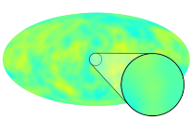
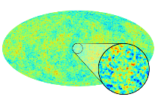
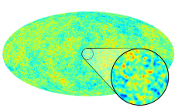
Figure 11 - COBE measurement of CMB (in 1990)
Figure 10 - WMAP measurement of CMB (in 2001)
Figure 9 - Planck measurement of CMB (in 2009)

Part IV – The Steady State Theory

Background and Concepts
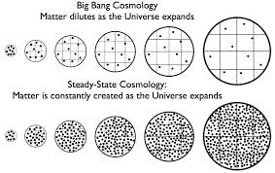
Contrary to popular belief, the Big Bang theory hasn’t always been the most popular scientific theory to explain the origin of our universe, and for a while, the Steady State theory was renowned to be scientifically accurate. It was developed by Herman Bondi, Fred Hoyle, and Thomas Gold as an alternative to the Big Bang. One of its fundamental concepts is called the Perfect Cosmological Principle, which illustrates that the universe is infinite in size, infinitely old, and isotropic in all directions (the same in all directions) at all times in the past, and will be in the future. I.e. The universe is eternal. It had no beginning
Figure 12 - Diagram of Steady State Theory
While the theory accepts that the universe is expanding, it suggests that matter is continually created so that the density of the universe stays the same all the time. So, a balance between expansion and creation and death is always maintained, and a steady state of energy is always kept, unlike in the Big Bang, where matter dilutes as the universe expands as seen by the image.

What are the issues with the Steady State Theory?
The Steady State theory was very short lived as the discovery of quasars and CMBR discredited it. Quasars were only formed in the early universe meaning that the universe hasn’t always been the same, which goes against the steady state theory. CMBR was only emitted when the universe was hotter and denser but as the universe expanded, it cooled so no more CMBR was emitted, meaning that the universe had changed overtime. As the steady state theory has no way of proving the origin of the CMBR, it is flawed.

Part V – What is the Origin of our Universe?
To Conclude, both religious and scientific theories provide strong arguments, all backed up with some form of evidence which cement their positions. To a certain extent, what explains the origin is in some way subjective. Religious believers who are not exposed to science may only believe in their creation myth, because that could only be the reasoning they have been taught. So, should both religious and scientific views be taken?
However, the foundations of my knowledge and person is based on science and proven ideas and for that reason, I believe that the Big Bang is the closest explanation out there for the origin of the universe simply due to the amount of compelling evidence that supports it. The reason I say ‘closest’ is because some aspects of the behaviour of universe is still not explained with great detail. Not everything is solved. What is debated on frequently, is that what initiated the Big Bang process? Where did the singularity come from? Will the universe keep expanding forever? This is why cosmology and studying the universe is so exciting, and we are getting very, very close to truly, and confidently answering what is the origin of our universe?

www.universetoday.com
https://map.gsfc.nasa.gov

