Is the Doomsday Argument credible in predicting our species’ demise?

For the last several thousand years, humans have unquestionably been the most dominant species on our planet. Nowadays, this bewildering fact is often taken for granted by the nearly 60% of us who spend most of our time in bustling concrete cities, where any wildlife beyond the grayscale pigeon and the occasional squirrel is seldom seen. This create the illusion that we are somehow the masters of this planet and can shape it to our will in any way we please. This naivety may well prove the cause of our demise once we realise as a species that nature has cunningly tricked us into believing we are safe and in control of the blue cradle of our civilisation. In truth, the Earth would do just fine without us, and in fact we are probably akin to parasites that the environment and the many ecosystems we have endangered would fare better without. In this essay I will use the language of science, maths, to examine what has made human beings so influential on Earth’s biological stage, and subsequently, the probabilities of the various methods by which nature could kill every last one of us in the very near future. Admittedly, this choice of topic appears unnerving; however, it is imperative that we address this ominous debate before it is too late. As a matter of fact, there is now a validated consensus in the scientific community that our end is immanent in the next thousand years, with a 1 of 5 chance of our demise unfolding before the close of this century [1].


Furthermore, humans are not by any stretch the first species to ‘rule the world’. First there was the ancient ‘extremophile’ microbes that thrived in the absence of oxygen, fulfilling their energy needs with sulphate instead [2]. This anaerobic lifestyle was the norm for eons until a new dominant species emerged: organisms that produced oxygen, thereby killing off 99% of all life on Earth. But the Great Oxygenation Event was only the first mass extinction [2]. The fame of the dinosaurs is a by-product of the Jurassic Park saga, however compared to the time periods dominated by ancient bacteria, the dinosaurs were only alive for the blink of an eye. It is astonishing to realise the dinosaurs were actually around for up to 177 million years [3]. What does that make us? So far, our existence is a mere instant in Earth’s lifetime. The first homo sapiens emerged between 200,000 and 300,000 years ago; if the Earth’s timeline were a clock, we would only have appeared at 11:58:43 [4]. Yes, that’s not a typo – compared to the Earth’s lifetime, we’ve not been around for even two seconds. The image [4] shows the primeval ‘soup’ from which life is thought to have first evolved. Scientists have not yet worked out an exact probability for human evolution, mostly because such a calculation is practically impossible, but we do know a mind-numbing number of random, chance events had to occur for our ancestors to finally stand up on two feet.

So, we are the oddball. The ugly duckling. The anomaly to the trend. Throughout all the history of life on our planet, we have risen to the top most quickly, and we have had the biggest impact in the shortest time. Predators like the lion and bald eagle, which are similarly at the top of the food chain, have spent millions of years fine-tuning their killing skills. This has taught them the importance of only killing what is necessary to keep them alive. Sadly, it seems we humans have not realised this. Greed is propelling us toward our own demise as we kill in excess for the lust of money, cutting the horns, tusks and claws off anything and everything to sell on the black market, and burn rainforests to save a few bills. Money. Thou art the root of all man’s evil. The global economy will double in size before 2100, as emerging & developing nations rapidly industrialise. This will hurt not only the environment, but also us as we use up the last of Earth’s precious resources. We call ourselves ‘stewards of the Earth’, but are we really? It seems to me humanity is the first species to actively bring about its own destruction. Eventually, when rising sea levels claim lives in the millions in coastal cities like New York, London, Shanghai, Amsterdam and Mumbai, we will have only ourselves to blame.
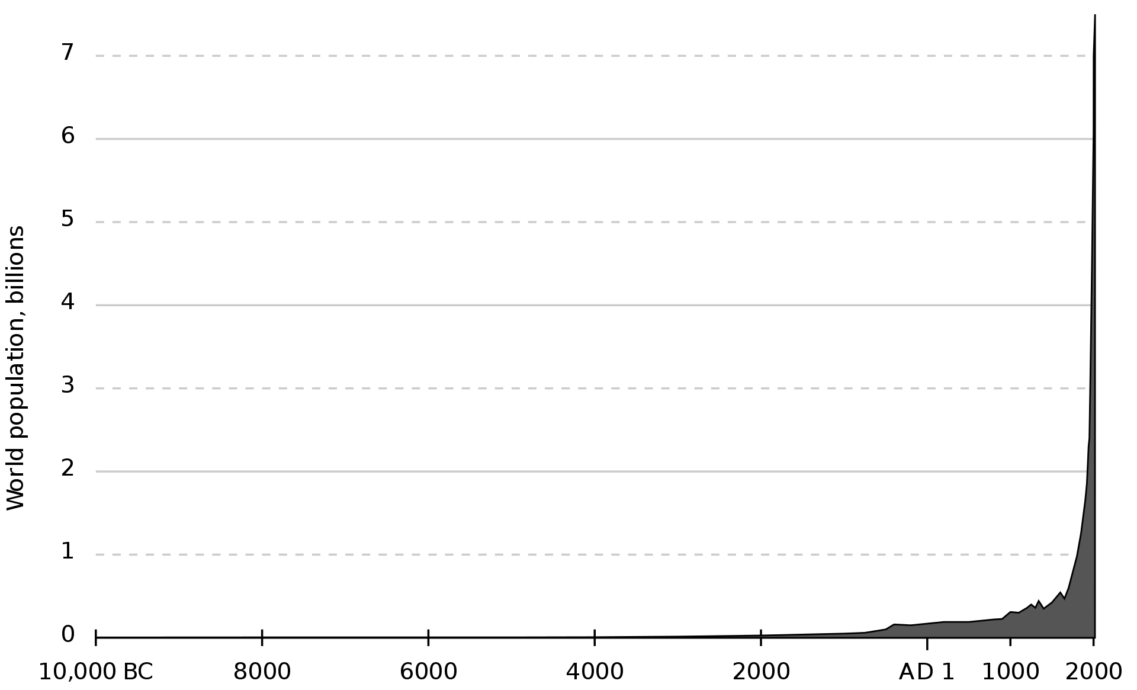
The graph makes the effects of industrialisation clear. Our population is skyrocketing, and along with it consumption is reaching new heights that challenge Earth’s current carrying capacity. In the 20th century the population began to grow exponentially for the first time in history.

The Maths Behind Population Growth

Earth is a system with limited resources, yet the human population continues to grow. A scientist called Malthus predicted in the 20th century that there would eventually come a ‘Malthusian Catastrophe’ when population would exceed Earth’s carrying capacity. Unable to feed itself, humanity would starve through wars spanning continents as civilisation collapsed in the absence of fundamental resources to sustain itself. So-called ‘water wars’ have been well-documented in science fiction. To test whether this haunting prediction has real merit, I have used the following equation:

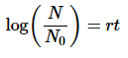
Where:
- N₀ (initial population) = The population at time t = 0.
- N (future population) = The population at time t.
- r (rate) = The rate of population change as a function of t (a 1% increase is expressed as 0.01).
  - This variable is called the Malthusian Parameter.
  - In population studies, r is usually taken to mean births minus deaths.
- t (time) = The amount of time required to produce a growth in population proportional to N/N₀.

Currently, the world population is growing at a rate of 1.1% per year. This equation’s derivations can be used to predict the time taken for population to double:

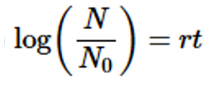
If this comes to fruition, there will be 14 billion people on Earth in 2074 (based on the 2011 population of 17 billion).

It is senseless to place the blame for our increase in resource consumption on the 3rd world, since population and resource consumption compare vastly differently in different countries. For example, America is home to 5% of the world population, but consumes an astounding 25% of resources! This means that, in terms of resources used, each new American born equals five new world citizens!

The outcome of the maths is the following conclusion: while it is important to clamp down on population growth by working towards social development in countries with high fertility rates, the biggest issue is disproportionate resource consumption in the 1st world, which needs urgent addressing.

Conclusion

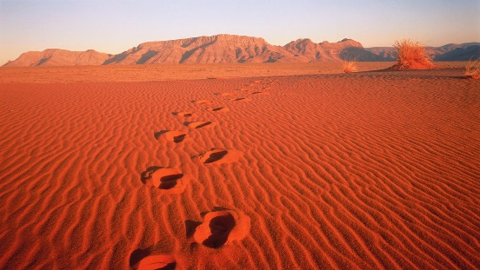
The biggest lesson we can learn from the demise of the dinosaurs is how lucky we are to still even be here. Based on the fossil record, the background rate of extinctions on Earth is about two to five taxonomic families every million years [2]. Marine fossils are usually used to measure extinction rates because of their superior fossil record and stratigraphic range compared to land animals. Nick Bostrom uses a series of equations to estimate the chances of human extinction are greater than 25% and the end of our species is long overdue. A few hundred million years, in fact. A little more optimistically, philosopher John Leslie assigns a 70% chance of humanity surviving the next five centuries. The image represents the footprint we have already left behind on the Earth, in terms of the atmosphere’s composition and the biomes we have both created and destroyed.

In conclusion, it is imperative for us humans to fully realise how much power we now have in our hands; for the first time ever, the dangers the world throws at us are more insignificant than the dangers we pose to ourselves through nuclear stockpiles and growing potential for a catastrophic epidemic. If we take one thing away from the havoc caused by Covid-19, it should be that we are never really safe. By the end of the century, I guarantee you that one event or the other will have occurred to threaten the existence of our species as a whole. The future is coming; building on all that we have already accomplished, we must be ready for it.

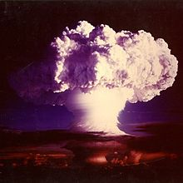
Nuclear war [6] is an often predicted cause of extinction of humanity.

References

- Future of Humanity Institute, 2008
- Phil Plait, 2014, Poisoned Planet
- David Biello, 2009, Scientific American
- www.activewild.com
- www.flowingdata.com
- Getty Images
Footnote

Despite the bleak and pessimistic view of the future this essay provides, rest assured that it is still extremely unlikely that we will be obliterated tomorrow. The best course of action seems to me to be the pursuit of fulfilling, happy lives as we encourage scientific thinking in today’s increasingly innovative society. Hopefully, a solution to any threat to life on Earth will be found long before it is needed. After all, our species, if nothing else, is resilient. Evolution has ensured our kind is adaptive to change, so when change comes, we will be ready for it.

