Fourier Transform and Music
By Yash Patel
Introduction
I have been able to play the flute for about 8 years, the guitar for 4, and the bass for one, so music is a big part of life. I’m intrigued about why music even exists in the first place. Why do humans respond to music? Where do the notes even originate from? Why do some songs stick in our brains and others don’t? I want to explore that last question through investigating if a pattern exists in the notes used in catchy music. Catchiness means how fast a person was able to recognize a song when it began to play as defined by the scientist that conducted the experiment that I will be using. Nikola Tesla once said, “If you want to find the secrets of the universe, think in terms of energy, frequency and vibration.” Therefore, the aim of the exploration will be to break down each song into the frequencies that make them up since notes are just frequencies, for example, an A is 440 Hz.
How?
I need to find a way to deconstruct the songs into their base frequencies. The best way to do that is through a Fourier transform. A Fourier transform is a function that can take a graph that graphs amplitude with respect to time and produces a graph that graphs amplitude with respect to frequency. So if a person wanted to know what frequencies made up a sine wave or a song wave when they only had the equation with an input of time, they could pass equation through the Fourier Transform that would result in a graph which essentially would graph the sound wave with the x-axis being frequency instead of time while the y-axis still measures the amplitude.
For example, the Figure 1 is of a graph I want to deconstruct into its base frequencies and Figure 2 is the graph passed through the Fourier Transform.
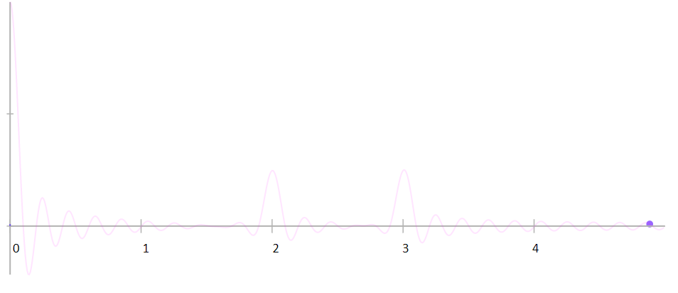
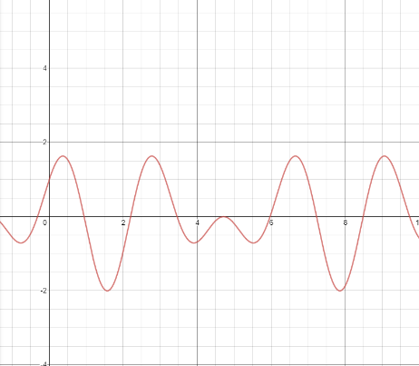
Frequency(ohms)
Amplitude(volts)
Amplitude(volts)
Time(s)
Fourier Transform
Figure 2 Graph of the Fourier Transform of y=sin3x+cos2x graphed with the x axis being frequency and the y-axis being amplitude
Figure 1 Graph of y=sin3x+cos2x graphed with the x axis being time and the y-axis being amplitude

Once Figure 1 goes through the Fourier Transform it produces a graph that has two humps at 2 and 3 indicating that the frequencies of y=sin3x+cos2x are 3 and 2. Since sound waves are just a bunch of frequencies added together the Fourier Transform is the best method of breaking down the songs.
The Equation of the Fourier Transform
Fourier Transform: $g\left(f\right)=\int_{t_{1}}^{t_{2}}{g\left(t\right)e^{-2πift}dt}$
$$g\left(t\right):The output of the graph we want to analyze$$
$$g\left(f\right)=Amplitude in terms of frequency$$
$$f=frequency$$
$t_{1}=start time for analyzation$
$$t_{2}=end time for analyzation$$
$$t=time$$
The equation is graphed with respect to f, so I choose the length of the sound wave which would designate the t₁, t₂, and t values. The function is also divided into three parts which are integral to understanding how the frequency is calculated.
Part 1:$e^{-2πift}$
This is the Euler Identity with slight modifications to allow it to calculate the Fourier transform. In the complex plane the Euler Identity graphs the tip of a vector which continuously rotates for set amount of time. The f is how fast the vector rotates, and the t is how long it rotates for.
Part 2: $g\left(t\right)$
The Euler Identity by itself just graphs a circle. The g(t) changes the length of the vector based on the amplitude of the g(t) graph at that current t value. This addition in turns allows us to turn the original sinusoid into a polar-like graph (Figure 3 or Figure 4). The importance of observing the graph as a circle like this is that mathematician can break up these circle-like graphs into individual circles aka the frequencies.
The resulting graph of $g\left(t\right)e^{-2πift}$ creates a polar-like graph and in order to find which frequencies make up that graph we need to find the center of the graph since the center is the average of all the vector magnitudes. Usually, the center hovers around zero but when f becomes a frequency of the original function then the center of the graph shifts to a value that is more distinct. The center shifts to something more distinctive because at that frequency the other frequencies do not result in a destructive interference. Think of it like a solar eclipse, at a certain time, the sun, moon, and earth line up which creates a solar eclipse. However, in this case, the frequency that we use lines up with a frequency that exists in the equation we want to analyze which leads to a large shift in the average magnitude of the circular graph which leads to part 3 of the Fourier Transform: the Integral.
Part 3:$\int_{t_{1}}^{t_{2}}{dt}$
The integral is taken of $g\left(t\right)e^{-2πift}$ from $t_{1}$ to $t_{2}$ to find the length of all the vectors, and the value of $t_{1}$ to $t_{2}$ is chosen based on which part of the graph we want to analyze. So, if I want to only analyze which frequencies are in the chorus of the song, I will choose $t_{1 }$ as the beginning point of the chorus and $t_{2}$ at the end of the chorus. Usually, the greater the difference between $t_{1}$ and $t_{2}$, the more frequencies the Fourier Transform would pick up since more of the graph we want to analyze is graphed; therefore, outputting frequencies that are much larger. Or in other words the range between $t_{1}$ and $t_{2}$ is the possible frequencies I can analyze, so if a graph had a frequency of 7 and my $t_{1}$ was 0 and my $t_{2}$ was 1, the Fourier Transform would not pick up on the frequency of 7. Finally, the original integral was divided by the time to find the average which would result in the center of the graph but that was unnecessary since the total length of all the vectors are already the largest at the frequencies present , so mathematicians took the division out.

Therefore, for a person to use a Fourier Transform, they chose a specific time frame like from zero to three second which designates $t_{1}$ and $t_{2}$. Then continuously change the frequency (f) until the center of the graph shifts a significant amount. Take for example the Fourier Transform done on the equation y=sin3x+cos2x below.
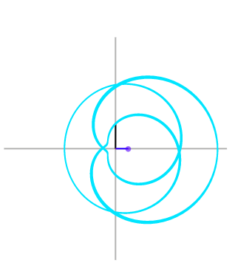
Real Axis
Imaginary Axis
Figure 3 A picture which visually demonstrates the Fourier Transform of y=sin3x+cos2x
In Figure 3 the graph currently has a f =3, t₁=0, and t₂=3and the purple dot symbolizes the center of the graph or the result of the real parts of the integral. To make things simpler to understand Figure 3 only calculates the real result of the Fourier Transform and subsequently only graphs the real amplitude but the results stay the same. Therefore, the Fourier transform’s graph would have a hump at 3, in relation to the rest of the graph (ex. Figure 2 where there are two humps at 2 and 3), indicating that one of the frequencies is at 3.

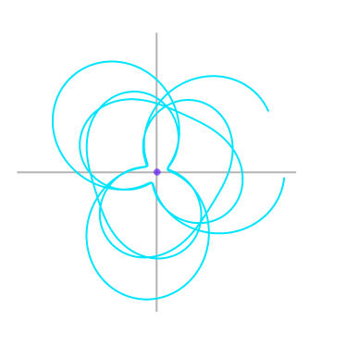
Imaginary Axis
Real Axis
Figure 4 Fourier Transform of y=sin3x+cos2x but with different frequency
In Figure 4, I chose to analyze the function at f=1.49, from t₁=0 to t₂=3, and the purple dot which is the total of all the real parts of the integral is in the center. The Fourier Transform’s graphs at f=1.49 would be near zero in comparison to Figure 2’s purple dot which means that the equation is not made up of a frequency of 1.49.

Methods of Solving the Problem
At first, I tried solving a Fourier Transform by hand by using Euler’s identity to turn $g\left(f\right)=\int_{t_{1}}^{t_{2}}{g\left(t\right)e^{-2πift}dt}$ into $g\left(f\right)=\int_{t_{1}}^{t_{2}}{g\left(t\right)((cos\left(-2πft\right)+isin⁡(-2πft))dt}$ because of Euler’s identity which states that $e^{ix}=cosx+isinx$. Then I split that function into their real and imaginary parts and solved for their antiderivatives. The antiderivative will be solved with respect to $t$ and with $f$and $g\left(t\right)$ being constants.
Real
$$\int{g\left(t\right)((cos\left(-2πft\right)dt→ \frac{-g(t)}{2πf}}\sin\left(-2πft\right)+C$$
Imaginary
$$\int{g\left(t\right)((sin\left(-2πft\right)dt→ \frac{g(t)}{2πf}(cos\left(-2πft\right)})+C$$

Then I plugged in the values I wanted to solve for, but to solve for every possible f value was tedious, and it would take even longer with sound waves from songs because song wave amplitudes are too detailed to find an exact number, so I tried to make a computer program.
I tried using Desmos to make a Fourier transform function that works in the real plane. I used polar equations and graphs which would graph the function. Then a vector would map out the function and another function would calculate the average of the vector which would result in the same answer as the Fourier transform. However, there were too many variables and the program became too complex and would not accept .wav functions (the format that the songs wave came in).
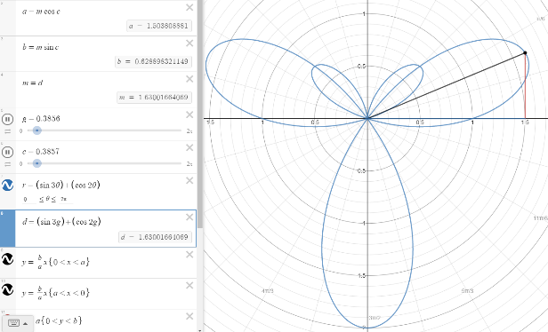
An attempt at a Fourier Function on Desmos

Thankfully, I learned that Fourier Transforms are extremely useful in sound editing. I downloaded a program called Audacity which had a feature called spectrogram which uses a Fourier Transform to break down the song into its frequencies.
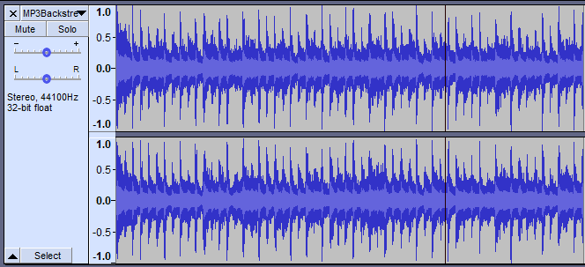
Figure 5 Sound Wave of "I Want it That Way" by the Backstreet Boys
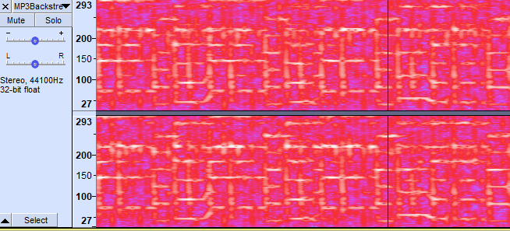
Circle 2
Vertical White Line that symbolizes percussion.
Circle 1
White line is roughly at 145 hertz
Figure 6 Spectrogram of "I want it that way” by the Backstreets Boys
Audacity takes the sound wave in Figure 5 and applies a Fourier Transform to create the spectrogram in Figure 6. The white lines are the frequencies present in the song at that current moment. Therefore, by identifying the frequencies (white lines) with a note name, I can figure out what notes are in the song. In music there are only 12 possible notes that musicians can use to create their songs. The notes are denoted from letters from A-G, and they each have a specific frequency. I find which note correspond with which frequency (white lines) by looking at Table 1.
For example, I circled (Circle 1) a white line in Figure 5 which is roughly at 145 hertz. I then look for a number around 145 hertz on the Table 1, and the closest note I can find is D₃ (highlighted in yellow). I use this same process for every white line in the chorus. I also noticed a pattern at the accuracy at which I can correspond a white line with a note. The higher the frequency, the greater difference between one note from the next, so I must be more careful when analyzing the white lines at lower frequencies. Then the white lines which are long vertical stripes like the one I circled in Circle 2 are percussion, so I do not count those as they are not notes.

Table 1
Note | Frequency | Note | Frequency
C₀ | 16.35 | B₂ | 123.47
C#₀/D^{b}₀ | 17.32 | C₃ | 130.81
D₀ | 18.35 | C#₃/D^{b}₃ | 138.59
D#₀/E^{b}₀ | 19.45 | D₃ | 146.83
E₀ | 20.60 | D#₃/E^{b}₃ | 155.56
F₀ | 21.83 | E₃ | 164.81
F#₀/G^{b}₀ | 23.12 | F₃ | 174.61
G₀ | 24.50 | F#₃/G^{b}₃ | 185.00
G#₀/A^{b}₀ | 25.96 | G₃ | 196.00
A₀ | 27.50 | G#₃/A^{b}₃ | 207.65
A#₀/B^{b}₀ | 29.14 | A₃ | 220.00
B₀ | 30.87 | A#₃/B^{b}₃ | 233.08
C₁ | 32.70 | B₃ | 246.94
C#₁/D^{b}₁ | 34.65 | C₄ | 261.63
D₁ | 36.71 | C#₄/D^{b}₄ | 277.18
D#₁/E^{b}₁ | 38.89 | D₄ | 293.66
E₁ | 41.20 | D#₄/E^{b}₄ | 311.13
F₁ | 43.65 | E₄ | 329.63
F#₁/G^{b}₁ | 46.25 | F₄ | 349.23
G₁ | 49.00 | F#₄/G^{b}₄ | 369.99
G#₁/A^{b}₁ | 51.91 | G₄ | 392.00
A₁ | 55.00 | G#₄/A^{b}₄ | 415.30
A#₁/B^{b}₁ | 58.27 | A₄ | 440.00
B₁ | 61.74 | A#₄/B^{b}₄ | 466.16
C₂ | 65.41 | B₄ | 493.88
C#₂/D^{b}₂ | 69.30 | C₅ | 523.25
D₂ | 73.42 | C#₅/D^{b}₅ | 554.37
D#₂/E^{b}₂ | 77.78 | D₅ | 587.33
E₂ | 82.41 | D#₅/E^{b}₅ | 622.25
F₂ | 87.31 | E₅ | 659.25
F#₂/G^{b}₂ | 92.50 | F₅ | 698.46
G₂ | 98.00 | F#₅/G^{b}₅ | 739.99
G#₂/A^{b}₂ | 103.83 | G₅ | 783.99
A₂ | 110.00 | G#₅/A^{b}₅ | 830.61
A#₂/B^{b}₂ | 116.54 | A₅ | 880.00

Methodology
To make things easier for data collection I chose to analyze the chorus of each song since that is the part most people remember of a song. I split up the chorus into one second blocks because it gives a clear sense of how to collect the vast amount of data. It also avoids the issue of repeating notes multiple times in a second which would create outliers, and it counts the whole notes which can last for multiple seconds and gives all frequencies an equal value. Then I looked at each one second block closely marking down the frequency of each white line. The data was collected in a chart like in pages of 22-23 of the Appendix.

Observation for the Catchiest Songs
I choose fourteen of the catchiest songs according to a scientific study conducted by the Museum of Science and Industry.
- Lou Bega- “Mambo No 5”
- Survivor – “Eye of the Tiger”
- Lady Gaga – “Just Dance”
- ABBA – “SOS”
- Michael Jackson – “Beat It”
- Whitney Houston – “I Will Always Love You”
- The Human League – “Don't You Want Me”
- Aerosmith – “I Don't Want to Miss a Thing”
- Lady Gaga – “Poker Face”
- Hanson – “MMMbop”
- Elvis Presley – “It's Now Or Never”
- Bachman-Turner Overdrive – “You Ain't Seen Nothin' Yet”
- Michael Jackson – “Billie Jean”
- Spice Girls- “Wannabee”
I had to omit Pretty Woman by Roy Orbison because it didn’t have a clear chorus, but I replaced it with “I Want it that Way” by the Backstreet Boys because I wanted to see if a pattern does exist with what I believe the catchiest song is or is “catchiness” a subjective ideal.
The charts and graphs for all the notes in the individual songs are in the appendix from pages 10-17. There is too much information in the charts and graphs, so I took note of which note occurred the most amount of times, the second most amount of times, and the third most amount of times and placed them in a table by song.

Table 2
Popularity of Note by Song
 | 1st | 2nd | 3rd
Mambo# 5 | F | A# | F#
I Want It that Way | A | F# | E
Just Dance | C# | E | F#,G#
SOS | F | C | A
Beat It | A# | D# | F
I Will Always Love You | F# | B | D#, G#
Don't You Want Me | F | D | C
I Don't Want to Miss a Thing | D | E,G | A
Poker Face | B | G# | E, F#
MMMBop | E | A | B
It's Now or Never | B | E | F#
You Ain't Seen Nothin' Yet | A | D | E
Billie Jean | F# | B,C# | D#
Wannabee | F# | B | C#,E
Eye of Tiger | C | G# | G
Table 2 is confusing to look at, so instead of organizing the notes by song I organized the notes alphabetically per each place as that method is easier to see which note is popular. It is also no longer important to take note of which note belongs to which song.
Table 3
Popularity of Note for “Catchiest Songs”
1st Place | 2nd Place | 3rd Place
A | A | A
A | A# | A
A# | B | B
B | B | C
B | B,C | C#, E
C | C | D#
C# | D | E
D | D | E
E | D# | E,F#
F | E | F
F | E | F#
F | E, G | F#
F# | F# | F#, G#
F# | G# | G
F# | G# | G#
In Table 3, the notes in each row don’t belong to certain song as they are sorted alphabetically because it is easier to view, and I only need to know which place it got and not what song it belongs to. To organize the data even more, I assigned points to the notes that got third, second, and first for each song to the chart below (Table 4).
Table 4
 | Score | Frequency | Sum
D# | 1+2 | 2 | 3
G | 2+1 | 2 | 3
C# | 3+1 | 2 | 4
A# | 3+2 | 2 | 5
D | 3+2 | 2 | 5
G# | 2+1+1+2 | 4 | 6
C | 3+2+1+2 | 4 | 8
F | 3+3+3+1 | 4 | 10
A | 3+1+1+3+2 | 5 | 10
B | 2+2+3+3+2+1 | 6 | 13
E | 2+2+1+1+3+2+1+1 | 8 | 13
F# | 3+3+2+1+1+3+1+1 | 8 | 15

I assigned a value for first, second, and third. Each note in first got 3 points, each note in second got two points, and each note in third got 1 point. Therefore, if F appeared three times in first, F would get 9 points, three points for each time it appeared. Notes that were tied received the same amount of points. The chart also helps visualize how many times the note appeared in the top three and gave a numeric value to the occurrences of each note.
Interpretation of “Catchiest Songs”
In music there are twelve different notes that a musician can use to make a progression for their chorus. Similarly, there are a lot of different possible chord combinations that a person can use in the music, so a musician must make a lot of choices when creating their music. They cannot choose notes at random and create good sounding music.
Therefore, if a note is more prevalent than other notes it is for a purpose. Following that logic because F# has the highest number of points at 15 I would say that there is a correlation between a song catchy and the possibility that is contains a large amount of F#. The probability of F# appearing is 16% which is twice probability then F# being chosen at random which is a 1 in 12 (8%) chance. There is trouble finding an exact mathematical way to say that there is a correlation because the notes don’t represent linearly progressing numbers, but I think that basic logic can see that there is some sort of correlation.
At first, I had only analyzed ten of the “Catchiest Songs”. F and F# were tied for the most common notes and all the frequencies were close together, so I decided to analyze five more and F# solidified its lead. Another interesting observation, but one that doesn’t have a lot of merit because the chart doesn’t account for the notes that showed up the least, is that D# and G are the least popular of the common notes.
Data Collection & Interpretation of the “Happiest Songs”
I am also curious if there is a correlation between the happiest songs and their notes, so I also analyzed the 10 happiest songs according to a neuroscientist named Dr. Jacob Jolij who conducted a large survey.
- “Don’t Stop Me Now” by Queen
- “Dancing Queen” by ABBA
- “Good Vibrations” by The Beach Boys
- “Uptown Girl” by Billy Joel
- “Eye of the Tiger” by Survivor
- “I’m a Believer” by The Monkees
- “Girls Just Want to Have Fun” by Cyndi Lauper
- “Livin’ On a Prayer” by Bon Jovi
- “I Will Survive” by Loria Gaynor
- “Walking on Sunshine” by Katrina & The Waves
I used the same method as when I was collecting and organizing data for the “Catchiest Songs” exploration for the “Happiest Songs”. If you want to see the graphs for each song go to the Appendix page 18-21.
Table 5
Popularity of Note
1st Place | 2nd Place | 3rd Place
A | A | A#
C | B | C
D | B | D#
E | B,C | F
E | C# | F#,G#
F | E | G
F# | G# | G
F# | G#,C# | G#

Table 5 takes a tally of when a note appears the most, second, or third amount of times in a song, and I excluded the table where the notes were organized by song (Table 2) because it was unnecessary.

Table 6
 | Score | Frequency | Sum
A# | 1 | 1 | 1
D# | 1 | 1 | 1
G | 1+1 | 2 | 2
D | 3 | 1 | 3
C# | 2+2 | 2 | 4
F | 3+1 | 2 | 4
A | 3+2 | 2 | 5
B | 2+2+2 | 3 | 6
C | 3+2+1 | 3 | 6
G# | 2+2+1+1 | 4 | 6
F# | 3+3+1 | 3 | 7
E | 3+3+2 | 3 | 8

The table above has the same scoring system as the one from the “Catchiest Song” exploration.
There were a lot of issues with this data set as “Don’t Stop Me Now” and “I’m a Believer” had to be excluded because the spectrogram was too muddled to see the correct frequencies. There is not enough data to say there is a direct correlation because a lot of the notes show up the same amount of time like four notes showing up three times in the top three. More songs will need to be analyzed before I can make a conclusion.
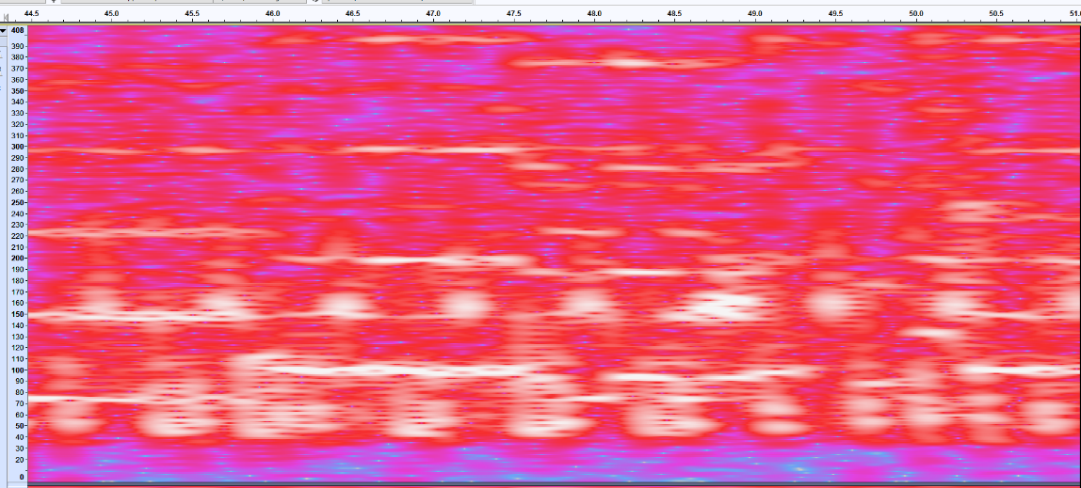
However, there are interesting patterns that I picked up on. Once again F# is one of the most common notes and D# and G are the least common notes. In my ears the happy songs can also fall under the category of catchy songs, in fact “Eye of the Tiger” fell under both the happy and catchy song category. Therefore, this insight further strengthens the case between a song being catchy and F# being one of the most common notes in it.

Circles 3+4 Spots with lots of interfere nce from percussion

Figure 7 Spectrogram of Don't Stop Me Now by Queen. Many of the white lines don't match frequencies of the notes and the large tall white spots muddle with the analysis of the notes.
During the analysis of the happy songs I ran into problems that prevented me from trusting the data presented. Like in Figure 7 the percussion will create a large blob of white (Circle 3+4) that would make it hard to distinguish between individual notes and the drums which prevents me from taking a proper tally of what notes are in the song making the data unreliable.
Conclusion & Reflection
Music is a hard concept to decipher because the number of variables that go into it. There is the rhythm, the words, and the notes. Isolating one aspect does not do justice to the song as the rhythm, dynamics, and words are just as integral and impactful to the effect that the song creates. If a musician wanted to reverse engineer a song to make it catchy, they can’t play an F# on a piano for a minute and make it sound good. A lot more elements are involved along with which notes are chosen that make a song catchy.
Nevertheless, the exploration did show a correlation between the occurrence of the note F# and how catchy or happy the song was which answered my original question. However, next time I will need to analyze a lot more songs to assert that claim with full confidence. I will also need to find a way to make the graph of the Fourier transform more pronounced to avoid the issues of the graph being too muddled, as I’m then not able to assign the correct note to the white line. Along with more the idea of more data, I will also organize the data in terms of the least popular note which I suspect to be D#.
While doing the exploration I was constantly amazed at the power of the Fourier Transformation. The white lines were at the frequencies of the specific note which just blew my mind because the simple function was able break up music which to me is very complex into simple numbers. With further reading I also learned that Fourier Transform can deconstruct images into their base frequencies as well which means that everything I hear and see can become a number which is quite intimidating but fascinating.

Appendix
Just Dance by Lady Gaga
Just Dance
Notes | Occurrences
A | 3
A# | 0
B | 3
C | 2
C# | 8
D | 2
D# | 3
E | 6
F | 4
F# | 5
G | 2
G# | 5

SOS by Abba
SOS
Notes | Occurrences
A | 20
A# | 19
B | 0
C | 25
C# | 0
D | 11
D# | 0
E | 5
F | 40
F# | 0
G | 15
G# | 0

Eye of Tiger by Survivor
Eye of the Tiger
Notes | Occurrences
A | 6
A# | 1
B | 2
C | 10
C# | 5
D | 0
D# | 5
E | 1
F | 0
F# | 3
G | 7
G# | 9

Don’t You Want Me Baby
Don't You Want Me Baby
Notes | Occurrences
A | 0
A# | 0
B | 0
C | 6
C# | 0
D | 8
D# | 0
E | 4
F | 11
F# | 2
G | 4
G# | 1

Wannabee by Spice Girl
Wannabee
Notes | Occurrences
A | 0
A# | 1
B | 6
C | 0
C# | 4
D | 0
D# | 3
E | 4
F | 1
F# | 12
G | 2
G# | 3

I Don’t Want to Miss a Thing by Aerosmith
I Don't want to miss a thing
Notes | Occurrences
A | 12
A# | 0
B | 7
C | 0
C# | 8
D | 21
D# | 0
E | 14
F | 0
F# | 5
G | 14
G# | 1

I Will Always Love You by Whitney Houston
I will always love you
Notes | Occurrences
A | 0
A# | 0
B | 17
C | 0
C# | 9
D | 0
D# | 12
E | 7
F | 1
F# | 25
G | 0
G# | 12

Beat It by Micheal Jackson
Beat It
Notes | Occurrences
A | 0
A# | 22
B | 4
C | 4
C# | 11
D | 8
D# | 16
E | 5
F | 12
F# | 8
G | 4
G# | 4

Mambo #5 by Lou Bega
Mambo#5
Notes | Occurrences
A | 0
A# | 9
B | 0
C | 0
C# | 2
D | 1
D# | 1
E | 2
F | 13
F# | 6
G | 2
G# | 0

I Want it That Way by Backstreet Boys
I want it that way
Notes | Occurrences
A | 25
A# | 0
B | 8
C | 0
C# | 8
D | 17
D# | 1
E | 18
F | 0
F# | 23
G | 4
G# | 4

Poker Face by Lady Gaga
Poker Face
Notes | Occurrences
A | 0
A# | 3
B | 9
C | 0
C# | 1
D | 0
D# | 3
E | 5
F | 0
F# | 5
G | 0
G# | 7

You Ain’t Seen Nothing Yet by Bachman Turner Overdrive
You Ain't Seen Nothing Yet
Notes | Occurrences
A | 27
A# | 0
B | 6
C | 0
C# | 5
D | 15
D# | 0
E | 12
F | 3
F# | 2
G | 2
G# | 6

MMMBop by Hanson
MMMBop
Notes | Occurrences
A | 9
A# | 0
B | 6
C | 0
C# | 2
D | 0
D# | 2
E | 13
F | 0
F# | 1
G | 1
G# | 0

Billie Jean by Michael Jackson
Billie Jean
Notes | Occurrences
A | 0
A# | 0
B | 11
C | 1
C# | 11
D | 2
D# | 4
E | 1
F | 0
F# | 18
G | 1
G# | 0

It’s Now or Never by Elvis Presley
It's Now or Never
Notes | Occurrences
A | 9
A# | 0
B | 27
C | 1
C# | 5
D | 0
D# | 5
E | 24
F | 0
F# | 19
G | 7
G# | 7

Happiest Songs
Good Vibrations by The Beach Boys
Good Vibrations
Notes | Occurrences
A | 0
A# | 11
B | 6
C | 0
C# | 16
D | 0
D# | 8
E | 0
F | 4
F# | 21
G | 0
G# | 16

Dancing Queen by ABBA
Dancing Queen
Notes | Occurrences
A | 21
A# | 0
B | 0
C | 0
C# | 4
D | 0
D# | 3
E | 13
F | 5
F# | 9
G | 6
G# | 9

Livin’ on a Prayer by Bon Jovi
Livin' on a Prayer
Notes | Occurrences
A | 1
A# | 0
B | 5
C | 5
C# | 3
D | 7
D# | 0
E | 3
F | 0
F# | 3
G | 4
G# | 0

Girls Want to Have Fun by Cyndi Lauper
Girls Want to have fun
Notes | Occurrences
A | 0
A# | 0
B | 1
C | 0
C# | 10
D | 0
D# | 7
E | 0
F | 0
F# | 18
G | 0
G# | 0

Uptown Girl by Billy Joel
Uptown Girl
Notes | Occurrences
A | 9
A# | 0
B | 23
C | 0
C# | 9
D | 0
D# | 4
E | 24
F | 0
F# | 7
G | 0
G# | 18

I Will Survive by Gloria Gaynor
I will survive
Notes | Occurrences
A | 10
A# | 1
B | 17
C | 11
C# | 2
D | 9
D# | 3
E | 24
F | 13
F# | 4
G | 10
G# | 3

Walking on Sunshine by Katrina & The Waves
Walking on Sunshine
Notes | Occurrences
A | 13
A# | 11
B | 0
C | 12
C# | 0
D | 10
D# | 4
E | 1
F | 21
F# | 0
G | 5
G# | 4

Data Table For Analyzing Song Choruses
Note | Frequency | Occurrences in the Chorus | Total Number
C₀ | 16.35
C#₀/D^{b}₀ | 17.32
D₀ | 18.35
D#₀/E^{b}₀ | 19.45
E₀ | 20.60
F₀ | 21.83
F#₀/G^{b}₀ | 23.12
G₀ | 24.50
G#₀/A^{b}₀ | 25.96
A₀ | 27.50
A#₀/B^{b}₀ | 29.14
B₀ | 30.87
C₁ | 32.70
C#₁/D^{b}₁ | 34.65
D₁ | 36.71
D#₁/E^{b}₁ | 38.89
E₁ | 41.20
F₁ | 43.65
F#₁/G^{b}₁ | 46.25
G₁ | 49.00
G#₁/A^{b}₁ | 51.91
A₁ | 55.00
A#₁/B^{b}₁ | 58.27
B₁ | 61.74
C₂ | 65.41
C#₂/D^{b}₂ | 69.30
D₂ | 73.42
D#₂/E^{b}₂ | 77.78
E₂ | 82.41
F₂ | 87.31
F#₂/G^{b}₂ | 92.50
G₂ | 98.00
G#₂/A^{b}₂ | 103.83
A₂ | 110.00
A#₂/B^{b}₂ | 116.54
B₂ | 123.47
C₃ | 130.81
C#₃/D^{b}₃ | 138.59
D₃ | 146.83
D#₃/E^{b}₃ | 155.56
E₃ | 164.81
F₃ | 174.61
F#₃/G^{b}₃ | 185.00
G₃ | 196.00
G#₃/A^{b}₃ | 207.65
A₃ | 220.00
A#₃/B^{b}₃ | 233.08
B₃ | 246.94
C₄ | 261.63
C#₄/D^{b}₄ | 277.18
D₄ | 293.66
D#₄/E^{b}₄ | 311.13
E₄ | 329.63
F₄ | 349.23
F#₄/G^{b}₄ | 369.99
G₄ | 392.00
G#₄/A^{b}₄ | 415.30
A₄ | 440.00
A#₄/B^{b}₄ | 466.16
B₄ | 493.88
C₅ | 523.25
C#₅/D^{b}₅ | 554.37
D₅ | 587.33
D#₅/E^{b}₅ | 622.25
E₅ | 659.25
F₅ | 698.46
F#₅/G^{b}₅ | 739.99
G₅ | 783.99
G#₅/A^{b}₅ | 830.61
A₅ | 880.00
A#₅/B^{b}₅ | 932.33

Work Cited
Glass, Jeremy. “The 10 Happiest Songs on Earth, as Decided by a Neuroscientist.” Thrillist, Thrillist, 28 Sept. 2015, www.thrillist.com/entertainment/nation/the-10-happiest-songs-on-earth-as-decided-by-a-neuroscientist.
Starr, Michelle. “The Top 20 Catchiest Songs of All Time, According to Science.” CNET, CNET, 4 Nov. 2014, www.cnet.com/g00/news/the-top-10-catchiest-songs-of-all-time-according-to-science/?i10c.ua=1&i10c.encReferrer=aHR0cHM6Ly93d3cuZ29vZ2xlLmNvbS8%3D&i10c.dv=16.

