The Concept of Infinity

The concept of infinity has baffled mathematicians for generations. It is defined as the quantity greater than any assignable value, or in other words the never-ending. How can we possibly imagine the never-ending with a human mind that has a set capacity for thinking? It is a pretty difficult concept to grasp, and thus infinity has always been treated with caution within mathematics.

In everyday language, the concept of infinity can mean many different things. Different interpretations include ‘the biggest number’, ‘forever’, ‘God’, ‘the universe’, however, in mathematics, all a number needs to be infinite is to be bigger than any finite number. This separates infinity into two distinguishable groups: countable and uncountable. Countable infinity is the infinity of ‘forever’ and ‘so on’. For example, 1+1+1+1+... or 1+2+3+4+5+... Both of these examples will go on forever as you can always add 1 to the previous number. Uncountable infinity is the infinity of all real numbers (1, 1.001, 4.1516…basically any number you can think of). This type of infinity is called uncountable because you could never list off all the real numbers in order without missing some. For example, if you were to be counting up in 0.1s, you would be missing the numbers in between since there are endless numbers that can fit in between. The German mathematician Georg Cantor first defined these different types of infinities.

When thinking about the concept of infinity, a number of paradoxes arise. For example, the theory that a specific length can be cut an infinite number of times causes a paradox. These parts either have some length or no length. If they have any length, they add up to an infinite length, but if they have no length, they do not add up to anything. This cannot be the case as there was a specific length to start with. This is known as ‘infinity by division’. Another example of a paradox is known as ‘infinity by addition’. There is an infinite number of even and natural numbers so they are the same amount. However, even numbers are a subset of natural numbers, so there are fewer even numbers than there are natural numbers. This creates the paradox that the number of even numbers is both equal and not equal to the number of natural numbers. Ancient Greek philosopher and mathematician Aristotle was the first to explain a very powerful idea that solved these paradoxes. He explained that there is such a thing as infinity, but only a potential infinity. If we compare an even number in both sets of even numbers and natural numbers, we always consider this number at a specific point in the two sets. However, it is impossible for infinity to have a specific point as it has no end. This idea of potential infinity was contrasted with the idea of an actual infinity, which he described as never-ending things that are contained in something with an end. Actual infinity is what gives rise to these paradoxes, saying that there is an actual infinity of parts on a line or saying there is an actual infinity of even and natural numbers. Using the idea of a potential infinity solves these paradoxes, which is the reason it is accepted by many mathematicians today.

Another interesting interpretation of Aristotle’s explanation is that the term ‘potential infinity’ means something never complete (we never actually get to infinity). It can, therefore, be used for things that are actually finite, but never actually reached. For example, ancient philosopher Thomas Aquinas said that our minds are infinite, in the sense that we can understand an infinite number of things. He stated that we have the potential to understand many different things even though it will never be possible, and so he believed that the term ‘infinity’ was acceptable to use in this manner. Aristotle’s theory of ‘potential infinity’ was so powerful that it influenced many other mathematicians to give their own opinion on this matter.

Although we may not be able to understand this concept, infinity plays a key role in mathematics and physics, especially in how we perceive the universe. One of the biggest questions in science is whether we can ever discover the size of the universe. Some believe that the size of the universe is infinite, and therefore it goes on forever. Another theory states that the universe is like the surface of a ball: it is never-ending but it is still finite since it does not go on forever. We do not know the answer to this question, but our understanding of infinity can help us form theories that will be argued for generations to come. Newton believed that space is, in fact, infinite and not merely indefinitely large. He claimed that such an infinity could be understood, particularly using geometrical arguments, but it could not be conceived.

One of the most astounding concepts in the study of infinity is the theory that 1+2+3+4+5+... = -1/12. Although this may seem absurd, there is a logical mathematical proof that proves this to be true, which is shown below:
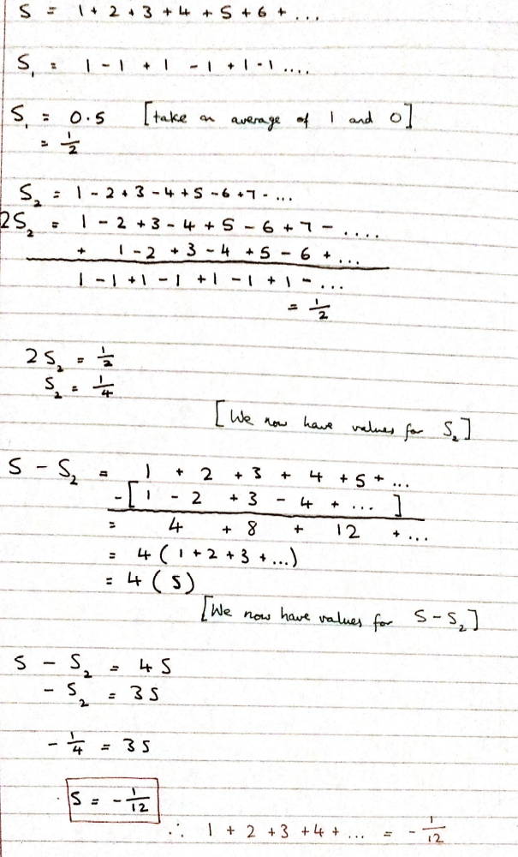

The reason why many people see this to be true is that it seen in physics regularly, particularly in the study of string theory. Those who do not understand this concept may be tempted to cut the sequence of numbers short, but this would mean that infinity is not reached so a large number is instead produced. For me, the most difficult part to grasp is the fact that it is the sum of all the numbers to infinity rather than just to a very large number. This proof defies many things we know about mathematics, which is why I personally find it so mind-blowing. How can the sum of many positive numbers give a small negative number? Perhaps one day more evidence will emerge to show this to be true, even though it defies many aspects of mathematics.
Overall, I believe that we are not capable of understanding what infinity really is because most of the things in our lives are finite, so our brain does not have the capability to imagine the never-ending. However, we can certainly get close to understanding it through mathematics, as mathematics allows us to understand many aspects of the universe without seeing it. The conclusion that humans cannot possibly understand infinity is backed up by the common misconception of something reaching infinity. If something were to ‘reach’ infinity, the subsequent numbers after this value would be greater, and therefore this would not be infinity. The correct language would be for something to ‘tend’ towards infinity rather than reach it. Infinity is a truly unique concept that will shape our mathematical and physical approach to many problems in the future. In the words of Grant Morrison, ‘the interior of our skulls contains a portal to infinity’, which one day may be unlocked.

