Complex numbers were first discovered more than four and a half centuries ago, in the year 1545. The discovery of complex numbers, a number in the form of a + ib, where a,b are real numbers and i^2 is -1, have a profound impact on all of mathematics, helping to solve many problems that had seemed impossible to solve, and opening the door for so much more understanding of maths. Complex numbers were first discovered by Girolamo Cardano, also famous for discovering the formula to solve a cubic equation, in the paper Ars Magna. He considered the square root of negative numbers when trying to solve problems using the quadratic formula, when b^2 – 4ac was negative. However, it was not the quadratic formula that made people take complex numbers seriously, it was the cubic. Bombelli, in 1572, realised that there were some cubic equations, that had solutions, but when put into the cubic formula, were only able to be solved through the use of complex numbers. He realised that complex numbers were an essential part of mathematics.
Although complex numbers were discovered in the 16th century, they were greeted with distaste and hostility for centuries to come. Even Cardano, in his work when discovering complex numbers, himself dismissed them as “subtle as they are useless”. Leibniz, who invented calculus independent of Newton, described them as “between existence and nonexistence”. These views were widely shared in the mathematical community for the 16th ,17th and most of the 18th century. The root of this unwillingness to appreciate complex numbers was due to the inability to answer the question “What is a complex number?”. This question was finally answered at the end of the 18th century, when Argand, Wessel and Gauss, all independently, expressed complex numbers as points on a two-dimensional plane, or the complex plane. This geometric interpretation helped many understand and accept complex numbers and led to them being widely used in every area of maths today.
The necessity of complex numbers is shown through the fundamental theorem of algebra which states that any polynomial with complex coefficients must have at least one complex root. This means that algebraically the field of complex numbers is closed.
When we have a complex function like f(z)=z²-1, and start with a number which we plug in and iterate by plugging in the solution each time, if the output after many iterations doesn’t spiral out to infinity then the number we started with is said to be in the Julia set of that complex function, and both surprisingly and stunningly, the Julia set doesn’t just look like a simple geometric shape, but is instead an incredibly detailed fractal.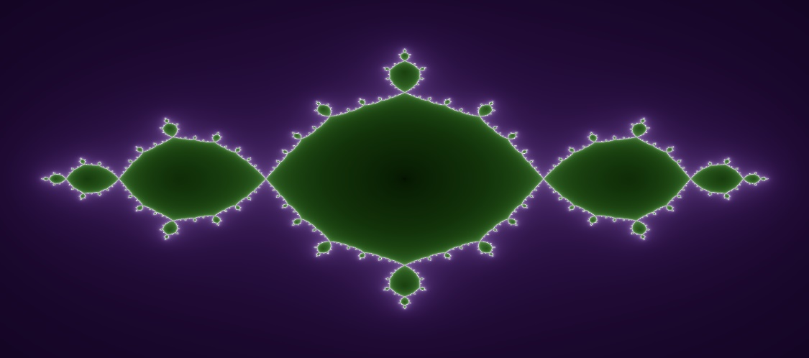
This Photo by Unknown Author is licensed under CC BY-SA
Now, if we generalise the function to f(z)=z² + c, with c being any constant, and look at the fractal generated, we see the fractal can be one of two things, either the fractal is a continuous shape like it is when c = -1, or it can be lots of separate, discontinuous, individual fractals. To work out which it is, we can generate a very famous and beautiful fractal, the Mandelbrot set.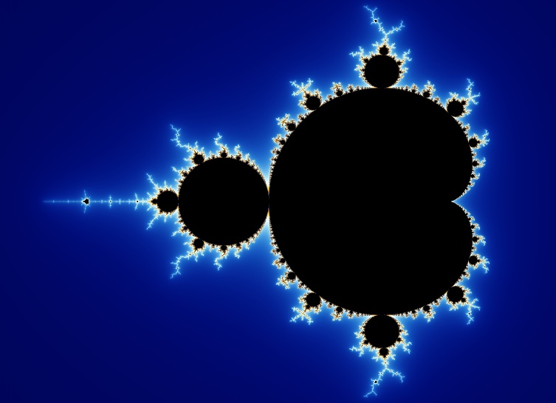
This Photo by Unknown Author is licensed under CC BY-SA
What the Mandelbrot set contains is a plotting of every single value of c that yields a continuous fractal on a set of axes, with the y being completely complex numbers, the x axis being real numbers, and the space in between a mix of the form a + bi. That set of axes are known as an argand diagram.
This is all part of the topic of complex analysis, which is the study of complex valued functions. What is incredible about that, is that functions of complex variables can be seen as mappings from one point to another in the complex plane, which means there are objects that look dreadfully complicated but in actuality are incredibly simple.
You may have heard of Euler’s formula. It states that $ⅇ^{ⅈθ}=\cos{θ}+ⅈ\sin{θ}$. The reason it is so important is that it links trigonometry and the exponential function e^{x}. This allows us to manipulate trig functions much more easily using power laws, in fact, this can even be manipulated to give cos(x)=$\frac{e^{ix}+e^{-ix}}{2 }$ , which is actually just the hyperbolic function cosh, but of a complex number inside the function (i.e. cosh(ix)) and the real part of $ⅇ^{ⅈx}$. Additionally, sin(x) =$\frac{e^{ix}-e^{-ix}}{2i}$ , which is the complex part of $ⅇ^{ⅈx}$. A famous result of Euler’s formula is $ⅇ^{ⅈπ}=-1,$ which can be obtained by substituting pi for theta and evaluating it. This allows us to integrate functions such as (-1)^{x} by substituting -1 for $ⅇ^{ⅈπ}$, and integrating using the standard integration technique for e^{kx}, which is (1/k)e^{kx} +c.
Another thing this incredible formula allows us to do, is to define the natural logarithm for negative numbers as $ⅇ^{ⅈπ}=-1$, taking ln of both sides gives us ln(-1) = i$π$.
Another major use of complex numbers is in mathematical modelling in physics, especially in the realm of quantum mechanics. In quantum mechanics some the fundamental equations are defined using complex numbers, in fact this bothered Schrodinger (the one with the cat) for years, as to why his wave equation was complex, and he tried very hard to find a physical interpretation of its real component. In fact, as much as some quantum physicists try to escape from complex numbers, it is Schrodinger’s wave equation that is part of the reason why complex numbers are so intrinsically linked to quantum mechanics. The reason for their necessity is some of the properties of the complex exponential in that it can have both a wavelength and an absolute value. Therefore, when he created his wave equation, he had to put i in there which caused an intrinsic connection between complex numbers and quantum mechanics.
In conclusion, complex numbers are an incredibly fascinating, useful and beautiful part of maths. They spawn a field of mathematical analysis called complex analysis and turn the number line into a plane. They can create beautiful fractals and relate trigonometry to exponentials through Euler’s formula. Finally, nowadays a major application of them is in physics, where they are part of the very fabric of quantum mechanics.
Written by Caleb Swabel

