Calabi-Yau Manifolds

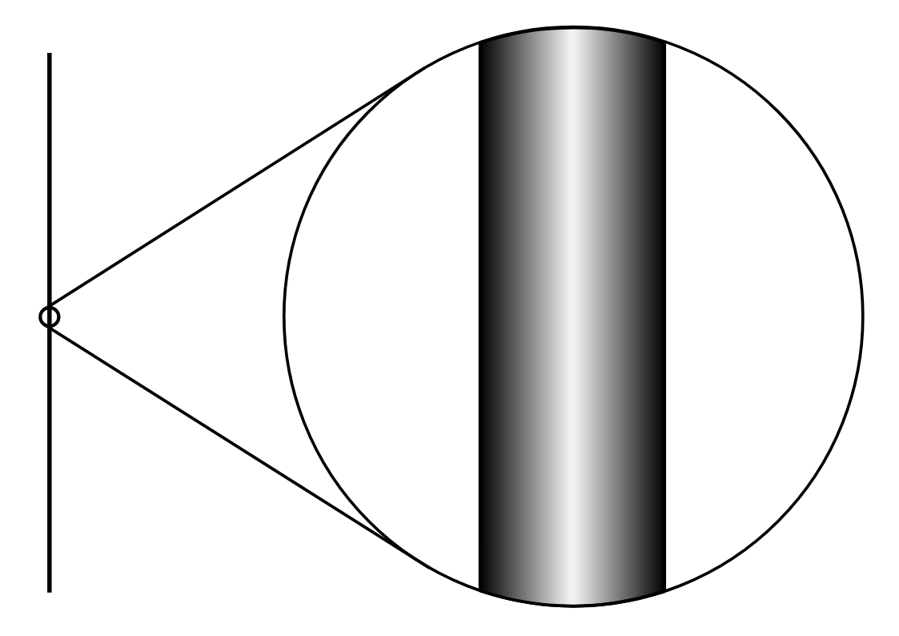
The world as we know it has four dimensions: three dimensions of space - width (x), height (y) and depth (z) - and one dimension of time. Einstein first linked these four dimensions with gravity and matter in his theory of general relativity. His calculations wouldn’t have been possible without the concept of measuring the curvature of an object from the ‘inside’ (a method developed by Riemann). However, our universe may contain numerous additional dimensions that we can’t see. Leading experts in superstring theory have even gone as far as saying that our universe contains 10 dimensions. So where are these extra six dimensions? It is believed that these six dimensions compactify (curl up on themselves), and form beautiful shapes which conform to what are called Calabi-Yau manifolds.

Compactification is the process of ‘curling up’ extra dimensions to a smaller size. For example a donut (2D surface) may be squeezed down to a circular wire with an unobservable cross section. This circular wire can then be shrunk into a point (one dimension).
Compactification

A manifold is a type of geometrical shape where each small ‘patch’ resembles normal Euclidean space. The classic example of this is an ant walking on the surface of the Earth. The ant will see the small patch it walks on as flat rather than curved. Manifolds don’t have to be 2D they can be multidimensional since it's mathematically possible to think of Euclidean space in any dimension you like (just use $n$coordinates rather than three). Once you've given a topological manifold a particular geometric structure (e.g a doughnut can be assigned a coffee cup shape as they are topologically the same https://plus.maths.org/issue10/features/topology/gluemug.gif), you can measure the curvature of the manifold at every point. We label the ‘average’ of all these curvatures the Ricci curvature of the manifold. Since we take an average, Ricci curvature only accounts for one component of a manifold’s curvature. Therefore a manifold may have zero Ricci curvature at every point and still not be flat. In terms of physics, the component captured by Ricci curvature happens to be the one that describes the curvature of spacetime induced by matter. So a manifold with zero Ricci curvature corresponds to a space with no matter, better known as a vacuum. In 2D, the only manifold that corresponds to this property is a torus.

It was shown that manifolds which had zero Ricci curvature could only take a certain topology. Manifolds with this topology are labelled as having a ‘vanishing first Chern class’ (named after Shiing-Shen Chern who discovered this property). Eugenio Calabi proposed a vital question later answered by Shing-Tung Yau. He pondered whether a certain type of topology guarantees that a certain type of geometry is possible. Could we form a geometric shape with zero Ricci curvature at every point given a complex manifold (also known as Kahler manifolds these are - manifolds in complex space instead of Euclidean space) that had a ‘vanishing first Chern class’?

The answer to Calabi’s question turned out to be yes. Shing-Tung Yau proved that any compact Kähler manifold with a vanishing first Chern class could be endowed with a geometry that had zero Ricci curvature. Such manifolds, which exist in all dimensions, are known as Calabi-Yau manifolds.

The basic maths behind the Calabi-Yau Manifolds

An n dimensional sphere can be described by considering the solutions to the equation -

x₁² + x₂² + x₃² … x_{n+1}² = r²

It turns out that similar to the n dimensional sphere, a Calabi-Yau manifold in two complex dimensions (known as ‘the quartic’) can be described by the complex solutions to the equation -

x₁⁴ + x₂⁴ + x₃⁴ + x₄⁴ = 0

And, the famous Calabi-Yau manifold in three dimensions (known as the ‘quintic’) is described by the complex solutions to the equation -

x₁⁵ + x₂⁵ + x₃⁵ + x₄⁵ + $Ψ$x₁x₂x₃x₄ = 0 (where $Ψ$is some parameter)

The shape of the Calabi-Yau manifold dictates the physical laws of that universe. Therefore, different Calabi-Yau manifolds, with different topological shapes, lead to different models of particle physics in four spacetime dimensions. Connected with each hole in the Calabi–Yau space is a group of string vibrational patterns. String theory states that our familiar elementary particles correspond to these vibrations, the presence of multiple holes causes the ‘string patterns’ to split / ‘drop’ into multiple groups, or families. So, if the Calabi–Yau manifold has three holes, then there exist three families of vibrational patterns and thus three families of particles will be observed.

The overarching answer from string theory to how many dimensions are in our universe is that there are 10; where the six extra dimensions are rolled up somewhere in the 4 dimensional space and are too small for us to see. As Yau puts it in more simplistic terms, "at each point of the 4D spacetime we observe there is in fact a tiny six-dimensional space". The only six dimensional structure that can harbour these hidden dimensions are Calabi-Yau manifolds. The manifolds are so tiny that they have a diameter of approximately 10⁻³⁰ cm (which is approximately a quadrillion times smaller than an electron).

There is no singular possibility for a six dimensional Calabi-Yau manifold. In fact, there are tens of thousands and none are more likely than others. As more manifolds were computed mathematicians began to notice a particularly interesting feature. Each manifold came in ‘pairs’ where one was the ‘mirror’ of the other. By a slight tweak of string theory, one can swap a Calabi-Yau manifold with its mirror without changing the physics at all.

The more dimensions we include the more complex and fascinating the manifolds become. These manifolds have proved to be vital part of string theory and are currently being used to prove the existence of the multiverse and also suggest the possible forms of these ‘unseen dimensions’. It also shows how regular mathematics / geometry can be complexified and modified to assess real life scenarios in physics.
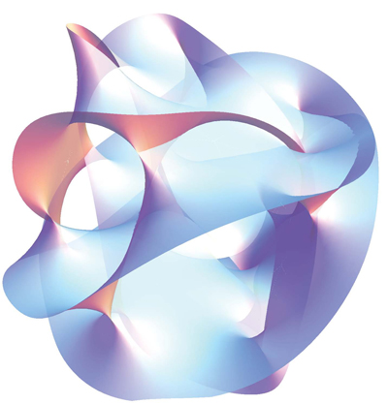
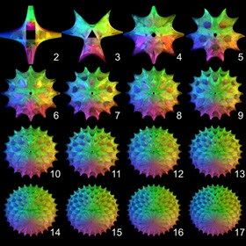
A simulation of some manifolds in different dimensions can be found here: https://observablehq.com/@sw1227/calabi-yau-manifold-3d

Bibliography -

https://www.maths.ox.ac.uk/about-us/life-oxford-mathematics/oxford-mathematics-alphabet/c-calabi-yau-manifolds#:~:text=Calabi%2DYau%20manifolds%20have%20become,looks%20like%20normal%20Euclidean%20space.

https://en.wikipedia.org/wiki/Calabi%E2%80%93Yau_manifold

