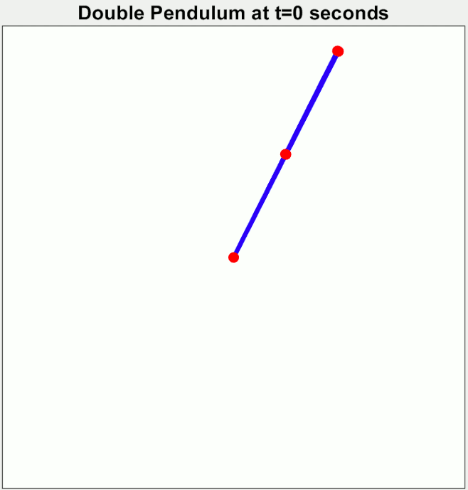
Finding order through chaos

“Chaos is the score upon which reality is written” -Henry Miller

You may be familiar with the term “The butterfly effect”. In short, it explains how the flapping of a butterfly's wings could subsequently cause a tornado in Texas. This concept is real in the sense that small changes in small scales could cause a change in the weather. However, it’s unlikely that a butterfly could produce any kind of meaningful change in the weather. Have you ever been in a situation where the weather forecast predicts sunny skies the next day and to your surprise, it’s pouring with rain the next day?. The weather is a chaotic system. Small errors in the initial conditions of a forecast can grow rapidly, and affect the predictability of the weather. Another example of a chaotic system is the double pendulum. The double pendulum executes simple harmonic motion when the displacement from the original position is small but with larger displacements, the pendulum becomes chaotic in its motion. You will be able to see the system more clearly with the following simulation. (https://www.myphysicslab.com/pendulum/double-pendulum-en.htmlhttps://www.myphysicslab.com/pendulum/double-pendulum-en.html)

Next, let’s try to be a bit more realistic, a classic example of a chaotic system that you could do right now. Go to a table and get some coins (make sure that they are all identical). Then slowly push the coin until it just tips over the table. Note the location of the coin after falling. Now, slowly push another coin on the same part of the table and mark that location(make sure to try to push the coin in the same way you did before). After a few trials, you may start to see that the coins are in completely different locations even though they were pushed in the same manner. You could do this 1000 times and find out that all the coins land in 1000 different places. Most of the coins will land in similar locations but you may have some outliers that may land further away. You could try to calculate the trajectory and final position of the coin and try to see where it's likely to land but you may not be able to make a completely accurate prediction as to where the coin will land.

Now, try to repeat the experiment but at different heights. As you increase the height of the table, you notice your ability to predict the final position of the coin gets progressively worse. At a 3cm difference in height, the coins practically fall in the same area. At a 3m difference, you have coins all over the floor in random directions. This shows us that as the time between initial conditions and final conditions increases, so does the chaos. That’s why predicting tomorrow’s weather isn’t so hard, but predicting the weather 3 weeks from now (with 100% accuracy) is almost impossible.

Chaos theory explains why this happens. Although the coin is obeying the laws of physics, any small change in the initial conditions that the coin faces on its journey to the floor could have huge changes on the final outcome of the coins overall path. Realisations such as this have caused a massive shift in how scientists understood physics. Before the development of this field, it was believed that such small shifts in initial conditions would have only a small shift in final conditions. That’s just not the case.

Chaos is deterministic meaning that if you knew everything about the initial conditions of a system you would be able to predict what would happen in the future. It is used to model dynamical systems that are highly sensitive to initial conditions. It is important not to confuse a chaotic system with a random system. Simply put, randomness is the absence of pattern or predictability, random events often have no order. But by using probability distributions (such as the normal or binomial distributions) then the number of certain outcomes becomes predictable. For example, if you were to roll 2 dice the outcome of any particular roll would be impossible to determine(meaning if I rolled a dice once and before I did I wouldn’t be able to say with certainty that the first roll will be a 2). But (assuming the dice are fair) a sum of 7 will occur twice as often as a sum of 4. The frequency of repeated events suddenly becomes predictable. So far we have only looked
At chaos theory within mathematics and physics. But dynamic systems are present even in nature.
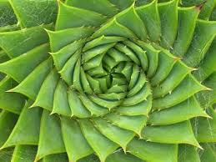
Have you ever looked at the structure of leaves, rivers and other natural designs? For example, you may see these patterns in nature repeating over and over again at smaller scales. Fractals are images of dynamic systems in nature, the pictures of chaos. Fractals are used to analyse the growth of bacteria and other biological processes, fractals can also be used to model the structures of nerve networks, circulatory systems, lungs, and even DNA.
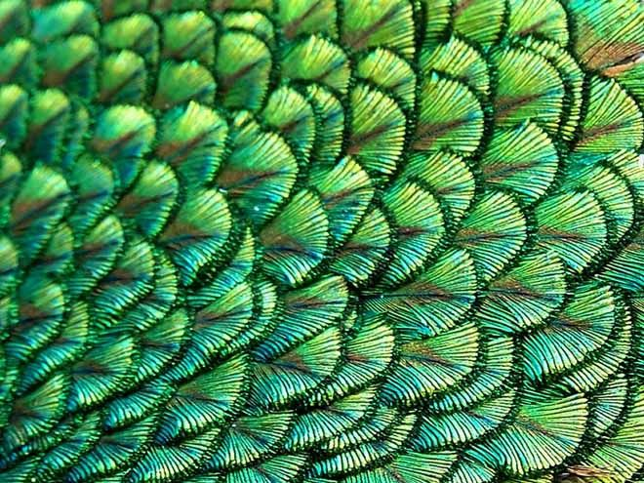


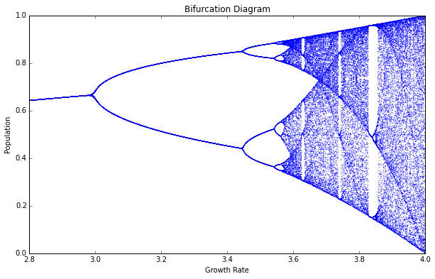
Images that are chaotic in nature are very common in the natural world. They make up the world around us and give us order, this suggests that chaos and order are more similar than people realise. I believe that chaos is the transition between order and disorder. Within the fractals are repeated images demonstrating symmetry and order. Fractals are related to the graphs in which we use to show chaotic systems. The graph below has an equation of x_{t+1}=ax_{t}(1-x_{t}) (where a is a constant and t represents time. As t increases the system becomes increasingly chaotic, if you were to zoom in and look at each individual point then you would see that there is a repeated pattern, just like with fractals.

So, is it possible to find order in chaos? The patterns that appear from chaos and this is one of the bases of chaos theory. And so I believe that chaos and order are equal in importance and allows for the universe to function and operate.

Sources:
https://www.quora.com/What-is-a-good-real-life-example-of-the-chaos-theory
https://en.wikipedia.org/wiki/Randomness
ttps://commons.wikimedia.org/wiki/File:Demonstrating_Chaos_with_a_Double_Pendulum.gif (Double pendulum gif)

https://earthscience.stackexchange.com/questions/16138/how-much-further-can-weather-forecasting-models-go-before-the-limits-of-chaos-th
https://medium.com/swlh/chaos-in-one-innocent-equation-168d0bd31bad

https://www.google.com/imgres?imgurl=https%3A%2F%2Fi.pinimg.com%2Foriginals%2F20%2Fd4%2F7d%2F20d47dd40f24327234ae8a1951fe3a75.jpg&imgrefurl=https%3A%2F%2Fwww.pinterest.com%2Fpin%2F187251296976598844%2F&tbnid=wHqfD85OGCCIGM&vet=12ahUKEwjKgYvK_8vvAhVH8IUKHTQxDTsQMygJegUIARDXAQ..i&docid=YvicNCepiyBTRM&w=660&h=495&q=natural%20fractals&ved=2ahUKEwjKgYvK_8vvAhVH8IUKHTQxDTsQMygJegUIARDXAQ (Image of Fractals)
https://images.theconversation.com/files/163339/original/image-20170330-4557-1tpeqb6.jpg?ixlib=rb-1.1.0&q=45&auto=format&w=1000&fit=clip (image of fractals)
https://encrypted-tbn0.gstatic.com/images?q=tbn:ANd9GcSDZ_fZV8j1rpjCGg61QM-FwjZW6qXCP_fPgg&usqp=CAU (Image of fractal)

By Casano Kirlew

