Samurai and Sangaku: Mathematics from Japan

“The first thing to understand about mathematics, is that it is art.”
A Mathematician’s Lament
Introduction and History Overview:
Japan had suffered from almost 150 years of near constant civil war and social upheaval until the establishment of the Edo Period in 1603, under the rule of a military government which took control over the entire country. This episode in Japan’s history has been remembered for beginning of prolonged peace of more than two and a half centuries to a war-torn country, severe isolationist foreign policies and economic growth.
Despite the social hierarchy imposed on Japan, where your social class is determined for the rest of your life, one past time that transcended through all rankings in post-feudal society has been Mathematics; being open to either professional or amateur, young or old, rich or poor.
Mathematicians (including some in the broadest sense of the term) around the country would devise their own geometric puzzles and would present their problems on wooden blocks that would be hung up at Shinto shrines and Buddhist temples for other mathematicians to try and solve.
These wooden blocks were called sangaku (算額), which literally translates to “calculation tablet”, and thousands would have been displayed in Buddhist and Shinto temples throughout Japan.
Now from the perspective of a westerner, such as myself, I can hardly imagine walking into a cathedral and seeing stain-glass windows of circles, triangles and equations instead of depictions of angels, the holy mother Mary and the baby Jesus.
From their placements, the entire collection of sangaku has been referred to as “temple geometry”, or “sacred mathematics”; a very high accolade indeed for the subject!
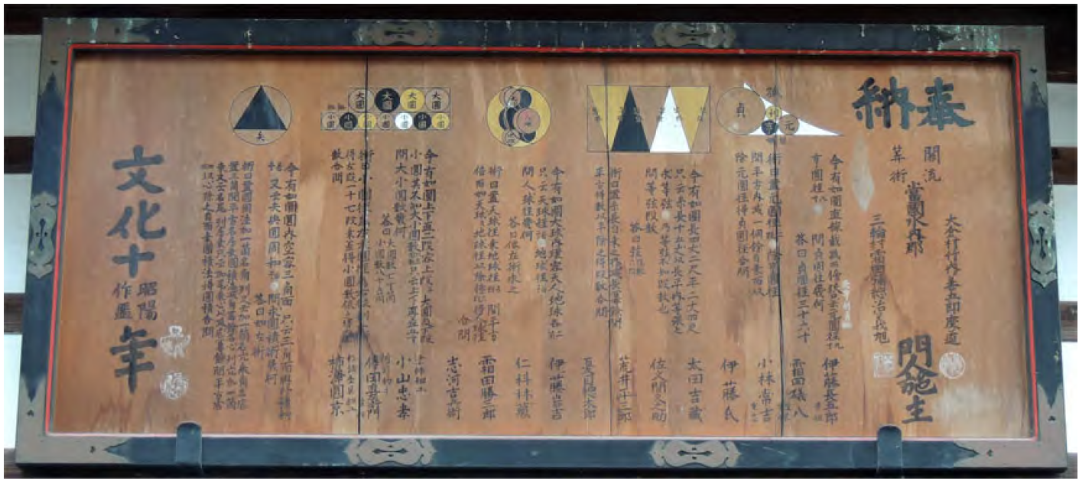
Diagram 1 – Sangaku at Miwa Shrine, Nara Prefecture. [2, pg. 248]

Key Principles of Japanese Mathematics
Being isolated from the outside world, Japan began to develop their own style of Mathematics, called wasan (和算), and was employed to be distinct from Western mathematics, called yosan (洋算), and in terms of sangaku
The majority of sangaku problems can be solved using GCSE-level maths, with a strong emphasis of using Pythagoras’ theorem, $a^{2}+b^{2}=c^{2}$ (as it was introduced to Japan through China), and the quadratic equation
$$x=\frac{-b±\sqrt{b^{2}-4ac}}{2a}$$
With these two tools under your belt, the majority of sangaku problems are able to be solvable.
Now one key feature that is missing from wasan is the lack of modern-day calculus. There are drawings that show that Japanese mathematicians were very close to unlocking the principles of calculus themselves, which had been independently discovered by Leibniz and Newton in 1684 and 1687 respectively (of course, the debate between the two scholars can be another essay on its own), as shown in Diagram 2 (Rothman, pg. 23).
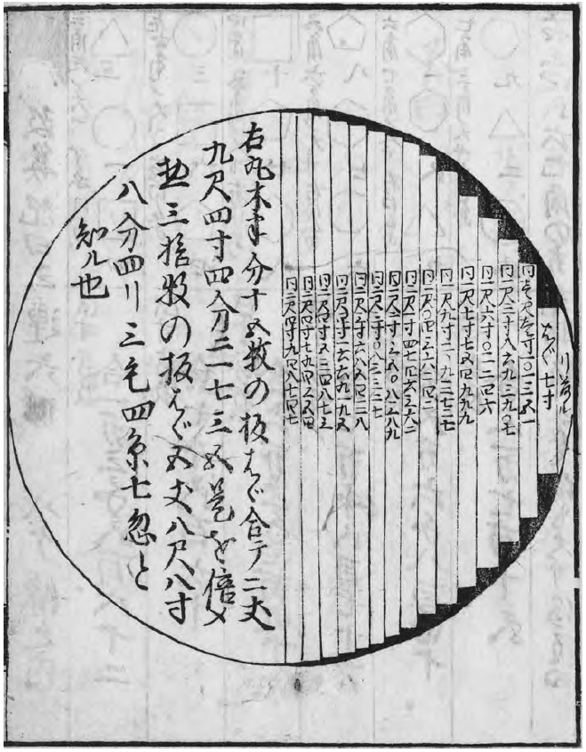
Diagram 2 – Taken from Sawaguchi Kazuyuki’s 1671 book Kokon Sanpoki (Translation: Old and New Mathematics) illustrates how the area of a circle can be approximated by finding the area of the rectangular strips, and the total area will converge to the circle’s area as the strip’s width tends towards zero – the same principles used

Where do the Samurai come into all this then?
Originally, small schools were set up as there was no official universities in Japan during the 17th century; in fact, the University of Tokyo was only formed in 1877, in the 19th century.
As the Meiji period began, and Japan entered a period of piece, the samurai were no longer needed as independent warriors. So the samurai class became teachers, as they were a well-educated class, with many holding hereditary posts in government administration or local aristocracy.
To help earn more money, samurai began working as teachers in small private schools; some samurai even started schools of their own, dedicated to reading, writing and arithmetic, all for a small attendance fee.
By the end of the Edo period, there were approximately 80,000 throughout the country! [4]
π = 3.16?!
A common motif in sangaku was the used of circles, and this was used to represent the Shinto goddess of the sun, Amaterasu (Hosking, pg. 247), who was often associated with the circle. The circle has further connections to Japanese mythology, included the legend of the two gods Izanami and Izanagi (and parents of Amaterasu), meeting by walking in a circle (Hosking, pg. 259). This idea serves about the basis of Enri, or “circle principle” to give a vague translation.
One difficulty when it came to sangaku was the using approximations for the constant π, as it wasn’t known to anyone during the 17th or 18th century that π was irrational (Rothman, pg. 75). To find approximations, the Japanese used series, as they lacked trigonometric functions, such as the Machin-like formulas such as:
$$\frac{π}{4}=4\tan^{-1}\left(\frac{1}{5}\right)+\tan^{-1}\left(\frac{1}{239}\right)$$
or
$$\frac{π}{4}=\tan^{-1}\left(\frac{1}{2}\right)+\tan^{-1}\left(\frac{1}{3}\right)$$
In a similar vein to Archimedes, calculating approximations of π were done by calculating the areas of polygons, and as the number of sides to a polygon increased, the shape of the polygon will converge to that of a circle.
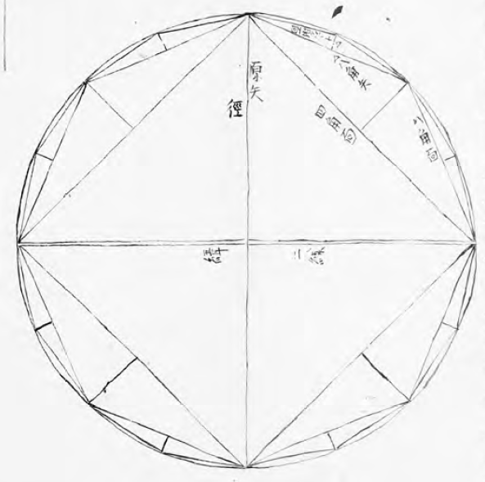
Diagram 3 – Starting from a square, and doubling on each iteration, the shape of an n-sided polygon converges towards the shape of a circle, as will the area of the polygon [1, pg. 303].
By using a 1,024-sided polygon, an approximation as given as:
$$π=\frac{5,419,351}{1,725,033}$$
It can be verified that
$$\frac{5,419,351}{1,725,033}-π=0.000000000000022144779300394$$
Given that these calculations would be carried out with nothing but pen, paper and a soroban (an abacus), this is a very accurate approximation!
Despite these findings and the value of accuracy that was found, traditional Japanese mathematicians preferred and found it simpler to use π=3.16, presumably because 3.16 = 4 × 0.79, and the area of a circle as described using the diameter, not the radius, so the formula would look like:
$$A=\left(\frac{π}{4}\right){\left(Diameter\right)}^{2}$$
Rather than $A=πr^{2}$
So, it might have been easier to have written the formula for the area of a circle as
$$A=0.79×{\left(Diameter\right)}^{2}$$
However, this is only a conjecture as to why [1, pg. 65].
Kissing Circles
This was the problem that got me interested in sangaku problems in the first place. I was doodling and was wondering what can be done to determine the relationship between three touching circles with a mutual tangent line?
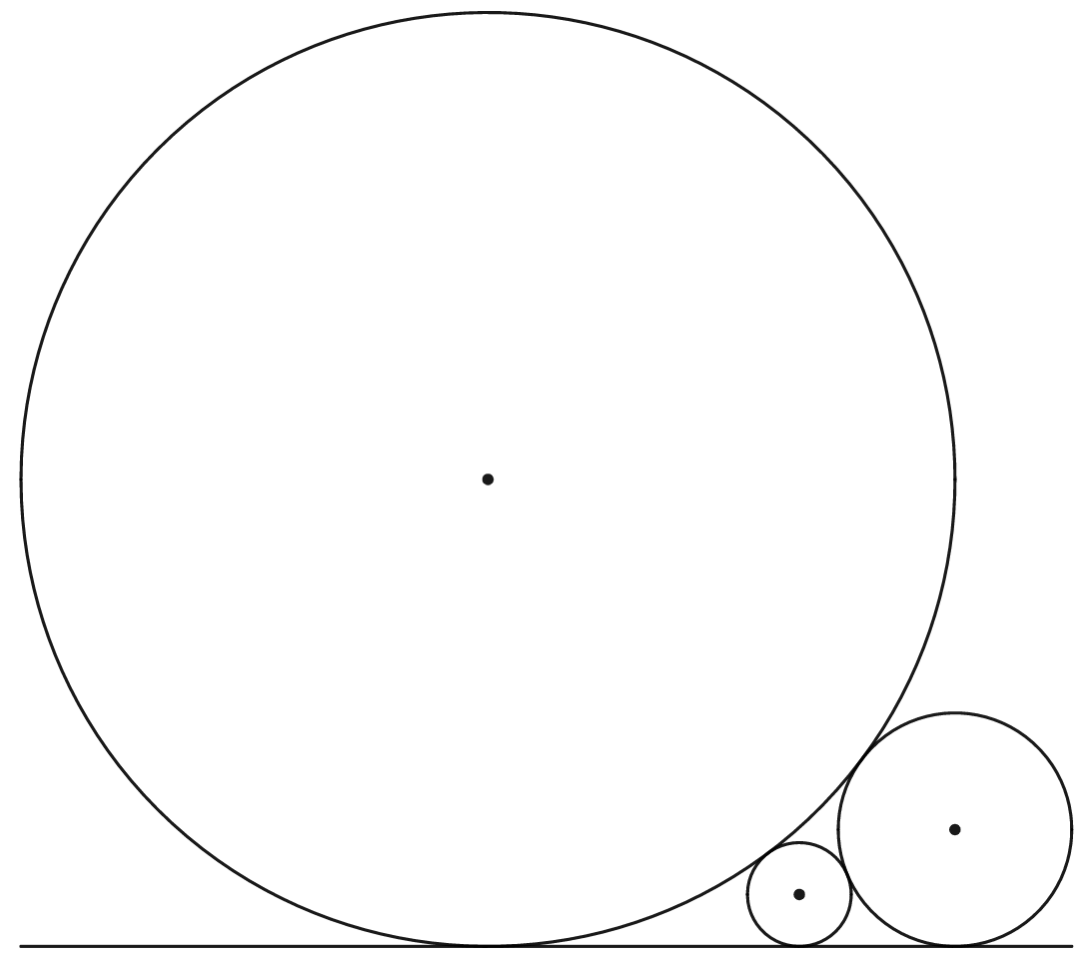
Diagram 4 – “Kissing” circles
If we take a look as a simple example, we can find a relationship between two touching circles:
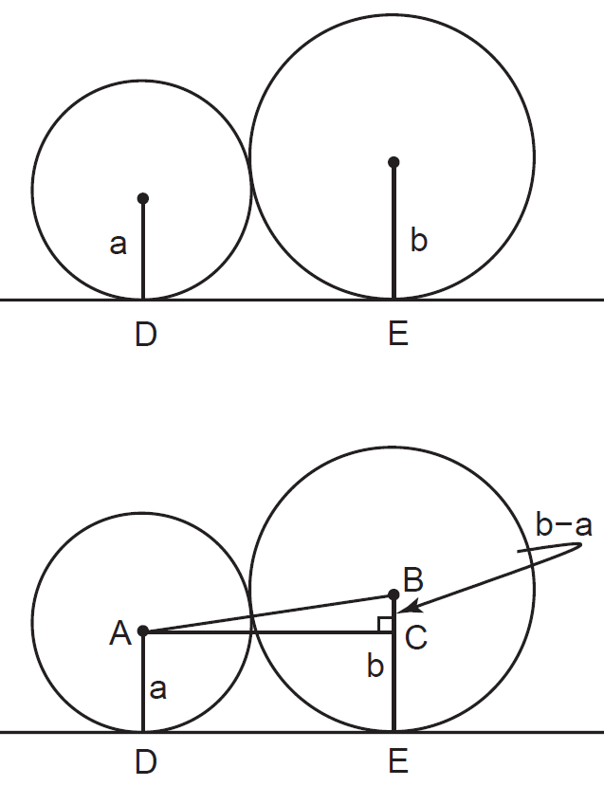
Diagram 5 – How to calculate the horizontal distance between two kissing circles.
From this, we can see a right-angled triangle, so Pythagoras’ theorem can be used.
$$DE^{2}+{\left(b-a\right)}^{2}={\left(a+b\right)}^{2}$$
$$DE^{2}+b^{2}-2ab+a^{2}=a^{2}+2ab+b^{2}$$
$$DE^{2}=4ab$$
$$DE=2\sqrt{ab}$$
So the horizontal distance between the radii (a and b, respectively) of two “kissing” circles is equal to $2\sqrt{ab}$. We can apply this back to our three circle problem
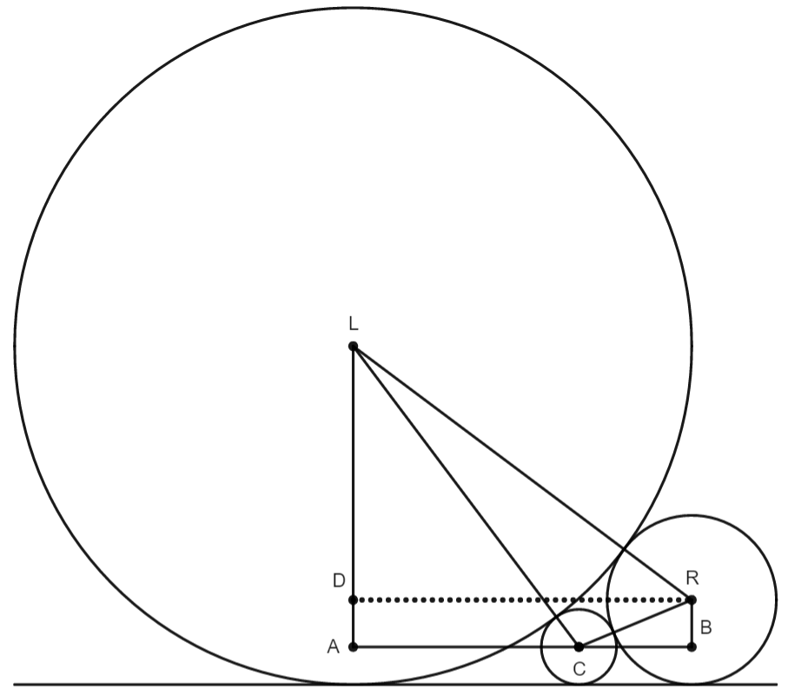
Diagram 6 – Finding the relationship between three kissing circles.
For the circles with centre points L, C and R (for left, centre and right) and respective radii $r_{L}, r_{C}, r_{R}$, we can determine the following distances:
$$AC=2\sqrt{r_{L}r_{c}}$$
$$BC=2\sqrt{r_{R}r_{c}}$$
$$RD=2\sqrt{r_{L}r_{R}}$$
We see that AC + BC = RD, hence:
$$AC+BC=RD$$
$$2\sqrt{r_{L}r_{c}}+2\sqrt{r_{R}r_{c}}=2\sqrt{r_{L}r_{R}}$$
Divide both sides by 2:
$$\sqrt{r_{L}r_{c}}+\sqrt{r_{R}r_{c}}=\sqrt{r_{L}r_{R}}$$
And if we divide all terms by $\sqrt{r_{L}r_{C}r_{R}}$, we get our equation
$$\frac{\sqrt{r_{L}r_{c}}}{\sqrt{r_{L}r_{C}r_{R}}} +\frac{\sqrt{r_{R}r_{c}}}{\sqrt{r_{L}r_{C}r_{R}}}=\frac{\sqrt{r_{L}r_{R}}}{\sqrt{r_{L}r_{C}r_{R}}}$$
$$\frac{1}{\sqrt{r_{RIGHT}}} +\frac{1}{\sqrt{r_{LEFT}}}=\frac{1}{\sqrt{r_{CENTRE}}}$$
Idai
One aspect of many sangaku is that the problem would be sometimes written with no intention of having an answer ready at the same time, with it being up to the reader to try to find a final answer.
From what I have read about this sub culture of maths, these sangaku would have also been set up as cerebral challenges amongst mathematicians. Upon the solution of a challenging question, another tablet would be put up as a returning challenge. [7]
One example [1, pg. 115, 136] is where a regular dodecagon is made by a string of length 150cm and wrapped around 12 pins as shown in Diagram 7:
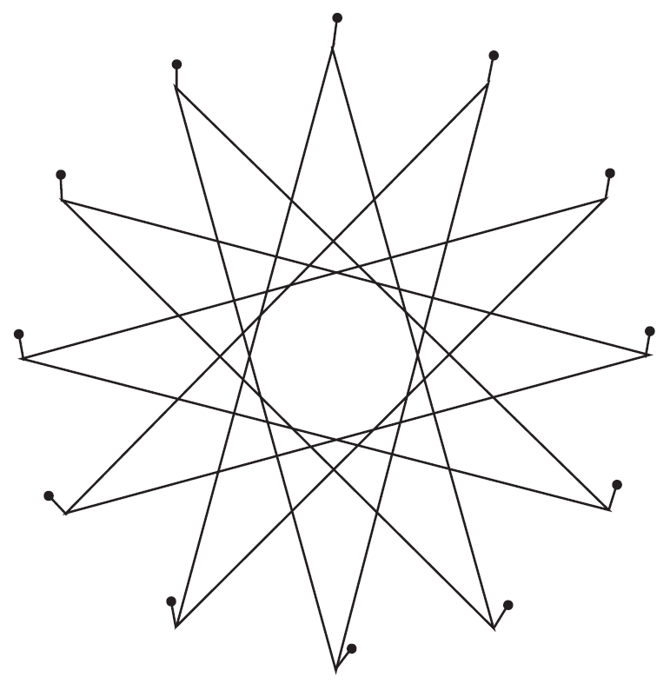
Diagram 7 – Find the length of side, s, of the regular dodecagon formed.
This would allow a chance for individuals to boast; a solution for this particular sangaku was written (no working out was provided) by a proposer, Mr. Kitani proudly, and correctly wrote:
$$s=0.897459621556315$$
Don’t forgot, this was done by hand and with only a soroban! [1, pg. 136]

Where do we go from now on?
Of the surviving sangaku, there still remains some problems that have only just recently been solved. [8]
It still remains a mystery, however, if they could have been solved using traditional wasan methods, due to the idai nature of the problems, where the answer only would normally be provided, in order to keep the problem from being spoilt to others. An example of an unsolved sangaku is the problem in Diagram 8, first proposed in 1821 by mathematician Sawa Masayoshi, and still remains unsolved in the non-symmetric case (where $b≠c$) [9].
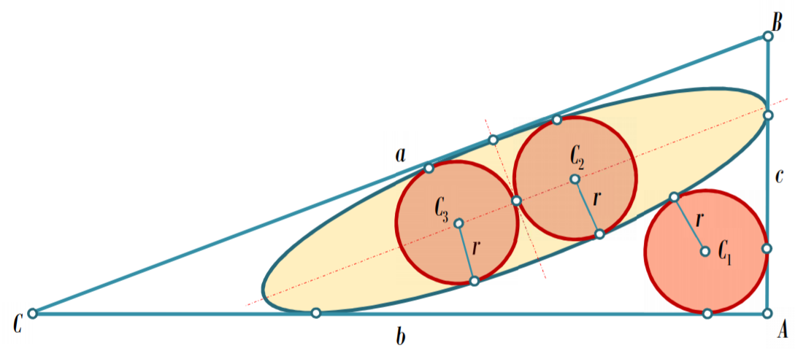
Diagram 8 – One of the several unsolved sangaku problems.
From my experience from being a private maths tutor, it is always great to get young students interested in mathematics, and as an educator, I am always on the look out to try and get my pupils engaged. What I see in sangaku is a new lesson that helps to develop an individual’s problem solving skills, regardless of age.
And of course, having an accurate diagram will be indisposable, as a rough sketch will be deceptive and
Further Reading:
For more information regarding this topic, I consider [1] to be the main authority to an English-speaking audience in regarding to sangaku geometry, and history.
I would strongly recommend those interested in reading further into this topic to read Dr. Hosking‘s thesis [2] as it shows an in-depth analysis and comparison between the traditional approach and the modern-day solution alternative.
References:
[1] Hidetoshi, F., Rothman, T. (2008), Sacred Mathematics: Japanese Temple Geometry.
[2] Hosking, R. (2016). Sangaku: A Mathematical, Artistic, Religious and Diagrammatic Examination. PhD Thesis. University of Canterbury, NZ. Available at: https://www.academia.edu/30061089/_PhD_Thesis_Sangaku_A_Mathematical_Artistic_Religious_and_Diagrammatic_Examination (Accessed: 3rd March 2021)
[3] https://archive.lib.msu.edu/crcmath/math/math/m/m004.htm (Machin like formula)
[4] https://japanthis.com/2020/06/22/the-japanese-creation-myth-explained/ (Japanese folklore)
[5] http:/library.u-gakugei.ac.jp (in Japanese), provided by [1]
[6] https://en.wikipedia.org/wiki/A_Mathematician's_Lament
[7] https://www.sangaku-journal.eu/2017/Okumura-Japanese-mathematics.pdf (2017)
[8] http://www.careerchem.com/MATH/Solution%20to%20an%20Unsolved%20Sangaku%20Geometric%20Puzzle-v6b.pdf
[9] https://vixra.org/pdf/1802.0091v1.pdf

