Circle of Life – Maths Essay

Circles.

This beautiful shape that we use in maths is what gave birth to many inventions that we see in everyday society like the wheels on a car, pulleys, gears, ball bearings and a thousand other items we take for granted wouldn’t exist without the use of circles.

Also, without this remarkable shape we wouldn’t be able to ride a Ferris Wheel, or the use of satellite shaped like circle to make us be able to see the moon on our television set. This shape may seem to look simple on the outside but truly it is more amazing when you use it for the outside world, to attract more people.

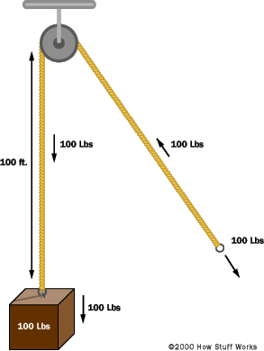
This picture shown on the right here is a representation of the first pulley system (block and tackle pulley) that was invented by the Greek mathematician and inventor over 2,000 years ago named Archimedes. This invention he created with the help of the power of the circle being incorporated has made sure that workload is done at a more efficient way. Making sure that workers don’t have to constantly pick up the heavy load and carry it somewhere else.

This creation mentioned here is one of many inventions that has shaped the future of humanity and changed the way of work all due to this simple, but complex system that is being shown here.

Archimedes: ‘Don’t disturb my circles!’
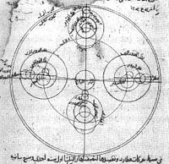
In addition, natural circles would have observed, such as the Moon and Sun. The study of circle has helped inspire the development of geometry, astronomy and calculus. The picture being shown here on the left are circles being used in old Arabic astronomical drawing, so therefore by using the circles it is able to determine what is in our solar system e.g. planets, moon and stars. Where early science, particularly geometry astrology and astronomy they beloved that there was something intrinsically ‘divine’ or ‘perfect that could be found in circles.

Some highlights in the history of circles are:

- 1700 BCE – The Rhind papyrus gives a method to find the area of a circular field.
- 300 BCE – Book 3 of Euclid’s Elements deals with the properties of circles.
- In Plato’s Seventh Letter there is a detailed definition ad explanation of the circle. Plato explains the perfect circle, and how it is different from any drawing, words, definition or explanation.
- 1880 CE – Lindemann proves that pi is transcendental, effectively settling the millennia – old problem of squaring the circle.
Inscribed circles of various polygons
Book 3 of Euclid’s Elements:

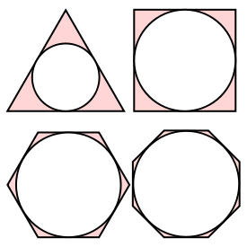
Seeing circles through your naked eye, you may not believe it helps in anything but in terms in maths to theorise, it does. As in geometry, an inscribed planar shape or solid is that that the enclosed by and ‘fits snugly’ inside another geometric shape or solid.

A polygon inscribed in a circle has each vertex on the outer figure; if the outer figure is a polygon there must be vertex of the inscribed polygon on each side of the outer figure
An inscribed triangle of a circle

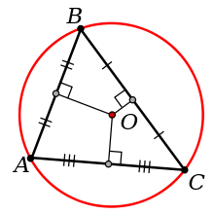

Familiar examples of inscribed figures include circles inscribed in triangles or regular polygons, and triangles or regular polygons inscribed in circles. Where a circle inscribed in any polygon is called its incircle. A polygon inscribed in a circle is said to be a cyclic polygon, and the circle is said to be its circumscribed circle or circumcircle. This shows that circles play a big part in geometry and proving if a circle has an inscribed polygon or triangle in it.

Properties of Book 3 – Euclid’s Elements:

- Every circle has an inscribed triangle with any three given angle measures (summing of course to 180 degrees), and every triangle can be inscribed in some circle (which is called its circumscribed circle or circumcircle).
- Every triangle has an inscribed circle, called the incircle.
- Every circle has an inscribed regular polygon of n sides, for any n>=3, and every regular polygon can be inscribed in some circle.
- Every regular polygon has an inscribed circle, and every circle can be inscribed in some regular polygons of n sides, for any n>=3.

Moreover, it’s the basic tool of all engineers and designers. It is used by the greatest artists and architects in the history of mankind some include:
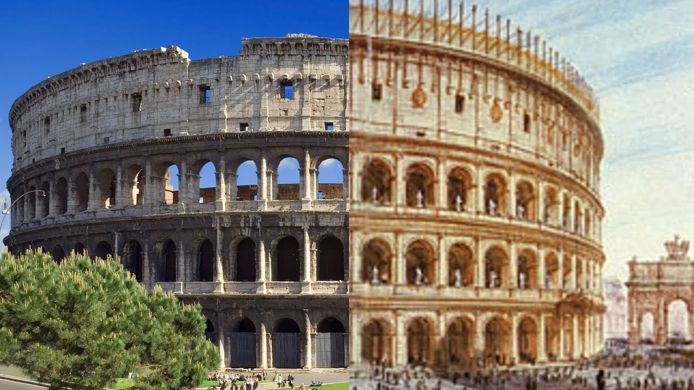
Al Dar Headquarters, Abu Dhabi
Frank Lloyd Wright Circular house
Colosseum – Emperor
Vespasian

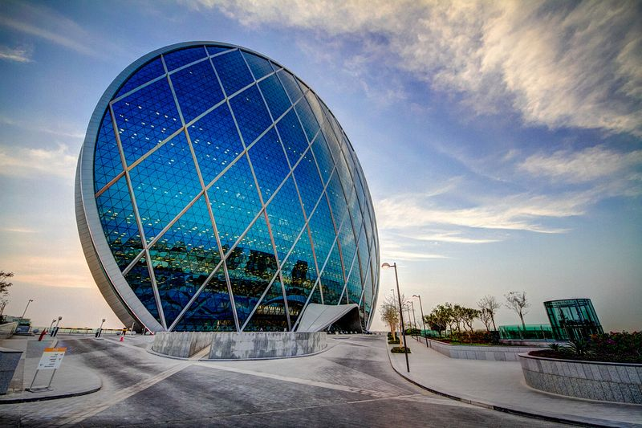
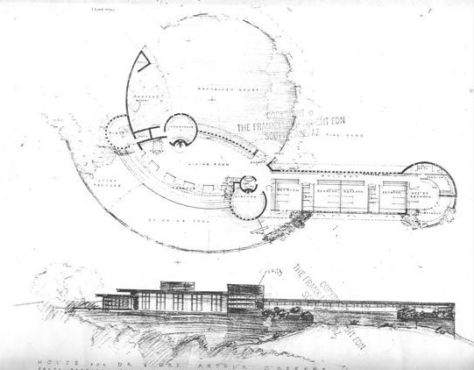

From these few examples of architecture, you can clearly see the impact of using a circle design truly is and that it makes the building look so much more unique and special then it already is. Therefore, it’s really outstanding how this shape can be used to show how maths can be transferred into architecture. Also the use of the GPS relies on circles when determining distance. It identifies and calculates the distance between the satellite and the point using a circle theory.

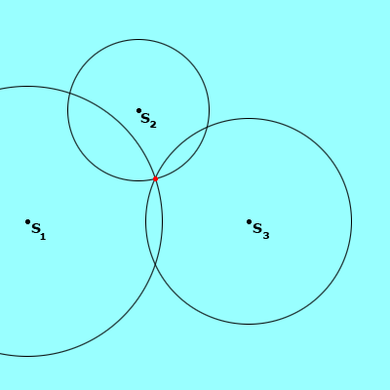
The picture shows three circles varying distances, centred on satellites (S1, S2, S3). The point where the three circles meet is the location of the GPS receiver. This process of using three sphere/ circles to locate a point is called trilateration.

Showing with the use of circles then you are able to calculate the location of where you are at the moment by using a GPS and able to pinpoint by finding out the intersection of these three circles, which I find really interesting.

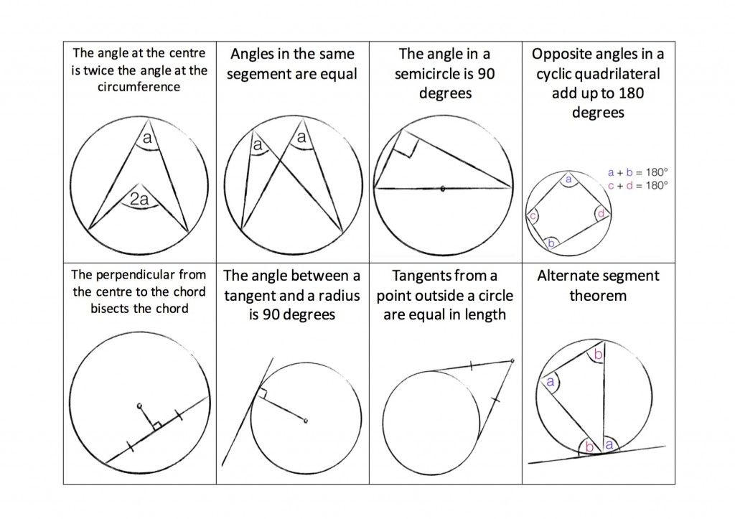
However, even if circles have this unique nature that is has contributed to this planet, what I found really interesting is again when applied in geometry where different set of rules and theorems have been created and without circles we wouldn’t even know these theorems. Where, in school we wouldn’t even learn these theorems as they haven’t existed, but now we have been able to gain this knowledge.

These amusing theorems created by Thales, a Greek mathematician around 650 BC, has completely changed the way I see circles. It’s just really stunning that even without the use of technology back then, people were still able to theorise such theorems. With these theorems that I’ve learnt, it really changes my ways of how can I solve a problem using these different principles.

Ultimately, I believe that this beautiful shape has truly shown us what incredible rules or architecture that can be made and how truly shows that without the in depth analysis of circles, the life we are living at this very moment wouldn’t be the same.

Sources

https://www.pinterest.com/pin/130815564154524251/ : ‘Circle Theorems’

https://circlesonly.wordpress.com/ : ‘Circles are the Mother of all inventions’

https://www.amusingplanet.com/ : ‘5 Unusual Circular Buildings’

https://en.wikipedia.org/wiki/Circle : ‘History of Circles

https://en.wikipedia.org/wiki/Euclid%27s_Elements : ‘Euclid’s Elements Book 3’

https://en.wikipedia.org/wiki/Inscribed_figure : ‘Euclid’s Elements Book 3 Notes’

