The Most Elegant Equation in Maths: Euler’s Identity

What is Euler’s Identity?

Euler’s equation ($e^{iπ}+1=0$) is known to be the most elegant and beautiful equation in maths because it is an equation which shows us the relationship between the most important and fundamental numbers; $e, i (=\sqrt{-1}), π, 1,$ and 0.

We know that 1 is the first non-zero natural number which is the underlying foundations of all maths. One is known as the multiplicative identity, this is because, any number multiplied by one remains itself. As a result of this property, we understand that one is its own factorial, its own square, its own square root, its own cube and cube root, etc. Zero is an important number in maths that represents the idea of nothingness. The number is the additive identity. Which means that any number(s) added to zero will always remain itself.

In addition, the equation also contains the three most fundamental mathematical operations: addition, multiplication and exponentiation. (Hogenboom 2016) The equation may look simple, yet the complexity of the equation allows it to be the base of so many ideas and topics in maths. The identity is named after a Swiss Mathematician, Leonhard Euler (1707 – 1783). He is one of the greatest mathematicians and has contributed a lot towards a wide range of topics in maths that we know of today, including but not limited to, complex analysis, graph theory, number theory, and calculus. Euler is also the reason why we have a lot of the mathematical notation that we have today; he introduced the notation for a function, $f(x)$ and he popularized the use of the letters a, b, c for constants and x, y, z for unknowns.

Euler’s identity is derived from Euler’s formula ($e^{iθ}=cosθ+isinθ$). We can see that when we substitute $θ$ with π we form Euler’s equation. Here $π$ represents an angle in radians; it is equal to $180°$.

$e^{iθ}=cosθ+isinθ$
$e^{iπ}=cosπ+isinπ$
$e^{iπ}= -1+0$
${∴e}^{iπ}+1=0$

Euler’s formula was officially published by Euler in 1748 and it combines arithmetic, exponential functions, imaginary numbers/complex analysis, calculus, and trigonometric functions into just one formula! One would think that these areas of maths are unrelated, but Euler was able to find the relationship between the individual ideas and bring them together which shows how remarkable and beautiful the formula is.

Euler’s Number, $e$

Euler’s number, $e$, is a mathematical constant, approximately equal to 2.7182818… $e$ is an irrational number and is present in so many different topics in Maths. $e$ is most commonly known as the base of the natural logarithm (ln) and the basis of all exponential growth.

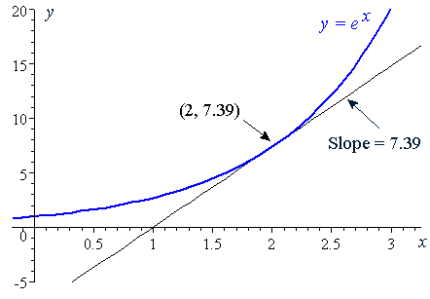
The graph $e^{x}$ is one that has been studied in great depth. A special property of the function is that any coordinate on this graph will have the same gradient as the value of the function itself and hence we can say that the derivative of $e^{x}$ is always $e^{x}$. Therefore, the integral remains itself as well.
Figure 1 (Bourne 2018) Graph of y=e^{x} which shows that its gradient at any point is equal to its y coordinate value
$∴y=e^{x}$
$\frac{dy}{dx}= e^{x}$

The constant was officially discovered by Leonard Euler in 1720 however, in 1683, Jacob Bernoulli came across the number while he was studying compound interest. This brings us to another definition/use of the number. The basic, general formula for compound interest is as follows; $A=P{\left(1+\frac{r}{n}\right)}^{nt}$
Where:
A = final amount
P = initial amount
r = interest rate
n = number of times the interest rate is applied per time period
t = time period

From this equation we can see that compounding more frequently will evidently result is more money. Bernoulli wanted to see what the value would be if we compounded continuously and thus formed the expression $\lim_{n→∞}{{\left(1+\frac{1}{n}\right)}^{n}}$ to see how much money would be received as n tends toward infinity, which suggests that the number of times the interest rate is applied is infinite and hence the interest rate is applied constantly. After expanding the brackets using binomial expansion, we get an infinite converging sequence that tends towards $e$. (Garbett 2001)

The binomial expansion of this expression gives us another definition of $e$:

$e=\sum_{n=0}^{∞}{=\frac{1}{n!}}1+\frac{1}{1!}+\frac{1}{2!}+\frac{1}{3!}+…+\frac{1}{n!}$

In reality, this is just the expansion of the first expression mentioned yet it is important to know that $e$ is also the sum of this infinite series of the reciprocal of factorials.

Imaginary number, $i$

$i$ is the imaginary unit and it is the square root of -1. Square rooting a negative number is not possible in the set of real numbers and thus the imaginary numbers are based on something that could not happen. The introduction of the number $i$ brings us into a whole new world of maths and complex numbers. Imaginary numbers can be added to real numbers to create complex numbers. Imaginary numbers were coined in the 17th century but were first seen to be fictitious. Euler then was able to put them to use in his work in the 18th century and thus imaginary numbers became more widely accepted.

Many mathematicians realised that there were some asymmetries in maths when we only deal with real numbers. For example, some solutions of polynomials require the square root of a negative number and hence without imaginary numbers, there is a lack of solutions for certain polynomials. When we allow negative square roots, we are able to form valid solutions of the equation. Imaginary numbers open up a whole new element to maths. (Waring 2019)

Ironically, complex and imaginary numbers also have many applications in the modern electronic world. They are used in alternating current power supplies, electromagnetic waves, audio signal processing in music or voice communication, MRI imaging, GPS and much more. (Hom 2014)

Pi, π

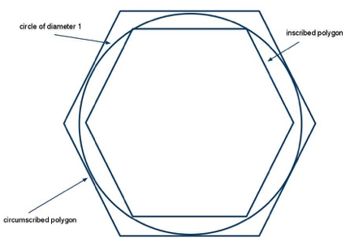
The first calculation of pi was done by Archimedes of Syracuse who is known to be one of the greatest mathematicians of the ancient world. Archimedes approximated the area of a circle by using two regular polygons, one inside the circle and one which the circle is within. Since the area of the circle is in between the two different polygons, Archimedes found an upper and lower limit for the area and hence a range for the value of pi as well. (Exploratorium n.d.) The Greek letter notation for pi (π) was first used in 1706 by William Jones and around 30 years later the notation was used more commonly in mathematics and became a standard notation.
Figure 2 (Staples STEM Journal 2020) Demonstration of how Archimedes found the limits for pi

Pi is an irrational number which is approximately 3.1415926… Pi is the circular constant which is the ratio between the diameter of a circle and its circumference. In addition, pi also connects the radius of a circle with its area and therefore Pi is often used in computations regarding circles. There are also many other applications of pi in maths. For example, in trigonometry, pi radians is a key angle that is used in many circumstances such as in Euler’s identity. (Bogart 1999)

Euler’s Identity in the Polar Form of Complex Numbers:

Euler’s formula is very important in complex numbers, the formula shows us another way to write a complex number such as $z= x+yi$. To write this number in the ‘polar’ form we can first show the complex number on an argand diagram.
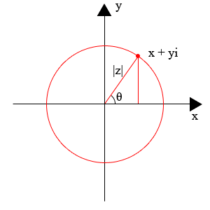
Figure 3 (Marianne 2017) Diagram showing a complex number on an argand diagram

In the diagram:
- |z| is the modulus of the complex number which represents the length. This is also shown as the letter r
- θ is the argument of the complex number which is the angle that the number makes with the positive x-axis (this is measured in an anti-clockwise direction).

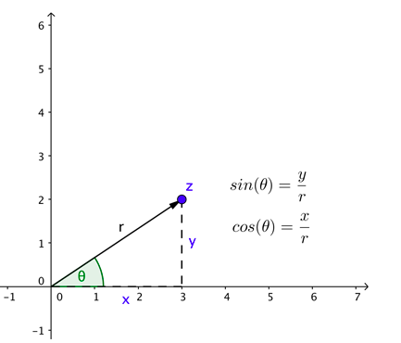
Figure 4 (Marianne 2017) Diagram showing a complex number on an argand diagram
$x=rcosθ$
$y=rsinθ$

Therefore, the complex number:
$z=rcosθ+irsinθ$
$z=r(cosθ+isinθ)$

Here we can see that we have obtained Euler’s formula, it is seen in the polar representation of z. Hence, by substituting $(cosθ+isinθ$) with $e^{iθ}$ (this is taken from Euler’s Formula), we can come to the conclusion that the polar form of a complex number is:

$z=re^{iθ}$
This format is often used by mathematicians to represent complex numbers as it is easy to manipulate a number in this format.

Proving Euler’s Identity

By Taylor/Maclaurin Series:

Taylor series is an infinite series of expansion of a function about a point that is expressed in terms of the function’s derivatives at that point. This was introduced by Brook Taylor in 1715 and we should also note that there is a special case of the Taylor series when the point on the function that is used for the expansion is at x=0, this is called the Maclaurin Series.

To form the expansion of a function, we take a certain point on the graph and then take the sum of all the derivatives of that point, with each term divided by the factorial of the number of differentials. This infinite series will equate to the function itself.

The formula for the expansion is:
$$\sum_{n=0}^{∞}{\frac{f^{\left(n\right)}\left(a\right)}{n!}{\left(x-a\right)}^{n}=f\left(a\right)+f^{'}\left(a\right)\left(x-a\right)+\frac{f^{''}\left(a\right)}{2!}{\left(x-a\right)}^{2}+…+\frac{f^{n}\left(a\right)}{n!}{\left(x-a\right)}^{n} }$$

Where $a$ is the point on the curve, for the Maclaurin series $a=0$

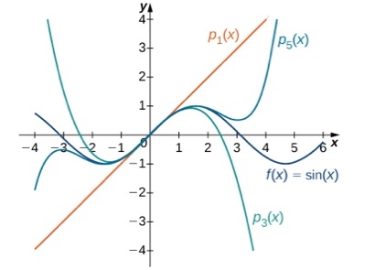
Figure 6 (OpenStax 2020) Diagrammatical representation of a Maclaurin Series expansion of sin(x)
This diagram above represents the idea behind the Maclaurin series. We can see that the first term of the expansion (P₁(x)) only has the correct gradient at the point x=0. However, when we introduce more terms to the series, the corresponding lines (P₃(x) and P₅(x)) will each match the function $sinx$ to a greater amount respectively. Therefore, we can see that as the series approaches infinity the graph will exactly match the original function. (OpenStax 2020)

To prove Euler’s Identity, we must use to Maclaurin series to obtain the expansion for the terms $sinx, cosx$ and $e^{x}$. We use the Maclaurin series because when we have $a=0$, $\sin\left(0\right)=0$ and $\cos\left(0\right)=1$. Therefore, we have values that are easy to work with. The Maclaurin series for the components are written below. (Charters-Nelson 2010)

$sinx=x-\frac{x^{3}}{3!}+\frac{x^{5}}{5!}-\frac{x^{7}}{7!}+…$

$cosx=1-\frac{x^{2}}{2!}+\frac{x^{4}}{4!}-\frac{x^{6}}{6!}+…$

$e^{x}=1+x+\frac{x^{2}}{2!}+\frac{x^{3}}{3!}+\frac{x^{4}}{4!}+\frac{x^{5}}{5!}+\frac{x^{6}}{6!}+\frac{x^{7}}{7!}+…$

Looking at these expansions we can see that there are similarities between them and hence there must be a connection. We may think that we would be able to add $sinx$ and $cosx$ to give us $e^{x}$however we need to take into account the alternating negative signs in the first two expansions. This is where we need to introduce $i$. Below is the expansion for $e^{ix}$ which simplified gives us a direct link to the expansions of the first two trigonometric functions. (Larson 2017)

$e^{ix}=1+ix+\frac{{(ix)}^{2}}{2!}+\frac{{(ix)}^{3}}{3!}+\frac{{\left(ix\right)}^{4}}{4!}+\frac{(i{x)}^{5}}{5!}+\frac{(i{x)}^{6}}{6!}+\frac{{(ix)}^{7}}{7!}+…$
$e^{ix}=1+ix-\frac{x^{2}}{2!}-\frac{{ix}^{3}}{3!}+\frac{x^{4}}{4!}+\frac{{ix}^{5}}{5!}-\frac{x^{6}}{6!}-\frac{ix^{7}}{7!}+……$

If we factorise this expression we get:

$e^{ix}=\left(1-\frac{x^{2}}{2!}+\frac{x^{4}}{4!}+\frac{x^{6}}{6!}+…\right)+i(x-\frac{x^{3}}{3!}+\frac{x^{5}}{5!}-\frac{x^{7}}{7!}+…)$

Here we can clearly see how each of the brackets are the expansions for $cosx$ and $sinx$ respectively. And therefore, we get Euler’s formula!

$e^{ix}=cosx+isinx$

As I mentioned before Euler’s identity is a special case of Euler’s formula where $x=π$. So, we get Euler’s identity: $e^{iπ}+1=0$

Bibliography
Garbett, Ian. 2001. "Where does e come from and what does it do?" +plus magazine.
Hogenboom, Melissa. 2016. The most beautiful equation is... Euler's identity . January 20. Accessed February 18, 2021. http://www.bbc.co.uk/earth/story/20160120-the-most-beautiful-equation-is-eulers-identity.
Marianne. 2017. "Maths in a minute: Euler's identity ." +Plus Magazine.
He, Jiwen. n.d. "Definition and Properties of the Exp Function." Accessed February 19, 2021. https://www.math.uh.edu/~jiwenhe/Math1432/lectures/lecture04_handout.pdf.
Waring, Chris. 2019. "A brief history to imaginary numbers ." Science Focus.
Hom, Elaine J. 2014. "What Are Imaginary Numbers? ." LiveScience.
Exploratorium. n.d. "A Brief History of Pi (π) ." Exploratorium.
Bogart, Steven. 1999. "What Is Pi, and How Did It Originate? ." Scientific American.
Kaplan, Robert. 2007. "What is the origin of zero? How did we indicate nothingness before zero? ." Scientific American.
Bourne, M. 2018. Derivative of the Exponential Function. April 3. Accessed February 20, 2021. https://www.intmath.com/differentiation-transcendental/6-derivative-exponential.php.
OpenStax. 2020. Taylor and Maclaurin Series. January 6. Accessed Ferbruary 20, 2021. https://cnx.org/contents/HTmjSAcf@9.2:CZi7x6Ls@9/6-3-Taylor-and-Maclaurin-Series?minimal=true.
Charters-Nelson, Dawne. 2010. "e πi + 1=0: The History & Development." Bridgewater State University.
Larson, Caleb. 2017. "An Appreciation of Euler's Formula." Rose-Hulman Undergraduate Mathematics Journal.
Staples STEM Journal. 2020. "The Life of Pi." Staples STEM Journal: Issue No. 9.

