Euler’s number e

Out of all the constants in mathematics I would have to say that e is my favourite this is due to its uniqueness. Unlike many other constants that are formed geometrically, e is related to growth and the rate of change.
e is approximately 2.71828 and similar to π it is an irrational number, it’s known as Euler’s number but is also called Napier’s constant. The discovery of the constant however is credited to Jacob Bernoulli who discovered e using compound interest which we will come back to later. Even though Bernoulli discovered it, Euler was the one who worked out the value of e and proved that it was irrational.
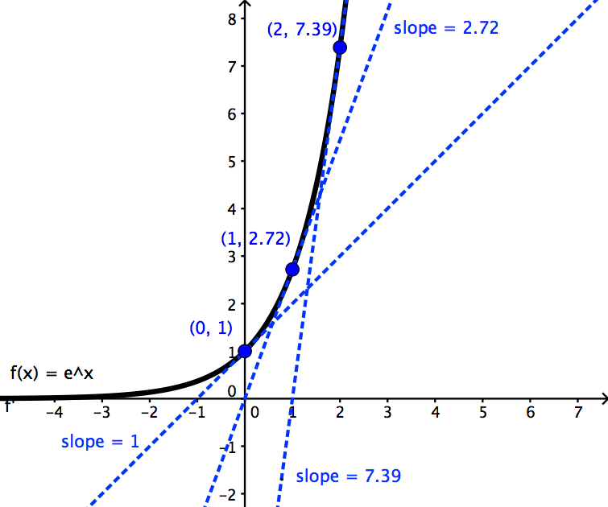

Growth
e is used in the natural exponential function y=e^x. Now the interesting thing about this function is the properties that it has.
It has an amazing property where the slope is its value. For example, let x=0 the value e^x=1 and the gradient will equal 1. Another property that this graph has is the area underneath up to any x-value is equal to e^x. These two properties are very useful for calculus.

Cut up and multiply
e has another property which isn’t as useful as the other properties it has none the less it is an interesting one. Let’s cut up a number into equal parts and multiply the equal parts together. For this example, we can use 8.
8/2=4 4*4=16.
Now we need to think about how to get the biggest possible answer.
2 parts: 8/2=4 4*4=16
3 parts: 8/3=2.66 2.66 ^3 = 18.96
4 parts: 2^4 = 16
5 parts: 1.6^5=10.49
As we can see from above the largest answer we get is when the parts that we have are closest to e.

Compound interest
As promised we will look at where e is involved in compound interest.
Let’s say you go to a very generous bank which gives you 100% interest so when you invest £1000 in one year you will have £2000. Let’s imagine that the bank pays you halfway through the year, which is 50% twice. So halfway through the year you get payed £1500 and if you reinvest that you will get £2250 so you get more money.
So, what happens when we break the year up into months? To do this we will need the compound interest formula: (1+r/n) ^{n}
Where r = annual interest rate (as a decimal) and n = number of periods within the year.
So, with our first example r=1, n=2 (1+1/2) ^2 = 2.25 which is how much more of your original amount of money you will get.
Breaking up the year into months (1+1/12) ^12 = 2.613
Let’s break up the year 1000 times (1+1/1000) ^1000 = 2.717
As you may have noticed the number is approaching e. So as n tends to infinity the value approaches e which is how Jacob Bernoulli discovered it. The reason for this is that when the interest rate is a 100% r=1 which makes the compound interest formula identical to the formula when working out the value of e.

Euler’s formula for complex numbers
Another interesting fact about e is that it’s involved in one of the most amazing equations known: e^{iπ} + 1 = 0
This equation includes:
-Two irrational numbers
-An imaginary number
-5 of the most important mathematical constants
I find it incredible that these numbers can combine in such a neat equation.

Calculating e.
As a mentioned before one way to work out e is with the formula similar to the compound interest formula: (1+1/n) ^n and as n tends to infinity the closer the value gets to e.
However, using factorials, we can use another method to work out e.
e is equal to 1/0! + 1/1! + 1/2! + 1/3! + 1/4! + …
Euler himself used this method to work out e to 18 decimal places.

Applications to real life
Since e is to do with growth we can use it to model real life situations. The example I’m going to use is an example that was shown to me by my teacher and is something we are all way too familiar with, COVID.
We are able to model a graph to see the number of infections rising as the days go on all thanks to e. The formula used for exponential growth is Ae^kt where A is the initial number of infections, k is the growth constant and t is the number of days. By looking at the start when corona had an outbreak in the UK, you are able to use those values to calculate A and k. I was able to work out this formula: 9e^(0.09978*t).
Now with this formula and with the help of excel we are able to predict and see the amount of total infections in the future.
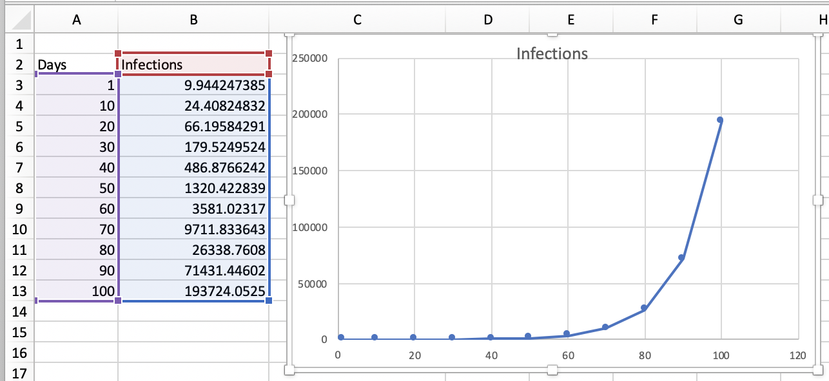
As we can see from above we obtain a nice exponential graph from the values we get from plugging in days into the equation. Now let’s compare it to an actual graph that represents COVID cases.

From above, we can see that e is a wonderful constant with wonderful properties.
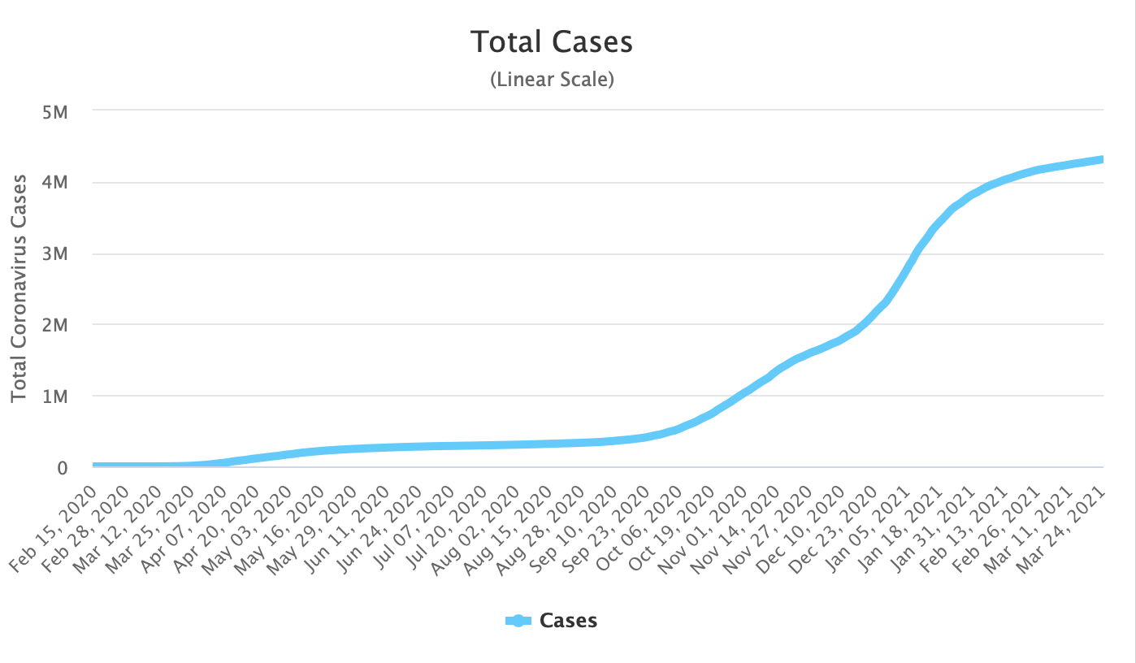

You may have noticed the graph I modelled is similar to the actual graph however they are not identical and this is due to the fact of lockdown, promoting social distancing and many other factors. None the less it is still interesting to see what would’ve happened if we didn’t try to prevent corona from spreading and what the world would look like. We also can see how useful e is where in this case you could help prevent a virus from infecting the country.

From above, we can see that e is a wonderful constant with wonderful properties. However, even though it has these amazing properties and brilliant uses it’s a constant that doesn’t get as much recognition as some of the other constants such as Pi. With e’s uniqueness, usefulness and fascinating uses I can personally say that e is my favourite constant.

