How to Draw a Complete Polynomial Function Graph: Finding Intercepts and Local Extremes
Shuxin Huang

Table of Contents.
I. Introduction
II. Basic Concepts: Linear and Quadratic Functions
III. Intermediate Level: Cubic Functions
IV. Ultimate Challenge: Local Extremes
A. Recognizing Polynomial Function Slopes
B. Solving for Local Extremes
V. Conclusion

I. Introduction.
It is taught in high school that we can rely on software, graphing calculators, or our own hands for graphing polynomials in 2D space and analyzing polynomial equations. With simpler, lower-degree polynomial functions, it is easy to draw fairly accurate graphs by hand, in order to visualize properties of a function and compare it to others. When the function is of a higher degree, however, it is more difficult to draw an accurate graph by hand using only our knowledge of intercepts, and the leading coefficient's sign. In addition, solving the equation for roots does not always provide a graph, which makes it necessary for us to explore new methods. Key information—namely, the local extremes of the polynomial—is also required to produce a higher-accuracy graph at a hand-drawn level. This paper will explore methods to calculate exact intercepts and local extremes of a polynomial function's graph, to prepare myself for future studies in calculus.
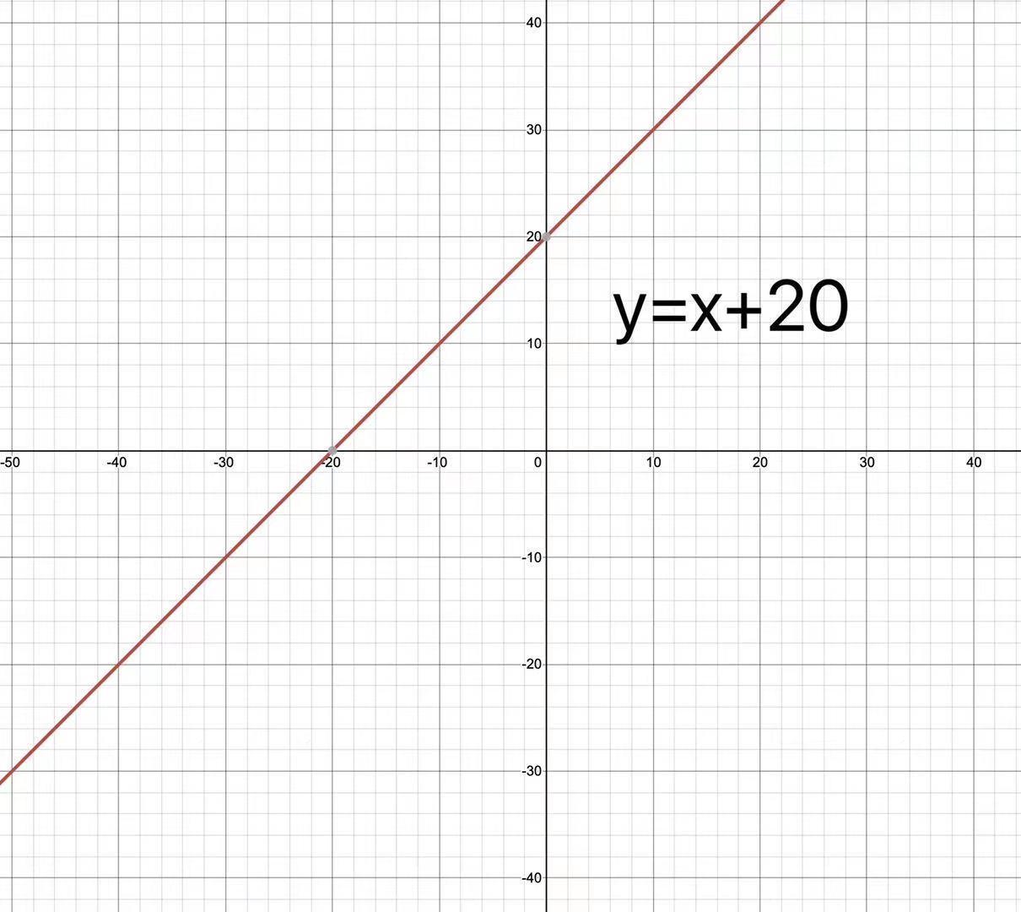
II. Basic Concepts: Linear and Quadratic Functions

A linear function is the simplest polynomial, with general form

$f\left(x\right)=ax+b$, where a and b are constants.

In this case, it is obvious that the graph of this function is a straight line, intersecting with the x and y axis at (0, b) and (-b/a, 0) respectively.

A quadratic function serves as the most fundamental polynomial function that can be used to illustrate basic concepts of a polynomial function graph. Consider
${f\left(x\right)=x}^{2}+6x+8$

Our goal here is to find where the curve crosses the axes, and the local extreme. Notice that the function can be factorized into its intercept form (which allows us to see easily the intersection between the graph of the function and the x-axis) :
$f\left(x\right)=(x+2)(x+4)$

The x-intercepts can be found when we let$f(x) = 0$. For this example we can verify that by substituting in$x = -2$or $x = -4$, we obtain f(x) = 0, and in fact these are the only 2 solutions. A similar method can be used to find the y-intercept: we set $x = 0$ and obtain the y-intercept, $y = 8$ = f(0).
The general quadratic equation can be expressed in the form
${f\left(x\right)=y=ax}^{2}+bx+c$, where a, b, c are constants, a ≠ 0
The vertex, which in this case refers to the lowest point in the diagram above, can be said to be the local minimum of the function.
If a quadratic equation cannot be factorized into intercept form, it is possible to use completing the square or the quadratic formula to find the x- and y-intercepts.
Completing the square brings the function into vertex form, where (h,k) is the vertex of the equation:
${f\left(x\right)=y=a(x-h)}^{2}+k$

By expanding the square bracket and comparing coefficients, we can see that -2ah=b and ah²+k=c, where a, b and c are constants of the quadratic function we defined. Notice that
(x-h)² is always positive, and so (for a > 0) x = h is the lowest point of the graph.

By using that h = -b/2a , the vertex of the function can be found at$(-3, -1)$. Since the leading coefficient of the function is greater than zero, the quadratic equation's graph opens upwards. With this and the intercepts, we can fully draw the graph:
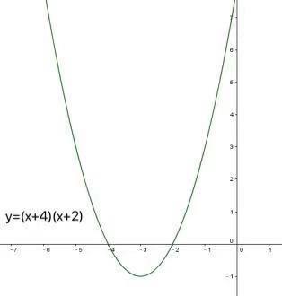
The quadratic formula can be used to solve for irrational x-intercepts when the discriminant ${(b}^{2}-4ac$) is greater than zero:
x=$\frac{-b±\sqrt{b^{2}-4ac}}{2a}$ , where a, b, c are the constants from the general quadratic equation

III. Intermediate Level: Cubic Functions
The general form of a cubic equation is:
$f\left(x\right)=y=ax^{3}+bx^{2}+cx+d$, where a, b, c, d are constants.
Solutions to the previous quadratic function should provide clues into the nature of cubic functions. As before, we find the corresponding x- and y-intercepts of the function before graphing it. Consider the function below:
f(x)=$x^{3}-2x^{2}-x+2$
This cubic function can (like some quadratic functions) be factorized into its intercept form:
f(x)=$\left(x^{2}\right)\left(x-2\right)-\left(x-2\right)=(x^{2}-1)(x-2)$
f(x)=$(x+1)(x-1)(x-2)$

From previous experience with the quadratic function, we conclude that the x-intercepts of this cubic function are x=$±1$ and x=2. Also, f(0) = 2, so as with the quadratic case we conclude that our curve crosses the y-axis at y = 2.
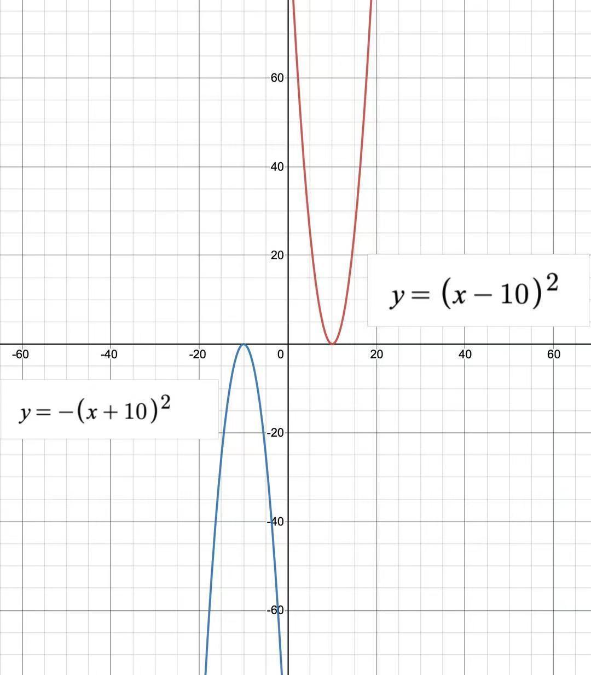
By plugging in numbers to plot the graph, or by looking at the sign of the leading coefficient (positive leading coefficient suggests upward opening and negative leading coefficient suggests downward opening), we come to the conclusion that the graph moves up on the right and down on the left, in a kind of N-shaped curve. This is shown by the hand-drawn graph on the right:

By the use of a graphing calculator or other software, we can find the heights of the local extremes or “hills and valleys” of the function, as can be seen from the graph below.
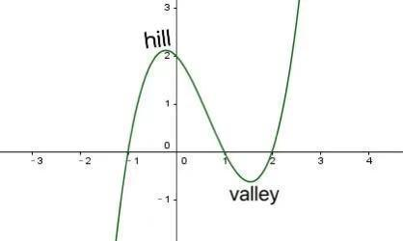
We get the following information:
The local minimum of the function is located at approximately x=1.5486, with a corresponding y-value at approximately y=-0.6311.The local maximum of the function is located at approximately x=-0.2153, with a corresponding y-value at approximately y=2.1126.
IV. Ultimate Challenge: Local Extremes
Part A: Recognizing Polynomial Function Slopes
Now the question is: Why is the answer in the previous example the way it is? It seems that there must be a way to find the extreme points for cubic functions, because we were able to find the extreme point for quadratic functions. To find an applicable method, we must look at the slope(s) of the graph.
We can think of the slope as the steepness of the curve, and it can be calculated by $Δy⁄Δx$, (Change in y divided by the change in x). Using this formula wisely is key to finding the local extremes, and thus accurately graphing the function, as we shall see.
Let us pick two points on the curve. We’ll call them A and B, with respective coordinates (x , x³- 2x² -x + 2) and (x +$Δx$, (x +$Δx$)³- 2(x +$Δx$)²- (x +$Δx$) + 2)
To find the slope of AB, we use the formula for the slope and simplify the numerator and denominator:
Slope = [((x +$Δx$)³ - 2(x +$Δx$)²- (x +$Δx$) + 2) - (x³- 2x² -x + 2) ]/[(x +$Δx$)-x]
which after some simplification =
[$Δx$³ + 3x$Δx$² +3x²$Δx$ - 2$Δx$² - 4x$Δx$ -$Δx$]/$Δx$
If A ≠ B, we can see that $Δx$≠ 0, so we can divide through to obtain:
Slope = $Δx$² + 3x$Δx$ + 3x² - 2$Δx$ - 4x -$1$
We are now very close to what we are trying to achieve. Although we have found the slope between points A and B, as you can see in this graph, this line AB does not exactly match the tangent of the polynomial at point A.

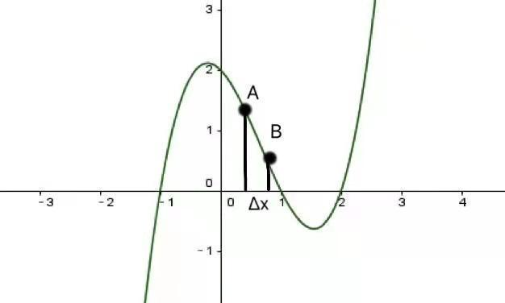

We can, however, calculate the slope of a line tangent to the graph at a specific point. By applying the definition of tangent lines (the tangent to a curve intersects it at exactly one point), we can infer that as the distance between A and B approaches 0, the slope of AB approaches the slope of the tangent.
However, this would indicate that $Δx = 0.$ As $Δx$ serves as a denominator in the previous steps, $Δx$ cannot be equal to zero, or the aforementioned equation would be invalid. Thus, in this case, we let $Δx$ be infinitely close to 0, or let it become a small enough number that we can remove it from the above equation. By substitution of $Δx = number infinitely close to 0 ≈ 0$, we conclude that slope at x =
3x² - 4x - 1
The above result is in the form of a quadratic equation, which we have already shown how to solve. It is the formula for the graph's slope at any point, which continuously changes as the variable x changes.
Part B: Solving for Local Extremes
How, then, are we supposed to use the previous section's results to calculate local extremes? Look at the lines tangent to the polynomial curve at its local maximums and minimums. These tangents will be horizontal, implying a slope that equals 0. By substituting our previously found equation into this definition, we get the following quadratic equation:
3x² - 4x - 1 = 0

Solving this equation requires use of the quadratic formula, and yields the following results: x = $\frac{2+\sqrt{7}}{3}$ or x = $\frac{2-\sqrt{7}}{3}$
By plugging in these x-values to the original cubic function, we get the points:
$(\frac{2+\sqrt{7}}{3},\frac{20-14\sqrt{7}}{27}) and (\frac{2-\sqrt{7}}{3},\frac{20+14\sqrt{7}}{27})$

These points are where the slope of the graph is 0, i.e. the local extremes for the original cubic function. As the original function is of the third degree, there must be at most one local maximum and one local minimum. We now check our answer with the previous result we received from software by converting these points to decimals:
$(1.5486,-0.6311) and (-0.2153,2.1126)$
We can now use graphing software to check these results.
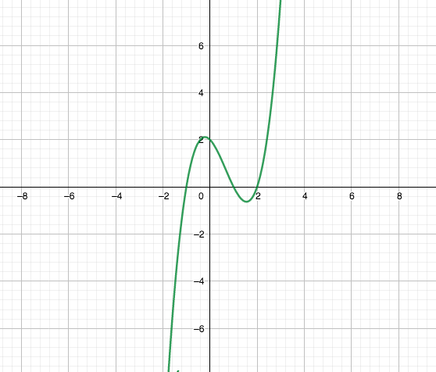

We have found an easy and fast way to use this information to draw the graph by hand - we have all of the intercepts and local extremes (where the graph "turns") and only one way to "connect the dots" and draw the graph.

V. Conclusion

In this project, we have explored the use of derivatives and software to determine the intercepts and local extremes of polynomials. The software can generate graphs and results quickly and is easy to understand and more accurate than hand drawing. However, when we do not have electronic devices at hand, hand drawing allows us to obtain key information about the graph. And when wanting to know more about the basic concepts of the graph, it is best to draw the graph by hand using the methods explored in this project.

In polynomials with degrees higher than 3, it is still useful to use the method of slopes to calculate the local maxima and minima, which, combined with the intersections with x and y-axis, gives us an idea of what the graph looks like.

Works Cited

"Quadratic Factorisation: The Complete Guide". Math Vault. 2016-03-13

Weisstein, Eric W. "Fundamental Theorem of Algebra." From MathWorld--A Wolfram Web Resource. https://mathworld.wolfram.com/FundamentalTheoremofAlgebra.html

“Graph Skills.” Graph Skills: Unit Four, Syracuse University, cls.syr.edu/mathtuneup/grapha/Unit4/Unit4a.html.

Chapter 2: Limits. Continuity. Slope and Derivative, MIT, www-math.mit.edu/~djk/18_01/chapter02/contents.html.

Loh, Po Shen. “Quadratic Method: Detailed Explanation.” Po, Carnegie Mellon University, www.poshenloh.com/quadraticdetail/.

"Quadratic Factorisation: The Complete Guide". Math Vault. 2016-03-13
Loh, Po Shen. “Quadratic Method: Detailed Explanation.” Po, Carnegie Mellon University, www.poshenloh.com/quadraticdetail/.
“Graph Skills.” Graph Skills: Unit Four, Syracuse University, cls.syr.edu/mathtuneup/grapha/Unit4/Unit4a.html.
Chapter 2: Limits. Continuity. Slope and Derivative, MIT, www-math.mit.edu/~djk/18_01/chapter02/contents.html.

