Mathematics and Game Theory
Game theory abstracts situations – allowing one to make the best decision possible given the current information. John von Neumann is seen as the first person to develop the theory.
Before anything, there is something I must make clear of. The theory in a mathematical context does not include issues of making clever choices. What it does include is the structure of logic in questions that comes up that comes up in making decisions.
I first encountered this interesting theory in a lecture on Saturday. It really made skipping the opportunity to play a football match worthwhile.
Well, was it? Let us use a pay-off matrix! It is simply a fancy name for a table listing gains and losses using numbers. A positive number will mean that a person has gained. A negative number means that a person has lost. The numbers will be formatted in the form ( person 1’s results , person 2’s result ). In the table below, actions that can be done by person 1 are typed in bold. Actions that can be done by person 2 are in italics.

Me (person 1) | Coach (person 2)  Doesn’t Care Cares
Play Football  Go to a maths lecture | ( -10000 , 0 ) | ( -10000, 0 )
Play Football  Go to a maths lecture | ( 99999 , 0 ) | ( 99999 , 0 )

In this case, I can get the highest number by choosing the option in the second row. Since the bigger the number, the more I gain, I should choose the option in the second row (i.e. going to the maths lecture). However, whatever the coach does, there is nothing for him to gain or lose. If he cares, I won’t do much about it. If he doesn’t care, I am not a great asset to the team anyways! Whatever he does, he will not gain or lose anything. Therefore, he can choose anything. As one may already see that person 1’s action has no impact on person 2, nor vice versa. Another sensible observation to make would be the following. If I need to make the decision one hundred more times, I would choose the same thing. An action I may choose to do is called a strategy. For example, “play football” is a strategy. Since it is not changing, it can be described as stable. It can be called a pure strategy too because one plays ‘purely’ only one row or column.

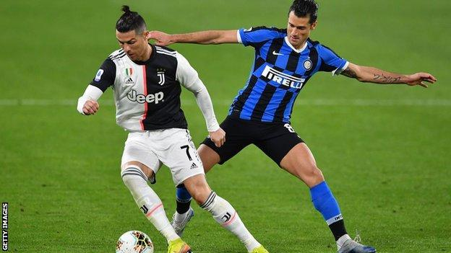
For person 1, the strategy of going to a maths lecture strictly dominates the other strategy (play football). What this means is that I will gain the most by following the strategy no matter what the coach does.
This is core to game theory. Game theory studies how people can make optimal decisions. Some eager readers may then question the meaning of the title. What defines a ‘game’? Well, here are the conditions.

- A bona fide player is someone who makes choices and gets the consequences.
- At least two bona fide players are involved.
- All rules are clearly stated. (i.e. All choices and outcomes are clearly defined.)
  - A choice may decide which person will make the next decision as seen in many card games.
- There are losses and benefits. This means that a person would prefer one choice over another.
- One or more of the people have to make a choice from a set of possible, stated choices.
- Were a game to have continuous choices or moves available to the player, there is a termination rule. Examples are listed in the following.
  - When all cards have been played in games.
  - Checkmate in Chess.
  - Lining up of three crosses or noughts in a straight line in Tic-Tac-Toe.

An observation worthy of note is that choices made do not have to be known by the all players in a game. “Games of perfect information” is the name given to games where choices of everyone is instantly known to everyone. Examples include Checkers, Chess and Tic-Tac-Toe. These games’ best strategies can be stated without mentioning chances. However, for games that are not of perfect information, this is not really the case.
“Why do we have conditions?”, I hear you ask. Well. They help to clarify the situation of choices and the outcomes of them.

Misconceptions of Games
Play the slot machine is not a game. Very interestingly, the machine can be considered as a bona fide player because it makes choices, albeit randomly; and it gets the consequences of its choice. However, the person using the machine does not make any choices. Therefore, the person is not a bona fide player. The person is only a dummy player at best. As this does not match with the above conditions, this is not a game.

Evolutionary Stable Strategy (ESS)
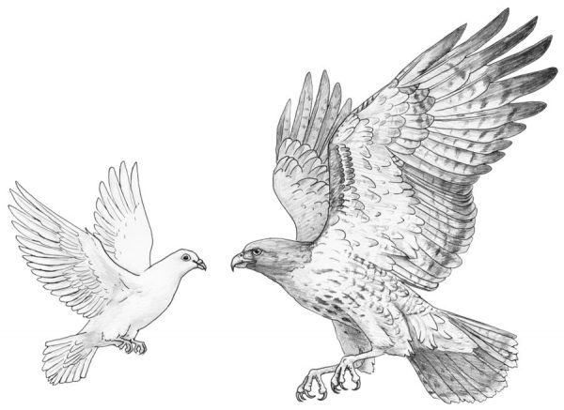
Game theory also shines brightly when it comes to evolutionary biology. In 1973 John Maynard Smith proposed an important idea called the evolutionary stable strategy. Essentially, ESS is the idea that there is a stable/pure strategy that an animal can take. In this case such strategy is defined so that when everyone is doing the strategy, there is no mutant that can do better.
Let us consider the following example. John Maynard Smith also came up with a theoretical and engaging game model. He proposes that there are two elementary types of animals: hawks and doves. As I am sure that you know, animals in nature will fight for resources. Hawks fight for resources. Doves only pretends to fight for resources. Animal 1 or 2 could be a hawk or a dove. We are going to consider the outcome of all combinations.

Allocation of points
- When a hawk meets another hawk, one dies or injured (-100). The other gets the resource (50).
- When a hawk meets a dove, hawks wins by getting the resource (50). Nothing happens to the dove (0).
- When a dove meets a dove, one gets the resource (50). However, time is wasted in pretending to fight for both of them (-20)

Aim
Find the probability that an animal is a hawk such that we can get ESS.

Animal 1 | Animal 2  Hawk. Dove
Hawk  Dove | ( -100 , 50 ) | ( 50, 0 )
Hawk  Dove | ( 0 , 50 ) | ( 30 , -20 )

Now, when animals have the same trait, both could win or lose. We are going to apply the idea that there is a definite winner and loser for all situations. One animal will gain more than the other. Therefore, the average result of each animal is the average of their winning and losing scores. Excitingly, the new table looks like this …

Animal 1 | Animal 2  Hawk. Dove
Hawk  Dove | ( -25 , -25 ) | ( 50, 0 )
Hawk  Dove | ( 0 , 50 ) | ( 5 , 5 )

We are going to say the sum of all probabilities is one. The animal can only be a hawk or a dove. Let p be the probability that animal 1 meets a hawk. It follows that the probability for animal 1 to meet a dove.
We multiply the value for the situations to the corresponding probability to get an expected value. The expected value is a value that one would get on average were the game to be played for an infinite number of times.

V_{H}: the expected value for being a hawk.
V_{D}: the expected value for being a dove.

If the animal acts like a hawk,
V_{H} = -25p + 50(1-p)
If the animal acts like a dove,
V_{D} = 0p + 5(1-p)

ESS happens when V_{H} = V_{D}. This makes sense because when everyone is following this strategy, no mutant can do it better. This means the mutant must get a lower expected value.

V_{H} = V_{D}
-25p + 50(1-p) = 0p + 5(1-p)
50(1-p) - 5(1-p) = 25p
45(1-p) = 25p
45 – 45p = 25p
45 = 70p
p = $\frac{45}{70}$ = $\frac{9}{14}$

From this, we can say that if the population consists of $\frac{9}{14}$ hawks and $\frac{5}{14}$ doves, animals are getting the highest value overall. Since the higher the value, the more they gain. Chance to survive for all types of animal are maximised. This strategy of having this ratio of hawks and doves is ESS.
To conclude, I have chosen game theory as a topic to write about because it is very powerful. It shows that maths can be applicable to real life situations if it wants to. It also shows that maths is an art and it can be played with just for fun.

Bibliography
Gardner, M., 2001. The Colossal Book Of Mathematics. New York: W. W. Norton & Company.
Rapoport, A., 1966. Two-Person Game Theory The Essential Ideas. Ann Arbor: The University of Michigan Press.
Detective, T. E., 2013. Youtube. [Online]
Available at: https://www.youtube.com/watch?v=3Y1WpytiHKE
[Accessed 20 March 2021].
Engelhardt, G., 2019. Game Theory. London: The Royal Institution.
SciShow, 2016. Youtube. [Online]
Available at: https://www.youtube.com/watch?v=MHS-htjGgSY
[Accessed 23 03 2021].
Wikipedia, 2021. Wikipedia. [Online]
Available at: https://en.wikipedia.org/wiki/John_Maynard_Smith#Early_years
[Accessed 23 March 2021].
Veritasium, 2015. Youtube. [Online]
Available at: https://www.youtube.com/watch?v=mUxt--mMjwA
[Accessed 26 03 2021].
Wikipedia, 2021. Wikipedia. [Online]
Available at: https://en.wikipedia.org/wiki/Evolutionarily_stable_strategy
[Accessed 21 March 2021].
Wikipedia, 2021. Wikipedia. [Online]
Available at: https://en.wikipedia.org/wiki/Chicken_(game)
[Accessed 22 March 2021].
Wikipedia, 2021. Wikipedia. [Online]
Available at: https://en.wikipedia.org/wiki/Nash_equilibrium
[Accessed 21 March 2021].

