In December of 2016 5-time Grammy award winning artist Jacob Collier released an acapella arrangement of “In the Bleak Midwinter”. Using the maths behind the tuning of notes and the physics of harmonics, he changes key in a way never done before, in a way that breaks tuning as we know it, and in a way that makes this music impossible to play. He modulates in between semitones, to the key of G half-sharp major – between keys on the piano.

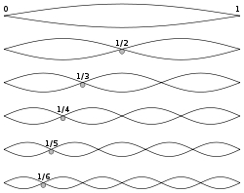
To break down how Collier achieves this, we first need to understand how harmonics work in stationary waves. A stationary wave will have a fundamental frequency, which we can call f_{0.} This frequency very simply describes the number of oscillations the wave performs per second, as this is the definition of the unit Hertz, 1/s. This concept can be visualised on a string, which could be in a piano, or on a violin or guitar, but the same concept applies for all sound. From top to bottom, the diagram to the left shows the fundamental, followed by the subsequent harmonics. The string of length 1 in the diagram can also be vibrated by a frequency of 2f₀, which creates the second harmonic. This is an octave above the fundamental, an octave being the distance between the two of the same notes on a piano. This relationship between the frequency of the fundamental first harmonic and the following harmonics is an arithmetic sequence, so if n is the number of the harmonic, the frequency of harmonic n is nf₀.

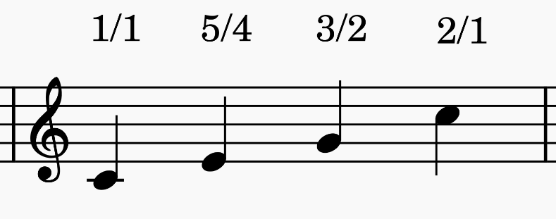
These harmonics occur with every sound produced, as natural ‘overtones’, and Just Intonation is tuning chords using these naturally occurring intervals, which is the key idea behind Jacob Collier’s impossible key change. To use just intonation, we can derive tuning ratios from the harmonic sequence so that we can apply the same intervals to any fundamental. One of the more common just intonation systems is 5-limit tuning, which derives these tuning ratios from the first 5 harmonics. The tuning ratios are closely related to the Fibonacci sequence, the first few of which being $\frac{1}{1}$, then $\frac{2}{1}$ for an octave, $\frac{3}{2}$ for a perfect fifth and $\frac{5}{2}$for a major third. 5-limit tuning uses these ratios to move intervals by multiplying the fundamental frequency by the corresponding fraction.
Assuming the key of C major, with middle C being the fundamental, the major third, fifth, and octave are shown with their respective ratios above.

The ratios for tuning can be found in 5 limit tuning using powers of 2, 3 and 5. These represent the 2nd 3rd and 5th harmonics respectively, therefore for every power of 2, you move that many octaves. For each power of 3, you move the corresponding number of perfect 5ths (plus one octave), and for each power of 5 you move the same number of major thirds (plus 2 octaves). Therefore, for example to find this $\frac{5}{4}$ ratio for a major third, we can do 5¹·3⁰·2⁻² as we are moving up by one major third (plus two octaves), moving by 0 perfect fifths, and taking away 2 octaves to negate those added by using the 5th harmonic. 5¹·3⁰·2⁻² = $\frac{5}{4}$, which is our tuning ratio for a major third, and all other intervals in 5-limit tuning can be found in a similar way.

The nature of these ratios however is such that pitch can shift quite easily just by calculating intervals from different starting notes. This effect is ultimately what allows Jacob Collier to work his modulation, but an example from nearly 500 years ago demonstrates this comprehensively.
In the 16th century, Italian mathematician Giovanni Benedetti wrote several letters to Cipriano de Rore, a composer at the time. These detailed musical puzzles that demonstrated what he called the “Comma Pump”, which is a name for the pitch shift that occurs when using a just intonation system.
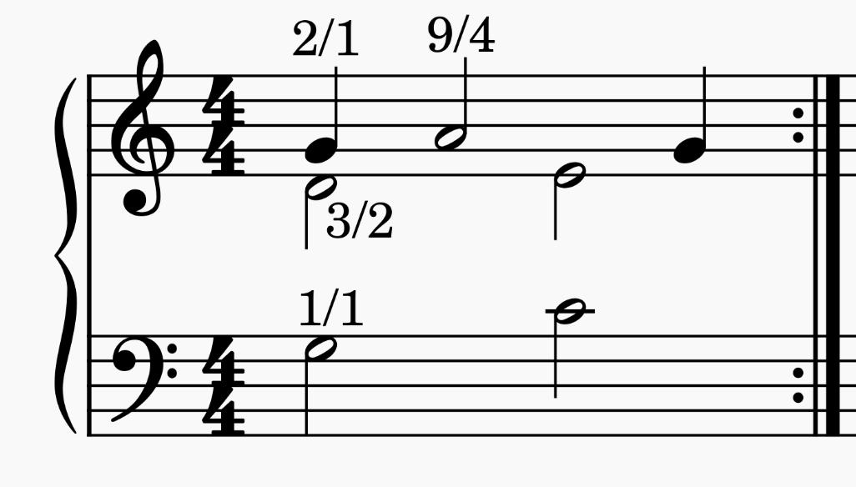

Above is one of the puzzles that Benedetti described, with the ratios of the first few notes written in. Assuming the G in the bottom stave as the fundamental (which is no different to the frequencies we were referencing earlier, just this time the frequency is being given the name G3), the middle note, a D, is a fifth above, therefore is given the ratio $\frac{3}{2}$, and the top note, another G, is an octave above and thus gets the ratio $\frac{2}{1}$. The following A in the top line gets a ratio of $\frac{9}{4}$. This is because it is a fifth above the previously calculated D at $\frac{3}{2}$, and therefore 2 fifths above the fundamental. We thus do $\frac{3}{2}·\frac{3}{2}=\frac{9}{4}$ to give the ratio of this note.
We are now faced with a decision, as the next note in the bottom line, a C, could be approached from the fundamental – up an octave, down a fifth. Going down an interval means using the reciprocal of the ratio, therefore $\frac{2}{1}·\frac{2}{3}=\frac{4}{3}$. The E above it in the middle voice could then be calculated with a major third above the C, $\frac{4}{3}·\frac{5}{4}=\frac{5}{3}$. However, as the A in the top line is held over, and it makes more sense to tune these two notes relative to the A, as opposed to the fundamental, as this will make them sound more in tune. So instead, we find the E by going an octave down from A, then up a fifth - $\frac{9}{4}·\frac{1}{2}·\frac{3}{2}=\frac{27}{16}$. The C is simply a major third below: $\frac{27}{16}·\frac{4}{5}=\frac{27}{20}$. Both of these ratios are slightly higher than their counterpart ratios when calculated from the fundamental G.
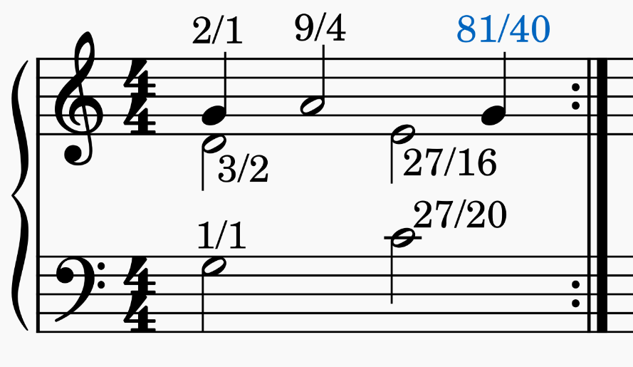

The ratio of the final G is calculated by $\frac{27}{20}·\frac{3}{2}=\frac{81}{40}$ because it is another perfect fifth above the C, which clearly demonstrates the rising in pitch, as $\frac{81}{40}>\frac{2}{1}$.

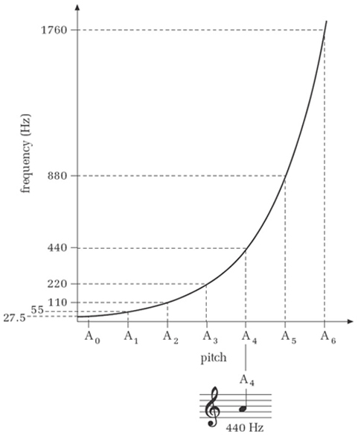
This pitch shift, however, is difficult to conceptualise as just a ratio, or even a frequency number, because the relationship between frequency and pitch is exponential. This is because the frequency doubles for each octave leap (shown below using the frequency of A), which entails the form 2^{n}f₀, where n is the number of octaves above the fundamental, f₀. 12 tone equal temperament (or 12TET) instead splits each octave into 12 equal semitones, each of which being split into 100 cents, which makes conceptualising pitch a lot easier, as this makes a linear scale. From this, we can calculate that the G tuned at a ratio of $\frac{81}{40}$ is 21 cents higher than the one tuned at $\frac{2}{1}$, or $\sim \frac{1}{5}$ of a semitone higher – it would take 5 cycles of Benedetti’s puzzle to shift up a key on the piano. Pitch drifting in Western music is a little unhelpful, which is why 12TET is used, it means that the distance between intervals stays the same regardless of where you measure it from. It serves as the best approximation of just intonation relative to any key, or in other words, any fundamental frequency.
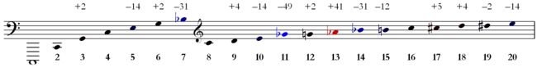
Using just intonation, notes differ in tuning based on the fundamental – as seen below where the harmonic sequence is notated, with the difference from 12TET written above. So, using this, if I wanted an E, the 5th harmonic (below), it would be tuned at -14 cents, yet if the fundamental was an A, an E would occur at the 3rd harmonic, or +2 cents – already we have two tunings of E that are 16 cents apart using just intonation. 12TET does not have this problem as every semitone is equidistant.
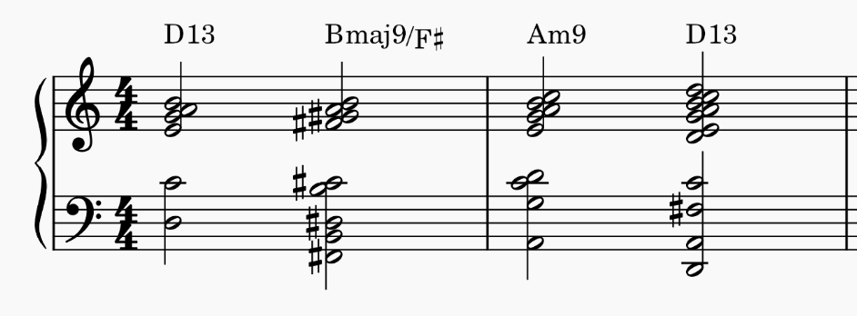
At first, this may seem like a huge issue – every equally tempered instrument is always going to be slightly out of tune – but Jacob Collier uses this very effect to change key in between semitones using his voice, making his key change impossible to replicate on a 12TET instrument.

These are the 4 chords Collier uses in his modulation. He modulates to a half sharp key, which means up half of a semitone, or 50 cents ($\frac{100}{2}$).
The first chord is a D13, but all we really need to know about what that means is that it has a B in it (the top note), and that it is closely related to the key centre of G major (it resolves there). From the diagram at the bottom of the previous page, we can see that the 5th harmonic is 14 cents flat, and the 5th harmonic represents a jump of a major third. The distance between G and B is a major third, and thus we can tune the B at the top of this chord 14 cents flatter than everything else in the chord. However, flattening the B at the top would not get us closer to moving up 50 cents, and therefore what Collier does is he brings the rest of the chord up 14 cents instead, while leaving the B in 12TET.
Another trick Collier employs is in the Am9 chord; here we are concerned with the fundamental A and the B at the top of the chord. By stacking 2 fifths (from A to E, then E to B), we add an extra 4 cents to the B at the top of the chord, as each fifth is 2 cents sharp (look at the 3rd and 6th harmonics for example). Instead of shifting the rest of the chord, Collier instead raises the B by this amount, and then uses the same technique on the final D13 chord as before. This means he moves a total of 32 cents up (14+4+14) with just these 2 exploits of the harmonic series. This leaves him less than 20 cents left, which divided across 4 chords is at the limit of the pitch difference a human can hear – <5 cents per chord, which is nigh on unnoticeable. This is how he modulates into G half sharp major without us even noticing.

Conclusively, Jacob Collier revolutionised key changes with this shift of 50 cents and proved microtonal key centres viable. He did this through utilizing the physics of harmonics, and the Fibonacci ratios behind tuning to these naturally occurring frequencies, similar to the pitch shift exercises of Benedetti 500 years before him. He made history in his approach to manipulating our ears using nature’s resonances, exploring the realm between the keys of a piano. He created a mathematical key change that is, all in all, impossible music.

References:
http://blog.dubspot.com/fibonacci-sequence-in-music/
https://casfaculty.case.edu/ross-duffin/just-intonation-in-renaissance-theory-practice/benedettis-puzzles/
https://www.youtube.com/watch?v=TYhPAbsIqA8
https://en.wikipedia.org/wiki/Five-limit_tuning
https://en.wikipedia.org/wiki/Harmonic_series_(music)
https://www.youtube.com/watch?v=Xd54l8gfi7M

