The journey of mathematics

Have you ever thought to yourself at times, wow math’s is hard, so sometimes you do not try as you will just get lost or confused. I get that. I think that if you are taught well you can get a feel for the things you are studying without getting this feeling, and I am going to prove it.
I am going to try and explain Poincaré conjecture (disclaimer: I am an A level student without a 4-year degree, but I will give you my best). You have probably never heard of that (neither had I when I started). By the end I hope you can explain it to someone else.
See it's easy to give up when thrown in the deep end with the wiki article giving you equations like this:
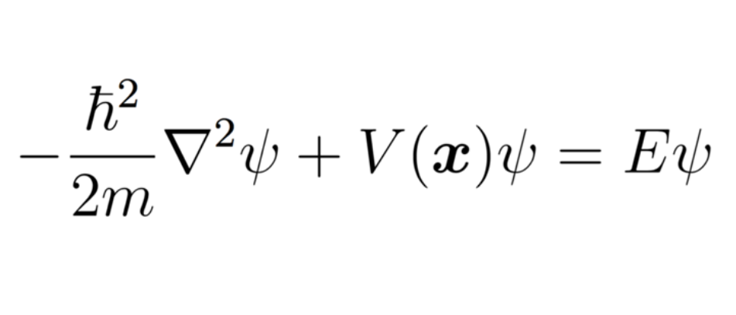
Arrrr, that's quite scarry, let's just take a quick cute animal break.
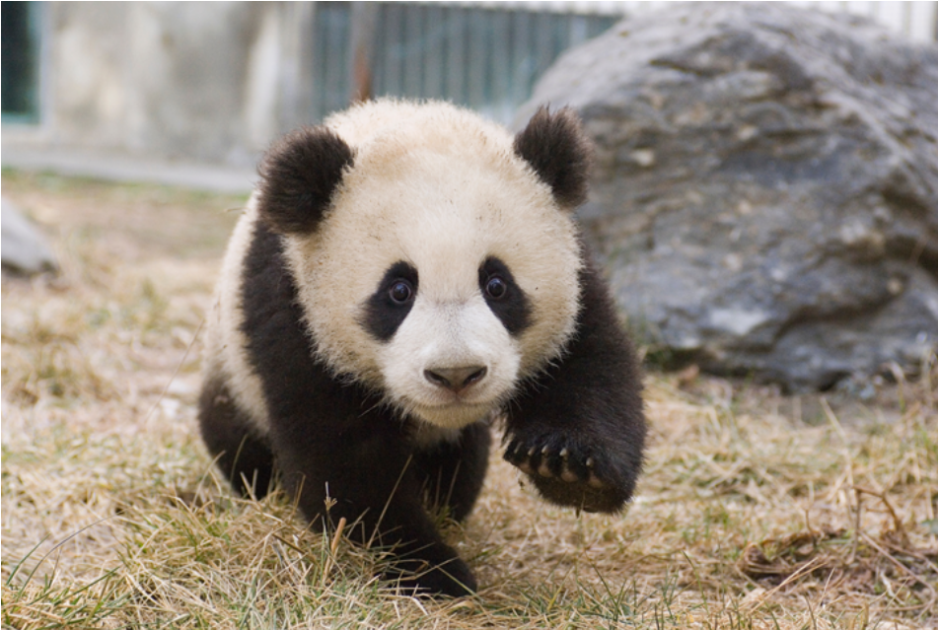

Maths can be a bit complicated. Pandas are less confusing: they will be here to make this less confusing.
That equation is there to illustrate the point that Maths can be confusing to everyone with loads of symbols shoved in your face. What is it? Well, I hope I will have inspired you to find that out for yourself by the end.
With a bit of knowledge of what it is like to live in 3d space, I thought it would be easy to imagine 4d until I tried it. See you and I are limited to 3d but let’s think about 2d. If we were in 2d space, what is the quickest way to the end of a maze? If I gave you another dimension to expand into, you can get there a lot easier. It’s the same concept from 3d to 4d. Dimensions allow for a freedom of movement.
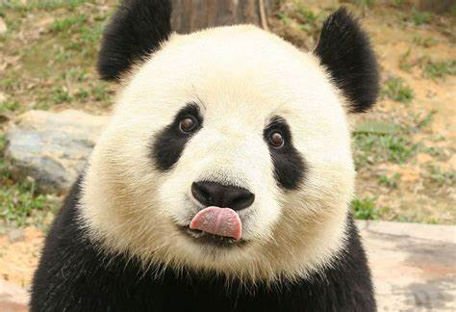
So, topology is an area of maths where anything is anything. I know it gets weird fast. But don’t worry there are a couple of rules.
But first explosions.

So back to topology, it is a certain kind of Maths that allows for things to be compressed into different things. I can turn a sphere into a cube by molding it, and a cup into a donut by the same process. But a donut is not a cube as there is one hole in the donut, and no holes in the cube. So, in topology you can push and pull the shape in any direction, to mold and reshape things, but you are not allowed to cut or stick things.
What us the main focus of this paper? Among other things it is to understand the relationship between what we have just done and the Poincaré conjecture. Imagine if you have an object that is not infinite and which has no holes. The object must be a locally 3-manifold, (around the area mostly 3d), it can be molded into a sphere. He did not just state this for our dimension, he stated it for all the dimensions.


How was this done? We can test this in 3d, but not in 4d and above. How do we even start? Well, if we have some blob of stuff with no holes, we can stretch it. Mapping this out requires something called a force vector. A vector is fancy speak for something that has a size and a direction, like left or right. So to use our force vectors to stretch and compress our object I need to use the idea of a tangent. This is something that is touching our object at only one point. So if my force acts perpendicular (at a right angle) it can mold other things. The name of this thing is called a metric tensor. We label it g. (g is not just one force vector, g is loads of force vectors. This is called global g. We can also speak about g as local. When I refer to g being big, this compares g to other vectors around and opposite to it.) So if we make it big we pull on the object and expand it in this direction. Conversely the opposite is true if local g is small. By deforming the manifold I can create curvature. So if g is small it will create a concave shape at the point where as if g is big it will create a convex shape at this point. So the key to solving this is to make the object rounder. This idea is called Ricci curvature. Think of it like where the vectors are. So we say object like a spoon has negative curvature. And object that are in to out like the back of a spoon are positive. So if we flatten the spoon we have to apply a force to it. This will pop it out from negative curvature to positive curvature. And subsequently the opposite is true for stating a positive curvature we have to bend to get it straight. So Ricci curvature is how g (and hence the object) contracts and expands. But how do we get the ideal position and direction of all of the g’s. This is after all what the Ricci curvature is. Well the equation looks like this:
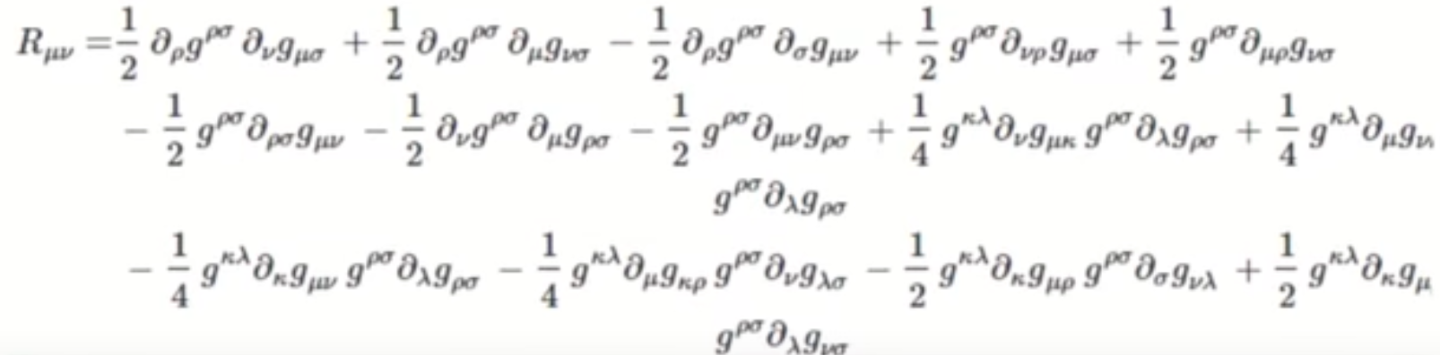
Arr, that looks scary and complicated and something which I will never be able to grasp, nevermind uses and explain. If you think that way then you are in good company as I though the same as well. But what I can see is a lot of g (which makes sense as this govens the position of g (after all this is what ricci flow is the best position of g to get an ideal sphere)) and lots of signs like this ∂. After doing some research I think this is the sign to represent the partial differential equation. Lets take a chill pill.
A partial differential equation is a long string of complicated words. Lets break it down. It means parts of things. Differential, the difference between things. Instead of me defining equations, first I think it is easier to understand what they do. They are just a way of writing down relationships. For example, the speed of an object is equal to the distance divided by the time. That’s quite obvious but that’s a word equation (they can come in words by the way). Putting it together. So this relationship is saying that with main part of g’s position on an object and the change or difference of g in a certain way (why there are numbers and other variable other than g) we get the Ricci flow (this is the ideal force vector position for max curvature and how it changes over time). This Wow, we just sort of got this.
To recap if we have g (the force required to mold an object surface) we get R (how does it move).
This is very powerful as it allows you to know how any object will curve in any way provided you have a force. So surely there is a way that allows for the most spherical change in our object. Yes this is called the Ricci flow. The best way to map this out is to think about bending a spoon flat. On one end the concave spoon is popping back out (for a lack of a better term) we call this by convention negative ricci flow. Hence if R (the symbol for ricci flow) is negative (the spoon bent inwards) g is increasing (trying to pull it out). Subsequently if R is positive g is decreasing. Due to the difference in the way g changes R, R is equal to the negative change of g, which makes sense as if R is big gis small and if R gets bigger g gets smaller.
Ricci flow allows us to manipulate the manofld into its most spherical shape, and hopefully into a sphere, due to R wanting to canecl the differences. Hence if you can prove that all fo g goes to 0, you’ve proven that at least for a short period of time you’ve had a sphere.
$$R= - \frac{d}{dt}g$$
This d over dt bit means how g changes over time.

This makes sense as of the opposite relationship discussed, so g is negative the Ricci flow is positive, he is pooping the object out of itself. Eventually as time progresses we get nothing. As when g is equal to all round it squishes its self to nothingness. This is because when R = 0 and the LHS must be 0 and the only thing that can change is g so g must be 0. So if we can prove that we go from something to nothing we must have had a sphere first. This I think is a represents a fundamental ideal in maths. To solve this problem first get a relationship (wiki this if need be (this means make it easier) play with it and see what it defines (tells you what has to be true)). This is something which I feel stops people learning maths as it can be quite daunting and scary at times.
I think we deserve a break.


If we take a random metric and give it a g and see that happens when Ricci flow is applied if we can prove the metric goes to 0 in a finite (not forever) time we have proven that we had a sphere first. since we haven’t broken any rules like put a hole in, something that starts identical to a sphere must end identical to a shape. But what if we get a point that are squished so hard that they just stop existing. Well, we can temporarily break the rules if we guarantee we can get back to our manifold. After all what starts as something ends as something, if doesn’t matter how we get there. We can just delete that bit that causes issues and replace it with a simple sphere. Why is this helpful? as long as we get back to the same topogical manifold it doesn’t really matter how we got there. If we get this and get a 0 R we get a 0 g so we get nothing. So go back we first spheres then we go back to our point squishing to nothingness. We see on one side stuff and another side stuff. But if they are counted, they must be one so if we keep going backwards, we can get to the point we started at hence proving that we can get a sphere from where we were as we proved it goes to nothing. That’s it?!😲😮😉
Well, that was a tricky adventure. This is what maths is about to me: the understanding of relationships.
This is what maths does. From times tables to higher dimensional surgery, all of this is just relations. Math is something special to give us. Whether we have created or discovered it, we get to experience it none the less. Don’t get bogged up in the equations first. To many times, bad maths teachers have just dived in. And made you learn or memorize things to pass the exam. Whether completely theoretical, or modelling, the universe of maths is just a puzzle where you add, subtract, multiply and divide. That’s it. This can describe all of everything (or so we think), so next time you have some free time, try and have a go, and think about --- how air flows, or how to model the rain, or what things are made from and piece the puzzle together. I promise if you got this far you will enjoy the experiences of free thinking.

This is a current thing that I'm watching about space time
Curved Spacetime in General Relativity
The videos most useful
https://www.youtube.com/playlist?list=PLzQxFrhHKh5LfX_xH14MRU2pdP3C6TM9w

