The Wave Function and Superposition
By Benjy Menachemson

Wave-Particle Duality
All waves have a wavelength, λ, associated with them, which is the distance between two adjacent peaks or troughs. They also have an angular frequency, ω, associated with them.
Einstein suggested, from results of the photoelectric effect, that the energy, E, of a wave is proportional to ħω, as follows:
$$E \sim ħ ω$$
Where ħ, the reduced Planck’s constant, is h/2π and where h is Planck’s constant.
He also suggested that the momentum of a wave, P, can also be written as h/λ, as follows:
$$P= \frac{h}{λ}$$
These two equations show that the energy and momentum of all waves, including light, are quantized. They also show that light has both wave and particle properties.

In 1923, Louis de Broglie suggested that all matter, not only light, has both particle properties and wave properties. He hypothesised that these equations apply to all objects, not just light. Since then, this has been experimentally proven: all matter behaves both as a particle and as a wave.

Introduction to the Wavefunction
In classical mechanics, if you know the position, x, and momentum, p, of a particle, you have complete knowledge of the system. However, in quantum mechanics, you cannot know both the position and momentum of a particle with great precision, due to the Heisenberg Uncertainty Principle. This principle states that if you make a measurement of any object, and you determine the x-component of its momentum with an uncertainty Δp, you cannot, at the same time, know its x-position, x, more accurately than:
$$Δx≥ħ /2Δp$$

So, if you take a measurement of a particle’s position and momentum at the same time, and the uncertainty in your measurement of the particle’s momentum is small, the uncertainty in your measurement of its x-position must be large.
Therefore, in quantum mechanics, complete knowledge of the quantum system is contained within the wave function of the system, denoted by the symbol Ψ.
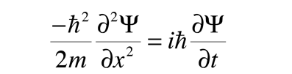
The wavefunction is a complex number and is a function of position. It was first introduced by Erwin Schrödinger, an Austrian physicist, in 1926 in his Schrödinger equation:
There are many versions of the Schrödinger Equation, but this version is for a free particle in one dimension. This equation describes how the wavefunction of a quantum particle changes with respect to time. You can also solve the Schrödinger Equation to find the wavefunction of any particle. But what does the wavefunction of a system represent?
This is still a widely debated topic in quantum physics. However, the most commonly accepted interpretation is the Copenhagen Interpretation, pioneered by Bohr and Heisenberg in the early 20th Century. This interpretation suggests that quantum mechanics deals with probabilities, and that the wavefunction of a quantum particle tells us about the probability distribution of finding a particle at a particular place. More specifically, the probability density that the object will be found at x, P(x), is the norm squared of the wavefunction, namely:
$$P\left(x\right)= {|Ψ|}^{2}$$
The sum of all possible probabilities of finding the particle at a certain location must add up to one, just like in normal probabilities, where the probability of all events sums to one. Therefore:
$$\int_{All}^{ }{{|Ψ|}^{2}dx=1}$$
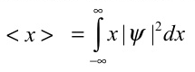
We can also work out the ‘expectation value’ of the position, x, of a particle, denoted with the symbol <x>. It is given by:

This represents the mean value of position, found from taking single measurements of an infinite collection of identical particles/wavefunction/system at the same time.

Interpreting the Wavefunction Graphically
If we have a wavefunction, where the real part, Re(Ψ(x)), looks like this:
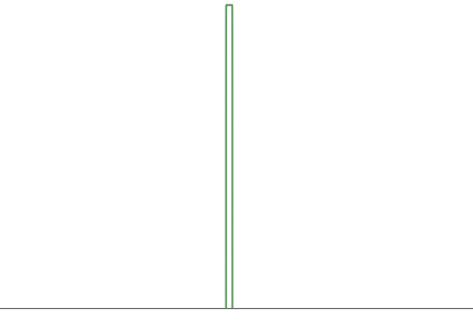
Re(Ψ(x))


We know that the probability density is the norm of the wavefunction squared, so the probability distribution would look like this:
P(x) = |Ψ(x)|²

From this graph, we can say with confidence that if we take a measurement of the location of the particle, we know where the particle will be, therefore Δx is small.

We can also have a wavefunction Ψ = e^{ikx}, and by using Euler’s formula, Ψ = cos(kx) + isin(kx).
So Re(Ψ(x)) = cos(kx). We can plot this on a graph as follows:
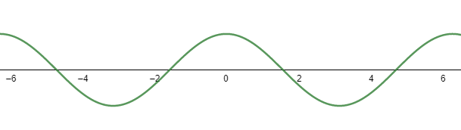
Re(Ψ(x))

This graph has a definite wavelength, and using the equation P = h/λ, it must have a defined momentum. So, if we take a measurement of the momentum of this particle, we can be confident in what that momentum will be. Therefore, ΔP is very small.
Now let us calculate the probability density of this wavefunction. We know that if β is a complex number, then |β|² = β*β.
So, for our graph of Ψ = e^{ikx}, the probability density, |Ψ|² = |e^{ikx}|² = e^{ikx} x e^{-ikx} = 1. So, the probability density of this wavefunction would look like this:
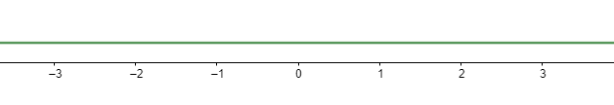
P(x) = |Ψ(x)|²

From this graph, we have no information where the particle will be when we make a measurement, as it has equal probability of being anywhere in space. Therefore, Δx is large.
This concurs with the Heisenberg Uncertainty Principle. We have a small ΔP and a large Δx.

Superposition of Wavefunctions
Given two possible wavefunctions of a quantum system, Ψ₁(x) and Ψ₂(x), the system can be in a superposition of these two wavefunctions, as follows:
Ψ(x) = α Ψ₁(x) + β Ψ₂(x)
Where α and β are complex numbers.
This is one of the main and essential theorems of quantum mechanics. It helps explain many phenomena that cannot be explained through classical physics, such as the double slit experiment, and forms the basis for many of the weird experimental results of quantum physics.

Any function, f(x), can be built by superimposing enough plane-waves of the form e^{ikx}.
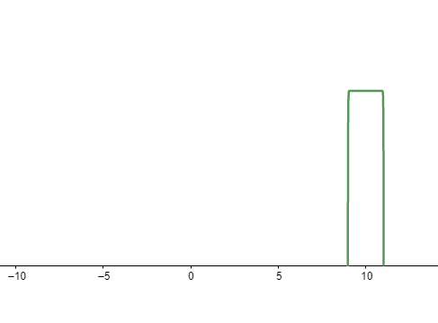
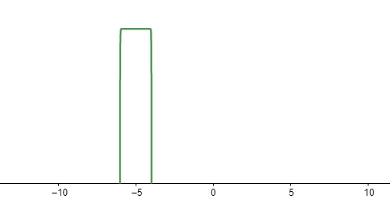
For example, if we have the two wavefunctions as shown:
Re(Ψ₂(x))

Re(Ψ₁(x))

X₁
X₂
The wavefunction of the superposition of these two quantum particles could look like this:
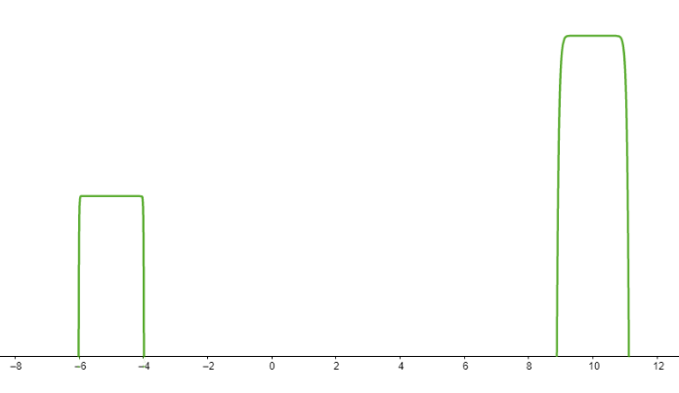

X₂
X₁
From this graph, we say that <x> will be somewhere between X₁ and X₂, and therefore Δx is not small, but it is not big.

We could also have two wavefunctions, Ψ₁ = e^{ik1x} and Ψ₂ = e^{ik2x}, and plotting the real part of the wavefunctions, we have:
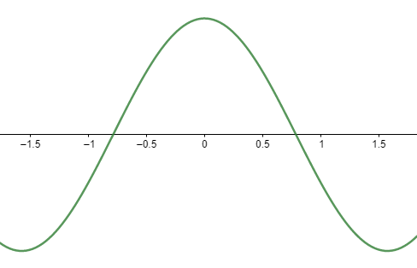
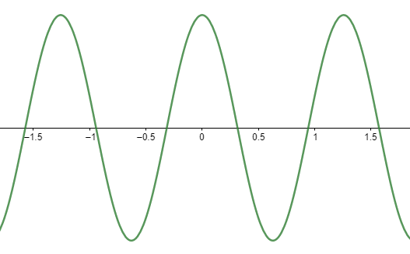
Re(Ψ₁(x))

Re(Ψ₂(x))

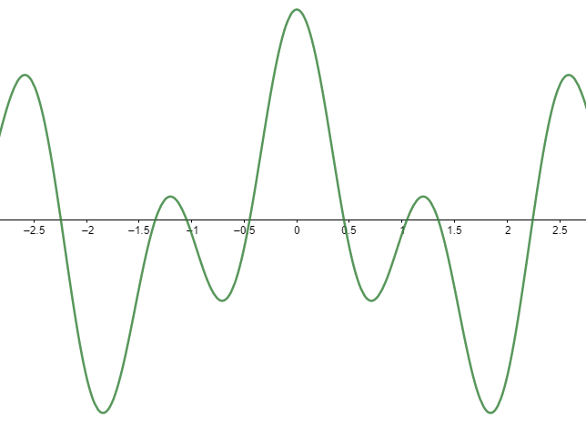
The wavefunction of the superposition of these wavefunctions could look like this:
Re(αΨ₁ + βΨ₂)

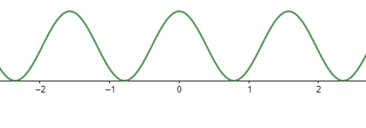
To work out the probability density of this wavefunction, we can take the norm squared of the superposition of these wavefunctions, and we will get:
P(x) = |αΨ₁ + βΨ₂|²

Something strange is happening. Before when we found the probability density of just Ψ₁, we got a constant. However, we now get P(x) is not constant, even though P(x) of the two wavefunctions that make up this superposition individually give a constant probability density. Why is this?
We would expect that just as the wavefunctions of these two graphs add, so too should the probability densities of the two graphs, and we should get a constant probability density for the superposition of the two wavefunctions. But clearly, this is not the case. We can see why this is if we expand the norm of the superposition wavefunction squared:
P(x) = |αΨ₁ + βΨ₂|² = |α|² |Ψ₁|² + |β|² |Ψ₂|² + α*Ψ₁*βΨ₂ ₊ αΨ₁β*Ψ₂*
= P₁ + P₂ + Interference Terms
The wavefunctions add, but not the probabilities. We can see from this that in quantum mechanics probabilities do not add like they do in classical mechanics.

Sources:
https://www.feynmanlectures.caltech.edu/III_01.html
https://www.youtube.com/watch?v=Ei8CFin00PY&list=PLUl4u3cNGP61-9PEhRognw5vryrSEVLPr&index=3

