Riemann And His Zeta Function:
A Beginners Guide to The Riemann Hypothesis
The phrase: “A One Million Dollar Question”, is usually given to a question that is considered so hard, that if someone were to solve it, they would warrant getting a theoretical one million dollars. However, in the case of the Riemann Hypothesis, if you were to prove or disprove it, you would get one million dollars as a prize for finally putting to rest a question that has stumped great mathematicians for the last 150 years.
First conceived by Bernhard Riemann in 1859, who, other than pose difficult questions, made massive strides in the fields of real and complex analysis as well as differential geometry (the last of which let Einstein fully realise his ideas of relativity in mathematical notation 50 years later). In the present day his arguably most well-known legacy is his famed Hypothesis which I shall explain shortly. Although the prize money is certainly an incentive, another reason that many are fascinated by the Riemann Hypothesis is that a great number of modern maths propositions all rely on it being true, so if you solve the Hypothesis you would in extent solve countless other theorems. To get a richer understanding of the problem I believe it’s important to be at least familiar with 2 ideas of mathematics:
- Infinite Sums
- Complex Numbers
As such I will briefly explore these two areas:
- Infinite Sums with Zeno’s Paradox
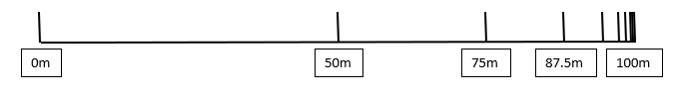
One way I like to think about infinite sums is with a race. If I run a 100m race after some time I will reach halfway, such that I am now 50m from the finish line. After an even shorter amount of time I half my remaining distance again (25m from the finish line), and so on forever: constantly halving my remaining distance as the time intervals get shorter and shorter:
The question is: will I ever finish the race if all I do it half my remaining distance over rapidly decreasing time intervals, surly I would only ever approach the finish, never to cross it? This is a paradox devised by the Greek philosopher Zeno of Elea around 450BC who said something similar about a race between Achilles and a tortoise. However, if it was true everyone would only ever approach their destination never to get there. What’s happening here? Maths has an answer: If we rephrase the question in terms of distance until the finish is reached as a fraction of the whole race, we get a sum like this:
$$\frac{1}{2}+\frac{1}{4}+\frac{1}{8}+\frac{1}{16}+\frac{1}{32}+\frac{1}{64}+…= ?$$

With the next power of 2 in the denominator and the sequence continued infinitely the sum, as we have seen, will approach and get closer and closer to 1.
However, in the context of infinite sums, to approach and to equal are the same thing and so we reach the end of the race. This is the essence of Infinite Sums: a non-random sequence repeated forever with every term summed together. There are two flavours of infinite sums: convergent and divergent:
- Convergent, a convergent infinite sum will converge to some number or upper limit no matter how many iterations of the sequence are summed:
$$1+\frac{1}{4}+\frac{1}{9}+\frac{1}{16}+\frac{1}{25}+\frac{1}{36}…=\frac{π^{2}}{6}←Convergent (1)$$

- Divergent, on the other hand, will race off to infinity and never converge to a point:
$$1+\frac{1}{2}+\frac{1}{3}+\frac{1}{4}+\frac{1}{5}+\frac{1}{6}+\frac{1}{7}+…←Divergent (2)$$
$$1+2+3+4+5+6…←Divergent (3)$$
Interestingly, the infinite sum (2) will diverge and race off to infinity despite that fact that, like infinite sum (1), each term keeps gets smaller and smaller.
- A Brief Introduction to Complex Numbers
If you were to draw a number line all your favourite numbers would be there: 0, 1, √2, -π/2…
In fact, all numbers: natural, integer, rational, irrational can be represented on a number line and come under the umbrella term: “real” numbers.
You may remember that a negative multiplied by another negative with result in a positive (e.g., both 3 x 3 and -3 x -3 are equal to 9) and so the square root of any positive number will have two parts: one positive, one negative, (e.g., going backwards: √9 can be equal to both 3 and -3, so we say √9 = ±3). However, since the square root of any positive number must lay on either side of 0 on our number line, this leaves no space for the square root of negatives, numbers such as √-1:
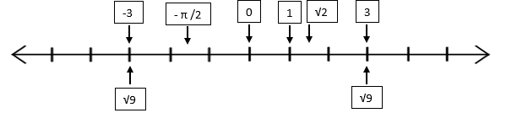

√-1

Its aparent that the square roots of negatives are not part of our collection of real numbers, despite this, mathmaticians have found it increasing useful to not ignore this different type of number but instead adjoin them perpendicular to our existing number line and dub them “imaginary” numbers. Although the name imaginary can mislead, they are just as real as the real numbers and are merely an extension of our number line into 2 dimentions.
Just as 1 is used as the base unit on the real number line (e.g., 3 can be written as 3 x 1), √-1 is the unit of the imaginary number line (e.g., √-9 can we written as √9 x √-1 or just 3√-1). For clarity, instead of writing √-1 to denote a complex number the letter “i” is used instead.

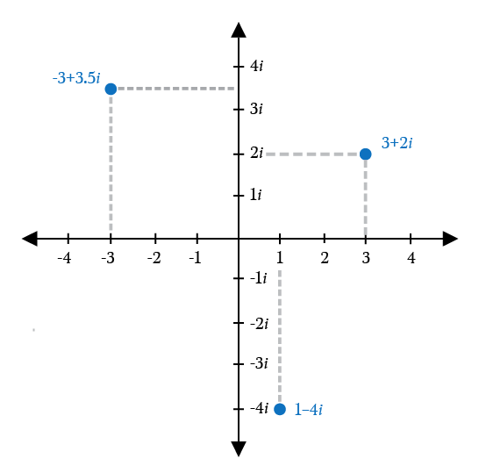
A number is called “complex” if it has both real and imaginary parts (e.g., 3 + 2i is a complex number) and is always written in the form “a + bi” where “a” is the real part and “bi” is the imaginary (complex numbers may look like 2 separate numbers but in reality, they represent a single number which is neither purely real or imaginary). All real, imaginary and complex numbers can be represented on the “complex plain” which is the 2-dimensional space created by adjoining the real and complex number lines perpendicularly, as mentioned before:
The Complex Plain
The Zeta Function
The Riemann Hypothesis has its foundations in an infinite sum called the Zeta Function (denoted by the greek letter “zeta” – ζ) which can take real and complex values:
$$ζ\left(s\right)=\frac{1}{1^{s}}+\frac{1}{2^{s}}+\frac{1}{3^{s}}+\frac{1}{4^{s}}+\frac{1}{5^{s}}+…(where the input \text{"s" }\text{can be complex})$$
For example, with an s value of 2 the Zeta Function will become sum (1) and, as mentioned before, converge to: $\frac{π^{2}}{6}$. On the other hand, if s = 1 is taken it will become sum (2) and diverge. In fact, The Zeta Function will diverge for all numbers with a real part of less than 1 (the ”a” in a + bi), including 1 itself. If we take all possible real and complex values in the complex plane which converge to a limit (e.g., all numbers that have a real part greater than 1) and plug them into the Zeta Function, then finally map those new points onto a different complex plane we would get something like this Fig.1:
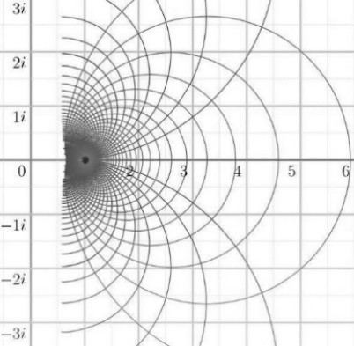
As you can see there is a “singularity” at s = 1 where the Zeta Function does not converge, also notice that the graph continues in some places past 1, this is merely a byproduct of plugging in complex numbers. However, perhaps more interestingly, the pattern appears to be cut off and incomplete,
Fig.1

Analytic Continuation
This is where Reimann’s genius is really shown: he wasn’t content with a “half finished” function but realised that this complex Zeta Function fell into the category of “holomorphic”. This meant that the Zeta Function could be subjugated to a method called “Analytic Continution”, a very difficult part of Complex Analysis for which Riemann was one of the founders. Although Analytic Continuation of $ζ\left(s\right)$ (shorthand for “Zeta Function”) transforms it:
$$From: ζ\left(s\right)=\frac{1}{1^{s}}+\frac{1}{2^{s}}+\frac{1}{3^{s}}+\frac{1}{4^{s}}+\frac{1}{5^{s}}+… To: ζ\left(s\right)=2^{s}π^{s-1}sin\left(\frac{πs}{2}\right)Γ(1-s)ζ\left(1-s\right)$$
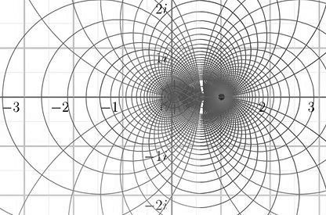
It can be undertood quite intuitivly as simply the logical continuation of our half completed graph into Fig.2(a continuation of the function outside the domain in which it was defined). Although this new Zeta Function, that now bears Reimann’s name, looks quite different from out previous one it would be mathmatically sound to say they are equal to one another (notice: the only place this new $ζ\left(s\right)$ doesn’t converge is the “singularity” at 1).
Fig.2
The Problem
Despite the Riemann$ζ\left(s\right)$ having many interesting properties, such as if s = -1 is taken the function will return $-\frac{1}{12}$ , this is peculiar as pluggin s = -1 into our original $ζ\left(s\right)$ it will simplify to divergent sum (3). This means that is now mathmatically sound to equate 1 + 2 + 3 + 4… (on forever) and $-\frac{1}{12}$ which appears to be total nonsense, however, mathmaticians postulate that there may be a deep unknown connection between the sum of all positive whole numbers and negative one twelth. Perhaps even more curious (if you can believe it) is the values for s which the Riemann Zeta Function return 0: there are in fact 2 reigons of complex input which $ζ\left(s\right)$ returns 0.
- If s is taken to be any negative even number (e.g., -2, -4, -6…) the function will return 0, these are in the same vain as if s = -1:
$$(s=-2) ζ\left(-2\right)=\frac{1}{1^{-2}}+\frac{1}{2^{-2}}+\frac{1}{3^{-2}}+…=1^{2}+2^{2}+3^{2}+…=1+4+9+…=0$$
- If the real part of s is taken to be $\frac{1}{2}$, there are certain values for the imaginary part of s which return 0 (e.g., $\frac{1}{2}+14.134i$, $\frac{1}{2}+21.022i$, $\frac{1}{2}+25.010i$ ).
The $ζ\left(s\right)=0$s from the region 1 are called the “trival zeros” as their pattern is easy to identify (every negative even number), while the $ζ\left(s\right)=0$s from the region 2 are named the “non trivial zeros”, this is because despite every one having a a real part of $\frac{1}{2}$ the distribution of their imaginary part appears to be random. Both regions are proved to be infinite but it can be shown that the position of the non trivial zeros on the line$\frac{1}{2}+bi$ (where b is an imginary value which returns$ζ\left(s\right)=0$) are connected to prime numbers. Knowing this, we now in effect have a formula to detect and find the spread of primes, something of a holy grail ever since the dawn of maths: to crack a seemingly random infinite code. However, this method falls apart as soon as one of these non trivial zeros lays off the line $\frac{1}{2}+bi$ and, as such, has a real part that is not $\frac{1}{2}$. This is what Riemann hypothesised: That all the non trivial zeros for his $ζ\left(s\right)$ are on the line
$\frac{1}{2}+bi$.
To solve the Riemann Hypothesis you must either: Prove that all non trivial zeros lie on the line $\frac{1}{2}+bi$ or, perhaps the “easier” method, to find a point that doesn’t lie on the line but where $ζ\left(s\right)$ is still 0. If you manage to do either one of those not only would you be solving one of the most difficult problems ever conceived but also, as mentioned before,you would complete all the other Theorems that still rely upon the unproven Riemann Hypothesis and get $1,000,000 to round it all off.
By Ben Kolicic

