The truth about the Fibonacci sequence.
In 1202, an Italian mathematician called Leonardo Pisano Bigollo published a book called Liber Abaci, or ‘Book of Calculations’, in which he helped introduce Arabic numerals to the Western world. In this book, Bigollo also described a sequence with the aid of an analogy to do with breeding rabbits. If you start with 2 rabbits, they breed to produce a third, then these three will become five, then eight and so on. This creates a sequence where the next number is always the sum of the last two. Leonardo Pisano Bigollo was also known as Leonardo Bonacci and he was nicknamed Fibonacci, short for filius Bonacci (son of Bonacci in Latin), which is where the name for the well-known Fibonacci sequence comes from.
The first 2 numbers in the classic Fibonacci sequence are of course: 1, 1. The next term in the sequence is given by adding the two previous terms. If we let n equal natural numbers, not including 1, then this can be summarized by this statement:
$n^{th}$ term = $({n-1)}^{th}$term + $({n-2)}^{th}$term.
Therefore the first 10 Fibonacci numbers are as follows:
1, 1, 2, 3, 5, 8, 13, 21, 34, 55, …
If we go further back in time, there is evidence that people in Ancient Greece and Ancient India knew about the Fibonacci numbers. The ancient Indian mathematician and author Pingala is believed to have developed the concept as early as the third century BC.
One thing we can do with these numbers is draw squares with side lengths that equate to the numbers in the sequence.
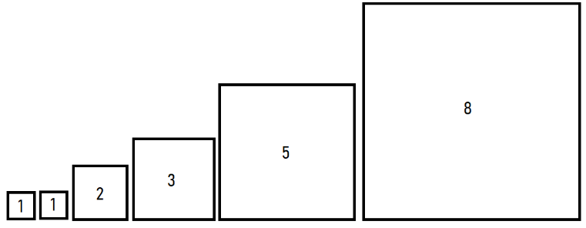
Then set them up side by side in a spiral pattern, inside a rectangle known as the golden rectangle, which looks something like this:
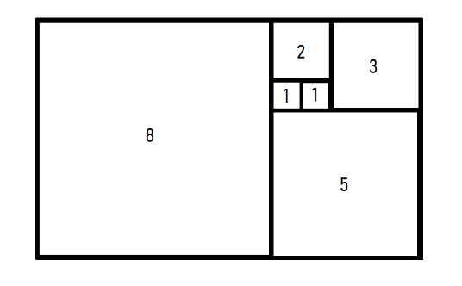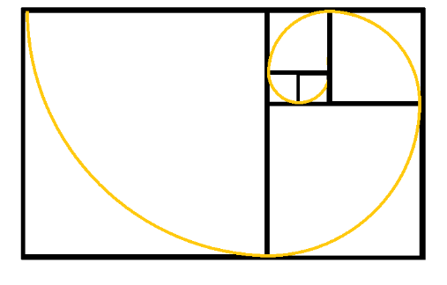
Another thing we can do is divide every term, apart from the first, by the previous term. Essentially, $n^{th}$term ÷ $({n-1)}^{th}$term:
1 ÷ 1 = 1
2 ÷ 1 = 2
3 ÷ 2 = 1.5
5 ÷ 3 = 1.66666…
8 ÷ 5 = 1.6
13 ÷ 8 = 1.625
21 ÷ 13 = 1.615384615…
34 ÷ 21 = 1.619047619…
55 ÷ 34 = 1.617647059…
As we can see, as n increases towards infinity, the answer of dividing the nth term by the previous term approaches one specific value. This value is called ‘The Golden Ratio’, or the golden section, and was named by a German mathematician called Martin Ohm in 1835. The golden ratio was originally designated the symbol of $φ$ (phi) in Ancient Greece and was written about by Euclid in around 300 BC. $φ$ equates to around 1.618 or exactly $\frac{1+\sqrt{5}}{2}$.
Starting the sequence with 1, 1 isn’t the only way to get the golden ratio between the terms in the sequence. In fact the first two terms can be any two integers, except 0 and 0.
Example: -4 , -7, -11, -18, -29, -47, -76, -123, -199, -322, …
-332 ÷ -199 = 1.618090452…
As previously stated the golden ratio ($φ$) is equal to $\frac{1+\sqrt{5}}{2}.$ If you square that expression you get $\frac{{(1+\sqrt{5)}}^{2}}{2^{2}}$. This simplifies to $\frac{6+2\sqrt{5}}{4}$ which is equal to $\frac{1+\sqrt{5}}{2}$ + 1. Therefore: $φ^{2}$= $φ+1$, and $φ$ is the only number that, when squared, is equal to 1 added to itself.
Another interesting thing about $φ$ is that it can also be written as:
$φ$= 1$+\frac{1}{φ}$
Therefore we can write it as a continued fraction like this:
$φ$ = 1 + $\frac{1}{1+\frac{1}{1+\frac{1}{1+\frac{1}{1+…}}}}$
The Golden ratio is less of a ratio and more of an example of an irrational number because similarly to $π$ and $\sqrt{2}$ , it can’t be written as a fraction where the denominator and the numerator are both integers. However, it is seen as even more irrational than$π$ and $\sqrt{2 }$, because its continued fraction consists of only 1’s whereas the continued fraction for $\sqrt{2 }$ has 1’s and 2’s, while the numbers present in the continued fraction for $π$ fluctuate a lot:
$\sqrt{2}$ = 1 + $\frac{1}{2+\frac{1}{2+\frac{1}{2+\frac{1}{2+…}}}}$ and $π$ = 3+ $\frac{1}{7+\frac{1}{15+\frac{1}{1+\frac{1}{292+…}}}}$
The fact that the golden ratio is so irrational is significant because the golden spiral is seen a lot in nature, and there is a reason for this. If we take the centre of the flower and place a seed and then repeatedly rotate a certain fraction of the circle before placing the next seed, what fraction of the circle is the best choice if the flower wants to maximise the area? Below are some examples using various fractions and on the right is an sketch using the golden ratio:
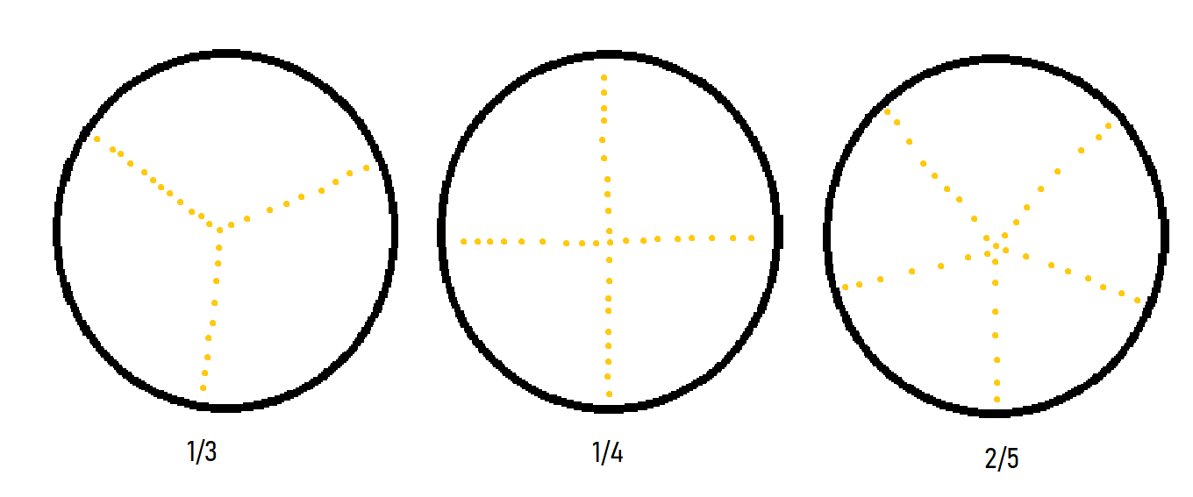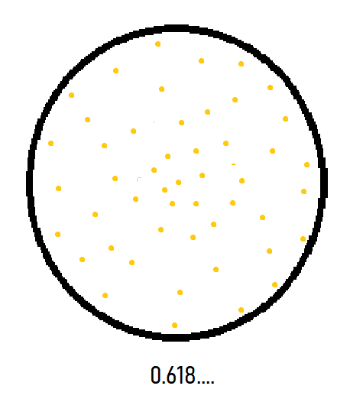
Below is an example using another irrational number, 1/$π$, compared with the golden ratio. However, since $π$ can be rounded down to 3, 1/$π$ is approximately a third. Therefore the arrangement appears to have 3 spokes.
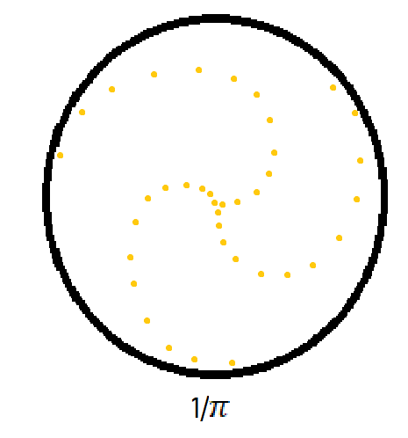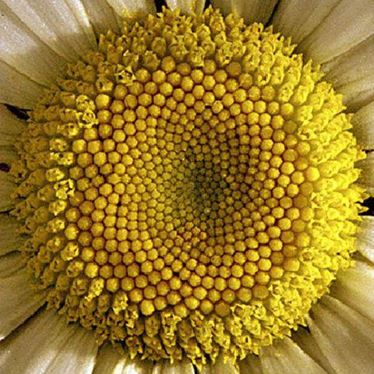
Daisy: picture from CNET article and Institute of Science in Society

The reason we see the golden spiral in seed arrangements on flowers is because plants need to arrange their seeds efficiently in order to maximise the area on their flower, pine cone or fruit.
You may have seen images of nautilus shells, spiral galaxies, hurricanes, architecture and various other things with the golden spiral drawn on top of them. However, most often than the not, a substantial connection between the golden ratio and these objects is dubious. For example the spiral galaxy and the nautilus shell:
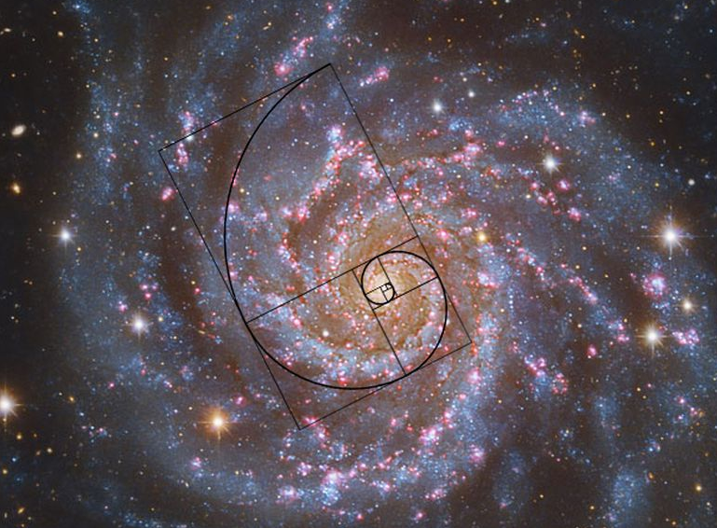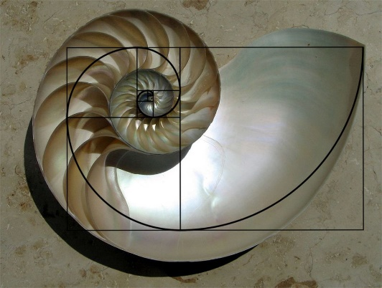
Nautilus Shell: picture from CNET article and Chris 73 / Wikimedia Commons, CC BY-SA 3.0

Spiral Galaxy: picture from CNET article and NASA/CBSI

The nautilus shell is probably what most people think of when they think of the golden ratio. However, the ratio of the spiral is actually averages around 1.587 instead of 1.618, which is close but clearly not the same.
The golden ratio is also known as the divine proportion or golden section. It has been theorised that the closer the proportions of your body are to the golden ratio, the more beautiful you are or that the golden spiral has some kind of uniquely aesthetically pleasing properties. It is debated whether Phidias intentionally used the golden section when designing the Parthenon because he believed it made it more aesthetically appealing. Salvador Dalí is an artist who purposefully used the golden ratio to paint his ‘Sacrament of the Last Supper’.
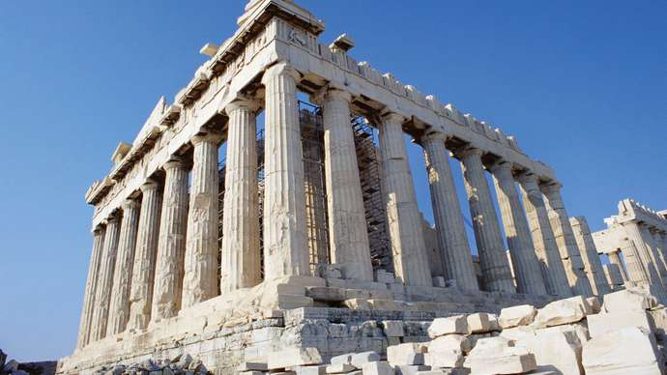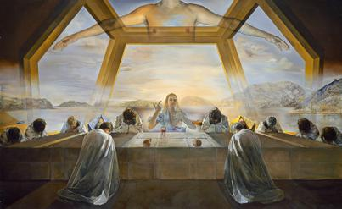
The Parthenon, Athens, Greece.
© Corbis
‘Sacrament of the Last Supper’ by Salvador Dalí, 1955

Is there something divine or aesthetically pleasing about the golden ratio and by extension the Fibonacci sequence? Perhaps not. However, the fact that such an intricate geometric pattern can arise from such a simple sequence, and can be emulated in some way by both seeds and stars, shows that there is beauty to be found in mathematics.

Bibliography:
Fibonacci Sequence - MathsIsFun website
Nature's patterns: Golden spirals and branching fractals - CNET article
What Is the Fibonacci Sequence? - Live Science
The Golden Ratio (why it is so irrational) - Numberphile
The Fibonacci Sequence: Nature's Code - The Sci Show
Mathigon - Timeline of Mathematics
History of the Golden ratio - The Golden Number
The Parthenon and Phi, the Golden Ratio - The Golden Number
Is the Nautilus shell spiral a golden spiral? - The Golden Number
Carlson, Stephan C.. "Golden ratio". Encyclopedia Britannica, 14 Nov. 2019, https://www.britannica.com/science/golden-ratio. Accessed 25 March 2021.
Pictures:
Britannica, The Editors of Encyclopaedia. "Parthenon". Encyclopedia Britannica, 26 Mar. 2020, https://www.britannica.com/topic/Parthenon. Accessed 25 March 2021.
Nature's patterns: Golden spirals and branching fractals - CNET article
The Sacrament of the Last Supper by Salvador Dalí - Wikipedia

