Wallpapers are wildly underrated.

You see, in maths there are, officially, only seventeen types of wallpapers. Of course, there are many different fabrics, motifs, and so on, but in terms of symmetry, there are only seventeen unique wallpaper designs- seventeen ways to present a pattern. No more, and no fewer.

So, how can we be so sure that there are exactly seventeen different wallpaper types? And why seventeen? It seems like such a strange number, but this can be proved by using topology.

Topology is a branch of maths based on the idea that any two objects are the same if you can deform one (twist, pull, stretch, etc.) in order to reach the other. One of the only limitations is that you cannot cut or glue the shape, so the number of holes must remain constant. Other than that, everything is fair game. A common example of this is a mug and a doughnut:
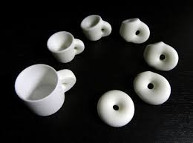
(Shapeways)
Both have one hole and so can be stretched to form one another. So from a topologist’s point of view a mug and a doughnut are the same thing!

This sounds very abstract, but it actually has lots of applications in real-life problems. One of the main benefits of using topology to solve problems as opposed to something more concrete (say geometry or trigonometry), is the fact that abstraction is so easy- dissecting problems and removing unimportant details is very easily done and so you can focus on the problem at hand. As well as this, simplifying shapes into the number of holes they have makes calculations involving higher-dimensional shapes much easier, because many of them will be considered identical.

Topology has been used in subjects such as Biology, Computer Science, Physics, etc. to solve what would otherwise be really complicated problems.

So, what does this have to do with our wallpaper? Well, the proof for why there are exactly seventeen wallpaper symmetries lies in a topological shape known as the orbifold. The orbifold is a basic, general version of a manifold. To explain what a manifold is, Euclidean geometry must be explored.

(If anyone’s interested, this is what Euclid looked like:

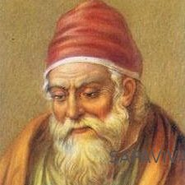

(sapaviva)

Consider a circle.

At every point on this circle, imagine that there is a small piece of information being represented. Manifolds follow this general idea.

For example, on the doughnut/mug from the picture above (I should note that a doughnut is called a torus in topological terms), imagine ‘zooming in’ to a small, small part of its surface area. In this region, there are certain pieces of information present. Think of it as a small collection of numbers or values if that helps.

The act of relaying information from the surface of a shape is called ‘charting’. This is where a piece of information that is in a lower dimension than the shape it is on is obtained, which is a very useful technique to use in maths because it makes abstraction easier.

An example of lower-dimensional information that can be obtained is for example the coordinates of a point on a square face of a cube:

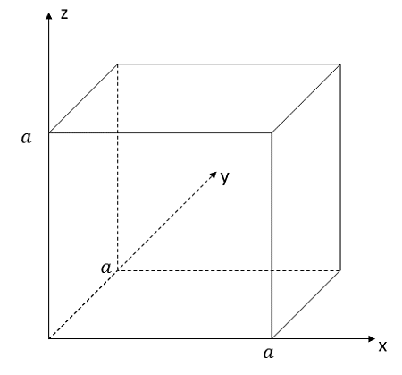
(Study.com)

There are two pieces of information present at every point on a square, mathematically speaking- the x and y coordinates. No matter if this square was one of the faces (faces are two-dimensional shapes present on a higher dimensional shape’s surface- cubes have six squares as their faces) of a cube or not, only the two of the x, y and z coordinates would need to be considered if only one of the faces of the square was being focused on. If this is getting a little too theoretical, feel free to scroll back up to the cube and focus on one of the faces to confirm this for yourself.

So, when really zoomed in, you don’t gain all of the higher dimensional information (the x,y and z coordinates), but rather only the lower dimensional information (for example, the x and y coordinates).
This is because a change in the z coordinates means that you are moving up and down, which you wouldn’t do on a flat surface.

In terms of appearance, any shape can be a manifold so long as it can be charted to. Another example is the world: it’s a roughly spherical shape, and when zoomed in it contains information such as coordinates, topography (not to be confused with topology), and so on. In fact, the flat maps that we have of smaller regions of Earth are another good example: when zoomed in, we can reduce the shape to a flat one and only focus on the information being stored there. This is because on very small distances, a large spherical object such as the Earth approximates a flat surface.

This storing of information at points is called Euclidean geometry, and manifolds tend to adhere to these rules and observations at very close distances. If a shape can be charted to, then it belongs in the realm of Euclidean geometry.

An orbifold is a general version of a manifold. Every manifold contains a certain number of edges, vertices, and two-dimensional shapes as its faces. On these faces, there are, once again, pieces of information. This is what comes up when you google “manifold”, but you can imagine any higher-dimensional shape.
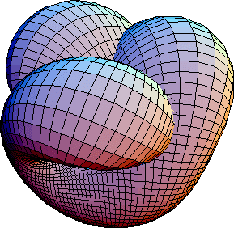

(wikipedia)

Anyways, this proves my point of higher dimensional shapes containing lower-dimensional information on their surface: there are two-dimensional shapes present as faces- represented here by quadrilaterals in the picture- when really zoomed in. However, when you zoom out, you can see that there are other things you miss out on when reducing the manifold to the sum of its parts, such as the angles between the faces, and the general curvature of the shape. This shows how the shapes only adhere to Euclidean geometry at close distances, because at large distances the information obtained is no longer a lower dimension to the overall dimension of the shape.

So, on our manifold, there are pieces of information, this time addressing the different operations (ways of moving the design) that can be carried out in the wallpaper. These operations are given certain values in the form of fractions and are then combined into an equation with all the other operations being carried out on that specific wallpaper. These operations have to end up equalling two.

The different translations have to equal two because the value given to the structure of the manifold, called the Euler Characteristic, is two. The two values are subtracted from one another and have to equal zero, because any other value that arises from combining them means more dimensions are needed to print the wallpaper.

The number of faces, edges and vertices also have to be combined in an equation to find whether the shape is valid or not as a piece of wallpaper. This is why a manifold is considered when trying to solve the problem; we can store geometrical data on it as well as translational. This equation is:

Number of corners - (number of edges + number of faces).

In order for this manifold to be accepted as a representation of wallpaper, this must be zero, otherwise the design does not work on flat walls.

So, with both of these limitations on possible translations and manifold geometry, there are only seventeen combinations that arise in a unique pattern of designs. Which is quite astonishing if you think about it: there are only seventeen ways of orienting any design on any two-dimensional surface!

In terms of the translations, there are four unique ones available to the wallpaper design: Reflection, Translation, Glide Reflection, and Rotation. Glide Reflection is when a shape is reflected before being moved a certain distance. These are called Isometries of the Euclidean Plane, and describe transformations that are possible that still preserve the shape and length of shapes.

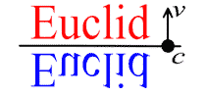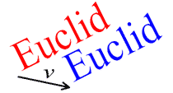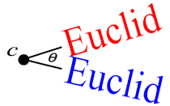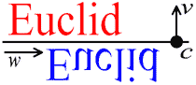
From top left to bottom right: Reflection, Translation, Rotation, Glide Reflection (wikipedia)

It’s the combination of these that make up every single wallpaper design ever made. Isn’t that cool?

Sources:

Wallpaper group
Manifolds #1 - Introducing Manifolds
Manifolds: A Gentle Introduction
Intro to Topology
Manifold | mathematics
https://en.wikipedia.org/wiki/Euclidean_plane_isometry#Reflections
Unit 3.7 - Glide Planes and Wallpaper Groups
Rigid Motions of the Plane
Topological string theory
Manifold -- from Wolfram MathWorld
Charting a Manifold
Euler characteristic

(Many thanks to all of my non-mathsy friends and family members who have given great input!)

