What makes the double pendulum chaotic?
You might often hear about the phenomenon of mathematical chaos, often synonymous with unpredictability and randomness (although we’ll see why this isn’t quite correct). The double pendulum is a neat illustration of this idea. Given certain initial conditions (the starting angles between the pendulum rods), the system will react erratically and wildly to even the slightest perturbation of these starting parameters. In this article, we’ll investigate the mathematical idea of chaos, and how exactly it relates to the double pendulum problem.
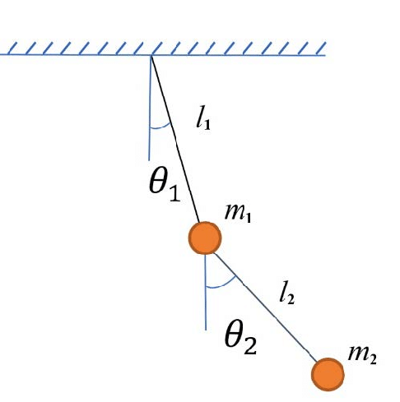
The diagram below gives a good visual of what exactly we’re dealing with.

We’ll consider mass and the lengths to be constant and (as always) air resistance and friction will be ignored. In addition, we will consider the rods to be massless.
Many of you will recognise this setup and will, perhaps, be familiar with some of the wild trajectories $m_{2}$ traces out.
As you can see, even the slightest difference in starting conditions, shown in Fig. 2, can lead to wildly different trajectories later on, for example in Fig. 3.

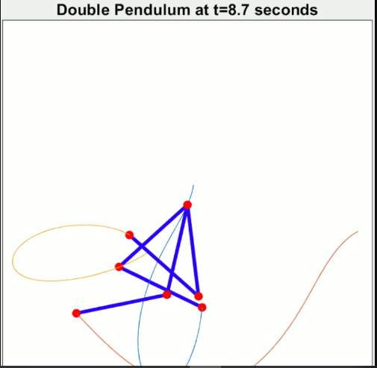
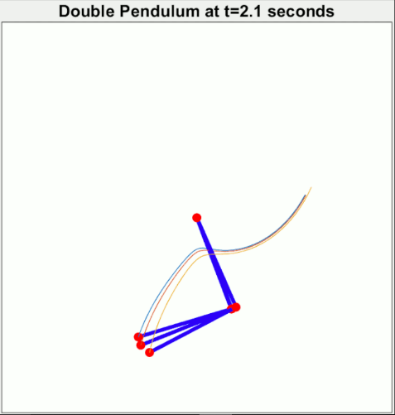
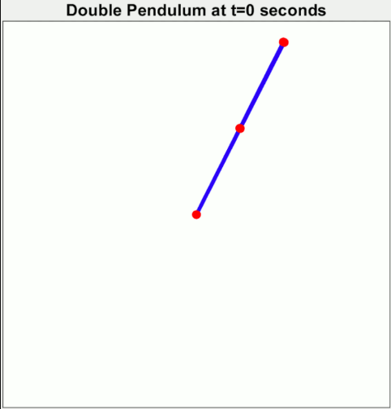
Fig. 1

Fig. 2 Fig. 3 Fig. 4
Now that we understand the setup of the problem, we need to formulate it mathematically. In order to give this mechanical system a rigourous treatment, we need to introduce Lagragian mechanics.
Mechanics as a whole is the mathematical study of motion. GCSE physics acquaints us with Newtonian mechanics, governed by Newton’s law’s of motion, the most important of which, the 2nd law, says that force is the derivative with respect to time of momentum, or, in a closed system (i.e. mass is constant and energy is conserved):
$$F= \frac{d}{dt}p=m\frac{dv}{dt}=ma$$
Where F is the force, p momentum, m mass and a acceleration. So far so familiar.
In mechanics, the idea of time derivative is so important is has its own notation:
$$\frac{dx}{dt}=\dot{x }, \frac{d\dot{x}}{dt}= \frac{d^{2}x}{dt^{2}}=\ddot{x}$$
Lagrangian mechanics is based on the principle of stationary action and says that a certain equation in terms of something called the Lagrangian holds true.
The Lagrangian, $L$, is the total kinetic energy of the system, minus the potential energy:
$$L=T-U$$
This seemingly innocuous quantity satifies a very useful equation:
$$\begin{aligned}\frac{d}{dt}\frac{∂L}{∂{\dot{q}}_{i}}=\frac{∂L}{∂q_{i}} \#\left(1\right)\end{aligned}$$

This seems very complicated, but breaking it down makes it clearer. We know what $L$ is and what $\frac{d}{dt}$ means, and $q_{i}$ is just one of our parameters. As we will see, this equation holds for all our parameters (in our case, $θ_{1}$and $θ_{2}$). Finally, the notation $\frac{∂y}{∂x}$is the partial derivative of $y$ with respect to $x$. To give an example: if $y=4x^{2}+xt+t^{2}$ then: $\frac{∂y}{∂x}=8x+t$. Basically, to take a partial derivative, think of everything which isn’t $x$ as a constant, and differentiate normally. This means, when we come to applying this equation we will be differentiating with respect to different variables on each side, and many of the terms will be constants with respect to that variable, so differentiate away.
Therefore, if the above equation is true, we can begin to derive equations describing how the double pendulum will move. Specifically, we will arrive at a differential equation, an equation involving $θ_{i}, {\dot{θ}}_{i}$, and ${\ddot{θ}}_{i}$, the angle, angular velocity and angular acceleration of mass $m_{i}$ respectively.
Firstly, let’s think about the kinetic energy:
$$T=\frac{1}{2}mv^{2}$$
But $v= \frac{dr}{dt}= \dot{r}$ where $r$ is the position of each of the swinging masses. Since each mass is moving in two dimensions, we can consider $r$ to be the vector $\left(\begin{matrix}x\left(t\right) \\ y\left(t\right)\end{matrix}\right)$ where $x\left(t\right), y\left(t\right)$ describe the positions of the particles at time $t$. For simplicity, we’ll refer to them as $x,y$.
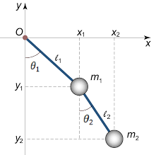
Looking at Fig. 5, it is clear, by a little trigonometry, that:
$$x_{1}=l_{1}\sin\left(θ_{1}\right)$$
$$y_{1}=-l_{1 }cos(θ_{1})$$
$$x_{2}=l_{1}\sin\left(θ_{1}\right)+l_{2}\sin\left(θ_{2}\right)$$
$$y_{2}=-l_{1}\cos\left(θ_{1}\right)-l_{2} cos(θ_{2})$$
The kinetic energy of $m_{1}$will be given by $T_{1}= \frac{1}{2}m_{1}({\dot{x}}_{1}^{2}+{\dot{y}}_{1}^{2})$.
Fig. 5 Likewise, the kinetic energy of $m_{2}$ is $T_{2}= \frac{1}{2}m_{2}({\dot{x}}_{2}^{2}+{\dot{y}}_{2}^{2})$.
Differentiating each of the variables with respect to time, while remembering $θ_{1},θ_{2}= θ_{1}\left(t\right), θ_{2}(t)$ and are dependent on time so we must use the chain rule, gives:
$$\frac{1}{2}m_{1}\left({\dot{x}}_{1}^{2}+{\dot{y}}_{1}^{2}\right)= \frac{1}{2}m_{1}\left({\left(l_{1}{\dot{θ}}_{1}cos\left(θ_{1}\right)\right)}^{2}+{\left(l_{1}{\dot{θ}}_{1}sin\left(θ_{1}\right)\right)}^{2}\right)$$
$=\frac{1}{2}m_{1}(l_{1}^{2}{\dot{θ}}_{1}^{2}(\cos^{2}{θ_{1}}+\sin^{2}{θ_{2}))= \frac{1}{2}m_{1}\left(l_{1}^{2}{\dot{θ}}_{1}^{2}\right) }$
Through the same process, we get $T_{2}= \frac{1}{2}m_{2}\left(l_{1}^{2}{\dot{θ}}_{1}^{2}+l_{2}^{2}{\dot{θ}}_{2}^{2}+2l_{1}l_{2}{\dot{θ}}_{1}{\dot{θ}}_{2}cos\left(θ_{1}-θ_{2}\right)\right)$
Taking care of the potential is much easier as the only potential energy we have in the system is gravitational potential.
$$GPE=mgh$$
$$∴U_{1}=mg\left(-y_{1}\right)=-m_{1}gl_{1}\cos\left(θ_{1}\right)$$
$$U_{2}=m_{2}g\left(-y_{2}\right)= -m_{2}gl_{1}cos\left(θ_{1}\right)-m_{2}gl_{2}\cos\left(θ_{2}\right)$$
Since $U=U_{1}+U_{2}$ and $T=T_{1}+T_{2}$:
$$L=\frac{1}{2}m_{1}l_{1}^{2}{\dot{θ}}_{1}^{2}+\frac{1}{2}m_{2}\left(l_{1}^{2}{\dot{θ}}_{1}^{2}+l_{2}^{2}{\dot{θ}}_{2}^{2}+2l_{1}l_{2}{\dot{θ}}_{1}{\dot{θ}}_{2}cos\left(θ_{1}-θ_{2}\right)\right)$$
$$+{(m}_{1}+m_{2})gl_{1}\cos\left(θ_{1}\right)+m_{2}gl_{2 }\cos\left(θ_{2}\right)$$
If we let $θ_{1}=q_{i}$ in equation $\left(1\right)$ then we get:
$$LHS=\frac{d}{dt}\frac{∂L}{∂\dot{θ}}=\frac{d}{dt}\left(m_{1}l_{1}^{2}{\dot{θ}}_{1}+m_{2}l_{1}^{2}{\dot{θ}}_{1}+m_{2}l_{1}l_{2}{\dot{θ}}_{2}\cos\left(θ_{1}-θ_{2}\right)\right)=\left(m_{1}+m_{2}\right)l_{1}^{2}{\ddot{θ}}_{1}+m_{2}{l_{1}l}_{2}\left(\frac{d}{dt} {\dot{θ}}_{2}(t)\cos\left(θ_{1}(t)-θ_{2}(t)\right)\right)$$
Now, by the chain rule and product rule, we get:
$$LHS= \left(m_{1}+m_{2}\right)l_{1}^{2}{\ddot{θ}}_{1}+m_{2}{l_{1}l}_{2}\left({\ddot{θ}}_{2}\cos\left(θ_{1}-θ_{2}\right)-{\dot{θ}}_{2}({\dot{θ}}_{1}-{\dot{θ}}_{2})sin⁡(θ_{1}-θ_{2})\right)$$
Differentiating the RHS with respect to $θ_{1}$ gives:
$$RHS= -m_{2}l_{1}l_{2}{\dot{θ}}_{1}{\dot{θ}}_{2}\sin\left(θ_{1}-θ_{2}\right)-\left(m_{1}+m_{2}\right)gl_{1}\sin\left(θ_{1}\right)$$
Setting these equal, rearranging, cancelling terms and dividing through by $l_{1}$ gives finally:
$$\begin{aligned}\left(m_{1}+m_{2}\right)l_{1}{\ddot{θ}}_{1}+m_{2}l_{2}{\ddot{θ}}_{2}\cos\left(θ_{1}-θ_{2}\right)+m_{2}l_{2}{\dot{θ}}_{2}^{2}\sin\left(θ_{1}-θ_{2}\right)+\left(m_{1}+m_{2}\right)g\sin\left(θ_{1}\right)=0 \#\left(2\right)\end{aligned}$$
Doing the same for $q_{i}=θ_{2}$ and dividing the end product through by $m_{2}l_{2}$ yields:
$$\begin{aligned}l_{2}{\ddot{θ}}_{2}+l_{1}{\ddot{θ}}_{1}\cos\left(θ_{1}-θ_{2}\right)-l_{1}{\dot{θ}}_{1}^{2}\sin\left(θ_{1}-θ_{2}\right)+g\sin\left(θ_{2}\right)=0 \#\left(3\right)\end{aligned}$$
At the end of all this we are left with two equations of motion. These are both non-linear second order differential equations in two variables.
Given certain initial conditions, the solutions to these equations will be functions themselves, namely the functions $θ_{1}=f\left(t\right), θ_{2}=g\left(t\right)$ which satisfy the above relationships between their derivatives.
To discover why this system is chaotic, we need to consider what chaos means. A chaotic behaviour is not one which is random, because randomness would imply this system is non-deterministic. However, the double pendulum is unpredictable, as any attempts to analytically solve equations $(2)$ and $(3)$ will fail, so obtaining a closed form for the angles at any desired point in time is impossible. This means we have to resort to approximations and numerical methods to extract a solution.
However, due to the non-linearity of these differential equations, which occurs because of the presence of sine, cosine and squared terms, any uncertainty in the initial values of the system will be compounded exponentially.
In conclusion, having derived the equations of motion of the double pendulum, we see that the chaotic behaviour it exhibits is reflected in the complexity of the differential equations describing it, and its chaotic behaviour is explained as a consequence of the non-linearity of this dynamical system.

You can’t use $F=ma$ when you get to higher speeds as a consequence of special relativity, but force being the time derivative of momentum remains meaningful.
Note that if we were to add these two quantities, we would have the total energy of the system.
I won’t explain how this follows from the principle of stationary action because it’s rather complicated.
It is.
Note that the $y$ direction is negative. This will not affect the calculations.
I’m assuming, a little unfairly, that if you’ve followed this far you know the chain rule. If not, it gives you a way to differentiate $f(g\left(x\right))$ and results in $\frac{d}{dx}f\left(g\left(x\right)\right)=f^{'}\left(g\left(x\right)\right)g^{'}\left(x\right)$.
Using the identities $\cos^{2}{x+\sin^{2}{x}}=1$, $cos\left(a\right) cos\left(b\right)+sin\left(a\right)\sin\left(b\right)=\cos\left(a-b\right)$ and $\sin\left(a\right)\cos\left(b\right)-\sin\left(b\right)\cos\left(a\right)=sin⁡(a-b)$
${\left(f\left(x\right)g\left(x\right)\right)}^{'}=f\left(x\right)g^{'}\left(x\right)+g\left(x\right)f^{'}\left(x\right)$
As we can see, the system’s prior behaviour will completely determine its later behaviour, making it deterministic.
This is made more rigorous by things called Lyapunov exponents.

