.Zero: Spaghetti in a black plate

Maths is the language of the universe.
A man walking down the street sees a rabbit wearing a shirt with such a print and converses insolently with it:
“Excuse me! How can I ask the universe what she means giving my daughter a maths problem with division by zero which I cannot work out? Does she try to insult me, claiming I am only a foolish organism that cannot comprehend her?”
The rabbit blinks - a deep blink that shatters everything visible. No sea of waves is seen anymore, only big ears catch something, but that something is not what the half-naked rabbit usually understands.
“Also, recently I have been experiencing some troubles with the black plate my wife gave me for our anniversary. Every time I attend to put food on it, something weird happens. There is a certain point where, my son calls it “event horizon”, my food swiftly, but incrementally, turns into spaghetti and disappears into the black plate. The dog said that what is happening is similar to my daughter’s math problem. I took that old dog to the psychiatrist. I cannot even eat those spaghetti.”
The rabbit gave a puzzling look and jumped into a hole right next to him.
Indeed, it is a weird and partially inappropriate beginning of an essay. However, this is a maths essay, explaining something through my lenses. What they see in maths is an imaginary world, like a fairy tale, where everyone is free to arrange the events according to their wishes. Here you can usually find an answer to the problem you work on if the answer is findable. Mathematics is a realm that manages uncertainty and provides us with a relatively coherent picture of the world around us. The little story I have made up is indeed, strange, but Maths is strange too. That is why it is quite beautiful. What I am to explain is going to make you see spaghetti every time you encounter division by zero or anything black. The topic of my essay is literally nothing or everything, it depends.

The journey today is going to make its way through the explanation why we cannot divide by zero. Limits and graphs are going to be used for visual elucidation. Then comes a rather puzzling concept in our universe - black holes. They are going to be the brilliant idea that division by zero resembles. What really happens when we divide by zero and why we see no solution? The answer lies, in my opinion, in spaghettification.

In the first place, we shall explain why we cannot divide by zero. But in the zero place, we must ask what division is exactly. Your intuitive mind will immediately come up with an example. For instance:
6÷3 = 2
Why is that true? One can quickly say that 3×2 = 6. That is a perfectly sound argument for proving the point. However, if we were to be a bit more fastidious, we would say that 6÷3 = 2 is right because
6-2= 4 → 4-2= 2 → 2-2=0
What we is see here is nothing more than a repeated substraction which leads to 0, more spesifically substracting 3 times. The next step will take forever to be made. If we try 1÷0, we should substract n times zero from 1 until we arrive at 0.
1-0-0-0-0-0-0-0-0-0-0-0-0 … =
The answer for n, therefore, is ∞ (infinity) - 1÷0= ∞. Where is the problem one might ask? It doesn’t look precarious or indeed very complicated. Maths has a far more convoluted spectrums. What should one be worried about then? First of all, 1÷0= ∞ cannot be stated because there is no accurate answer to infinity. ∞ is not treated as a number, but rather as an idea.
Let’s take look into a slightly more comfortable world where numbers are called the number; where they are all synonyms to each other and no one worries much about what an abreviation they use.Well, almost! If $\frac{1}{0}$= ∞ was the case, we can readily say that
$$\frac{2}{0}=∞; \frac{3}{0}=∞; \frac{4}{0}=∞;\frac{5}{0}=∞;\frac{6}{0}=∞; \frac{7}{0}=∞; …$$
It does not really matter what number is chosen. The answer is always the same. Thus, if this were true, we could presume for those numbers – 1 = 2 = 3 = 4= 5 = 6 = 7= … ,and this can be right if we believe so, but it is honestly not practical. Also, as we said, infinity is not a number, but an idea. Thus, one sort of infinity is different from another. It depends whether you like green or red apples, but don’t lim yourself. Hence, we cannot say that $\frac{1}{0}$= ∞, because if we were to try, mathematics will not make any sense. Infinity cannot be the answer, beacause we don’t understand it.
If we have no actual definition of ∞ then, we should think of some other way to express it (It - is not a helpful option). Brilliant mathematicians have conjured up the ingenious idea of limits in order to do it.
$\lim_{n→0}{\frac{1}{n}}$ =∞
It might look rather fancy, not in the best manner, at first glance if you have never ecnountred it before. However, it is quite easy once you grasp it. As n approaches 0 ( $n→0$ ), the expression $\frac{1}{n}$ approaches ∞. It implies a never ending Tom and Jerry story of values. Were we to try to reach zero, we would go through something like that:
$$\frac{1}{0.1}=10$$
$$\frac{1}{0.01}=100$$
$$\frac{1}{0.001}=100$$
$$\frac{1}{0.0001}=1000$$
…..

Indeed, we ought to assert it is equal to infinity, because, as we get closer to 0 in the denominator, we alsmost touch it. However, it is never equal to it. The limit is something utopian; the dream of $\frac{1}{n}$ to be ∞. That is the brillintness of limits.
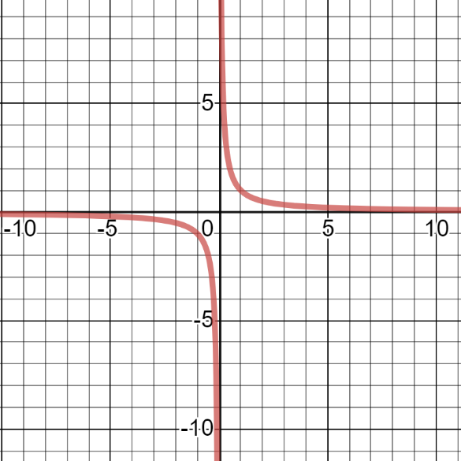
Unfortunately, the adventure does not end here. The problem stems from something else. We can aslo say that
$$\lim_{n→0}-{\frac{1}{n}}=-∞$$
$\frac{1}{n}$
$$-\frac{1}{n}$$
This is correct, because, if we calculate the numbers above, with a minus in front, we will get smaller and smaller values. The functions of $\frac{1}{n}$ and $-\frac{1}{n}$ , if drawn, suggest something rather bizzare.
Taking a closer look at the graph, it becomes clear that no agreement is present between those two functions and consequently their limits. What the graph implies is, should we move from right to left on the x axis (the positve) , trying to reach zero, our y axis grows closer and closer to infinity. That is totally correct on the premise that we came only from that direction. Our second limit, however, does not. It travels from left to right, aprroaching zero and instead of infinity, it skyrockets to minus infinity. The conclusion is that when negative or positve values for n are used, as it approaches zero, the answer is different. That is the why $\frac{1}{x}$ is labeled as undefined.. Because it does not have one single value. Of course, were one to ∞-∞ (substracting infinity from infinity), one might claim this to be equal to zero. However, as infinity is not a certain value, such proposition is to no avail.

Lets drift off seemingly light years away and explore the notion of black holes. They are, perhaps, more bizzare and purplexing than most of the things we have ever imagined, and yet they are in a great resemblence with our (one)1- ne=0 .
Fist, we are going to briefly aquaint ourselves with black holes, their formation, properties and strangeness.
They form after a very massive star dies. A star, while being luminous (a sun for simplicity), usually produce a lot of energy which fights gravity, resulting in equilibrium between those two. Thus, the star is not crushed upon itself. When it runs out of the fuel needed for fusion, gravity wins and the whole mass of the star collapses into a single point, with infinite density (singularity).

In order to escape that infinite density, one has to go beyond specific escape velocity. However, to elude the warp of space-time of a black hole, one has to go faster than the speed of light, which is, as you may know, the limit of fast when going through space. Nothing is faster than the speed of light, therefore no matter escapes from a black hole. It is like an infinitely deep chasm with some upgrades.
Consider the following equation.
$$Vesc. =\sqrt{\frac{2GM }{R}}$$
G is the gravitational constant (the value is not important now). M is the mass of of a certain object and R represents its radius. This equation calculates the velocity needed for an object to escape a gravitational pull from another object. For example, the escape velocity of Earth is around 11km/s. Think of it as reaching the floor of the Mariana Trench for a second.
Having said that, what if we give R, which is in the denominator, a value of zero? Obviously, V ecs. will be equal to infinity. Remember that infinity only exists as a limit, not as a number, therefore infinity will be the limit.
$\lim_{R→0}{\sqrt{\frac{2GM }{R}}}$ Vecsp. → ∞
There is a profound rule in nature, as it is undersood so far, that nothing can travel in space faster than the speed of light. If we substitude Vescp. for the speed of light c (3.00×10⁸m/s) and solve for R, we will get a compelling equation.
$$R=\frac{2GM}{c^{2}}$$
Why is it compelling? In order for an object to be considered a black hole, it has to have a smaller radius than the one the equation provides. Because the escape velocity of a spacetime warping object (a black hole) is greater than the speed of light, we cannot see it. Thus, it is black. Practically, anything can become a black hole in this way if sufficiently compressed. For example, the Earth would have a radius of 0.9cm if it were to be a black hole. Imagine the whole mass of the planet stuffed into a circle with a radius equall, more or less, to the distance from the top of your finger to the place where your nail ends.
Next, imagine you get near such an object (for the analogy we are using only stellar mass black holes). What would happen to you if you fell in and you are not Matthew McConaughey ? Here arrive the spaghetti in a black plate.
As you approach the event horizon of a stellar mass black hole(the place of no return), the gravity on your feet will be a million times stronger compared to your upper body (you should train legs). This in turn will make your stretch like a spaghetto; all of your muscles, skin, hair(finaly you will resemble Rapunzel for a moment). You are actually going to be a thin long spaghetto, killometres long, in the event horizon of the black hole (the plate). Now let’s make it weirder. Once upon a time, a brilliant patent clerk came up with the idea of time slowing as you are closer to a gravitating mass. For example, time on Earth passes slower than time at a greater distance of its distortion of the fabric of spacetime. The fascinating idea here is that if you fell into a black hole, due to its immense mass ( causing extremely strong gravity), your time, observable by someone else, would essentially stop. They would see you frozen, although from your perspective you would be a spaghetto, flying into the black hole. If that is soothing!
How is this related to division by zero?
We take our initial example of $\frac{1}{0}$ in order to make the conection. The gigantic black hole – zero spaghettifying every number into itself; folds all of the lines of any number in the shape of a zero. Only real numbers work here, however(it is important to be mentioned). What about that esacape velocity? As 1 is divided by 0, the answer we would usually get when we perform normal division without zero in the denominator, will not appear. It is not because it does not exist. It is because we cannot exist enough to witness it. The escape velocity of the answer of $\frac{1}{0}$ , or any other number in the numerator (above), is greater than the speed of light. Also, as the division happens, the time it takes grows to infinity relative to us. Therefore, we cannot cease to observe any answer we know of. Any number divided by zero is spaghettified into it as if it is a black hole. Our inability to perceive any of that spaghettification as an observer is the fault for the seemingly no answer.
Zero warpes the spacetime of mathematics so much that the time for the answer of such division to happen becomes for us infinite.
In brief we cannot see an answer to anything divided by zero, because the escape velocity after we divide, becomes essentially faster than the speed of light. Any numerator is spaghettified, but we cannot actually witness this, so it is all in the kingdom of imagination. Every time you encounter the number zero (or a black hole), I hope, you contemplate a bit how weird and magical everything is. Even though we think we understand it, we are perhaps completely ignorant (or it is just me) of some hidden characteristics of reality. Zero can be a black hole, but a black hole is a mystery enwrapped by our curiosity, waiting impatiently for answers. Maths is perhaps the whisper of the universe, hence it is very important for undertanding the nature of that reality. The drive to comprehend it is, perhaps, one of the core charachteristics of humankind. Therefore, I kneel in front of all the people in this world, show them an enticing ring and ask them the question.
Would you jump into the black hole of curiosity and wonder? That rabbit did it. He seems to know what he is doing.
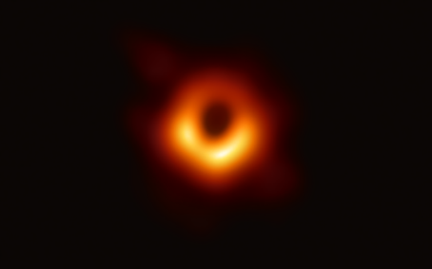
1

“Black holes are where God divided by zero.”
-Albert Einstein

Sources:
https://www.desmos.com/calculator
Problems with Zero - Numberphile
https://thecrashcourse.com/courses/astronomy
https://www.nasa.gov/audience/forstudents/5-8/features/nasa-knows/what-is-a-black-hole-58.html
Professor Dave Explains – How to make black holes
https://www.nasa.gov/mission_pages/chandra/news/black-hole-image-makes-history

