The Journey of Arabic Numerals

What thought pops into your mind when someone mentions maths? For most people, their initial thought is in relation to numbers. Of course, those at more advanced levels of mathematics perhaps think of more complex ideas, but the likelihood is that most of those concepts make use of the fundamental backbone that is numbers.

This is because numbers are everywhere. From buses, to license plates, to price tags. We see numbers almost all the time, and yet most of us never seem to question where they come from. But those are numbers; what about numerals? What is a numeral? In its broadest sense, a numeral is a symbol, figure, word or phrase that describes, or denotes a number. This ‘journey’ that we will be exploring together, will touch on the basis of our base 10 number system, and focus on the central numerals that we use daily, particularly where they come from.

Mathematics, and rather its history, is quite centralised on breakthroughs based in the Western Hemisphere, and it is felt that perhaps developments in Asia have not always been given the same significance. The Nine Chapters, seen as the most important work in the history of Chinese mathematics, contains various arithmetic and geometric algorithms that heavily influenced European mathematics. The bases for algebra, binomial theorem and spherical trigonometry were all developed in the Islamic Empire in the 8th Century. Whilst there were many other significant developments, arguably the simplest yet most complex system that has undoubtedly remained at the heart of all mathematics, is the Hindu-Arabic numeral system.

1, 2, 3, 4, 5, 6, 7, 8, 9, 0. You probably see a fair few of these digits every day, but where do they come from? These numerals were first introduced in Europe from Spain in the 11th Century and they soon entered common use to replace Roman numerals from the 15th Century. However, you will find that wide use of the system was around more than 500 years prior in Arabia, and before that in India where it was first discovered.

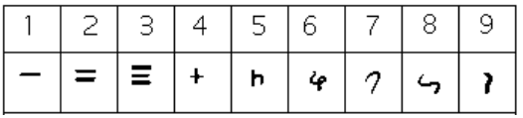

Now, let’s go back to the third century BCE. Rome is winning its last war over who will dominate Italy, and an alarm clock is created in Greece. Best of all, one of the earliest records of a numeral system like ours is being discovered in this period: Brahmi numerals. As you can see in the image above, Brahmi numerals also had separate symbols for the numbers 1-9, much like the Roman numeral system, had distinct symbols for 10, 20, 100 etc. For numbers 1-3, you can see the corresponding numbers of lines have been used much like some forms of Chinese numerals today. Whilst you may feel that the rest of the numbers do seem quite foreign to you, we will soon see how these symbols have morphed to today’s 1, 2, 3, …, 9.

Now stop for a moment and look at the image again. Does anything seem lacking to you? Well, at this point you may notice that something is missing: there is no symbol for zero. In fact, Roman numerals even after for a while had no concept of zero either, and ‘Aristotle had dismissed it because you couldn't divide by zero and get a down-to-earth result.’ It wasn’t until the 11th Century when the Nagari Numbers were developed, that a symbol representing zero was introduced.

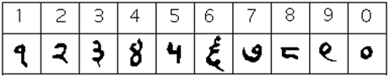

But why so? If the Romans and the rest of Europe were surviving without zero, why did those in Asia feel the need for it? In older systems of calculation, addition and subtraction had been done using counting frames or with an abacus, but the Indians recognised an issue with this. They realised that they needed to create an abacus column with nothing in it, much like using a zero in the column addition we do at school. At first the symbol they used was just a dot but later it became known as the ‘0’ we used today (though a dot is still used in numbers in Arabia). Whilst it was great Arab mathematician Al-Khwarizmi who took it up and eventually had the Arabs bring this system to Europe, the root of this system actually came from India.

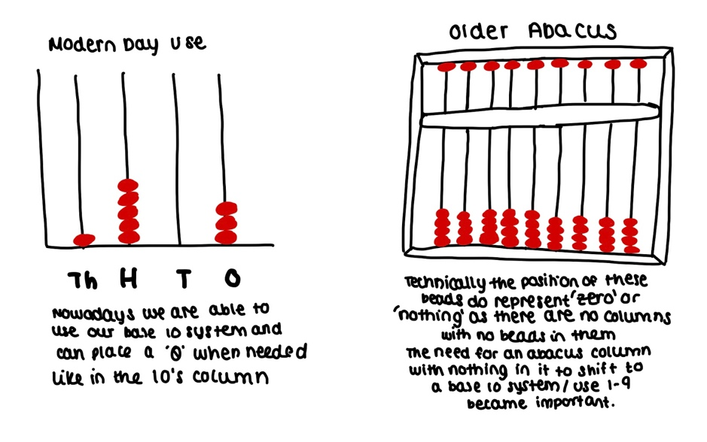
You may recognise the abacus that I have drawn on the left as something that you may have come across during primary school. Your teachers would have asked you to represent various numbers, and this would be done with ease (1,234 could be represented with 1 bead in the 4th column, 2 in the hundreds, 3 in the tens and 4 in the ones column). If the number had a zero in it, for example 1,503, it was still simple; you knew to just leave that column empty as shown above. Mathematicians in the 7th Century had not yet discovered this concept and representing ‘0’ or ‘nothing’ became quite a complex issue, especially in the developments of a system using symbols for 1-9 with no representation of zero. Without zero, the base 10 system and development of those symbols would not have continued.

What we must remember is that a symbol for zero wasn’t necessarily created to represent ‘nothing,’ and there’s much dispute as to whether it does really represent nothing at all. That aside, what was more important than the creation of number symbols to simply represent one number, was the development of the place value system. The use of symbols to represent numbers greater than 9 were abandoned by the Indians and Arabs to instead use a more familiar system much like our own, where the position of the symbol determines its value.

Though they may not have used an exact base 10 system at the time, the below above is a rough representation of what the early workings of the system were. It might help to think of it like primary school mathematics again, channelling your inner child who was playing around with beads on an abacus, and mastering column methods for addition, subtraction and even multiplication.

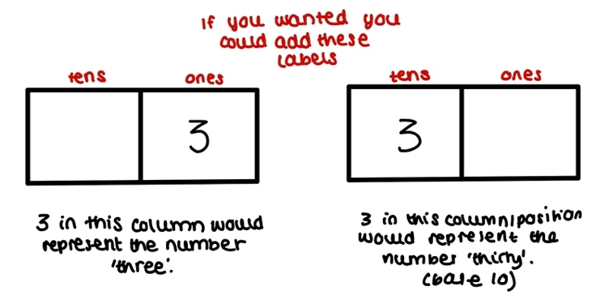

But how did they (the Arab-Indians) come up with this brilliance? It was indeed their fascination with very large numbers that drove them to create a system in which those numbers could be easily written down. As we explore further, we will see the issues in representing those large numbers in the earlier systems.

So, we come back to the Arab contribution to this numeral system which is still somewhat disputed amongst different accounts. Whilst the Arabs’ main role appears to be the transmission of this system to the West (which ultimately meant that we could be using that system today) there is also a degree of mystery around where the Arabs got their ideas from. Al-Khwarizmi’s work very much suggests that the Arab influence was a development on the pre-created Indian numerals. This leads us to question; had the Arabs just taken the work of Hindu mathematicians and made it their own?

Al-Baghdadi, another famous Arab mathematician of the time, rather states that the Arabic numeral system was a work on finger counting methods of their own. So why the dispute? It is clear that number systems did vary over different regions in India and the Arab world at the time, thus the lack of clarity on where things came from. But a more plausible explanation is perhaps that similar developments on the same system were being made in both places.

Looking more at the finger counting system that Al-Baghdadi had mentioned, we can see an entirely different way of looking at a system for arithmetic. An Arabic scholar Abdu’l-Wafa, despite being an expert in the use of the Indian numbers system, produced work stressing for the use of finger-reckoning arithmetic which was widely used for business at the time.

Known as huruf al jamal, which translates to ‘letters for calculating,’ this system replaced numbers with letters. This was not simply done in alphabetical order necessarily but rather just representation of the numbers that they represented:

The numbers 1-9 were each assigned a letter (1 = a, 2 = b, 3 = j, 4 = d)
Then the numbers 10, 20, 30, …, 90 were represented by a letter (10 = y, 20 = k, 30 = l …)
Numbers 100, 200, 300, …, 900 were next to be represented as letters (100 = q, 200 = r, 300 = sh …)
Since the Arabic alphabet had 28 letters (and 27 letters had already been used to represent numbers if you had been counting), the last letter was used to represent 1000.

Of course, this system posed a great issue when large numbers were being dealt with, as there was difficulty in using anything to express them. Would you have liked to write ‘gggggggggg’ to try to represent 10,000? I suppose the Arabs didn’t for much longer either, and probably saw more value in handing over to the Indian numeral system that we discussed before. The earlier versions of Arab mathematicians’ work on these numerals looks closer to the symbols that we use today.

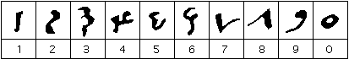

Looking at the image above, you may be thinking that those characters look very strange compared to what we use in the current day, but perhaps we can see eye to eye on certain numbers like 1, 2, 3, 9 & 0 looking very much like they do today. If not, it is definitely more so than the symbols I am about to explore that came after which I have drawn below.

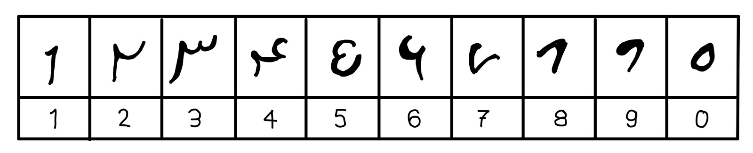

I know these don’t look too different from the strange looking numbers I had shown you before, however I can assure you that they are very close to the Arabic symbols used today. The greatest indicator of this, and the biggest change from these symbols to the ones on the previous page, is the rotation of the numbers 2 and 3. Below are two drawings explaining some of the change which was mainly a result of the way in which scribes wrote at the time; the scroll in which they wrote on were wound from right to left across their bodies, so they wrote in lines from top to bottom (thus the rotation of 90 degrees when reading).
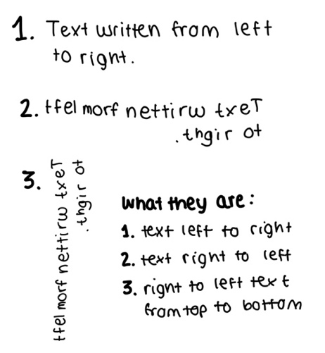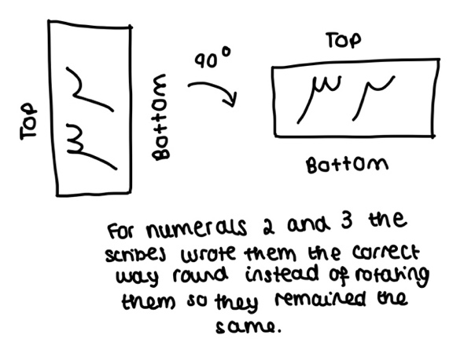

This was definitely not the end to the changes in the numerals; 100 years later the numerals had changed again. Here below you will find that almost all of the symbols look completely recognisable to present day numbers (with the exception of perhaps 4 and 5). Though 0 is not present in the image, at this point it was still represented by a dot or the ring-like shape in the previous image.
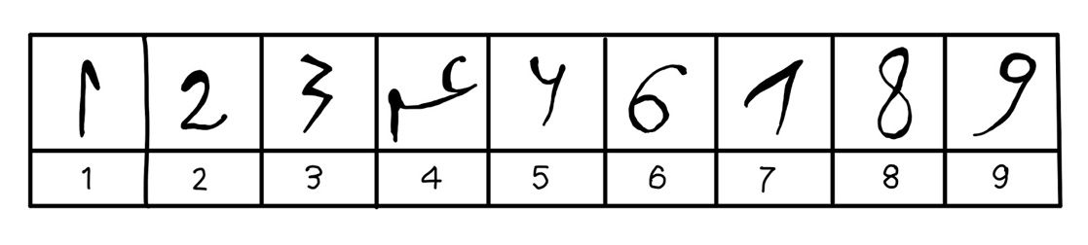
This was mathematician Al-Banna Al-Marrakushi’s form of the numerals. He lived in Spanish controlled Morocco for most of his life. Though it is not clearly known the true transmission of these number systems and symbols to Europe, it would have been through traders, travellers and the Arabs in Spanish controlled regions (people much like Al-Banna) where the numerals made their journey to Europe. Early traces of the Arabic numeral system that we explored before, have been found in a tenth-century Spanish manuscript, suggesting that the Arab traders had been heavily influencing mathematics from early stages.

Nevertheless, as we draw nearer to an end on our beautiful journey through the development of the numerals, you may be sitting with many more questions on what happened next. Or perhaps sad that our journey has come to an end. From the earliest forms of the Arabic Numerals, to the standard 1, 2, 3, 4, 5, 6, 7, 8, 9, 0, that we use today, we have seen an intricate path of development. Starting as early as 300 BCE in south-east Asia, to 11th and even 17th century Europe, the colourful bloom of these numerals peaked from a work-in-process group of symbols to a fully functioning base 10 system, equipped with a powerful zero as ammunition to fuel its success. Whilst the exploration must end here today, the legacy and continuation of the Arabic Numerals shall be one that never ends.

Bibliography

'East Asian Mathematics' (Encyclopaedia Britannica, 2021)

'Islamic Mathematics' (The Story of Mathematics)

The Hindu Arabic Number System - Lumen

'There Is No Zero In Roman Numerals. Who Invented Zero, And When? |

A History of Mathematics in the Islamic World - J. L. Berggren

THE INTRODUCTION OF "ARABIC" NUMERALS IN EUROPEAN ACCOUNTING - Journal John W. Durham

The Arabic Numeral System - Prof at Pierce College

Timeline: 3rd Century BCE (300 to 201)

Hindu-Arabic Numerals- Britannica

Huruf al Jamal - Journal

Lecture notes on Arabic Numerals

How modern mathematics emerged from a lost Islamic Library - BBC

