An insight into the computational brain
Throughout this article, I will be talking about a neural network that is based on the “MNIST handwritten digit classification dataset.”
How is it possible that a Tesla can drive autonomously? How does your mobile phone recognise your face when you turn it on? How do digital signatures automatically approve bank transactions? One word – computers. Well, a little bit more specifically, neural networks and deep learning. You increasingly often hear these terms in the media, but what do they mean and what is the maths behind them?
I will firstly explore the basic parameters of neural networks, before drilling down into the maths that create and dictate them. Taking a general definition directly from Google:
“Neural networks are computing systems with interconnected nodes (neurons) that work much like the human brain. Using algorithms, they recognize hidden patterns and correlations in raw data, cluster and classify it and – over time – continuously learn and improve”
There are clear similarities between a human brain and a neural network; both contain elegant arrays of neurons, interconnected in layers. To explain a neural network without suitable context is a Herculean task, so hence everything I reference will be in relation to training a neural network for handwritten digit classification using a multilayer perceptron, which is one type of neural network (yes, there are multiple types).
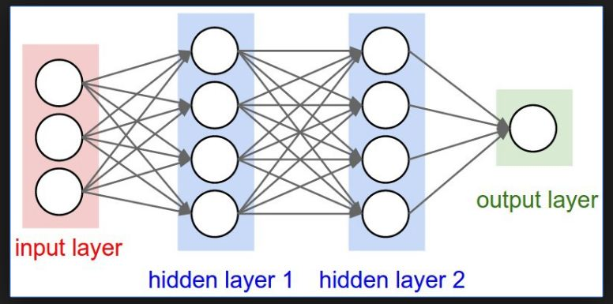
Figure 1
You must feed a neural network data: In our case, images of handwritten digits in binary black and white, and this is broadly how the network can make predictions. It looks for patterns in the current data, then once it is trained up enough you can evaluate it on real, unseen data. So, what if we just fed a neural network raw unseen data, would the neural network make predictions? Well, to put it simply, no. Without any initial adjustment the network is useless; no better than someone making random guesses.
A network can be understood as consisting of three main parts: The input layer; the hidden layers (n) and the output layer. Computer scientists feed the neural network data into the input layer in the form of numbers (0-9) which then are put through the hidden layers, which can be thought of as a one-to-one function – mapping one input value to another output value. This process is continued for the n number of hidden layers and eventually the data ends up in an output layer, holding a final value, in this specific case a number between 0 and 1.
I will now introduce the idea of weights and biases, and here is where the maths begins. Neurons are connected via individual weights, (w) which are variables. Each neuron is connected to another neuron with a different weight. Each line in figure 1 is a connection which has its own corresponding weight. There is an overall bias, (b) for each layer (there could be n layers) where$b∈R, -∞≤b≤∞$. In this system a bias can be thought of as being analogous to the role of a constant in a linear function, y = mx + c.
When passing information between neurons in different hidden layers we use an activation function which defines how the weighted sum of the input is transformed into an output from a node or nodes in a layer of the network. We take our current layer to be n and compute the value of the neuron in the n+1 layer you take the weighted sum of all the activations in the previous layer n.
Figure 2
- w = Weights | a = Activations
When dealing with n number weights and n number of activations, we theoretically can have an infinite weighted sum. In practice, the smaller the order of magnitude of the weighted sum, the easier it will be to optimise. Therefore, the weighted sum is put through a logistic function (a function that maps the domain of a function to a range between 0 and 1), two examples are the Sigmoid and ReLU functions.
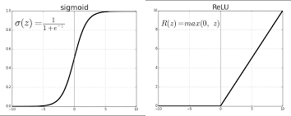
Figure 3

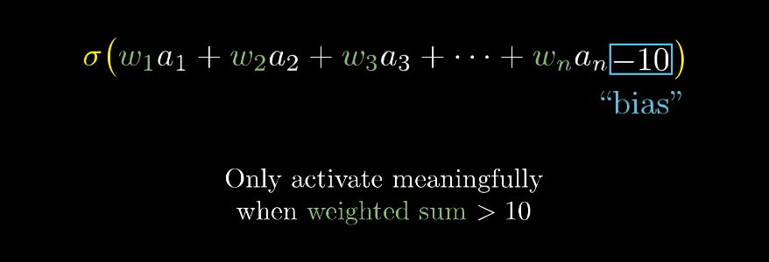
Figure 4
Figure 4 shows how the sigmoid function and the bias connect with the weighted sum of the activations in the nth layer.
Transitioning to the second part of the article, we can discuss the relevance of cost functions and gradient descent. Currently we have managed to successfully calculate a weighted sum for every neuron in our hidden layers and have reached a value between 0.0 and 1.0. To train the network, we must feed it copious amounts of data, known as training data. The network then learns by looking at the training data and making increasingly more accurate predictions through every generation.
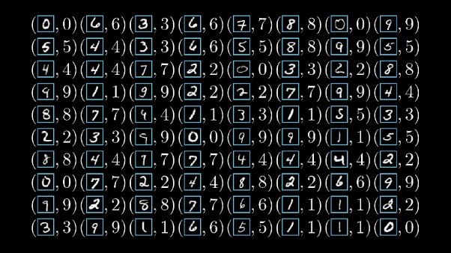
Figure 5
Figure 4 is a visual representation of labelled training data; It has a handwritten digit with a complementary classified numeric digit (0-9)
If we are to feed the neural network a single data entry and initialise random weights and biases for each activation, the neural network would throw out a random number between 0 and 1. The neural network currently has no way of predicting what number we gave it.
How would you make this neural network start making accurate predictions? It all comes down to finding the minima of a function.
Have a go on desmos and create some basic functions.
At the beginning of our training process, when we initially feed training data, we set the weights and biases to be random numbers, and this gives us a completely random outcome with zero accuracy. How could we tell the network that it is doing a poor job? We use Cost functions: These can be thought of a measure for informing the network how poorly it performed on a set of data.
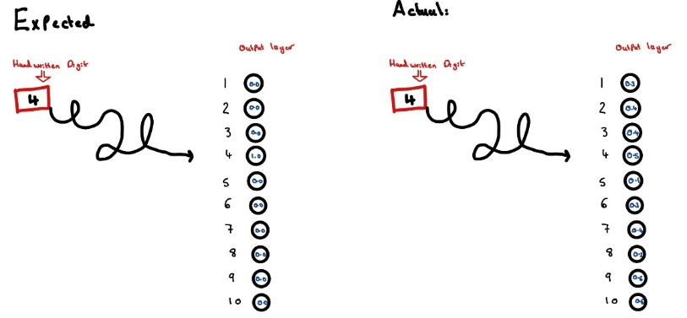
Figure 6
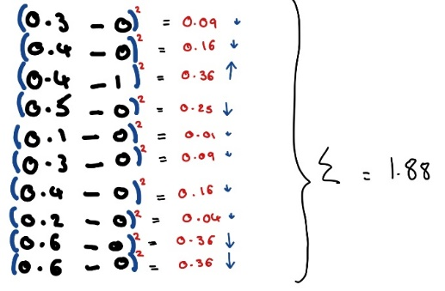
Figure 7
The cost of the neural network’s prediction is calculated through the least squares, taking the squared difference between the expected and the actual value. The two values we are comparing against each other are the activations in the output layer and the expected value.
In figure 7, we see a cost of 1.88 for this specific handwritten digit. The smaller the difference the more confident the network was at classifying the image; therefore we want the lowest cost possible. It is now possible to start to understand the relevance of finding the minima of a function - we want to minimise the cost function.
Referring to figure 6, we calculated a cost of 1.88. This is for a specific value in a huge data set, however in our training data we have tens of thousands of data entries and hence have tens of thousands of different costs for each numeric digit that the neural network has classified.
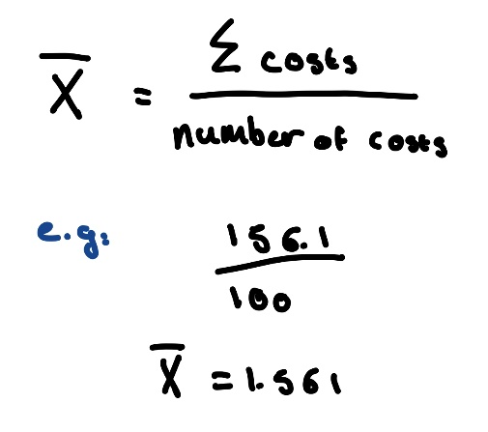
Figure 8
Hence, we need to consider the average cost throughout the entire training dataset. The cost function then tells the computer how poorly its initial randomisation of the weights and biases performed.
How can we find a specific input that minimises the cost function?
One way is to find the point where derivative is 0 then check to see if it’s a minimum, maximum or stationary point that may work for very simple functions, but when we have an entire training data set of inputs, the function will be anything but simple.
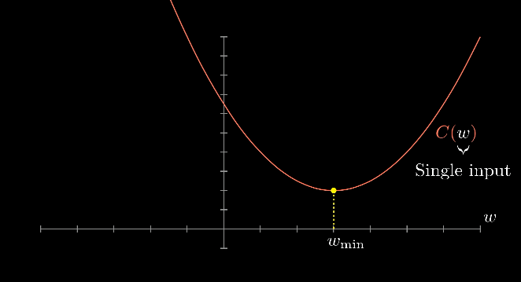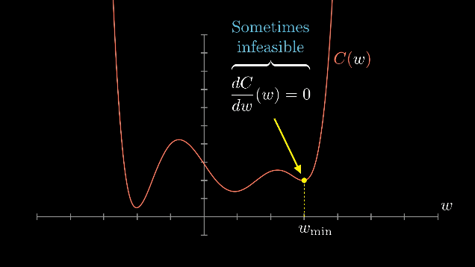
Let me introduce gradient descent; an iterative optimisation algorithm to find the local minimum of a function. We initially start with a random input and figure out which direction to step in order to make the output lower. In practice the gradient descent algorithm calculates the next point along the x axis, which maps back to a value for the function using the gradient at the current position, $p_{n}$ (which in our model is initially set randomly), which then scales using the learning rate denoted by the symbol, $η$.
The learning rate is a scaled step, which has an enormous impact on how well the model performs; the smaller the learning rate, the longer it takes to reach the minimum of the function, but if the learning rate is too great, then the algorithm may not converge to the optimal point.
The new point is subtracted from the original point${ p}_{n}$, as we are wanting to find the minimum. The computer will repeat this process until the scaled step size, the learning rate, becomes so small that it is insignificant (reached tolerance)
Once the first step of gradient descent has been completed, the paramameters are initilsied in a gradient vector
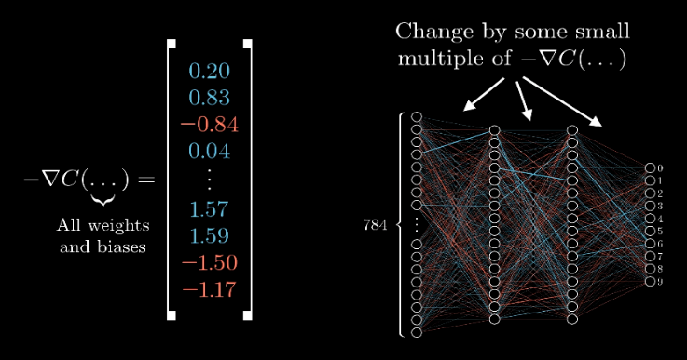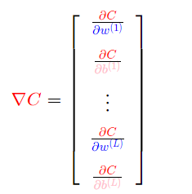
Figure 9 & 10
Once the gradient descent algorithm has been completed and the cost function has been minimised, the network then makes the changes to the cost function (as gradient descent is ongoing) displaying the changes in a gradient vector.
The changes to the weights and biases are displayed as a gradient vector. The algorithm for efficiently calculating the value of this gradient vector is called backpropagation which leads onto the concluding section.
Let us recap what’s happened so far: We have initialised the network with random weights and biases; fed the network training data; evaluated the cost-function, so we know how poorly the network initially did; ran gradient descent to find a way to minimise the cost function and now we must execute what we have just computed.
Backpropagation is an algorithm for supervised learning (the task of mapping an input to an output based on input-output pairs, which in our case is the labelled training data for MNIST). This comes from the gradients of the outputs being calculated first, the backwards flow of error information allowing us to accurately calculate the gradients of each layer separately. Note that the negative gradient of the cost function is an n dimensional vector which tells the network how to change the various weights and biases most efficiently to minimise the cost function. This vector tells us how to change each weight to minimise the cost function most efficiently. Conceptionally, think of it as if we have received the instructions to the LEGO Death Star – Great! Now we just must build the thing, easy enough, right?
Each element in the gradient vector has specific value, the greater this number the larger its overall effect on the performance of the network.
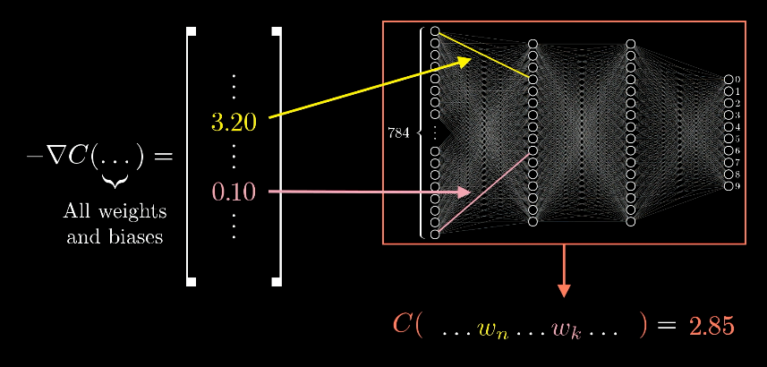
Figure 11
Here you can see that the cost has been reduced to 2.85 from the initial cost (n). The greater the difference between the final value and the intended value the greater the weights and biases are adjusted. Note, you can’t directly change the activations to the number you want it to be. Each neuron wants its activation adjusted a slightly different way, thus it is impossible to completely satisfy them all, however the best option is to add up all the desired changes to each activation to find the overall change. From this you can recursively apply this same process again until the neural network begins to make accurate predictions. The gradient descent algorithm and backpropagation run together in tandem; first gradient descent calculates the gradient vector then backpropagation implements the optimal changes as provided by the gradient descent algorithm which then minimises the cost function. It is a similar process to tuning a piano; you start with a discordant and un-tuned, generalised instrument but with some slight changes and tweaks you are able to create beautiful arpeggios and melodies.

If you want to see how a Neural Network is coded in python then check out my GitHub

REASOURCES:
3BlueOneBrown - YouTube series
Wikipedia
Gradient Descent, Step-by-Step

IMAGES:
3BlueOneBrown
Hand Drawn
Wikipedia

