The wonders of Bayes theorem

Let’s pretend for a minute that you are an oncologist, and you’ve just told a woman that she has tested positive for breast cancer. She, convinced that the diagnosis is wrong, asks what the chance is that she has cancer given that she tested positive. Is it 100%? Is there any data you could refer to inform her further? The way that we can use data to shed light on these types of problems is the wonderous study of statistics.

The use of data

Britannica defines statistics as ‘the science of collecting, analysing, presenting, and interpreting data’. The field of statistics was only properly invented in 300 years ago (a blink in the lifetime of mathematics), developing alongside the modern world as it became increasingly interconnected. Everything we do is recorded and observed, whether we like it or not. Companies record what we are buying, what images we click on Instagram, constantly consuming information about us that we divulge every day. Data as a commodity is becoming the most valuable resource on the market, with companies paying billions of dollars to gather analytical data to predict costumer patterns, selling their product more effectively. Statics the tool through which we can use and give purpose to this ‘big data’.

Basic Language of Statistics

Before we get into the complexity of medical statistics, let’s start simple. I get the bus every morning to get to school. One week, I write down whether the bus is late or not.

Day | Bus on time?
Mon | N
Tues | N
Wed | N
Thurs | Y
Fri | N

Looking ahead at the next week, I can assume on any given day that the bus is likely to be late. In that assumption I have used statistics, conducting myself differently based on data collected from past events. I could go so far as to suggest that the probability of the bus being late is 4/5, and that the probability of it being on time is 1- 4/5, or 1/5. In maths terms, we say that P(B), where B is the event that this bus is on time, is 4/5 or 0.8 and P(B’), the probability that B does not occur, is 1/5 or 0.2. Notice that B’ is not necessarily a unique event, but merely represents the alternative option to B.

That data, however, is not very useful in a vacuum. Due to the thousands of factors which contribute to our decisions and what happens to us, most modern statistics takes into account many different types of data. In the next few weeks, I take another set of data, and this time record whether I am late to lessons on the same day.

Day | Bus on time? | Late?
Mon | Y | N
Tues | N | Y
Wed | N | Y
Thurs | Y | N
Fri | Y | N
Mon | Y | Y
Tues | N | Y
Wed | N | N
Thurs | Y | N
Fri | Y | Y

Similarly to last week, I now have data to predict whether the bus will be on time. I could also guess the probability that I will be late on any day: P(L) = 5/10 = ½.

However, there may be a correlation between the two data sets, as logic would suggest. We can possibly get more specific data than a simple 0.5 probability that I will be late. Here is where we see another integral aspect of statistics: meaningful data organisation. Let us consider the days when the bus is on time (note that this could be done is reverse, by seeing if the bus was on time or late on the days that I am on time).

Out of these days, I am only late 2/6 days, and am on time 4/6 times. When compared with the results from days when the bus arrives late, we can see that I have a much larger statistical change of being late if the bus is late (3/4). Using this logic, we can construct a data diagram which represents the events that could occur, known as a tree diagram.

Tree diagram of Late Buses and Late Student
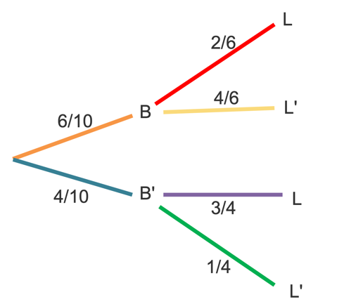

Bus on time? | Late?
Y | N
Y | N
Y | N
Y | Y
Y | N
Y | Y

The probability of two events occurring is their probability multiplied together. So, we can interpret the data from the tree diagram as such:

 | P(L) | P(L’) | Total
P(B) | P(B) x P(L|B)  6/10 x 2/6 = 12/60 | P(B) x P(L’|B)  6/10 x 4/6 = 24/60 | 6/10
P(B’) | P(B’) x P(L|B’)  4/10 x ¾ = 12/40 | P(B’) x P(L’|B’)  4/10 x ¼ = 4/40 | 4/10
 | Total probability of being late = the branches that lead to L added together  12/60 + 12/40  = 5/10  = P(L) | Total probability of being NOT late = the branches that lead to L’ added together  24/60 + 4/40  = 5/10  = P(L’) | 1

As the data does not ‘know’ that one of these events comes before the other, we can equally represent this information by looking at the days where I was late and seeing if the bus was on time based on this data.
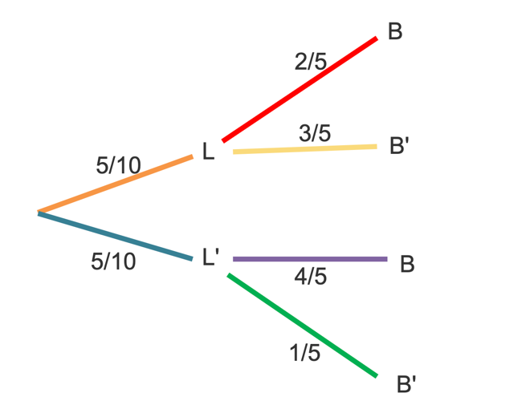

Late? | Bus on time?
Y | N
Y | N
Y | Y
Y | N
Y | Y

 | P(B) | P(B’) | Total
P(L) | P(L) x P(B|L)  5/10 x 2/5 = 10/50 | P(L) x P(B’|L)  5/10 x 3/5 =  15/50 | 5/10
P(L’) | P(L’) x P(B|L’)  5/10 x 4/5 = 20/50 | P(L’) x P(B’|L’)  5/10 x 1/5 =  4/40 | 5/10
 | Total probability of the bus being on time = the branches that lead to B added together  15/50 + 20/50  = 6/10  = P(B) | Total probability of the bus being on time = the branches that lead to B’ added together  10/20  15/50 + 5/50  = 4/10  P(B’) | 1

Laying out it in this way is very good for considering the options for each looking at the numbers, we can quickly make some interesting observations.

5/10 x 2/5 = 10/50

P(B) x P(L|B) = 12/60 = 2/10
P(L) x P(B|L) = 10/50 = 2/10

This is the case for all probabilities: P(A) x P(B|A) = P(B) x P(A|B), a property known as bayes theorem. This is a very simple, but powerful observation which can be used to make incredibly informative statements from vast samples of data.

Medical Applications of Probability and Bayes Theorem

Interestingly, this basic statistical tool is vital in giving meaning and purpose to medical statistics. Say, instead of late buses and missed registrations, we consider a sample of a population (size 100) where a certain proportion have an illness (10), and everyone is tested using the same test.
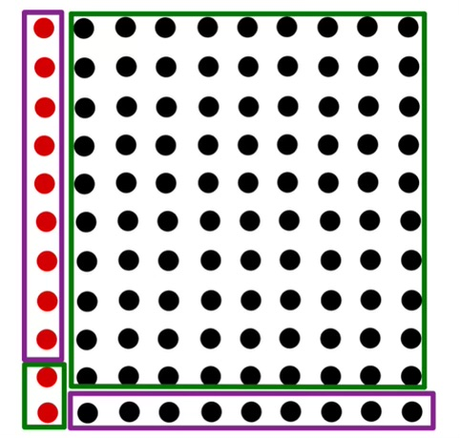
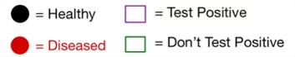

In this case, we consider two events. First, whether a person tests positive for the test (T). Second, whether they have the disease (D). The probability of testing positive (P(T)) in this case is 82/100. The probability of testing negative (P(T’)), is 18/100. Similarly, the probability of having the disease (P(D)), is 10/100 and the probability of not having the disease (P(D’)) is 90/100. But we can infer more from these values – the accuracy of the test. P(T|D) is the probability that you test positive, given that you have the disease, otherwise known as the sensitivity of the test. In this case, it is 8/10 (out of the 10 individuals with the disease, 8 tested positive. P(T’|D’) is the probability that you test negative, given that you don’t have the disease, otherwise known as the specificity. In our sample, this value is 80/90 (out of the 90 individuals with the disease, 80 tested negative). Beyond giving a scale by which we can determine the accuracy of the test (sensitivity), we can derive more interesting data from these values.

Let’s go back to the first question proposed – given that the women tested positive for breath cancer, what is the chance she has the disease? This can be rewritten as P(D|T). In this case, 17 people tested positive, but only 8 had the disease. So, P(D|T) is 8/17. Considering that less than half the positives indicated that the subject had the disease, maybe she shouldn’t be worries.

Beyond this, in the real world when we consider epidemics such as the corona virus, it very important to know if you have a disease. Similarly to collection of information regarding bus times, I could look at a population where I know the proportion that has the illness and guess what the probability is that I have the illness. Before, we could guess that the probability of having the disease is 10/100, or 10%. This is known as the prior.What a medical test does is not give a definitive answer, buts updates the hypothesis provided by the population estimate. This is where Bayes Theorem comes into play.

This is where Bayes Theorem comes into play. According to Bayes Theorem P(T) x P(D|T) = P(D) x P(T|D).

We can rearrange Bayes Theorem to say that:

$$P\left(T | D\right)=\frac{P\left(T\right)P\left(D | T\right)}{P(D)}$$

$$P\left(T' | D\right)=\frac{P\left(T'\right)P\left(D | T'\right)}{P(D)}$$

Using the information from the test (namely discovering the ratio of the $P(T) * P\left(D | T\right)$ to P(D) and the ratio of the $P\left(T’\right)* P\left(D | T'\right)$to P(D)), we can calculate something known as Bayes Factor.
$$\frac{P\left(T | D\right)}{P\left(T' | D\right)}$$

When you multiple this to the prior, it provides an updated probability of whether you have the disease ($P\left(T | D\right)$) which can be used to not only give an estimate as to whether a positive really means, but also give insight as to the prevalence of the disease in the general population with further use of Bayes theorem.

Everyone, especially in light of the recent pandemic, should learn to love and appreciate statistics!

