The Beauty of Trigonometry
Trigonometry is defined as the branch of mathematics dealing with the relations of the sides and angles of triangles, and with the relevant functions of any angles, which is indeed a decent summary of trigonometry at its core, and how we use it at school: memorising SOHCAHTOA, labelling the hypotenuse, opposite and adjacent, using the inverse functions to find angles, etc. But in this essay, I will shed light on the graceful appearance that trigonometry makes in the real world and its uses, as well as in art and furthermore, its contribution to what is known as the most beautiful equation in the world.
But first of all, I feel like it would be villainous of me to not mention the geniuses who all contributed to the discovery of trigonometry...
From 3000BC, the Egyptians and the Babylonians were the first to suspect and recognise that in a right-angled triangle, there is a relation or ratio between one side and another, while using a base 60 system. The thought process of the Babylonians can be seen in the Plimpton 322.
Plimpton 322 Rhind Papyrus Seked
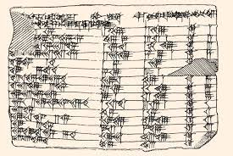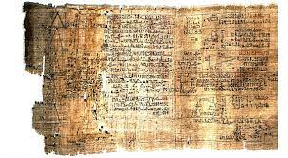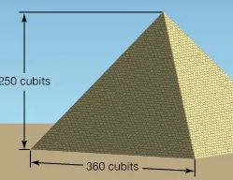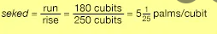

The Rhind Papyrus (1550BC) from Egyptians showcases their ability to recognise the relationship between angles and sides, and it contains the following problem: “If a pyramid is 250 cubits high and the side of its base is 360 cubits long, what is its seked?” Ahmes’ solution to the problem is to find the ratio of half the side of the base (180 cubits) of the pyramid to its height, or the run-to-rise ratio of its face. Seked describes the inclination of the triangular faces of a right pyramid. The Egyptians also used trigonometric triplets (3,4 and 5) because when constructing pyramids, they needed to find a way to obtain a right-angled triangle, and through making one of the sides, 3, the other 4 and the hypotenuse (the longest triangle facing opposite the right angle), 5. This way they guaranteed creating a right-angled triangle while building pyramids, but there is no evidence to suggest that they knew this was because of the Pythagoras theorem.
The Golden Age of trigonometry began between 190BC-120BC, by the Greeks, but especially a man called Hipparchus of Nicaea: Astronomer, Geographer and Mathematicians, usually referred to as the ‘father of modern trigonometry,’ because he was the first person to compile a table of chord that was usually used by astronomers, geographers and mathematicians of the time. An important figure names Ptolemy used trigonometry to observe planetary motion.
From 476AD to 550AD, the world witnessed the uprise of the Indian mathematicians and their contribution to trigonometry. The mathematician, physicist and astronomer Aryabhata discovered the circumference of the Earth, as well as pi to 4 decimal places. He is also credited for discovering sine and cosine.
From 780AD to 980AD, this is where we witness the influence of Persian and Arab mathematicians. Muhammad Ibn Musa Al-Khwarizmi, an astronomer, geographer and mathematician, also known as the ‘father of algebra’ discovered the tangent; Abu al-Wafa Buzjani, with the same occupations, discovered other trig functions like the secant, cotangent, cosecant, and the trig ratio reciprocals.
Now that I’ve shed light on the origins of trigonometry, brought together by people of many different communities and ethnicities all over the world (which is partially what makes it so special), I will now touch on the stunning appliances of it: first of all, in art.
Are YOU able to match these equations with these pictures correctly?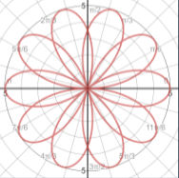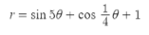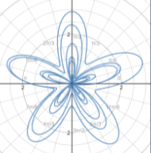 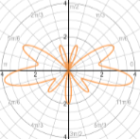 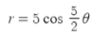

These are the correct matchings. If you got this correctly, well done!
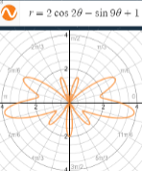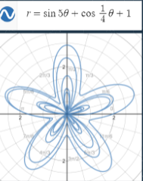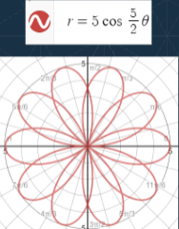
Art can be made up of anything and everything. Trigonometry is no exception. Not only can you make art with trigonometric equations, but art also has trigonometric equations in use that you might not see. The equations just above are called polar equations, and these can be used to create beautiful art and shapes.
25-year-old Iranian student Hamid Naderi Yeganeh uses trigonometric functions and polar equations as part of his daily life, creating incredibly intricate pieces of art on his computer
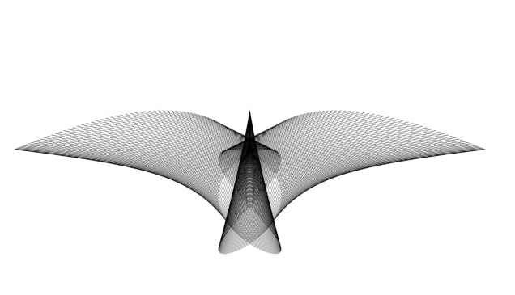
This image is a bird in flight. It shows 500-line segments. For each i=1,2,3,...,500 the endpoints of the i-th line segment are: ((3/2)(sin((2πi/500)+(π/3)))^7, (1/4)(cos(6πi/500))^2) and ((1/5)sin((6πi/500)+(π/5)), (-2/3)(sin((2πi/500)-(π/3)))^2)
Yeganeh's formula, (cos(6πk/2000)-i cos(12πk/2000)) e^(3πi/4), acts like his pen and ink. He uses formulas like these, combined with computer software programs to create fantastical and intricate mathematical artworks.
When different numerical values are assigned to the equation above, the end results can pictorially represent at bird in flight.
"The images (I make) are defined by basic mathematical concepts. At first, I use multiple formulas to create many different images. Then, I choose the best results," Yeganeh explains
Yeganeh began studying mathematics at the University of Qom in Iran in 2012. At the same time, he developed a love for art.
"At first I was interested in beautiful, symmetrical shapes. So, I started to create mathematical figures using trigonometric functions to define the endpoints of line segments. After a while, I understood I could find interesting shapes that looked like real life things, such as animals."

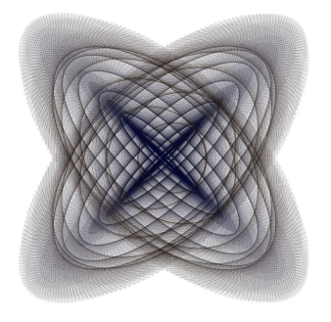
.
This image shows 10,000 line segments. For each k=1,2,3,...,10000 the endpoints of the k-th line segment are: (sin(108πk/10000)sin(4πk/10000), cos(106πk/10000)sin(4πk/10000)) and(sin(104πk/10000)sin(4πk/10000), cos(102πk/10000)sin(4πk/10000))
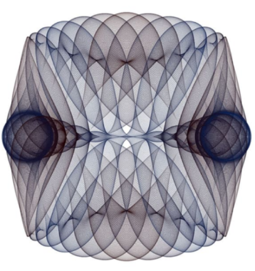
This image shows 8,000 circles. For k=1,2, 3,...,8000 the centre of the k-th circle is: (sin(14πk/8000), (cos(26πk/8000))^3)
and the radius of the k-th circle is: (1/4)(cos(40πk/8000))^2
It takes a seriously advanced mathematician to come up with such visibly satisfying creations, so for anyone who’s interested (why wouldn’t you be!?), I will now show you beginner steps for being able to create interesting patterns with Python using mathematical and trigonometric codes.
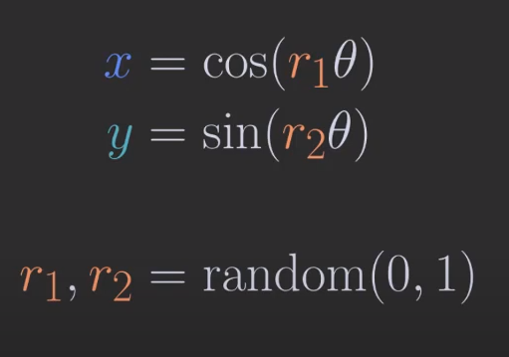
This involves using variables x and y which represent our trig functions too. The values for the two Rs represent random numbers between 0 and 1, and as these numbers are substituted into the equation, they determine the steepness of the trig graph shown. To get started, you want to use the function np.append and go on the website jupyter.org.
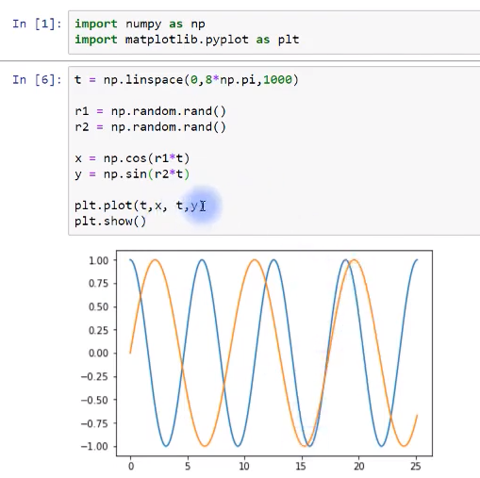
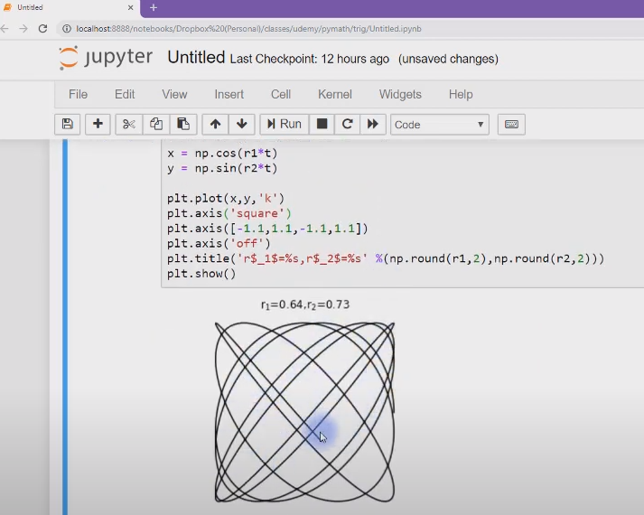
The first diagram shows a more basic idea of how to get started with creating interesting curves onto python. The second diagram involves keeping the first 7 lines of the codes, but to get into more interesting shapes, involves changing plt.plot to make the curves black, adding plt.axis to give the shape the square shape, plt.axis to create limits to the numbers as well as plt.axis(off) to get rid of the x and y axis and let there be a shape by itself, as well as plt.title to round the values for r to 2 decimal places.
As for our brilliant mathematician previously discussed, he also revealed that he combed through tens of thousands of computer-generated images. So he never created the ‘A Bird in Flight’ creation all at once. It was created through layered trig functions all joined together, while picking and choosing the best ones. 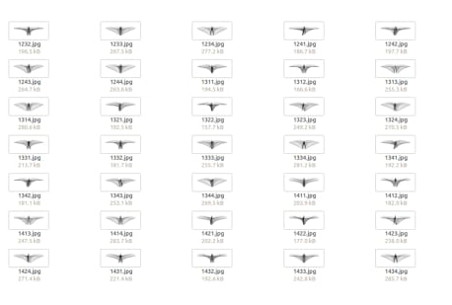
Well...THAT was a lot to take in.
Trigonometry not only has shown itself in art, but also in the everyday world. In many ways, we couldn’t live in a world without trigonometry.
In the construction of buildings, as well as the analysis of mountains, trigonometry is vital. If you know the distance from where you observe the building and the angle of elevation you can easily find the height of the building. Similarly, if you have the value of one side and the angle of depression from the top of the building you can find and another side in the triangle, all you need to know is one side and angle of the triangle. Architects use trigonometry to calculate structural load, roof slopes, ground surfaces and many other aspects, including sun shading and light angles
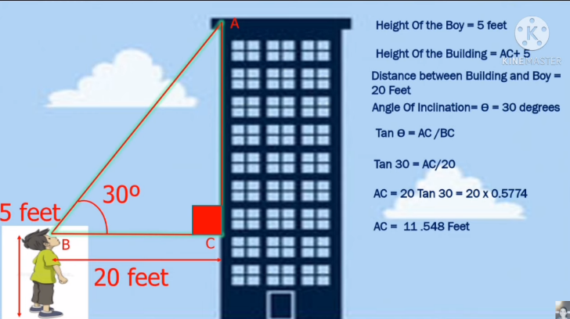
In criminology, trigonometry can help to calculate a projectile’s trajectory, to estimate what might have caused a collision in a car accident or how did an object fall down from somewhere, or in which angle was a bullet shot. It is also used to find useful angles in blood spatter analysis. A useful question usually solved is, for example: “If the width of a blood stain is 8mm, and the diagonal length is 16mm, find the angle of impact.” This ‘angle of impact’ helps us find the angle at which the blood was splattered onto the wall from the horizontal floor.
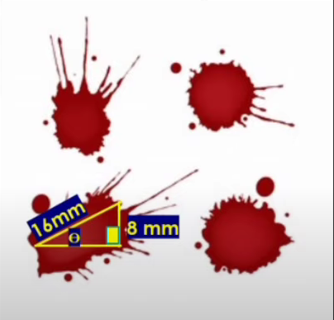
Marine biologists often use trigonometry to establish measurements. For example, to find out how light levels at different depths affect the ability of algae to photosynthesize. Trigonometry is used in finding the distance between celestial bodies. Also, marine biologists utilize mathematical models to measure and understand sea animals and their behaviour. Marine biologists may use trigonometry to determine the size of wild animals from a distance so they, you know, don’t get eaten to death.
Trigonometry is used to set directions such as the north south east west, it tells you what direction to take with the compass to get on a straight direction. It is used in navigation in order to pinpoint a location. It is also used to find the distance of the shore from a point in the sea. It is also used to see the horizon. This is one of the most useful uses of trigonometry in the real world because we all use navigations for getting to places that we don’t know very well.
Finally, trigonometry is a base of the mere existence of computer-generated sounds created by sound engineers and music producers. Mainly, because music is nothing but sound waves, and these can be represented through the equation and graph:
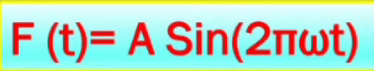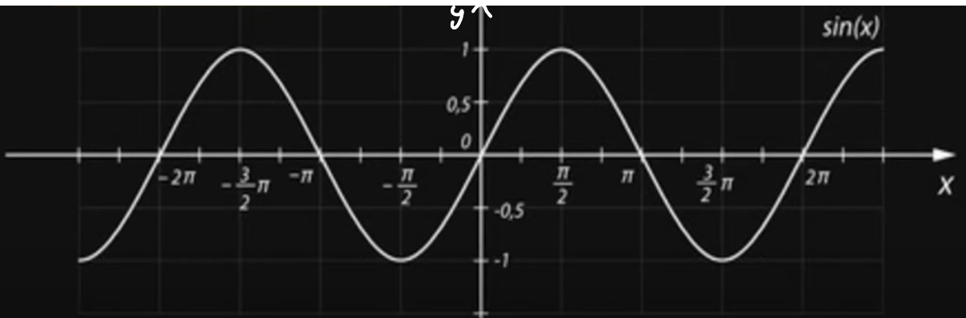

You have over here the variables A for amplitude, ω for angular velocity, t for time and F for frequency, and by manipulating and changing these variable values, you can change the steepness, stretch and height of the waves, creating the perfect sound for these producers to utilise.
For mathematicians, the most iconic use of trigonometry is its involvement in the most beautiful mathematical equation in the world, Euler’s identity. Step by step we will through how this equation was formed, so you can see how trigonometry plays its part.
Let us start with the Taylor series, which allows us to represent any function as an infinite sum of terms. The function e^{x} can be represented as follows:
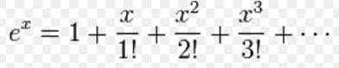
Here x can represent any value, so we can substitute x with ix, where i² = −1. Hence, we get the following series
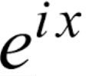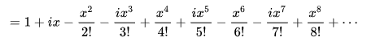
Next, we group terms according to whether or not they contain i:
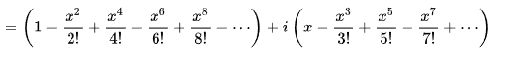
Taking an apparently irrelevant detour, it is also possible to find a pair of Taylor series to represent the sine and cosine functions, which leads to the following result:
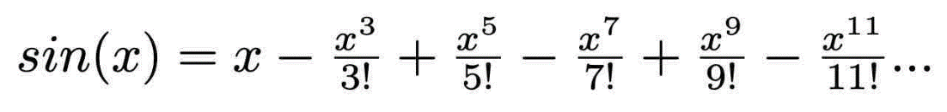
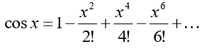
Do you notice the relationship between these trig functions and the e function?
By multiplying sin(x) by i, and then adding this to cos(x) unchanged, we can write, in terms of sin x and cos x, e^{ix}
We are now ready to calculate Euler’s identity by substituting x for pi, as it involves the term e^{iπ}
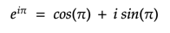
In this context, pi is an angular measurement in radians, such that 360 degrees=2π radians. Hence, cosπ= -1 and sinπ= 0. This means that...
To understand this more visibly
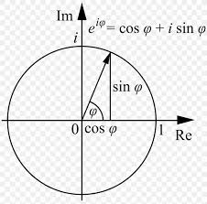and thereforeis what is known as Euler’s identity.
Why Is Euler's Identity Important?
Mathematicians love Euler's identity because it is considered a mathematical beauty since it combines five constants of math and three math operations, each occurring only one time. The three operations that it contains are exponentiation, multiplication, and addition. The five constants that this equation combines are the number 0, the number 1, the number pi, the number e, and the number i. This formula is the most important tool in AC analysis.
In conclusion, trigonometry is a concept that not only we can admire visibly and artistically, but also because of its important uses in finding distances and angles of buildings, mountains, even blood, as well as its use in music, and in forming the most beautiful equation in the world. Its amazing how something generally seen as abstract can shine through the human eye in these ways.

(1999 words, excluding title and references. Yep, you read that correctly)

References
https://youtu.be/9-7YMiNQB0M
https://youtu.be/bGPIcQftgYI
https://youtu.be/RxsdDkgJRAY
Euler's formula - Wikipedia
Trigonometry in Art by D'Rikka Cruz (prezi.com)
Iranian math genius: Meet 'new da Vinci' - CNN Style
https://www.mathnasium.com/real-life-applications-of-trigonometry#:~:text=Trigonometry%20can%20be%20used%20to%20roof%20a%20house%2C%20to%20make,its%20applications%20in%20satellite%20systems.
Trigonometry - Wikipedia
Real life applications of trigonometry | Mathnasium

