Crocheting for Mathematicians

Drawing shapes on a flat piece of paper is simple. However, we start to have trouble when picturing more complex ideas, such as representing curved surfaces on a flat plane or visualising shapes in more than three dimensions. Sometimes these ideas are so complicated that humans have to find visual tools to represent them. Often these models combine artistic areas which aren’t often associated with the sciences to make them more accessible.

One idea that humans often struggle to understand is non-Euclidian geometry, which occurs on a curved surface and contradicts at least one of Euclid’s postulates. The two main types of non-Euclidean geometry are spherical (positive Gaussian curvature) and hyperbolic (negative Gaussian curvature). They typically don’t have a natural coordinate system and have properties which we find counterintuitive and therefore difficult to comprehend. Another concept we find hard to perceive is shapes in four (or more) dimensions. We judge our world in three dimensions, so struggle to perceive higher dimensions in the same way we cannot imagine a colour that we have never seen before.

For many areas of scientific research to advance, it is imperative that we can understand these ideas. Surgeons are interested in non-Euclidean geometry because it can be used to analyse the curvature of body parts before surgery. Other applications are Einstein’s theory of special relativity in which space-time is curved, for creating maps of the Earth and to help ships and aeroplanes to navigate. It is also important to understand the fourth dimension (which uses non-Euclidean geometry) as it helps us learn more about the world, for example in Einstein’s theory of special relativity where the three dimensions of space and the fourth dimension of time are combined into a four-dimensional manifold. Therefore, scientists are searching for better ways to present these ideas so they are easier for us to understand.

A hyperbolic plane is a plane with constant negative Gaussian curvature, meaning that if two perpendicular lines were drawn on the surface, one would curve up and the other would curve down. The easiest way to visualise this is a horse’s saddle. A hyperbolic plane contradicts Euclid’s Parallel Postulate because each line on the plane has an infinite number of lines which don’t intersect it. It also has other unusual properties. The sum of angles in a triangle on a hyperbolic plane is less than 180° and the greater the triangle the smaller the sum of the angles, so an infinitely large triangle on a hyperbolic surface would have an angle sum of 0°.
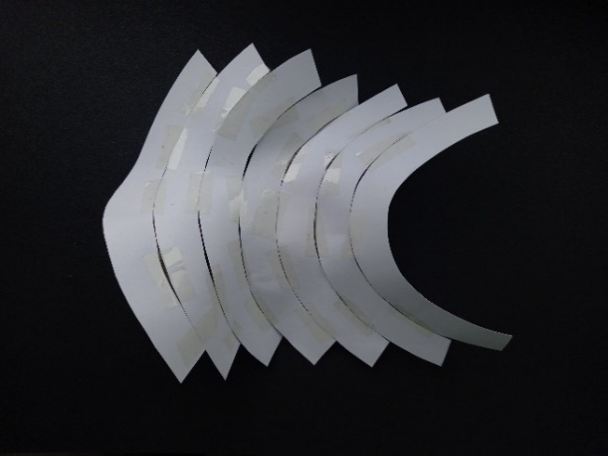
Figure 1- My attempt at the Thurston Model.
For years, the Thurston model, suggested by William Thurston, was used to visualise hyperbolic planes. This was constructed using many paper crescent shaped annuli by taping the inner edge of one to the outer edge of another and so on. However, this was difficult to make, incredibly fragile and couldn’t be handled easily, making it useless for exploring properties. When I attempted to construct this myself I also found that it was difficult to line up the crescent shapes exactly so there wasn’t a sense of flow between sections. Instead, it felt very fractured and made it hard to present features and visualise the hyperbolic plane as a whole.
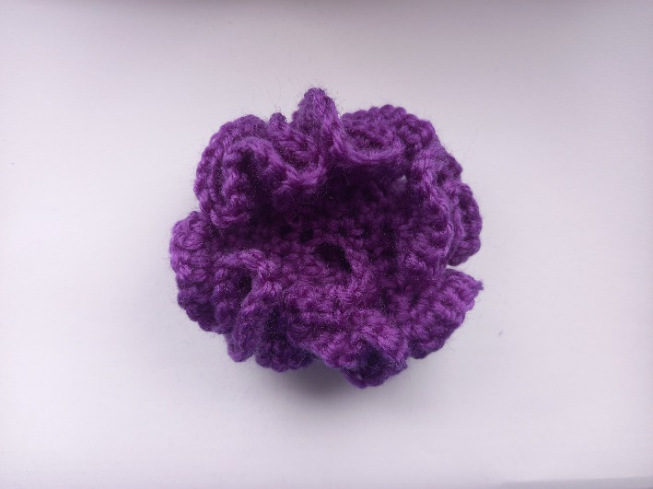
Only in the late 1990s was a better visual tool invented by Diana Taimina, a mathematician who had struggled with envisioning these properties since she attended university. When considering the fact that space around a point on a hyperbolic plane grows exponentially as you move away from it, she realised that she could illustrate this using crochet. By adding more stitches to each row of crochet she could create the ‘ruffles’ that form due to the plane’s hyperbolic nature.
Figure 2- My first attempt at crocheting a hyperbolic plane.
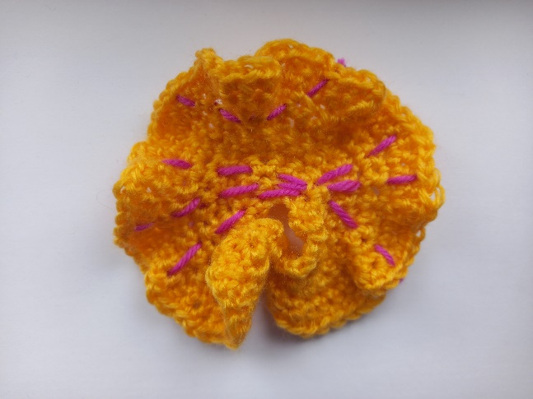
This technique was sturdier and could be used to present properties and explore features. It was also much easier to change the rate of expansion by altering how often extra stitches are added. However, these extra stitches must be added in the same ratio between rows in order to get a hyperbolic plane. Figure 2 shows my first attempt at this technique, where I started with 5 stitches and doubled the number of stitches every row. This produced extreme ruffles, which looked pretty but wasn’t practical for exploring the surface’s properties. Figure 3 shows my second attempt where I began with 9 stitches and added an extra stitch every 3 stitches. On this model it was much easier to show the properties of hyperbolic planes by stitching on to the surface. For example, I was able to present visually how hyperbolic geometry challenges Euclid’s Parallel Postulate by stitching 3 lines that go through one point and do not cross another line. It also gave a tangible sense of the hyperbolic nature, with each row taking more time to crochet. This wasn’t present when using the Thurston model.
Figure 3- Contradiction of Euclid’s Parallel Postulate on a hyperbolic plane.
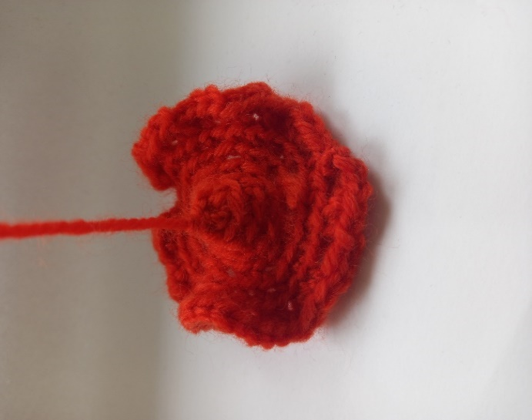
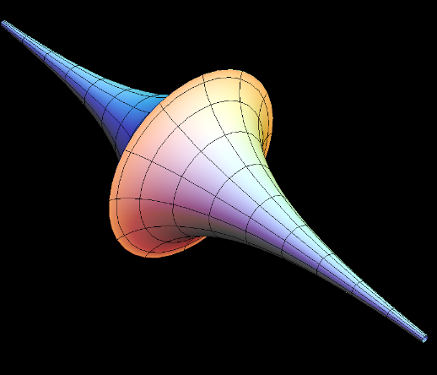
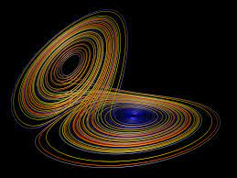
Taimina then went on to show how to crochet the pseudosphere, which is another non-Euclidean surface seen in both French horns and moon flowers. This is created by rotating a tractrix about its asymptote. To precisely crochet this it would be necessary to start from a point but this is not possible with crochet so instead you must start with a small circle. To construct it you crochet in the same way as for a hyperbolic plane, adding stitches each row. It will begin as a cone shape and then will form ruffles, which would eventually cover this initial cone, should you crochet for long enough. Figure 5 shows my attempt at this surface.
Figure 5- My attempt at crocheting a pseudosphere.
Figure 4- A pseudosphere.
Figure 6- The Lorenz Attractor.

Having been inspired by Daina Taimina’s work, scientists Dr Hinke Osinga and Professor Bernd Krauskopf used this technique to represent the Lorenz Manifold in 2004.
Developed by Edward Lorenz in 1963, the Lorenz equations are a simplified model for atmospheric convection. They describe the pathways of points in 3D space as they heat and rise and then cool and fall and so on. When a set of chaotic solutions to the equations is plotted in three dimensions the famous Lorenz attractor is created. To do this a computer plots the first point and then plots the rest based on the previous point’s position, creating a spiral pattern that changes direction randomly and never arrives at the same point twice. This represents the movement of most points in the system. However, the Lorenz Manifold shows the paths of the few points that do not act in this way, instead going to the origin. Simply, the Lorenz manifold is “the surface of all points in space that don’t result in the convection role model.” Osinga uses the analogy of leaves floating down a river to visualise this: the leaves passing around the rocks follow the Lorenz attractor whilst those which stick on the rocks have followed a special path, represented by the Lorenz manifold.

The pair began trying to generate an algorithm to represent the Lorenz manifold. The algorithm they created started with a small circle and added bands around it, with points added or removed to create the shape’s surface.
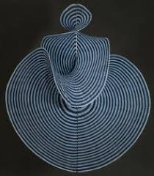
Osinga quickly realised she could interpret this as crochet instructions, using the algorithm to tell her when to add or remove stitches. Once crocheted, the bottom part lays flat whereas the top part ruffles up due to the constant negative curvature (as in hyperbolic geometry). However, when hung it forms a beautiful swirling pattern. This work quickly gained popularity, with many people creating their own Lorenz Manifolds. This shows using visual aids can also inspire people that might not previously have known anything about this branch of mathematics.
Figure 7- The crocheted Lorenz Manifold.

Another area of maths that humans find difficult to visualise are shapes that occur in more than 3 dimensions, for example the Klein Bottle.
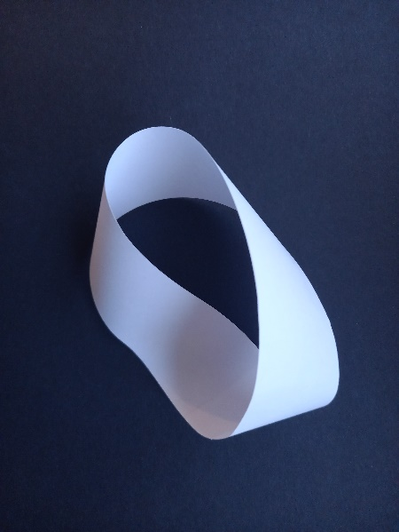
Scientists began thinking about the Klein Bottle after the discovery of the Möbius Strip, a continuous surface with a twist in it. This means it is a two-dimensional shape that requires three dimensions to exist (the third dimension is required to twist the strip).
Figure 8- A Möbius Strip.
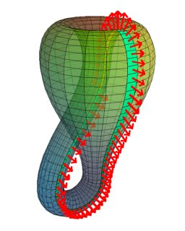
Interestingly this shape cannot be cut in two down the middle. Cutting a 2 twist Möbius strip results in one longer Möbius loop and cutting a three twist Möbius loop results in another loop but with a knot in it. Biologists in particular are interested in this because this is what happens when bacteria reproduce and their twisted DNA is ‘unzipped’ down the middle. Enzymes called topoisomerases then untangle these knots by cutting and re-joining the DNA. Research into this would enable biologists to prevent topoisomerases untangling the DNA and potentially stop harmful bacteria reproducing.
Figure 9- A Klein Bottle.
After this discovery, scientists began looking for a two-dimensional shape that requires four dimensions to exist: the Klein Bottle. Like the Möbius Strip, the Klein Bottle is a non-orientable surface, which means if you ran your finger along the entire surface, you would get back to the start but facing the other way up. This is shown by the arrows in figure 9 which end up facing in opposite directions once they have gone round the surface. Whereas the Möbius strip is a rectangle that has been twisted in the third dimension, the Klein bottle is a cylinder that has been twisted in the fourth dimension. Unfortunately, it is not possible for us to actually twist the cylinder in the fourth dimension. Instead, the shape appears to go through itself to join back up. What we see is the 3D shadow of a 4D Klein Bottle.
Paper is flexible enough to construct a Möbius strip but not a Klein Bottle. Instead, they are often made with glass, which allows the viewer to see through the bottle and view the contiguous nature of the inside and outside. Another common medium used is crochet: whilst the viewer cannot see through it, the crocheting can be pulled to actually allow the surface to move from the inside to the outside, which isn’t possible when constructed with glass.
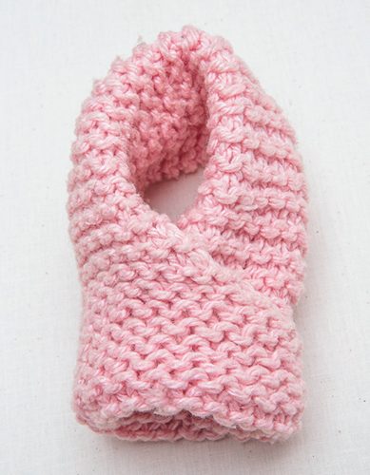
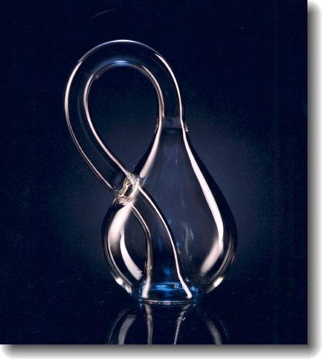
Figure 10- A crocheted Klein Bottle.
Figure 11- A glass Klein Bottle.

Interestingly crochet has proved itself to be great for presenting many of these complex ideas, which combines a historically feminine art form with a male dominated field to progress.

Throughout history people have used tangible representations of complex mathematical ideas to better understand them. These concepts can be presented through mediums such as paper, crochet, knitting and glass blowing, which has the ability to make these ideas more accessible. For example, I was able to begin to understand mathematical areas beyond my A-Level course by utilising skills not traditionally associated with the sciences. By combining artistic and scientific areas, it aids not only scientific progress but also has the potential of making scientific concepts accessible to people who wouldn’t consider themselves interested in science.

Essay word count: 1933
References:
[1] Lambert, A. Wonders of Mathematical Crochet. [online]. Available from: https://chalkdustmagazine.com/blog/wonders-mathematical-crochet/
[2] Anisa. The Mathematics of Crochet. [online]. Available from: https://hellohartblog.wordpress.com/2015/05/25/the-mathematics-of-crochet/
[3] Szecsei, D. Geometry: Non-Euclidean Geometry. [online]. Available from: https://www.infoplease.com/math-science/mathematics/geometry/geometry-non-euclidean-geometry#:~:text=One%20of%20the%20reasons%20why,grid%20with%20nonintersecting%20straight%20streets.
[4] Taimina, D and Henderson, D. Crocheting the Hyperbolic Plane. [online]. Available from: http://pi.math.cornell.edu/~dwh/papers/crochet/crochet.html
[5] Crocheting the Hyperbolic Plane: An Interview with David Henderson and Diana Taimina. [online]. Available from: https://www.cabinetmagazine.org/issues/16/wertheim_henderson_taimina.php
[6] Nargi, L. 6 Maths Concepts Explained by Knitting and Crochet. [online]. Available from: https://www.mentalfloss.com/article/86016/6-math-concepts-explained-knitting-and-crochet
[7] Osinga, H and Krauskopf, B. Crocheting the Lorenz Manifold. [online]. Available from: https://research-information.bris.ac.uk/ws/portalfiles/portal/163834512/2004r03.pdf
[8] Osinga, H and Krauskopf, B. The Lorenz Manifold: Crochet and Curvature. [online]. Available from: https://archive.bridgesmathart.org/2006/bridges2006-255.pdf
Taimina, D. Crocheting Adventures with Hyperbolic Planes. CRC Press, 2018. ISBN 978-0-367-37507-2
Parker, M. Things to Make and Do in the Fourth Dimension. Penguin Books, 2015. ISBN 978-0-141-97586-3
Figure 1- Photo by Anoush Rule.
Figure 2- Photo by Anoush Rule.
Figure 3- Photo by Anoush Rule.
Figure 4- https://virtualmathmuseum.org/Surface/pseudosphere/pseudosphere.html
Figure 5- Photo by Anoush Rule.
Figure 6- http://paulbourke.net/fractals/lorenz/
Figure 7- https://research-information.bris.ac.uk/ws/portalfiles/portal/163834512/2004r03.pdf
Figure 8- Photo by Anoush Rule.
Figure 9- https://plus.maths.org/content/imaging-maths-inside-klein-bottle
Figure 10- https://www.americanscientist.org/article/adventures-in-mathematical-knitting
Figure 11- https://adamschittenden.com/products/special-projects/klein-bottles

1. A straight line segment can be drawn joining any two points. 2. Any straight line segment can be extended indefinitely in a straight line. 3. Given any straight lines segment, a circle can be drawn having the segment as radius and one endpoint as centre. 4. All Right Angles are congruent. 5. If two lines are drawn which intersect a third in such a way that the sum of the inner angles on one side is less than two right angles, then the two lines inevitably must intersect each other on that side if extended far enough. (Parallel Postulate)

