Elliptic Curves: A Key to the Past, Present and Future

What is an elliptic curve:
An elliptic curve is, fundamentally, a Cartesian equation of the form $y^{2}=x^{2}+ax+b$ where a and b are constants. Like most other equations it can be plotted on a graph, a few variations of which are shown below:
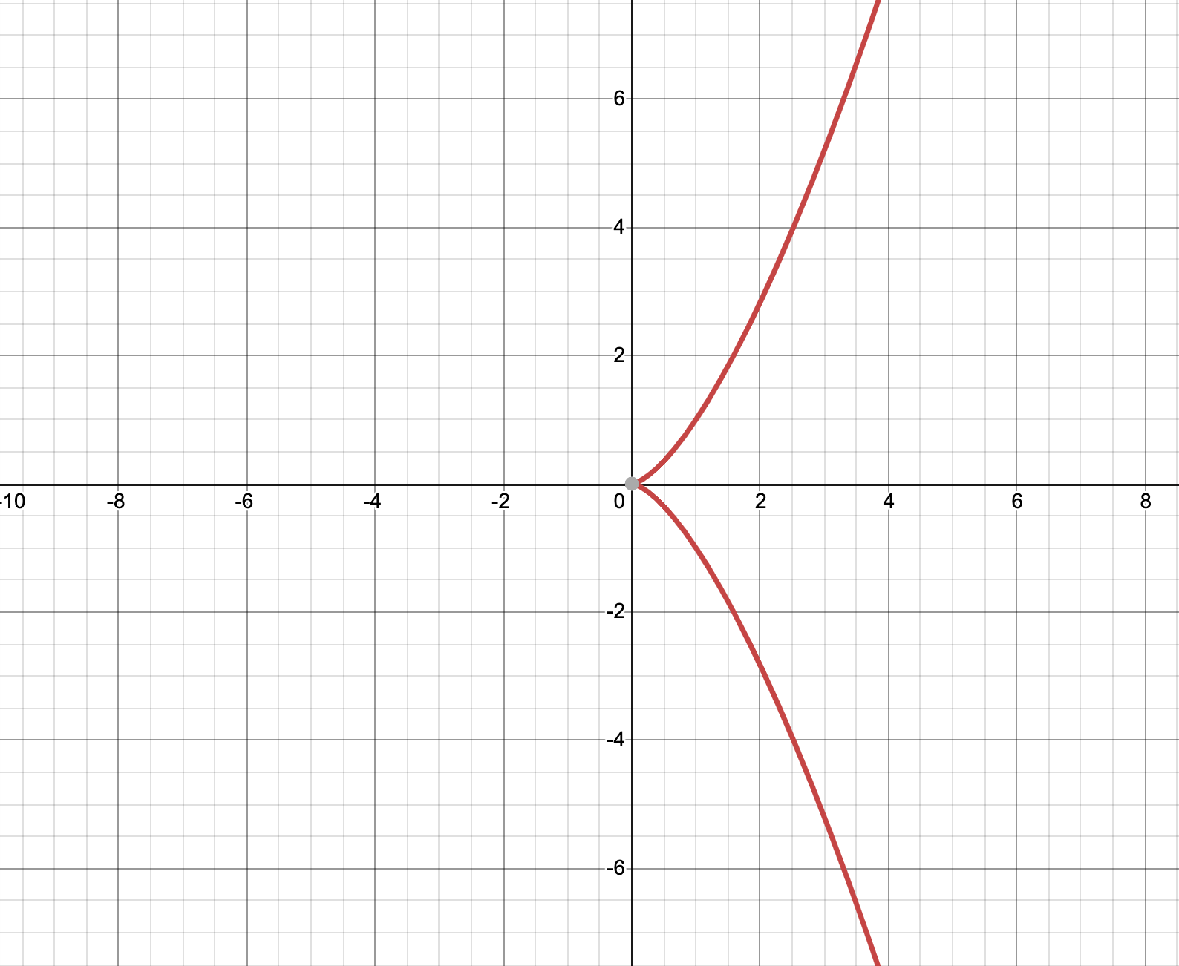
Figure 1: $y^{2}=x^{3}$

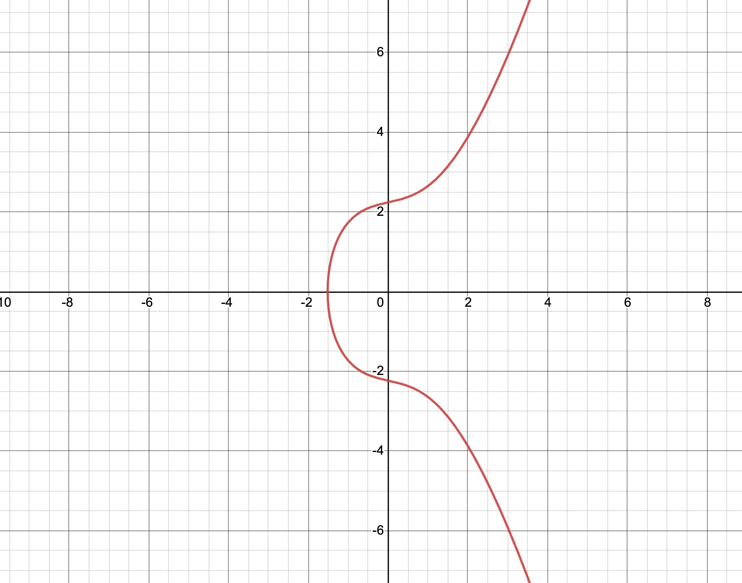
Figure 2: $y^{2}=x^{3}+x+5$

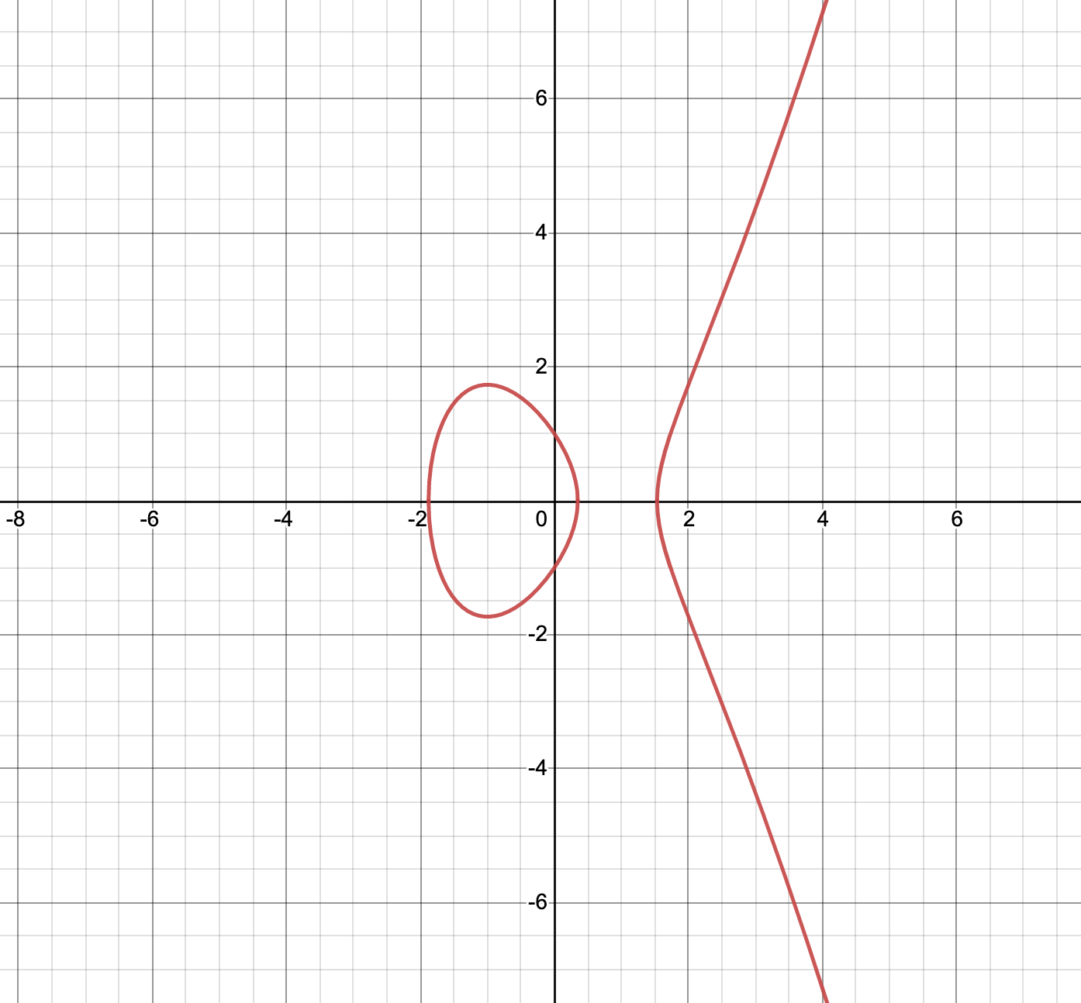
Figure 3: $y^{3}=x^{2}-3x+1$

While they don’t all look identical, or perhaps even similar, the key property of elliptic curves is clear to see. They are all symmetrical about the x axis. When re-examining the equation of an elliptic curve it becomes evident why this is. The important $y^{2}$ aspect means that for every x value there will be two generated y values, the positive and negative root of $y^{2}$. Take for example one of the displayed graphs above, figure 2: $y^{2}=x^{3}+x+5$. If we plug in $x=3$, we can use this to evaluate for y.
$y^{2}=3^{3}+3+5$.
$$y^{2}=35$$
$y=±\sqrt{35}$
As a decimal $\sqrt{35}$is about 5.92, which makes sense if we look at figure 2, as when x = 3, it appears that y is ever-so-slightly under 6 and over -6.

The property of horizonal symmetricity is hugely important for some of the present uses of elliptic curves. Their characteristic shape opens up the possibility for new and exciting types of mathematical operations, namely point addition, point doubling and point multiplication.

Point addition:
Point addition is an operation which ‘adds’, as the name suggests, two points on the curve to get a third point. While instinctually this operation may seem obvious (add the x coordinates and then add the y coordinates), the process is instead far from rudimentary.

First two arbitrary points on the curve need to be chosen, one of which will be named P and the other will be named Q. The resultant point, and answer to the addition operation, will be the point R on the curve so $P+Q=R.$ Then another of the interesting properties of an elliptic curve is put to use; any line intersecting two points on the curve will also always intersect precisely one other point on the curve. In this case the first two intersecting points of the curve and line are P and Q and the third is R’. Here it is key to note that R’ is the complement of R - not R itself. R is actually the reflection of R’ in the x axis (i.e. the other root of $y^{2}$). This is shown in figure 4 below.
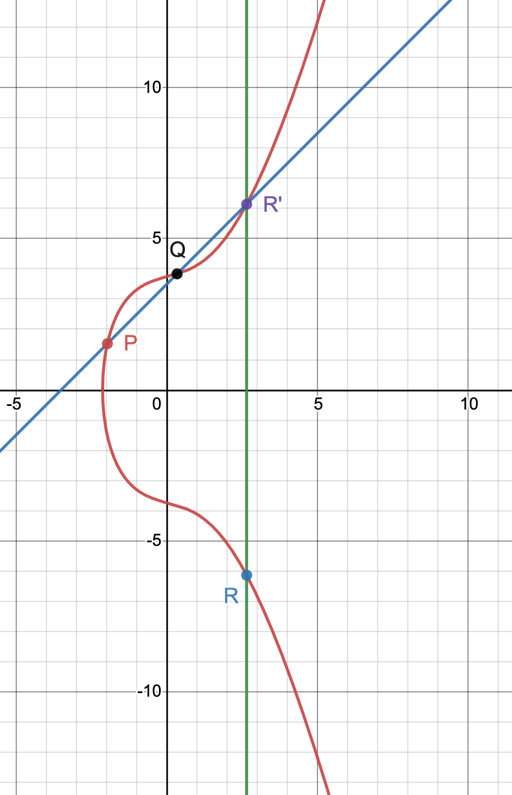
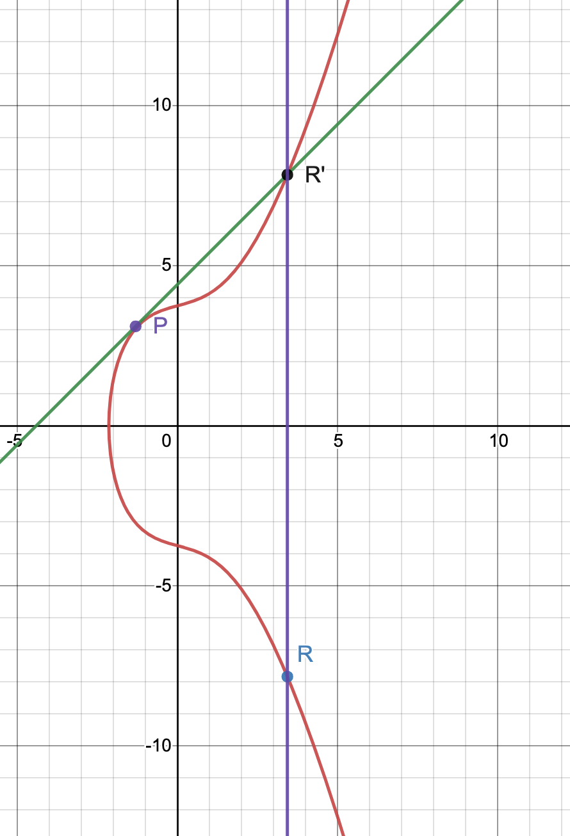
Figure 4: Point Addition
Figure 5: Point doubling

Point doubling:
Point doubling is in essence just a special case of point addition, where instead of having two different arbitrary points P and Q, they are both the same point P. Hence this time $P+P=R$ or $2P=R$. This again relies on yet another special property of the elliptic curve; the tangent to the curve at a point will always intersect the curve at precisely one point (that isn’t where it touches). We can call the point at which the tangent touches the curve P, and the point at which the tangent intersects the curve R’ (again not R). In the same manner as last time, R is found as the reflection of R’ in the x axis. This whole process is displayed above in figure 5.

Point multiplication:
Point multiplication is not in itself a stand-alone operation, but rather a mixture of point addition and point doubling. For example, if you wanted to multiply the point P by 7 (7P) you would have to break it down into bitesize chunks comprised of point addition and point doubling. Therefore 7P could be broken down into $7P = (2(2P+P))+P$ or$2(2P)+(2P+P).$ Any way that the operation is broken down will yield the same result at the end. The utility of this operation is down to the fact that it is a trapdoor or one-way operation. This is because for $nP=R$, even if P and R are known, there is no way of finding out n as point subtraction and point division do not exist. Of course, in reality there are ways of finding n, namely by using supercomputer that use brute force of trial and error to find the unknown, but when big enough coordinates of P and Q are used, even the strongest of computers can find this problem infeasible.
The nature of the two fundamental operations (point addition and doubling) means they can be done with any type of number constituting the curve coordinates: decimal, integer, irrational, complex and imaginary. This in turn means that elliptic curves have a myriad of applications in the past, present and future within both pure and applied mathematics.

Elliptic Curve Cryptography (ECC):
Cryptography is all about encryption and decryption, and being able to transfer messages securely. As such it is used by government agencies like GCHQ and The Pentagon for espionage and top secret communications, as well as Big Tech companies like Facebook and Google which use cryptography to protect all of our text messages, emails and private data. ECC is one of the most novel, effective, and popular methods of cryptography to date. One of its earliest pioneers was Bitcoin, which still now uses the curve $y^{2}=x^{3}+7 F_{p}.$ Here the parameter or notation that may seem obscure is $F_{p}$. The $F$ indicates that the curve has been put under a finite modulo field which means that there is a ‘limit’ on the axis sizes.

For example, for the point (39,86) under the finite modulo field of 30, the coordinate would become (9,26). This is because of the properties of modular arithmetic, where numbers are treated like a clock face, i.e. if something exceeds the modulo, in this case 12, it will reset at 1 and move around again.
As such $39 mod 30=9$as $\frac{39}{30}=1 remainder 9.$The remainder when divided by the modulo is the number we are left with; the result of applying the modulo.
Similarly, $86 mod 30=26$ as $\frac{86}{30}= 2 remainder 26$. This in itself is a trapdoor (one-way) function as you could know the result was 26 and the modulo was 30, without being able to discover the starting number was 86. When you consider it, there are infinite possibilities for the start number: 56, 86, 116, 146 etc…. and so this can never be uncovered by working backwards. The same principle works when the modulo is applied to the whole graph (or field) of numbers, and we call this a finite field - as the range of coordinates is limited, and so cannot exceed the modulo. An example of an elliptic curve under a finite modulo field is shown in figure 6 below. The curve is no longer smooth, it becomes a pattern of dots due to the modulo, but what is distinguishable still is the horizontal symmetry of the field which remains an integral feature.
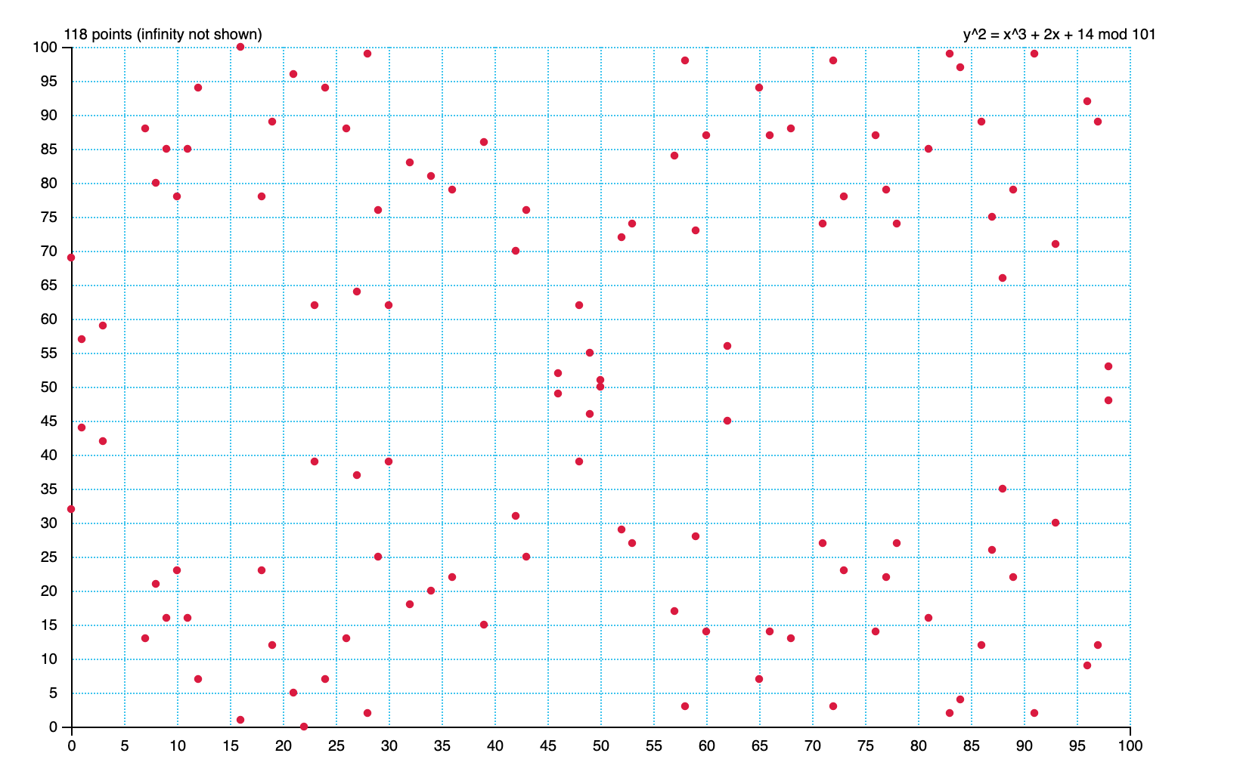

Figure 6: Elliptic curve under a prime finite modulo field

The second part that may be unfamiliar is the subscript p after the $F$ ($F_{p}$). The p means that the modulo for the finite field must be a prime number. This important as although point addition and multiplication still work under a finite field, they become slightly more complicated and rely on something called the modular multiplicative inverse which only exists if the finite field is prime (as is the case in figure 6).

ECC is an asymmetrical cryptography system so makes use of a public and private key. In this case the public key ($K_{pub}$) is a point on the curve and the private key ($K_{priv}$) is an integer such that $P×K_{priv}= K_{pub}$where P is also a point on the curve. As we can see this is just point multiplication and the reason that it is secure is that from the private key one can create the public key, but access to both P and the public key does not reveal the private key which is used to encrypt and decrypt the message (hence the names public and private). This allows messages to be encrypted, sent, and then decrypted along insecure paths (those that are vulnerable to hacking or interception) securely.

Elliptic Curve Digital Signature Algorithm (ECDSA):
A further extension of ECC is ECDSA, which is an algorithm that uses the public and private keys as well as a function called a ‘hash’. This function generates a unique number that is related to the data being sent but can’t be traced back to it (another trapdoor function). The signature verification method tells the receiver that the original message was the one the sender intended to send. If the message had been tampered with during transit, then the hash would be completely different, and the verification would come back as invalid. This can be very useful, especially when the frequency along which the message is sent or the sender is untrustworthy. This application makes ECC advantageous over other current cryptography methods like Diffie-Hellman and RSA which are less secure, less efficient and can’t verify that the original message hasn’t been tampered with. Some problems may arise in the future though, as it is thought this method of cryptography will still be susceptible to quantum computing attacks.

Fermat’s Last Theorem:

Long referred to as ‘the hardest problem in mathematics’ Fermat’s Last Theorem states that $x^{n}+y^{n}≠z^{n}$ for n greater than 2. For $n=2$ this is just Pythagoras’s Theorem $a^{2}+b^{2}=c^{2}$ which has countless solutions called Pythagorean triplets such as $3^{2}+4^{2}=5^{2}$. Several mathematicians proved the Theorem for special cases such as when $n=3$however the problem of the general case haunted thousands of unsuccessful mathematicians for over 350 years. That was, until Sir Andrew Wiles. Though he struggled with the problem for several decades, hitting road-block after road-bock, eventually he was able to prove the staggeringly hard problem, and all with the help of elliptic curves.
Figure 7: Andrew Wiles

He found that by proving a special case of the modularity theorem, otherwise known as the Taniyama–Shimura conjecture which deals with a specific type of elliptic curve called semistable elliptic curves, this could also give him the proof of Fermat’s Last Theorem. Finally he could accomplish his childhood dream.

His breakthrough came, on the brink of admitting defeat, thanks to the meshing together of the Kolyvagin–Flach and Iwasawa methods which had each individually proved inadequate to the task. Whilst the proof itself is incredibly complicated and intricate, what is obvious to even a novice is the centrality of elliptic curves to the problem. The first of two manuscripts published by Wiles which comprised the proof was entitled ‘Modular Elliptic Curves and Fermat’s Last Theorem’. His proof was so ground-breaking that it won Wiles several high-level awards including the Abel prize and a knighthood, and inspired the popular book entitled ‘Fermat’s Last Theorem’ by Simon Singh. Away from pop culture, Wiles’ work has had huge ramifications in the area of maths called number theory, and lead to a full proof of modularity theorem.

Looking to the future:
Even though it is evident that elliptic curves have already had a huge influence on our day to day lives in terms of technology, communication and government security with ECC and ECDSA, as well as pure mathematics and even literature with the proof of Fermat’s Last Theorem and number theory, there is still so much current research and potential for this simple type of equation - such as its part in the Birch and Swinnerton-Dyer conjecture which is one of the Millennium problems. These are seven chosen problems by the Clay Mathematics Institute (of which Andrew Wiles is part of the advisory board) for which a verifiable proof will earn $1 million. This clearly shows how mathematicians around the world view elliptic curves as being one of the keys to our future of mathematical understanding and progress, not just a tool of the past.

Figures 1-5 were created by me using desmos: https://www.desmos.com/calculator
Figure 6 was created by me using graui: https://graui.de/code/elliptic2/
Figure 7 was source from Wikipedia: https://en.wikipedia.org/wiki/Andrew_Wiles#/media/File:Andrew_wiles1-3.jpg

