The theoretical mathematics of human relationships

As an autistic individual, relationships are something I often struggle to comprehend. Being mathematically minded, I have wondered for a while if there is an equation to determine the behaviour of relationships, and how to define how attractive an individual is. The following essay will explore my own ideas around this subject, in addition to work that has been done by others.

To start, let's look at two similar physics equations:

$F_{G}$=$\frac{GM_{1}M_{2}}{r^{2}}$ and $F_{e}$=$\frac{K_{e}Q_{1}Q_{2}}{r^{2}}$

The two equations that determine the force of attraction between masses and charged objects respectively.

To hypothesise an equation, let’s take
$F_{G}$=$\frac{GM_{1}M_{2}}{r^{2}}$

Fg= a force of gravitational attraction
G= a gravitational constant (6.67408 × 10^-11 m^3 kg^-1s^-2)
M1 and M2 are two masses of objects (measured in kilograms)
r is the distance between them

Likewise, for
$F_{e}$=$\frac{K_{e}Q_{1}Q_{2}}{r^{2}}$

Fe= electric force of attraction
Ke= Coulomb’s constant (8.9875517923(14) ×10^9 kg⋅m^3⋅s^−2⋅C^−2)
Q1 and Q2 are electric charged (measured in coulombs)
r is the distance between two charged particles

Both equations have a constant, two measured quantities of which the force is to be
determined between, and a division by the square of the distance between the two objects.

A hypothesised relationship equation could be

$F_{A}$=$\frac{CA_{1}A_{2}}{S^{2}}$

Where:
Fa=force of attraction between two people
C=a relationship constant
A1 and A2 are the attractiveness of each individual
s is the distance between two individuals

The relationship equation appears to be plausible, however, the biggest challenges are still to come, namely:

- How do you calculate attractiveness?
- What is a “distance” between two people, and how is it even measured?

Gottman and Murray’s relationship equations

To discover the topic further, let’s look at what has already been created.
Psychologist John Gottman teamed up with mathematician James Murray to derive the following two equations about how relationships work. These have been known to predict when a couple will divorce with 90% accuracy. It can also predict the moves of nations in an arms race.

w(t+1) = w + rwWt + IHW(Ht)
h(t+1) = h + rhHt + IWH(Ht)

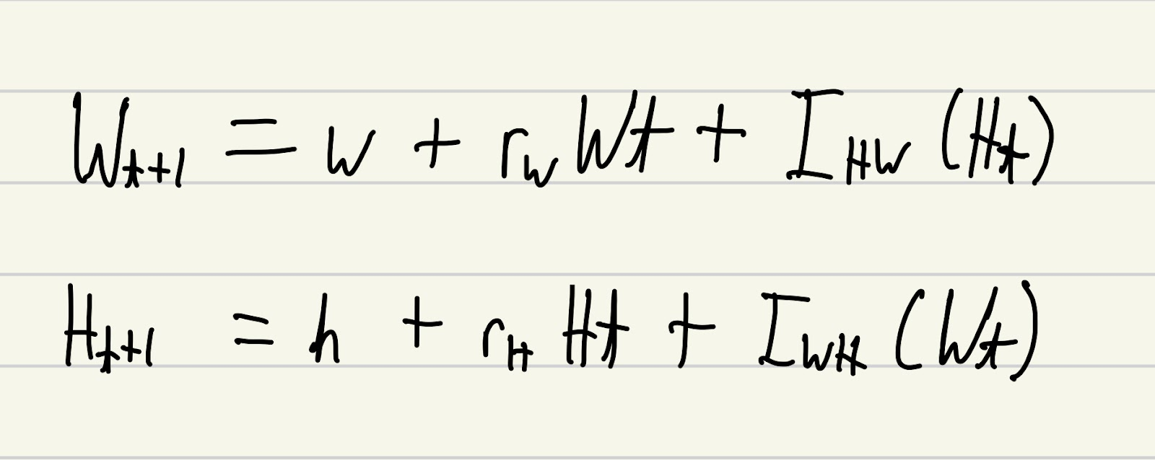

Where:
- w(t+1) is the wife’s next move in a relationship
- w is the wife’s general mood
- rwWt is the wife’s general mood with the husband
- IHW(Ht) is the husband’s influence on the wife considering the husband’s most recent action

Similarly
- h(t+1) is the husband’s next move in a relationship
- h is the husband’s general mood
- rhHt is the husband’s general mood with the wife
- IWH(Wt) is the influence of the wife on the husband considering the wife’s most recent action

Putting in my ideas

Let’s focus on the equation of the wife to start off with.

w(t+1) = w + rwWt + IHW(Ht)

We can set the term of IHW(Ht) (i.e., the husband’s influence on the wife), equal to the force of attraction in the relationship

w(t+1) = w + rwWt + Fa

Rearranging the equation, we get:

Fa= w(t+1) - (w + rwWt)

Remembering that
$F_{A}$=$\frac{CA_{1}A_{2}}{S^{2}}$

we get

$\frac{CA_{1}A_{2}}{S^{2}}$= w(t+1) - (w + rwWt)

Let $A_{1}$ be the attractiveness of the wife, and $A_{2}$ be the attractiveness of the husband,
rearranging for the attractiveness of the wife gives us:

$A_{1}$ = $\frac{S^{2}}{{CA}_{2}}$(w(t+1) - (w + rwWt))
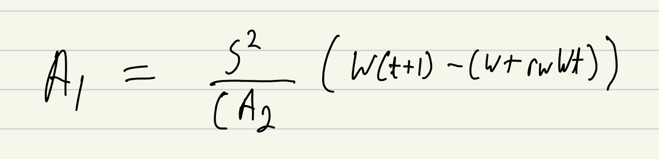

We will notice that this implies that the attractiveness of the wife depends on the attractiveness of the husband. If we then take the equation for the husband and set $F_{A}$ = IWH(Wt) and repeat the process as we did above rearranging for an equation in terms of. $A_{2}$ , and substitute this into the equation above (the one solving for $A_{1}$), many terms cancel out, leaving us with

(w(t+1) - (w + rwWt)) = (h(t+1) - (h + rhHt)

Or

Fa=Fa
(Unsurprisingly)

It is apparent that we have made an assumption that is very important to recognise:

We assume that: Fa = IHW(Ht) = IWH(Wt)
Or in English, the influence of the husband on the wife = the influence of the wife on the husband = force of attraction

If we continue to work with this assumption, let’s call the equation the ideal attractive relationship equation. To formally define this, let’s say that:

“The ideal attractiveness relationship equation uses the assumption that the influence of the husband on the wife = the influence of the wife on the husband = force of attraction in a relationship and algebraically is: $A_{1}$ = $\frac{S^{2}}{{CA}_{2}}$(w(t+1) - (w + rwWt)) ”

Note that the term “ideal” used here refers to an equation “nice” to work with, rather than a desirable relationship that is ideal to be in.

A “non-ideal” relationship equation is something to be worked on in the future.

The “distance” and “attractiveness “in a relationship

$F_{G}$=$\frac{GM_{1}M_{2}}{r^{2}}$ and $F_{e}$=$\frac{K_{e}Q_{1}Q_{2}}{r^{2}}$are very nice equations to work with; they have constant values, and variables that can be measured (mass, charge, and distance are all tangible quantities measures and definable by SI units that exist in the 4 dimensions of space time)

But then $F_{A}$=$\frac{CA_{1}A_{2}}{S^{2}}$ comes along. C will be a constant which is nice to work with, but then attractiveness and distance in a relationship appear, of which neither are tangible in the 4 dimensions of space time, nor have definable definitions.

My theory is that attractiveness and distance are some measurable quantities (that can be measured with a degree of uncertainty), that exist in another dimension, much like how theoretical physicists propose that “strings” exist in higher dimensions in string theory. What dimension this is if existing at all is a difficult concept and is something to be looked at in the future.

With regards to attractiveness, it can be believed that attractiveness behaves in a similar way to matter. That is, much like how Einstein proposed that mass warps space-time creating what we know as gravity, “attractiveness” may behave in a similar way warping the dimensional planes around it attracting other bodies towards it.

Conclusion

By developing the work of Gottman and Murray in the theoretical world, we have derived an ideal attractiveness relationship equation which can calculate the attractiveness of an individual in an ideal relationship (this is where the influence of partner 1 on partner 2 is equal to the influence of partner 2 on partner 1, which is equal to the force of attraction between the two individuals in a relationship). This implies that the attractiveness of one individual in a relationship is inversely proportional to the attractiveness of the other person in a relationship.

Attractiveness and distance currently have no tangible or formal definition; however, it is proposed that these exist in dimensions outside of those in the 4 dimensions of space time, and these can be measured and given formal definitions.

In the future work on a non-ideal relationship equation can be done as well as exploring what “distance” and “attractiveness” in relationships formally are.

