Fanta Flow (Exploring the basics of Fluid Dynamics through the lens of Fanta)
Contents:
- Fanta the Fluid
- Reynold’s Number and Turbulence
- Bernoulli’s Equation
- The Navier-Stokes Equations
- Grad, Div and Curl
- Citation
Fanta the Fluid (properties and behaviour)
Fanta, as we all know, is a soft drink. Fanta Orange is about £3 for 6. Its approximately 29% carbohydrate and is good for cleaning teeth from your head. And it’s not a very viscous fluid. This makes it the perfect medium for us to explore the fundamental concepts behind Fluid Dynamics through.
Reynold’s Number and Turbulence
What is the Reynold’s Number?
The Reynold’s Number is a dimensionless measurement that helps us predict the behaviour of a fluid by its flow pattern. Low (<1000) Reynold’s Numbers correspond to more laminar and even flow while high (>1000) Reynold’s Numbers corresponds to more turbulent and chaotic flow.
It is defined by being the ratio of inertial forces to shear stress or driving force to resistive force.
Derivation:
Inertia $(N)$:
This is the resistance to change in a body. It is dependent upon velocity and is the first derivative of momentum.
$$I= \frac{ⅆ}{ⅆt}\left(mv\right)$$
Here, velocity is taken to be constant. As such, this can be rewritten as:
$$I=ρAv×v$$
$$I=ρAv^{2}$$
----------------------------------------------------------------------------------------------------------------------------------------------------------------------------------------------------------------------------------------------------------------------------------------------------------------------------------------------------------------------------------------------------------------------------------------------------------------------------------------------------------------------------------------------------------------------------------------------------------------------------------------------------------------------------------------------------------------------------------------------------------------------------------------------------------------------------------------------------------------------------------------------------------------------------------------------------------------------------------------------------------------------------------------------------------------------------------------------------------------------------------------------------------------------------------------------------------------------------------------------------------------------------------------------------------------------------------------------------------------------------------------------------------------------------------------------------------------------------------------------------------------------------------
Viscous Force $(N)$:
Viscous Force can be considered as Shear Stress multiplied by the area over which it takes effect.
$$τ=A×μ\frac{u}{y}$$
As the body in question is a particle in the fluid, this equation can be rewritten as:
$$τ=Aμ\frac{du}{dy}$$
----------------------------------------------------------------------------------------------------------------------------------------------------------------------------------------------------------------------------------------------------------------------------------------------------------------------------------------------------------------------------------------------------------------------------------------------------------------------------------------------------------------------------------------------------------------------------------------------------------------------------------------------------------------------------------------------------------------------------------------------------------------------------------------------------------------------------------------------------------------------------------------------------------------------------------------------------------------------------------------------------------------------------------------------------------------------------------------------------------------------------------------------------------------------------------------------------------------------------------------------------------------------------------------------------------------------------------------------------------------------------------------------------------------------------------------------------------------------------------------------------------------------------------
So the ratio of inertial to resistive forces must be:
$$Re=\frac{I}{τ}=\frac{ρAv^{2}}{Aμ\frac{du}{dy}}=\frac{ρv^{2}}{μ}\frac{dy}{du}$$
----------------------------------------------------------------------------------------------------------------------------------------------------------------------------------------------------------------------------------------------------------------------------------------------------------------------------------------------------------------------------------------------------------------------------------------------------------------------------------------------------------------------------------------------------------------------------------------------------------------------------------------------------------------------------------------------------------------------------------------------------------------------------------------------------------------------------------------------------------------------------------------------------------------------------------------------------------------------------------------------------------------------------------------------------------------------------------------------------------------------------------------------------------------------------------------------------------------------------------------------------------------------------------------------------------------------------------------------------------------------------------------------------------------------------------------------------------------------------------------------------------------------------------
Since $\frac{du}{dy}$ is rate of change of velocity with respect to distance, it can be rewritten as:
$$\frac{du}{dy}=\frac{v-0}{L}$$
Where $v$ is the maximum velocity and $0$ is the minimum. Substituting this into the previous equation will yield:
$$Re=\frac{ρv^{2}L}{μv}=\frac{ρLv}{μ}$$
----------------------------------------------------------------------------------------------------------------------------------------------------------------------------------------------------------------------------------------------------------------------------------------------------------------------------------------------------------------------------------------------------------------------------------------------------------------------------------------------------------------------------------------------------------------------------------------------------------------------------------------------------------------------------------------------------------------------------------------------------------------------------------------------------------------------------------------------------------------------------------------------------------------------------------------------------------------------------------------------------------------------------------------------------------------------------------------------------------------------------------------------------------------------------------------------------------------------------------------------------------------------------------------------------------------------------------------------------------------------------------------------------------------------------------------------------------------------------------------------------------------------------------
$$Re=\frac{ρLv}{μ}$$

Bernoulli’s Equation
Below is the Bernoulli equation. It states that the total energy of a fluid remains constant in a streamline.
$$P_{1}+\frac{1}{2}ρv_{1}^{2}+ρgh_{1}=P_{2}+\frac{1}{2}ρv_{2}^{2}+ρgh_{2}$$
Core concepts:
Work Done ($J$):
$$W=Fd=PAd$$
----------------------------------------------------------------------------------------------------------------------------------------------------------------------------------------------------------------------------------------------------------------------------------------------------------------------------------------------------------------------------------------------------------------------------------------------------------------------------------------------------------------------------------------------------------------------------------------------------------------------------------------------------------------------------------------------------------------------------------------------------------------------------------------------------------------------------------------------------------------------------------------------------------------------------------------------------------------------------------------------------------------------------------------------------------------------------------------------------------------------------------------------------------------------------------------------------------------------------------------------------------------------------------------------------------------------------------------------------------------------------------------------------------------------------------------------------------------------------------------------------------------------------------
Kinetic Energy ($J$):
$$KE=\frac{1}{2}mv^{2}$$
----------------------------------------------------------------------------------------------------------------------------------------------------------------------------------------------------------------------------------------------------------------------------------------------------------------------------------------------------------------------------------------------------------------------------------------------------------------------------------------------------------------------------------------------------------------------------------------------------------------------------------------------------------------------------------------------------------------------------------------------------------------------------------------------------------------------------------------------------------------------------------------------------------------------------------------------------------------------------------------------------------------------------------------------------------------------------------------------------------------------------------------------------------------------------------------------------------------------------------------------------------------------------------------------------------------------------------------------------------------------------------------------------------------------------------------------------------------------------------------------------------------------------------
Gravitational Potential Energy ($J$):
$$GPE=mgh$$
----------------------------------------------------------------------------------------------------------------------------------------------------------------------------------------------------------------------------------------------------------------------------------------------------------------------------------------------------------------------------------------------------------------------------------------------------------------------------------------------------------------------------------------------------------------------------------------------------------------------------------------------------------------------------------------------------------------------------------------------------------------------------------------------------------------------------------------------------------------------------------------------------------------------------------------------------------------------------------------------------------------------------------------------------------------------------------------------------------------------------------------------------------------------------------------------------------------------------------------------------------------------------------------------------------------------------------------------------------------------------------------------------------------------------------------------------------------------------------------------------------------------------------

Derivation:
We start with a fluid moving in a streamline. A streamline is a line of travel for which the fluid experiences minimal friction. The fluid is measured at points $Δx_{1}$ from the mouth of a pipe and $Δx_{2}$ from the end of the pipe.
The sum of energy used (or work done) by the fluid is equal to the change in kinetic and potential energies.
$$W_{T}=W_{1}+W_{2}=ΔKE+ΔPE$$
----------------------------------------------------------------------------------------------------------------------------------------------------------------------------------------------------------------------------------------------------------------------------------------------------------------------------------------------------------------------------------------------------------------------------------------------------------------------------------------------------------------------------------------------------------------------------------------------------------------------------------------------------------------------------------------------------------------------------------------------------------------------------------------------------------------------------------------------------------------------------------------------------------------------------------------------------------------------------------------------------------------------------------------------------------------------------------------------------------------------------------------------------------------------------------------------------------------------------------------------------------------------------------------------------------------------------------------------------------------------------------------------------------------------------------------------------------------------------------------------------------------------------------
Total work done:
$$W_{1}=F_{1}Δx_{1}=P_{1}A_{1}Δx_{1}=P_{1}V$$
$$W_{2}={-F}_{2}Δx_{2}={-P}_{2}V$$
We can view $W_{2}$ as the unused in the pipe which is why it is negative.
----------------------------------------------------------------------------------------------------------------------------------------------------------------------------------------------------------------------------------------------------------------------------------------------------------------------------------------------------------------------------------------------------------------------------------------------------------------------------------------------------------------------------------------------------------------------------------------------------------------------------------------------------------------------------------------------------------------------------------------------------------------------------------------------------------------------------------------------------------------------------------------------------------------------------------------------------------------------------------------------------------------------------------------------------------------------------------------------------------------------------------------------------------------------------------------------------------------------------------------------------------------------------------------------------------------------------------------------------------------------------------------------------------------------------------------------------------------------------------------------------------------------------------
Kinetic and Potential Energies:
$$ΔKE= \frac{1}{2}mv_{2}^{2}-\frac{1}{2}mv_{1}^{2}$$
$$ΔPE=mgh_{2}-mgh_{1}$$
----------------------------------------------------------------------------------------------------------------------------------------------------------------------------------------------------------------------------------------------------------------------------------------------------------------------------------------------------------------------------------------------------------------------------------------------------------------------------------------------------------------------------------------------------------------------------------------------------------------------------------------------------------------------------------------------------------------------------------------------------------------------------------------------------------------------------------------------------------------------------------------------------------------------------------------------------------------------------------------------------------------------------------------------------------------------------------------------------------------------------------------------------------------------------------------------------------------------------------------------------------------------------------------------------------------------------------------------------------------------------------------------------------------------------------------------------------------------------------------------------------------------------------
Therefore:
$${P_{1}V-P}_{2}V=\frac{1}{2}mv_{2}^{2}-\frac{1}{2}mv_{1}^{2}+mgh_{2}-mgh_{1}$$
Given that pressure, $ρ$ can be found with the following:
$$ρ=\frac{m}{V}$$
Then:
$${P_{1}-P}_{2}=\frac{1}{2}ρv_{2}^{2}-\frac{1}{2}ρv_{1}^{2}+ρgh_{2}-ρgh_{1}$$
$$P_{1}+\frac{1}{2}ρv_{1}^{2}+ρgh_{1}=P_{2}+\frac{1}{2}ρv_{2}^{2}+ρgh_{2}$$
----------------------------------------------------------------------------------------------------------------------------------------------------------------------------------------------------------------------------------------------------------------------------------------------------------------------------------------------------------------------------------------------------------------------------------------------------------------------------------------------------------------------------------------------------------------------------------------------------------------------------------------------------------------------------------------------------------------------------------------------------------------------------------------------------------------------------------------------------------------------------------------------------------------------------------------------------------------------------------------------------------------------------------------------------------------------------------------------------------------------------------------------------------------------------------------------------------------------------------------------------------------------------------------------------------------------------------------------------------------------------------------------------------------------------------------------------------------------------------------------------------------------------------
Which gives us the Bernoulli Equation for the sum of energy in a streamline.

The Navier-Stokes Equations
What are they?
All the Navier-Stokes equations really say is that the sum of forces is equal to the mass multiplied by the acceleration. However, they hold much more detail than the usual $F=ma$. The Navier-Stokes equations can describe a fluid with more turbulent flow (i.e. higher Reynold’s Number), giving a more complete picture than the usual $F=ma$.
Here they are in 3 dimensions:
$$ρ\left(\frac{∂u}{∂t}+u\frac{∂u}{∂x}+v\frac{∂u}{∂y}+w\frac{∂v}{∂z}\right)=ρg_{x}-\frac{∂P}{∂x}+μ\left(\frac{∂^{2}u}{∂x^{2}}+\frac{∂^{2}u}{∂y^{2}}+\frac{∂^{2}u}{∂z^{2}}\right)$$
$$ρ\left(\frac{∂v}{∂t}+u\frac{∂v}{∂x}+v\frac{∂v}{∂y}+w\frac{∂v}{∂z}\right)=ρg_{y}-\frac{∂P}{∂y}+μ\left(\frac{∂^{2}v}{∂x^{2}}+\frac{∂^{2}v}{∂y^{2}}+\frac{∂^{2}v}{∂z^{2}}\right)$$
$$ρ\left(\frac{∂w}{∂t}+u\frac{∂w}{∂x}+v\frac{∂w}{∂y}+w\frac{∂w}{∂z}\right)=ρg_{z}-\frac{∂P}{∂y}+μ\left(\frac{∂^{2}w}{∂x^{2}}+\frac{∂^{2}w}{∂y^{2}}+\frac{∂^{2}w}{∂z^{2}}\right)$$
What is this essentially akin to is saying that:
$$ma_{x}=∑F_{x}$$
$$ma_{y}=∑F_{y}$$
$$ma_{z}=∑F_{z}$$

As $ρ=\frac{m}{v}$
Core concepts (for the following derivation):
Force ($N$):
$$F=ma$$
----------------------------------------------------------------------------------------------------------------------------------------------------------------------------------------------------------------------------------------------------------------------------------------------------------------------------------------------------------------------------------------------------------------------------------------------------------------------------------------------------------------------------------------------------------------------------------------------------------------------------------------------------------------------------------------------------------------------------------------------------------------------------------------------------------------------------------------------------------------------------------------------------------------------------------------------------------------------------------------------------------------------------------------------------------------------------------------------------------------------------------------------------------------------------------------------------------------------------------------------------------------------------------------------------------------------------------------------------------------------------------------------------------------------------------------------------------------------------------------------------------------------------------
Gravitational Potential Energy ($J$):
$$GPE=mgh$$
----------------------------------------------------------------------------------------------------------------------------------------------------------------------------------------------------------------------------------------------------------------------------------------------------------------------------------------------------------------------------------------------------------------------------------------------------------------------------------------------------------------------------------------------------------------------------------------------------------------------------------------------------------------------------------------------------------------------------------------------------------------------------------------------------------------------------------------------------------------------------------------------------------------------------------------------------------------------------------------------------------------------------------------------------------------------------------------------------------------------------------------------------------------------------------------------------------------------------------------------------------------------------------------------------------------------------------------------------------------------------------------------------------------------------------------------------------------------------------------------------------------------------------
Density ($kgm^{-3}$):
$$ρ=\frac{m}{V}$$
----------------------------------------------------------------------------------------------------------------------------------------------------------------------------------------------------------------------------------------------------------------------------------------------------------------------------------------------------------------------------------------------------------------------------------------------------------------------------------------------------------------------------------------------------------------------------------------------------------------------------------------------------------------------------------------------------------------------------------------------------------------------------------------------------------------------------------------------------------------------------------------------------------------------------------------------------------------------------------------------------------------------------------------------------------------------------------------------------------------------------------------------------------------------------------------------------------------------------------------------------------------------------------------------------------------------------------------------------------------------------------------------------------------------------------------------------------------------------------------------------------------------------------
Equations of Fluid Motion:
$σ_{xx}=-p+2μ\frac{ⅆu}{ⅆt}$, $τ_{xy}=τ_{xy}=μ\left(\frac{∂u}{∂y}+\frac{∂v}{∂x}\right)$, $τ_{zx}=τ_{xz}=μ\left(\frac{∂w}{∂x}+\frac{∂u}{∂z}\right)$
----------------------------------------------------------------------------------------------------------------------------------------------------------------------------------------------------------------------------------------------------------------------------------------------------------------------------------------------------------------------------------------------------------------------------------------------------------------------------------------------------------------------------------------------------------------------------------------------------------------------------------------------------------------------------------------------------------------------------------------------------------------------------------------------------------------------------------------------------------------------------------------------------------------------------------------------------------------------------------------------------------------------------------------------------------------------------------------------------------------------------------------------------------------------------------------------------------------------------------------------------------------------------------------------------------------------------------------------------------------------------------------------------------------------------------------------------------------------------------------------------------------------------------

Take a particle in a can of Fanta. That one particle’s volume compared to the rest of the Fanta is extremely small. As such, its volume can be referred to as a differential volume and its dimensions as $\frac{∂}{∂z}$, $\frac{∂}{∂y}$, $\frac{∂}{∂z}$. Its velocity in the $x$ direction is $u$, in the $y$ direction is $v$, and in the $z$ direction is $w$.
To begin, notice that the velocities can be described as functions of each axis.
Therefore $u$ is a function of $x, y, z$ and $t$. This can be written as $u(x, y, z, t)$
Acceleration:
The acceleration in a given direction can be viewed as the partial derivative in that direction with respect to time. Acceleration is $a_{n}$, where $n$ is the direction of the acceleration.
$$a_{x}=\frac{du}{dt}=\frac{∂u}{∂x}\frac{∂x}{∂t}+\frac{∂u}{∂y}\frac{∂y}{∂t}+\frac{∂u}{∂z}\frac{∂z}{∂t}$$
$$a_{y}=\frac{dv}{dt}=\frac{∂v}{∂x}\frac{∂x}{∂t}+\frac{∂v}{∂y}\frac{∂y}{∂t}+\frac{∂v}{∂z}\frac{∂z}{∂t}$$
$$a_{z}=\frac{dw}{dt}=\frac{∂w}{∂x}\frac{∂x}{∂t}+\frac{∂w}{∂y}\frac{∂y}{∂t}+\frac{∂w}{∂z}\frac{∂z}{∂t}$$
$$\frac{∂x}{∂t}=u, \frac{∂y}{∂t}=v, \frac{∂z}{∂t}=w$$
Therefore:
$$a_{x}=\frac{∂u}{∂t}+u\frac{∂u}{∂x}+v\frac{∂u}{∂y}+w\frac{∂v}{∂z}$$
$$a_{y}=\frac{∂v}{∂t}+u\frac{∂v}{∂x}+v\frac{∂v}{∂y}+w\frac{∂v}{∂z}$$
$$a_{z}=\frac{∂w}{∂t}+u\frac{∂w}{∂x}+v\frac{∂w}{∂y}+w\frac{∂w}{∂z}$$
Finally, to make this equal to the sum of forces we multiply this by the mass, or $ρ(dx dy dz)$
----------------------------------------------------------------------------------------------------------------------------------------------------------------------------------------------------------------------------------------------------------------------------------------------------------------------------------------------------------------------------------------------------------------------------------------------------------------------------------------------------------------------------------------------------------------------------------------------------------------------------------------------------------------------------------------------------------------------------------------------------------------------------------------------------------------------------------------------------------------------------------------------------------------------------------------------------------------------------------------------------------------------------------------------------------------------------------------------------------------------------------------------------------------------------------------------------------------------------------------------------------------------------------------------------------------------------------------------------------------------------------------------------------------------------------------------------------------------------------------------------------------------------------
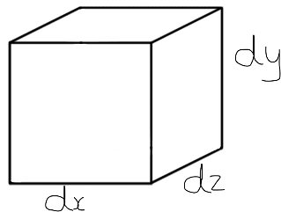
Forces:
The force exerted by gravity in the $x$ direction would be:
$$ρg_{x}(dx dy dz)$$
The same concept applies for the $y$ and $z$ directions:
$$ρg_{y}(dx dy dz)$$
$$ρg_{z}(dx dy dz)$$
Take a particle in the Fanta. If the bottom left corner is at a point $\left(x,y,z\right)$ the stresses on each face of the cuboid particle can be evaluated.
Initially, the forces will be observed exclusively in the $x$ direction.
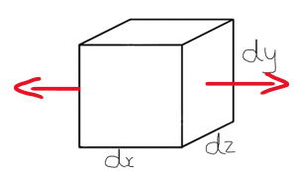
First, in the $x$ direction where $σ_{nx}$ is the pressure function in a given direction:
$$σ_{xx}\left(x+dx\right)dy dz-σ_{xx}\left(x\right)dy dz$$
Then the shear forces in the $y$ and $z$ directions where $τ_{nx}$ is the shear function in a given direction:
$$τ_{yx}\left(y+dy\right)dx dz-τ_{yx}\left(y\right)dx dz$$
$$τ_{zx}\left(z+dz\right)dx dy-τ_{zx}\left(z\right)dx dy$$
Therefore, the total force on the particle of Fanta in the $x$ direction is:
$$ρg_{x}\left(dx dy dz\right)+σ_{xx}\left(x+dx\right)dy dz-σ_{xx}\left(x\right)dy dz+τ_{yx}\left(y+dy\right)dx dz-τ_{yx}\left(y\right)dx dz+τ_{zx}\left(z+dz\right)dx dy-τ_{zx}\left(z\right)dx dy$$
----------------------------------------------------------------------------------------------------------------------------------------------------------------------------------------------------------------------------------------------------------------------------------------------------------------------------------------------------------------------------------------------------------------------------------------------------------------------------------------------------------------------------------------------------------------------------------------------------------------------------------------------------------------------------------------------------------------------------------------------------------------------------------------------------------------------------------------------------------------------------------------------------------------------------------------------------------------------------------------------------------------------------------------------------------------------------------------------------------------------------------------------------------------------------------------------------------------------------------------------------------------------------------------------------------------------------------------------------------------------------------------------------------------------------------------------------------------------------------------------------------------------------------
Unification:
$$ρg_{x}\left(dx dy dz\right)+σ_{xx}\left(x+dx\right)dy dz-σ_{xx}\left(x\right)dy dz+τ_{yx}\left(y+dy\right)dx dz-τ_{yx}\left(y\right)dx dz+τ_{zx}\left(z+dz\right)dx dy-τ_{zx}\left(z\right)dx dy$$
$$=ρ(dx dy dz)\left(\frac{∂u}{∂t}+u\frac{∂u}{∂x}+v\frac{∂u}{∂y}+w\frac{∂v}{∂z}\right)$$
$$\frac{ρg_{x}\left(dx dy dz\right)+σ_{xx}\left(x+dx\right)dy dz-σ_{xx}\left(x\right)dy dz+τ_{yx}\left(y+dy\right)dx dz-τ_{yx}\left(y\right)dx dz+τ_{zx}\left(z+dz\right)dx dy-τ_{zx}\left(z\right)dx dy}{dx dy dz}$$
$$=ρ\left(\frac{∂u}{∂t}+u\frac{∂u}{∂x}+v\frac{∂u}{∂y}+w\frac{∂v}{∂z}\right)$$
$$=ρg_{x}+\frac{σ_{xx}\left(x+dx\right)}{dx}-\frac{σ_{xx}\left(x\right)}{dx}+\frac{τ_{yx}\left(y+dy\right)}{dy}-\frac{τ_{yx}\left(y\right)}{dy}+\frac{τ_{zx}\left(z+dz\right)}{dz}-\frac{τ_{zx}\left(z\right)}{dz}$$
----------------------------------------------------------------------------------------------------------------------------------------------------------------------------------------------------------------------------------------------------------------------------------------------------------------------------------------------------------------------------------------------------------------------------------------------------------------------------------------------------------------------------------------------------------------------------------------------------------------------------------------------------------------------------------------------------------------------------------------------------------------------------------------------------------------------------------------------------------------------------------------------------------------------------------------------------------------------------------------------------------------------------------------------------------------------------------------------------------------------------------------------------------------------------------------------------------------------------------------------------------------------------------------------------------------------------------------------------------------------------------------------------------------------------------------------------------------------------------------------------------------------------------
Substitution:
$$\frac{ρg_{x}\left(dx dy dz\right)+σ_{xx}\left(x+dx\right)dy dz-σ_{xx}\left(x\right)dy dz+τ_{yx}\left(y+dy\right)dx dz-τ_{yx}\left(y\right)dx dz+τ_{zx}\left(z+dz\right)dx dy-τ_{zx}\left(z\right)dx dy}{dx dy dz}=$$
$$ρg_{x}+\frac{∂}{∂x}\left(-p+2μ\frac{∂u}{∂x}\right)+\frac{∂}{∂y} μ\left(\frac{∂u}{∂y}+\frac{∂v}{∂x}\right)+\frac{∂}{∂z} μ\left(\frac{∂w}{∂x}+\frac{∂u}{∂z}\right)=$$
$$ρg_{x}-\frac{∂P}{∂x}+μ\left(\frac{∂^{2}u}{∂x^{2}}+\frac{∂^{2}u}{∂y^{2}}+\frac{∂^{2}u}{∂z^{2}}\right)+μ\frac{∂}{∂x}\left(\frac{∂u}{∂x}+\frac{∂v}{∂y}+\frac{∂w}{∂z}\right)$$
Due to the continuity equation (something, here, we simply accept), $\frac{∂u}{∂x}+\frac{∂v}{∂y}+\frac{∂w}{∂z}=0$
Therefore, we end up with the following equation:
$$ρ\left(\frac{∂u}{∂t}+u\frac{∂u}{∂x}+v\frac{∂u}{∂y}+w\frac{∂v}{∂z}\right)=ρg_{x}-\frac{∂P}{∂x}+μ\left(\frac{∂^{2}u}{∂x^{2}}+\frac{∂^{2}u}{∂y^{2}}+\frac{∂^{2}u}{∂z^{2}}\right)$$
----------------------------------------------------------------------------------------------------------------------------------------------------------------------------------------------------------------------------------------------------------------------------------------------------------------------------------------------------------------------------------------------------------------------------------------------------------------------------------------------------------------------------------------------------------------------------------------------------------------------------------------------------------------------------------------------------------------------------------------------------------------------------------------------------------------------------------------------------------------------------------------------------------------------------------------------------------------------------------------------------------------------------------------------------------------------------------------------------------------------------------------------------------------------------------------------------------------------------------------------------------------------------------------------------------------------------------------------------------------------------------------------------------------------------------------------------------------------------------------------------------------------------------
Which is the Navier-Stokes equation for the $x$ direction. The same processes can be applied to the $y$ and $z$ directions to yield the Navier-Stokes equations in full.
Why are the Navier-Stokes equations currently unsolved?
The problem with Navier-Stokes is that it often involves turbulence. This is one of the many unsolved problems in Physics and were Navier-Stokes to be found to have a general solution, it would shed a great amount of light on turbulent flow. This is one of the reasons that the discovery of a solution is valued so highly.

Grad, Div and Curl
Core concepts:
Fields:
Systems of real or complex numbers. They can be represented on a plane.
Scalar fields give single values for some variable at a point in space whereas vector fields give a vector instead.
Dot Product ($⋅$):
$$\left(a_{x},a_{y},a_{z}\right)⋅\left(b_{x},b_{y},b_{z}\right)=a_{x}b_{x}+a_{y}b_{y}+a_{z}b_{z}$$
Produces the scalar product of its source vectors.
----------------------------------------------------------------------------------------------------------------------------------------------------------------------------------------------------------------------------------------------------------------------------------------------------------------------------------------------------------------------------------------------------------------------------------------------------------------------------------------------------------------------------------------------------------------------------------------------------------------------------------------------------------------------------------------------------------------------------------------------------------------------------------------------------------------------------------------------------------------------------------------------------------------------------------------------------------------------------------------------------------------------------------------------------------------------------------------------------------------------------------------------------------------------------------------------------------------------------------------------------------------------------------------------------------------------------------------------------------------------------------------------------------------------------------------------------------------------------------------------------------------------------------
Cross Product (×):
$$\left(a_{x},a_{y},a_{z}\right)×\left(b_{x},b_{y},b_{z}\right)=\left|\begin{aligned}a_{y},a_{z} \\ b_{x},b_{z}\end{aligned}\right|,- \left|\begin{aligned}a_{x},a_{z} \\ b_{x},b_{z}\end{aligned}\right|,\left|\begin{aligned}a_{x},a_{y} \\ b_{x},b_{y}\end{aligned}\right|$$
Produces a vector perpendicular to its source vectors.
----------------------------------------------------------------------------------------------------------------------------------------------------------------------------------------------------------------------------------------------------------------------------------------------------------------------------------------------------------------------------------------------------------------------------------------------------------------------------------------------------------------------------------------------------------------------------------------------------------------------------------------------------------------------------------------------------------------------------------------------------------------------------------------------------------------------------------------------------------------------------------------------------------------------------------------------------------------------------------------------------------------------------------------------------------------------------------------------------------------------------------------------------------------------------------------------------------------------------------------------------------------------------------------------------------------------------------------------------------------------------------------------------------------------------------------------------------------------------------------------------------------------------------

Nabla/Del ($∇$) is an operator and is a vector quantity such that $∇=(\frac{∂}{∂x},\frac{∂}{∂y},\frac{∂}{∂y})$
Visualisations:

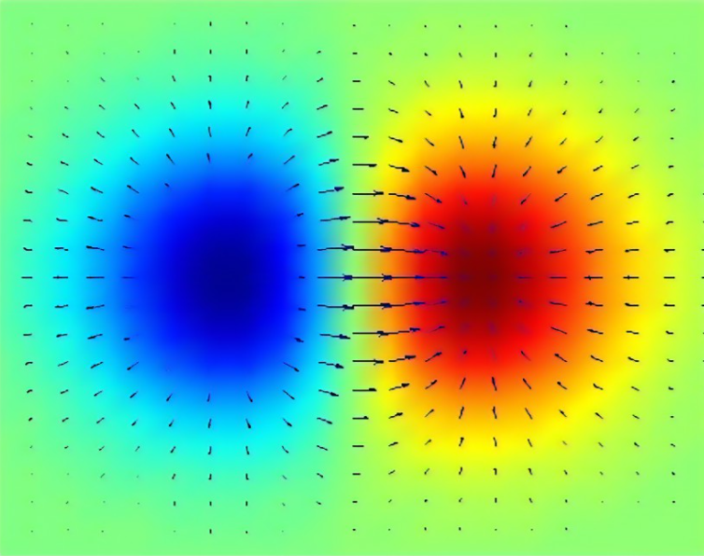
When Del is applied to a scalar field, it is called Grad/Gradient. This will transform it into a vector field that shows direction and rate of change of the scalar quantities. In other words, Grad can be seen as the gradient function of a scalar field. The scalar quantities are represented above as colours. Warmer colours correspond to a higher value (i.e. $\frac{1}{f}∝x$ where $f$ is the frequency of the colour and $x$ is the variable scalar quantity). This is like seeing how the particles in your Fanta will flow through time
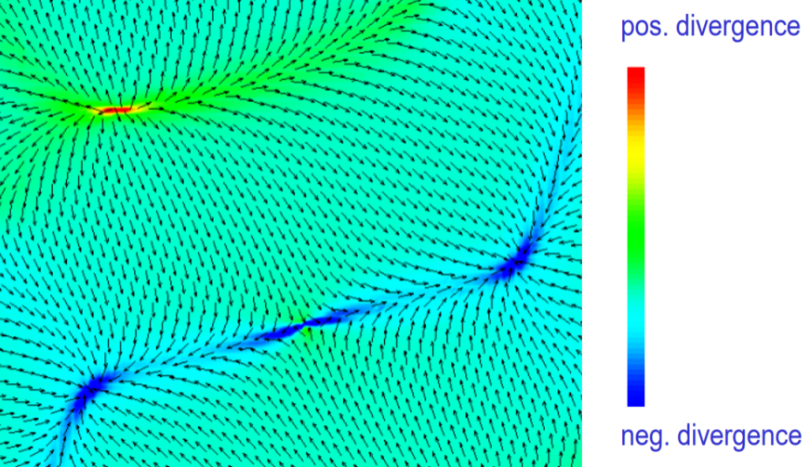
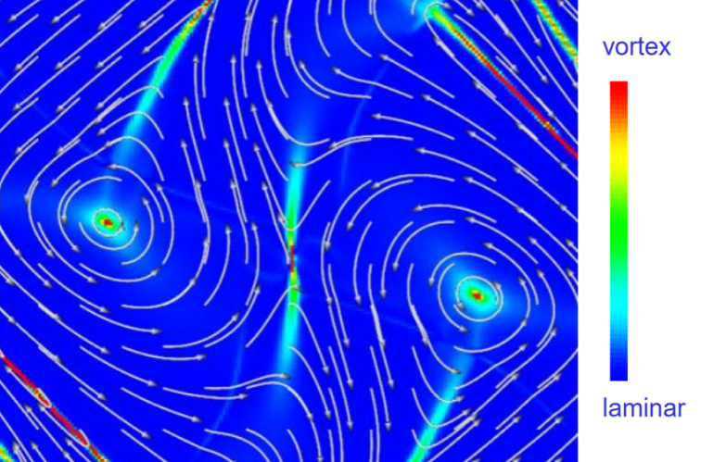
When Del is applied as a dot product to a vector field, it is called Div/Divergence. This will produce a scalar field and in the case of our vector field, it will give us the scalar field from before. In fluid dynamics, it measures the tendency of the fluid to collect or disperse at a point. When you drink your Fanta, it diverges negatively in the direction of your mouth and positively towards the bottom of the can.
When Del is applied as a cross product to a vector field, it is called Curl. This measures the circulation of the field or how the field rotates overall. The magnitude of the resultant vector (after applying Curl) is the size of the circulation of the field. This is akin to spinning your can of Fanta and seeing the direction that it swirls in.

That concludes my overview of the basics of Fluid Dynamics.

Citation:

Derivation of the Navier-Stokes equations - tec-science
Description and Derivation of the Navier-Stokes Equations - YouTube
Bernoulli Equation Derivation - YouTube
Reynolds number: Reynolds number formula, derivation, significance and critical reynolds number - YouTube
Derivation of Reynolds Number – Explanation, Derivation, Significance and Value (vedantu.com)
This Downward Pointing Triangle Means Grad Div and Curl in Vector Calculus (Nabla / Del) by Parth G - YouTube
Wright State University’s Vector Visualisation PDF as of 31/03/2022 at 22:55
main-qimg-a7282244f4f57554ba793526f28d7e77-c (560×420) (quoracdn.net)

