The Fascinating world of Fractals
If I asked you to solve this puzzle, would you be able to?
Let’s say you have a largely impossible number of sheep and an infinite number of fences. You need to create and build an enclosure for them – how do you do that? What shape do you lay your fences in?
Well, the title gives away the answer : fractals. Simply put, a fractal is a never ending shape that is heavily complex and self-reflecting for an infinite distance as far as we know. Fractals depend on a never ending feedback loop and the process of recursion : trying to reach a point however failing to do so. Due to this, no matter how close one might magnify or zoom in on a thought-to-be specific point, it will not be reached. Instead, it appears to the human mind and eye as if we are converging onto that point and at the same time distancing ourselves even further away, creating a mirage effect, sometimes described as a hypnotic effect.

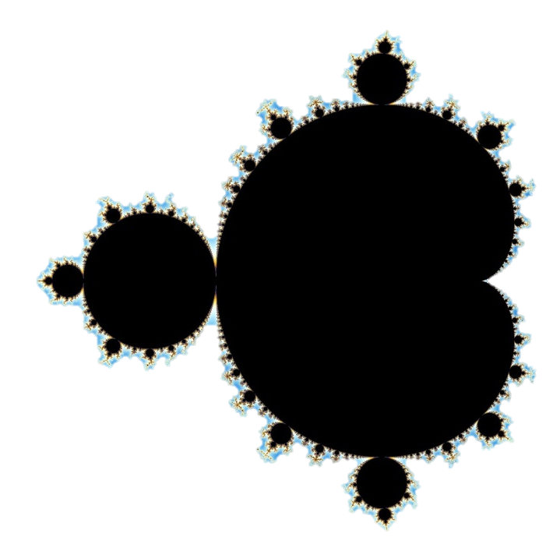
Back to the problem of fences, however much theoretical it is and seems to be, it can prove that fractals, one – have a closed perimeter, and two – have an infinite area. These two facts somewhat contradict each other and the basis of geometry: having a set perimeter and yet not being able to calculate the area within. It is absolutely fascinating, especially to those who understand this concept since no matter how vague fractals seem to be and can be, we are constantly surrounded by and reminded of said fractals.

As far as the laws of mathematics refer to reality, they are not certain, and as far as they are certain, they do not refer to reality.”
-Albert Einstein

Rivers, leaves, mountains and coastlines : what do they have in common?
Of course, they are all part of nature, and that too on a massive scale. Nevertheless, despite their magnitude of size, even they are subjected to the wonders of fractals. Our entire being and creation seems to be a fractal within itself. Fractals do not necessarily have to be the iconic shape that we’ve seen before as mathematics can take any shape or form as we know it.
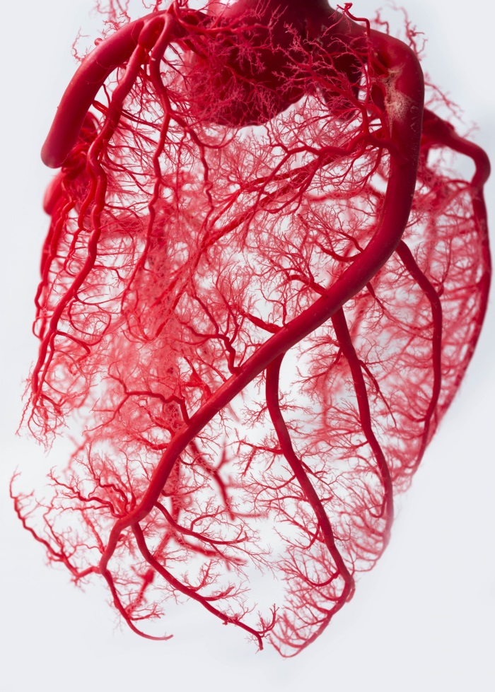
For example, a single spot of tissue : if we zoom in past the skin and then past our tissue and then past our tissue fibre, diving down past a single fibre and into a single cell – even then we do not reach the epitome of the micro-verse within ourselves. This is because even within our very cells, there are micro-organelles which have their own individual structures and components.
It is highly likely that we could delve even further than ever before as the only limiting factor in knowing more about our very being and surroundings would technically be us. Our technology, ideologies and theorems have allowed humanity to see deep into worlds within our world and will eventually limit us knowing just how far we can explore the universe within our universe.
However, knowing what we know now , especially how not everything is in a set dimension and allows freedom of movement and interpretation , allowing curiosity and chaos to drive our inevitable search for the limits of the unknown – and is that not a representation and example of a fractal?
What about outside the realm of micro-verses the sole reliance of microscopes?
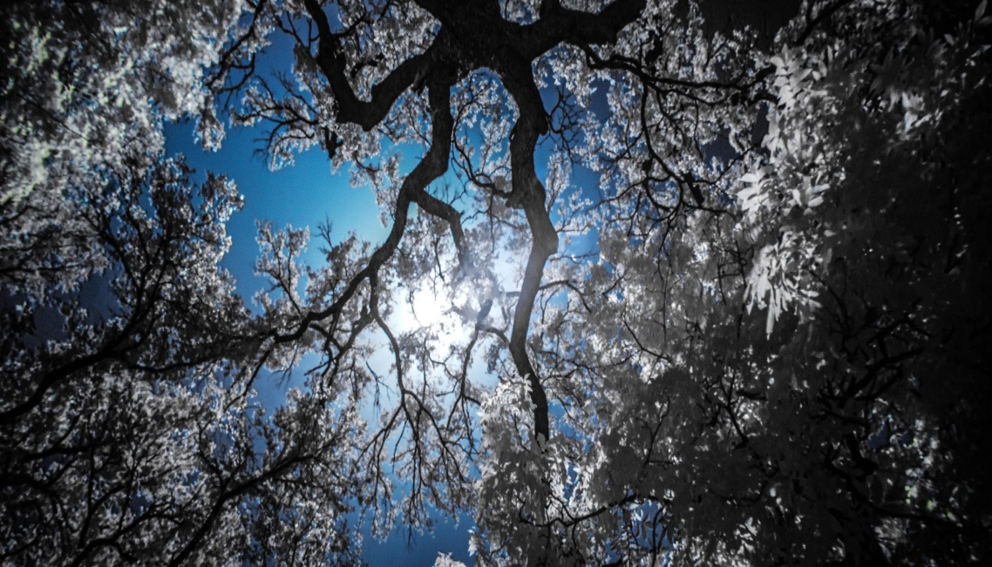
Where else in nature can we see fractals? One of the most common examples would be that of trees and fern species.
The random movement and outstretch of branches creates a pattern similar to that of a fractal as each smaller growing branch seems to be a replica or have a similarity to that of which it grew out of. Fractals not only allowing curios shapes to form, but also allow an extended amount of structure and support to an object as the repeated structure and accuracy stabilises the object.

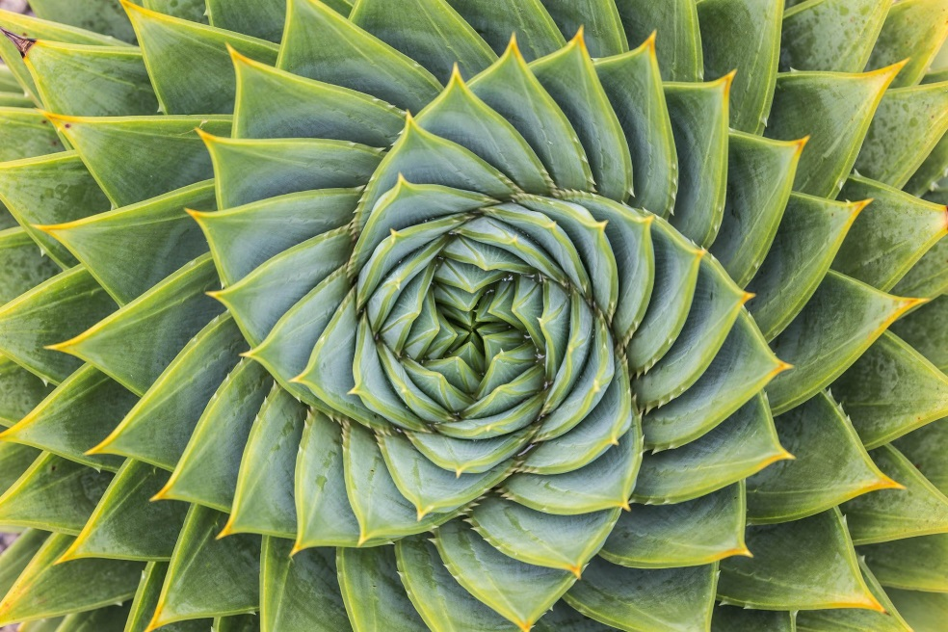
The most common example is that in broccoli and cauliflower , whose repeated pattern – on the surface level and microscopically- show the fine lines of mathematical accuracy and precision allowing a repeated work of meticulous folds and sequences.

Aside from the biological aspect and example of fractals, they can be found everywhere in nature however, disguised as something else : art. Many assumed , and some still assume that science and art are too different to be compared and contrasted with each other, when in fact, they survive and are dependent on one another to create a harmonic masterpiece of both versions of art.

Math is beautiful, and when answering when or why, others may assume we are referring to the completion of an equation or derivation. When in fact, answers can stem further away from that than thought. Fractals in itself can be thought of art – Benoit Mandelbrot, inventor and discoverer of fractal – geometry is known for helping bridge the gap between art and mathematics via his discovery of fractals and admiration of the arts.
One of the easiest pieces of art to recognise from both sides of the spectrum is a snowflake. Naturally created and found in nature, snowflakes create intricate pattering and crevices resulting in a one of kind shape, all whilst representing a fractal. This is due to the ongoing iteration of the shape : the smaller it becomes, the more details it displays which therefor creates a complex patterning.

On the other hand, snowflakes also represent the mathematics behind fractals. As fractals can and do stem from simple shapes, such as squares, triangles, circles ; to create a complex design by simply adding to the shape in a particular way.
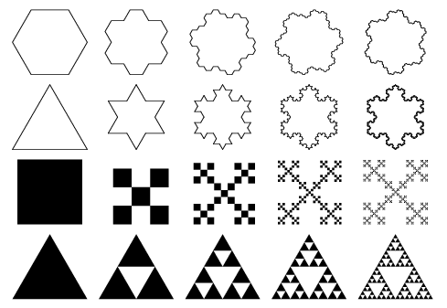
Below is a common diagram displaying how a fractal can originate from a once simple and straightforward shape.
The most iconic base shape is a triangle, which can be used to create what is referred to as the Sierpinski Gasket : a single triangle with an infinite number of iterations in which you can triple the triangles shape to create an inverted triangle within it , whilst assuring the overall shape still represents the starting triangle.
It is quite astonishing how infinite the possibilities and likelihood of noticing a fractal is. Iteration of a single root of graph – which is where I most recently noticed it being a fractal whilst learning about converging on a set point – is a fractal within itself, of course increasing its identity the further you go on the more precise you wish to be with your point. Even the fact that, whilst reading this right now, your computer screen is made up of many fractals making up pixels, and those pixels making up what you see and can not see is fascinating within itself.
Fractals have both opened up whole new possibilities and theories – not only in the STEM community but rather in all across the board of different curiosities. Yet, only created new problems to solve and variables to take into account. The infinite-area shape, which has proven infinite multi-verses within our known universe and galaxy, has left an infinite amount of possibilities waiting to be discovered.

