Cryptography, Quantum Computing and Primes

Throughout history, empires, governments, and people have always wanted to keep things secret, to protect themselves, others, or the public. In this short essay I will seek to decode the history of cryptography, unlock its strong relation to the primes and decipher the future of cryptography.

Early Years
One of the earliest forms of cipher was the scytale used by Spartans around 500 BC.

An example of what they looked like with a worrying message.

The scytale consisted of a length of leather usually with letters written on it and then sent to its destination. This message could then be decoded by recipient by wrapping leather around a rod of the same radius as the one it was encrypted on.
Then came one of the most heard about and simplest ciphers - the Caesar cypher. This type of encryption simply shifts the letters in the alphabet a certain number of times. A shift of 4 maps A to E and so on.
For a while there was small improvements and in the world of cryptography as mathematics went through its ‘dark ages’ but it was reignited by WW2.

WW2
The Germans created the Enigma machine, a revolutionary machine which builds upon Edward Hebern’s device by including multiple rotors and a plugboard to increase the level of encryption.
Unknown to many a Polish mathematician named Marian Rejewski uncovered how Enigma worked in 1932.
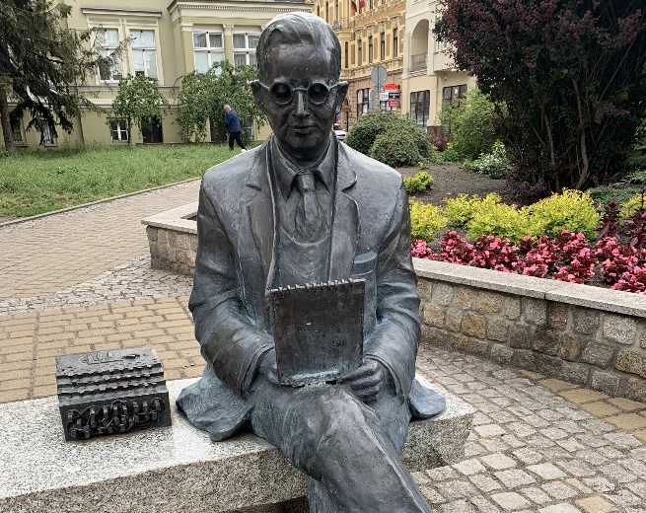
This is his statue in Bydgoszcz, Poland. With an enigma machine on the bench with him.
Rejewski attended Gottingen University for a time. At the same time David Hilbert was professor there, a legend famous for his work with prime numbers and the Riemann hypothesis, a hypothesis born from Gottingen by Riemann which holds great importance in everyday cryptography today.

Perhaps it was by coincidence or fate that Rejewski, a man who worked in cryptography was to cross paths with the place where Hilbert studied the primes as later cryptography and the primes would encounter each other again.
With the information of Enigma discovered by Rejewski now being shared with the French and British intelligence the story of Alan Turing and Bletchley Park could begin. Many of us know of the incredible work of Alan Turing and his team at Bletchley from Andrew Hodges’ book ‘Alan Turing: The Enigma’ and the fantastic movie ‘The Imitation Game’. The work at Bletchley, kept secret from the public, set in motion the cogs for modern day cryptography with the development of computers.

RSA and Primes
We jump a few years to RSA cryptography. RSA standing for Rivest-Shamir-Adleman, the surnames of the outstanding mathematicians who developed this clever algorithm to encrypt and decrypt messages. Many of the previous examples of ciphers have been one key, this means that one key to encrypt the data and the same key to decrypt However, RSA uses two keys. One is called the public key used to encrypt your data and can be seen by everyone, the second is the private key used to decrypt your data and is only known by those needed to decrypt the sensitive information such as banks.
The main takeaway is that RSA uses extremely large prime numbers, those which have over 100 digits. We know from Euler that there is an infinite number of primes but we know little of how they are distributed which is what RSA so cleverly exploits therefore, I will briefly return to the Riemann hypothesis and the implications that this may have on RSA. It is possible that a proof of the Riemann hypothesis and deeper understanding of the primes that there are methods which are more efficient to find these large primes. This could topple current encryption making online banking transactions no longer secure and have a devastating global impact. This is strange since it seems the more we understand of the primes, the greater the devastating the effects. However, proving the Riemann hypothesis could have many positive impacts such as a greater understanding of quantum physics. The Riemann hypothesis’s allure of not just the one million pounds prize money for solving it but immortal fame is inviting but, should we risk modern safety and cryptography in the pursuit of such new knowledge?

Quantum Computing and the Future
Recently there has been great investment by countries and companies in quantum computing including Microsoft, IBM, GCHQ, and the UK government, with Prime Minister Rishi Sunak planning to invest nine million pounds in the program. A quantum computer carries immense risks to modern day cryptography as a large quantum computer may only take minutes to solve a problem that would take a current computer a couple million years. Similar to the Riemann hypothesis there are huge benefits to quantum computers such as speed up of life-saving drugs and molecular simulation. However, they will also be able to solve the problems that are the current strengths of modern day cryptographic algorithms. Public key encryptions like RSA are described as asymmetric algorithms and their strength is due to the factoring of large integers comprised of huge primes. Peter Shor, an American professor at MIT, created Shor’s algorithm which exposed the faults of public key cryptography. He discovered that with a sufficiently powerful quantum computer his quantum algorithm could efficiently solve the factoring of these primes.
Let us also look into the past at our old and sensitive data that we have forgotten that is encrypted with old methods. This data will become susceptible to decryption once a quantum computer has been produced so it is not just new data that needs protection.
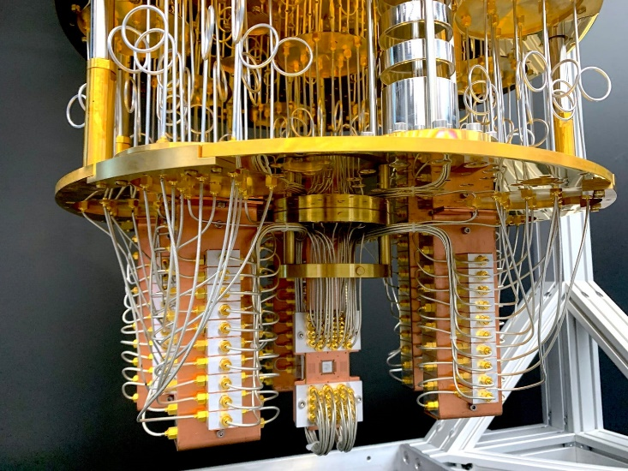
Here is an example of IBM’s quantum computer. Similar to early computer’s they are the size a whole room. One day could they be portable too, even able to fit in our pockets?

From the last few paragraphs the future seems bleak as in many ways current cryptographic techniques could be broken but there is hope.

Governments are preparing for this eventuality of a quantum computer which can decrypt modern techniques and are starting to implement programs to address this issue but the question becomes how can we adapt our methods of encryption for a future involving quantum computing? The National Institute of Standards and Technology (NIST) have initiated a ‘Post-Quantum Cryptography Standardization Program’ to discover new ways to overcome the threats of quantum computing. The NIST have whittled these algorithms down to start testing them so we can discover a new method. Is this enough? I believe that these algorithms will quickly become outdated and unsafe once quantum computing gathers pace; similar to RSA which had to evolve to larger and larger primes for security these new algorithms will have to overcome the power of a quantum computer. It is difficult to say how powerful these computers can become and we must be ready.
I hope from this short essay you can see cryptography is a living organism such as Darwin theorised. An organism which has evolved overtime from the simple Caesar cipher to enigma then RSA and has had to adapt to its surroundings becoming safer and harder to crack. Currently cryptography is going through another evolution in its life into the world of quantum and it must be able to change to keep our world’s secrets safe. This leaves us with these questions: How will quantum computing revolutionise the world? Who will be the one to discover an algorithm capable of warding off attacks by quantum computers? What will the future of cryptography look like?

Bibliography
https://www.ibm.com/cloud/blog/what-is-quantum-safe-cryptography-and-why-do-we-need-it
https://www.thalesgroup.com/en/markets/digital-identity-and-security/magazine/brief-history-encryption
https://mathshistory.st-andrews.ac.uk/Biographies/Rejewski/
https://www.ncsc.gov.uk/whitepaper/preparing-for-quantum-safe-cryptography
https://www.uab.edu/inquiro/issues/past-issues/volume-9/the-unexpected-connection-between-internet-security-and-the-riemann-hypothesis

