Fractals and their applications in cancer research

Fractals are geometrical shapes which have infinite levels of detail. Fractals have an identity known as self-similarity meaning that no matter how much you zoom in, the same pattern is produced.

They are useful in a range of areas including mathematical modelling and medicine.

The well-known Euclidean Geometry has been a useful tool in mathematical modelling throughout the age. Euclidean Geometry exists such that a point has dimension 0, a line dimension 1, a plane dimension 2 and a volume with dimension 3. However, fractal geometry concerns itself with dimensions in a range between one and two or two and three or three and four; 1.585 (the fractal dimension of the Sierpinski triangle) is an example. This helps us to understand the complex systems within the human body as many structures are not simply shapes but intertwine and extend through one another. The dimension held by a fractal is known as the fractal dimension and this helps us determine the size of the irregular curves which cannot be done with Euclidean Geometry. In the same way that Mandelbrot said, “Clouds are not spheres, mountains are not cones, coastlines are not circles, and bark is not smooth…”, we can use fractals to gain deeper understanding to the intricate workings of a shape.
Fractals can be physical or generated on a computer. An example of a physical fractal is Koch’s snowflake:
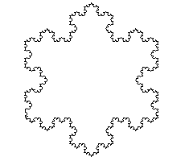
Here, zooming into the top of the snowflake will result in the same generated image, self-similarity.

However, physical fractals will never truly be infinitely self-similar as when zooming in so far to subatomic particles, it is found that there is nothing physically infinite.

The famous known computer-generated Mandelbrot set is generated by iteration, the repetition of a function at increasing values.
The equation for this iteration is very simple and consists of just a quadratic as follows:
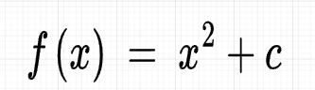
Where c is a constant number

In order to iterate this function, we assign a seed to the iteration such that:
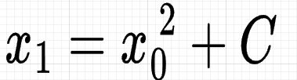

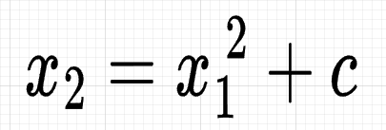
Then, we iterate by using the result for the previous as the input for the next:

And so on.
There is a list of numbers produced from this iteration which are known as the orbit of x₀ under iteration of x²+c.

If we have the constant c = 1, and the seed x₀=0, then we see that the values we obtain tend to infinity:
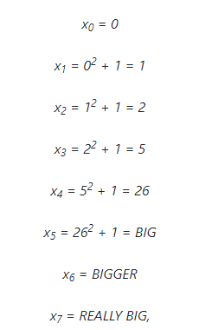

With c as 0, the results are all 0:

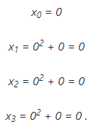

With c = -1, the results are known as having a cycle period of 2 with repeating values.
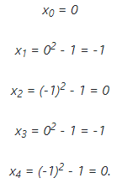

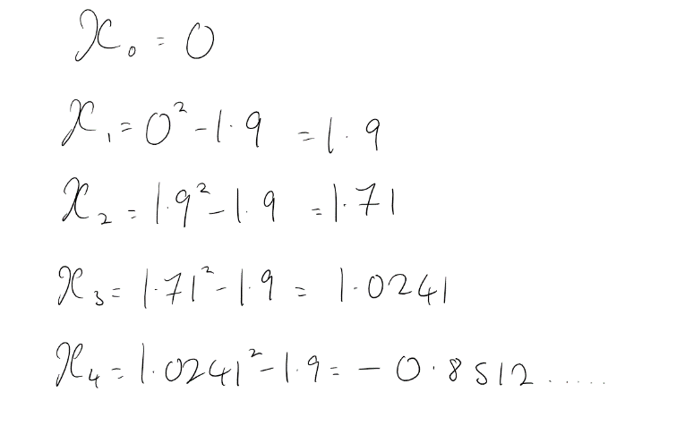
For other values of c such as -1.9, there is no pattern to the iterations produced which is known as chaos, the unpredictability of the sequence.

When inputting complex numbers as c. When c = i, then the iteration is given as a cycle period of 2.
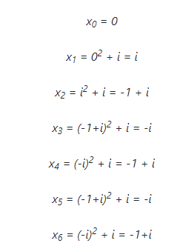

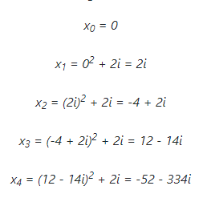
However, if we chance c to 2i, then the orbit tends to infinity but on the complex plane.

From this, we can conclude that the orbits are a dichotomy, they will either tend to infinity or will not for specific values of c.

The Mandelbrot set consists of all the complex values of c for which their orbits under x²+c does not tend to infinity. These graphed on an argand diagram result in the following image:
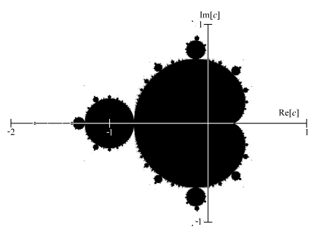

The box counting method is a technique used to study the fractal properties of an object. It is a method that involves counting the number of boxes of a fixed size needed to cover the object at different scales.
The method is based on fractal defining concept of self-similarity.
To apply the box counting method, we start by selecting a scale, which is the size of the boxes we will use to cover the object. This scale needs to be small enough to contain the smaller details of the object but large enough to cover the entire object. Next, we place the boxes over the object and count the number of boxes needed to cover the object we are interested in at that scale. We repeat this process for different scales, covering the object with boxes of progressively larger or smaller sizes.
After counting the number of boxes needed to cover the object at different scales, we plot the number of boxes against 1 / the size length of the boxes on a logarithmic scale.

If the object is a fractal, the plot should be linear, with a gradient equal to the fractal dimension of the object.
D = The fractal dimension
N = number of boxes
r = 1/side length of boxes
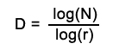

The fractal dimension is a measure of the complexity of the object, and it can be used to identify its fractal properties.

For an example, the box method will be carried out over a map of the British coastline.

The first step is to take the object and overlay is with a grid of boxes with a known length of 10 units on each side:

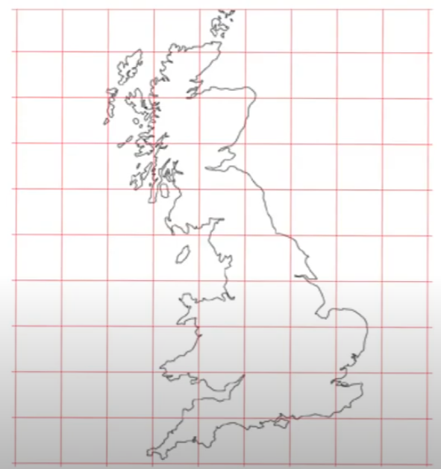
A
B

You then count the number of boxes in which the coastline Britain appears. Box A is not counted as it does not contain any of the coastline however box B is counted.

Here, the number of boxes counted was 36.

Then, the number of boxes at a different scale is counted with the new length of each side being 12 units.

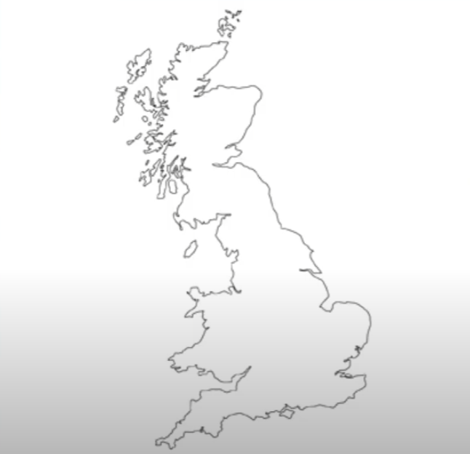


Now, 27 boxes have been counted.
This is then repeated, resulting in a list of numbers comprising of the number of boxes and the length of each side.

The intelligent design argument is that the human body and all the intricacies of the body must be subject to an omnipotent creator and although this cannot be disproven, the usage of fractals brings us one step closer to understanding the human body from a mathematical perspective.
The human body is made up of a range of complex structures from the tree like branching of bronchioles in the lung to the network of capillaries, what looks impossible to navigate can actually be modelled geometrically. The precision of fractals allows us to interpret the size of the irregular curves and the ability to apply this in medicine.

We can use fractal dimension values to help distinguish between cancerous and normal cells. As cancerous cells divide at faster, uncontrollable rates they generally would have a higher fractal dimension number than normal cells providing a way to determine between the two. However, there are some limitations one being that there would be a range at which both the cancerous and healthy cells would have the same fractal dimension number meaning there would be no way using fractals to distinguish between the two.

This was done in practice with an experiment ran by Bauer and Mackenzie who took electron microscope imagining of hairy leukaemia cells and calculated the fractal dimension using the box counting method and then comparing them to that of the normal cells. The data collection showed that the normal cells had a fractal dimension of d = 1.28 or less whereas the cancer cells had only more than 1.28, as shown in the following histogram.

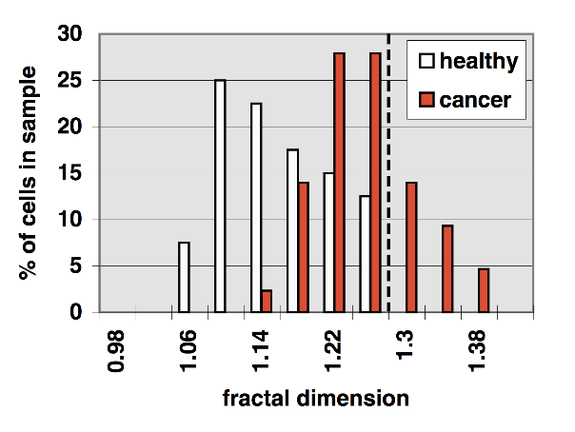

By determining the fractal dimension of healthy cells, we can also see if treatments for cancerous tissues is effective. If the dimension number on a treated cell tends to the number of the healthy cell, this shows a positive affect and can result in more time and development into this medicine.

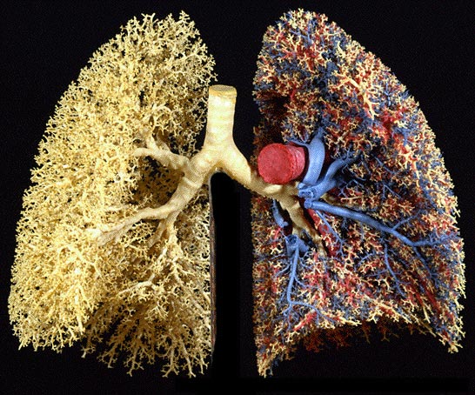
In other areas of medicine, fractals are also beginning to be used such as in MRI and CT scans to help analyse and identify certain diseases and even in the development of prosthetics analysis of fractals has been used to study the structure of bone and develop new prosthetic devices that mimic the structure of regular bone tissue. This has led to more effective prosthetics that are better integrated into the body. Fractals are present in everyday life in lightning strikes, in the complex nature of the branches of trees and their relation with the lungs. These images are now being used to save those lives making them all the more fascinating to explore.

References:
https://fractaltodesktop.com/mandelbrot-set-basics/index.html#:~:text=How%20the%20Mandelbrot%20Set%20is,the%20original%20location%20as%20C.
Applications of fractals in medicine - Kaoutar Lamrini Uahabi and Mohamed Atount
https://royalsocietypublishing.org/doi/10.1098/rsos.160558
http://fractalfoundation.org/OFC/OFC-12-4.html
https://www.researchgate.net/publication/226787567_Cancer_Detection_on_a_Cell-by-Cell_Basis_Using_a_Fractal_Dimension_Analysis
https://www.ncbi.nlm.nih.gov/pmc/articles/PMC8836744/
https://math.stackexchange.com/questions/3401675/what-is-the-fractal-dimension-hausdorff-dimension-of-a-kochs-snowflake
https://math.stackexchange.com/questions/3450800/finding-the-fractal-dimension-of-the-mandelbrot-set-using-the-box-counting-metho
https://www.youtube.com/watch?v=f83rCaCkdh4
https://www.bbc.co.uk/news/magazine-11564766
https://fractaltodesktop.com/mandelbrot-set-basics/index.html#:~:text=How%20the%20Mandelbrot%20Set%20is,the%20original%20location%20as%20C.
https://plus.maths.org/content/what-mandelbrot-set#:~:text=For%20the%20Mandelbrot%20set%2C%20the,c%20is%20a%20constant%20number.

