Geometry in Action: A Journey through the World of Numbers
Allow me, if you will, to ask you a simple question. Which area of mathematics fascinates you the most and why?
I vividly remember being asked this exact same question by a classmate earlier this year. Eventually, after much thought, I arrived at my answer: the geometry of numbers.
As a subject that encompasses a wide range of concepts and theories, mathematics is often divided into distinct, disparate branches.
However, it is important to recognize that these branches are not completely independent of each other. In fact, the different branches of mathematics are deeply interconnected, and many ideas from one branch have applications in others.
Personally speaking, the geometry of numbers is the branch of mathematics which best embodies this characteristic. For those who many not be too familiar with this topic, it is the branch of number theory which uses geometry for the study of algebraic numbers.
To begin, it would be remiss for me to not mention Minkowski’s theorem, one of the fundamental results in and the foundation of the geometry of numbers. For simplicity’s sake, we’ll only consider the case for two-dimensional space.
Theorem 1: Suppose $C$is a bounded, convex and symmetric set in $R^{2}$. If the area of $C$ is greater than $4$, then $C$contains at least one lattice point in $Z^{2}$ other than the origin.
Sounds confusing? Let’s unpack this term by term.
A lattice point in $Z^{2}$ refers to a point in $R^{2}$ with integer coordinates. For $C$ to be bounded, that means we are able to enclose $C$ within another body, such as a large circle. When we say $C$ is convex, any segment joining any two of its points is entirely contained within it. Taking the two shapes below as an example, the blue set on the left is convex while the green set on the right is not.
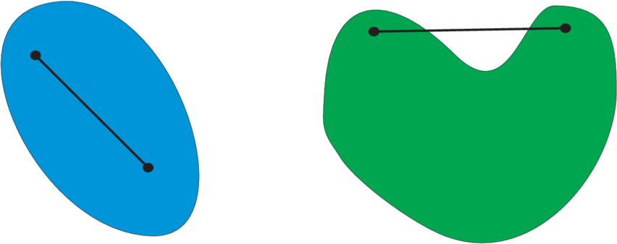
Fig 1: A convex set (left) and a concave set (right)
Lastly, if $C$ is symmetric, reflecting a point in $C$ about the origin would give us a point that also lies in $C$. Thus, if $A=\left(x,y\right)$ is a point in $C$, $A^{'}=\left(-x,-y\right)$ also lies in $C$.
Now that we have the jargon out of the way, it is only natural for us to ask why does Minkowski’s theorem even hold in the first place?
To prove the theorem, we would actually have to rely on an auxiliary result.
Lemma 1: If $M$ is a bounded and open set in $R^{2}$ such that its area is greater than $1$, there exists two points $X$ and $Y$ in $M$ such that $\vec{XY}$ is a non-zero vector with integer entries.
To see why this is the case, let us consider a bounded set $M$ and the unit squares which contain some portion of $M$. Since $M$ is bounded, there is only a finite number of these squares. If we stack these squares on top of one another, we note that there must be an overlapping of at least two different parts of $M$ as the area of $M$ is more than $1$. This is evident when we think about the contrapositive of this statement. If the there is no overlap between the different segments of $M$, the area of $M$ is less than or equal to $1$, a claim which we know to be true.
To properly visualize this, let us take the ellipse in the diagram below as set $M$.
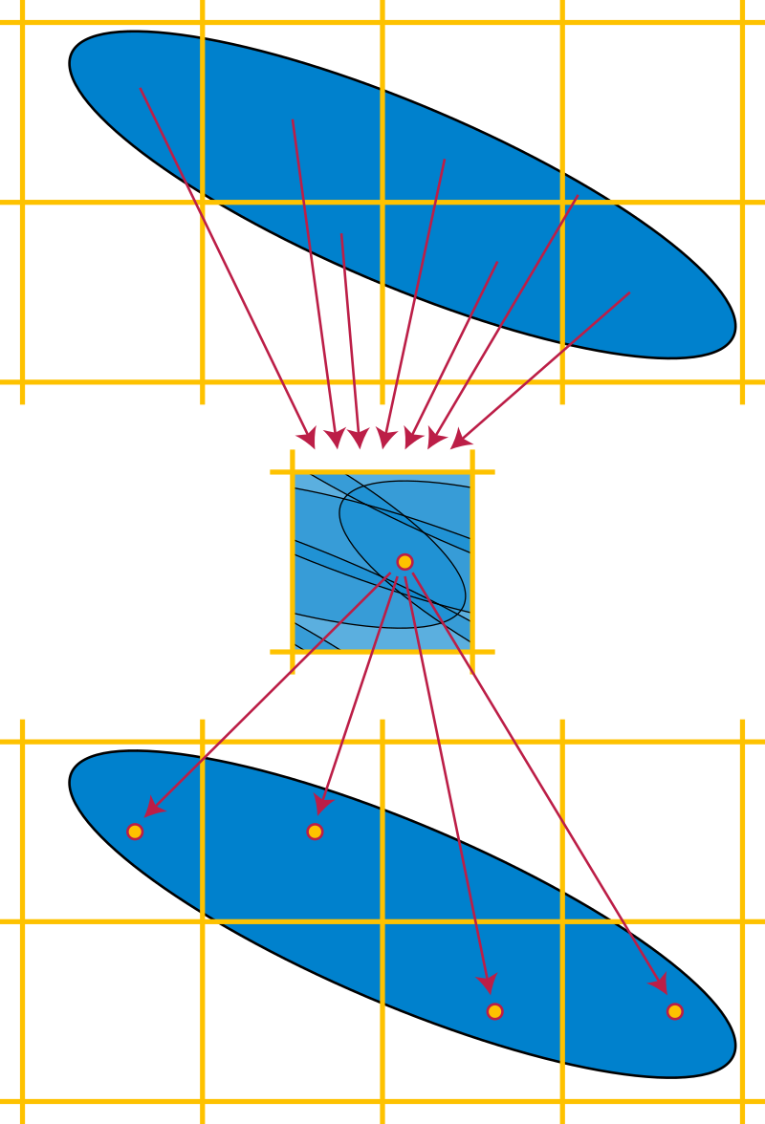
Fig 2: A visual representation of the overlapping process
As seen in Fig 2, we would now choose a point in the unit square (middle) covered by multiple sections of the overlapped ellipse. Thereafter, we would translate each section by an integer translation vector into a single unit square, effectively undoing the overlapping process we initially started out with. However, we have now ended up with preimages in the ellipse (below) of the point chosen in the unit square (middle). Setting any two preimage points in the ellipse at the bottom of Fig 2 as $X$ and $Y$, $\vec{XY}$ must be a non-zero vector with integer entries.
With our lemma, we can now move on to deducing the main theorem.
Suppose we have a bounded, convex and symmetric set in $R^{2}$ with an area greater than $1$. By our lemma, there exists two points $X$ and $Y$ in the set such that $\vec{XY}$ is a non-zero vector with integer entries. Scaling up the set by a factor of $2$ along the $x$ and $y$-axis respectively, the area of the set would be greater than $4$. Furthermore, the points with position vector $2\vec{OX}$and $2\vec{OY}$ must lie in the set. Since the set is symmetric, the point with the position vector $-2\vec{OY}$ also lies within the set. Combining this with the fact the set is convex, the midpoint of the two points with position vector $2\vec{OX}$and $-2\vec{OY}$ must lie in the set.
Hence, the point with position vector $\frac{2\vec{OX}-2\vec{OY}}{2}=\vec{OX}-\vec{OY}$ can be found inside the set. Thus, the set contains at least one lattice point in $Z^{2}$ other than the origin.
Interestingly, what if we applied a particular linear transformation $B$ to the integer grid? Would the theorem still hold? The answer is yes! Although, we would have to make a slight alteration to theorem 1, a change reflected in theorem 2.
Theorem 2: Suppose the $C'$is a bounded, convex and symmetric set in $R^{2}$. If the area of $C'$ is greater than $4∙\left|\det\left(B\right)\right|$, then $C'$contains at least one lattice point in the grid other than the origin.
Intuitively, this ought to be the case if we try to visually interpret exactly what $B$ does. The lattice points initially contained by the set would still remain in it. Simultaneously, the area of the set would be scaled by $\left|\det\left(B\right)\right|$. Hence, the lower bound of $C'$ required for it to contain a lattice point would be $4∙\left|\det\left(B\right)\right|$.
Now that we have seen why Minkowski’s theorem holds, let us consider the practical applications of what we have just discovered. Beyond its beauty on a mathematical basis, this theorem is indeed a powerful result to use in tackling different problems.
Namely, let’s see how the theorem relates to a classic number theory observation, Fermat's theorem on the sums of two squares.
The theorem states than any odd prime $p$ can be expressed in the form $p=x^{2}+y^{2}$, whereby $x$ and $y$ are integers, if and only if $p≡1(mod{4)}$. That means $p=4k+1$ for some integer $k$.
For instance, the following primes exhibit such a property:
$29=2^{2}+5^{2}$, $41=4^{2}+5^{2}$, $53=2^{2}+7^{2}$;
whereas primes like $19, 31$ and $59$ do not.
To start off, suppose that there is a prime $p$ such that $p=4k+1$ for some integer $k$. From Wilson’s theorem, $\left(p-1\right)!≡-1(mod{p)}$. Hence,
$$\left(4k\right)!≡-1(mod{p)} \\ 4k\left(4k-1\right)⋯\left(2k+1\right)\left(2k\right)\left(2k-1\right)⋯\left(2\right)\left(1\right)≡-1(mod{p)} \\ \left[4k-\left(4k+1\right)\right]⋯\left[2k+1-\left(4k+1\right)\right]\left(2k\right)\left(2k-1\right)⋯\left(2\right)\left(1\right)≡-1(mod{p)} \\ \left(-1\right)\left(-2\right)⋯\left(-2k\right)\left(2k\right)⋯\left(2\right)\left(1\right)≡-1(mod{p)} \\ {\left(-1\right)}^{2k}{\left[\left(2k\right)!\right]}^{2}≡-1(mod{p)} \\ {\left[\left(2k\right)!\right]}^{2}≡-1(mod{p)}$$
Since $\left(2k\right)!$ is an integer,
$p|{\left[\left(2k\right)!\right]}^{2}+1⟹u^{2}+1=vp$, for some integers $v$ and $u=\left(2k\right)!$.
Moreover, let the transformation matrix $B=\left(\begin{matrix}p & u \\ 0 & 1\end{matrix}\right)$.
$$∴B\left[\left({x \atop y}\right)\right]=\left(\begin{matrix}p & u \\ 0 & 1\end{matrix}\right)\left({x \atop y}\right) \\ =\left({px+uy \atop y}\right)$$
Also, we notice that:$${\left\|\left({px+uy \atop y}\right)\right\|}^{2}={\left(px+uy\right)}^{2}+y^{2} \\ =p^{2}x^{2}+2pxuy+u^{2}y^{2}+y^{2} \\ =p\left(px^{2}+2xuy\right)+\left(u^{2}+1\right)y^{2} \\ =p\left(px^{2}+2xuy\right)+vpy^{2} \\ =p\left(px^{2}+2xuy+vy^{2}\right) \\ ∴p|{\left\|\left({px+uy \atop y}\right)\right\|}^{2}$$
Lastly, the area of the fundamental parallelogram of the lattice is $\left|\det\left(B\right)\right|=p$ and the area of the circle $D$ centered around the origin with radius $\sqrt{2p}$ is $2πp>4p$. As $D$ is symmetrical, bounded, convex, and has an area greater than $4∙\left|\det\left(B\right)\right|$; by Minkowski’s theorem, there exists a lattice point with position vector $\left({a \atop b}\right)$ contained within the circle.
As shown above, due to the fact that $p|a^{2}+b^{2}$ and $0<a^{2}+b^{2}<2p$, there is no other option but for $p=a^{2}+b^{2}$, where $a$ and $b$ are integers. Consequently, we know $p$ can be expressed as the sum of two squares.
Conversely, if $p$ is an odd prime that can be expressed in the form $p=x^{2}+y^{2}$, without loss of generality, we can let $x$ be even and $y$ be odd.
- If $y≡1(mod{4)}$, $y^{2}≡1(mod{4)}$ and $x^{2}≡0(mod{4)}$. Thus, ${x^{2}+y}^{2}≡1(mod{4)}$.
- If $y≡3(mod{4)}$, $y^{2}≡1(mod{4)}$ and $x^{2}≡0(mod{4)}$. Similarly, ${x^{2}+y}^{2}≡1(mod{4)}$.
Combining both cases, we see that $p≡1(mod{4)}$.
Voila! We are done!
While there are many proofs of the sum of two squares ranging from the use of infinite descent to quadratic forms, in my opinion, the above proof is by far the most elegant one out there. In truth, we could not just stop here. Believe it or not, Minkowski’s theorem serves as one of the many tools available to solve various number theory problems; such as proving Dirichlet's approximation and Lagrange’s four-square theorem. The possibilities are endless! But for the sake of not boring you guys out, let’s discuss this in further detail on another occasion.
In conclusion, I really wish that you would be able to get a glimpse into this slightly more obscure branch of math from this article and appreciate for a while simply how remarkable mathematics is. In overall, from seeking out visual representations of problems to deriving a result from an almost unrelated theorem, the geometry of numbers is the subject that I would say most accurately encapsulates the rigor of pure math. Hopefully, I’ve inspired you to research the area of math that most engages you too!

References:
- “Geometry of Numbers.” Wikipedia. Wikimedia Foundation, March 18, 2023. https://en.wikipedia.org/wiki/Geometry_of_numbers.
- Matoušek, Jiří. “Lattices and Minkowski’s Theorem.” Graduate Texts in Mathematics, 2002, 17–28. https://doi.org/10.1007/978-1-4613-0039-7_2.
- “Minkowski's Theorem.” Wikipedia. Wikimedia Foundation, December 1, 2022. https://en.wikipedia.org/wiki/Minkowski%27s_theorem.
- Olds, C. D., Anneli Lax, and Giuliana P. Davidoff. “The Geometry of Numbers.” Cambridge Core. Mathematical Association of America, February 22, 2001. https://doi.org/10.5948/UPO9780883859551.
- “Blichfeldt's Theorem.” Wikipedia. Wikimedia Foundation, July 17, 2022. https://en.wikipedia.org/wiki/Blichfeldt%27s_theorem.
- “Figure 1: A Convex Set and a Non-Convex Set - Researchgate.” Accessed March 27, 2023. https://www.researchgate.net/figure/A-convex-set-and-a-non-convex-set_fig1_316282987.

