Why is aerodynamics so prevalent in Formula one?

Joshua Pope
Teddy Rocks Maths Essay Competition
March 23, 2023

Contents
1 Contents 2
2 Table of figures 2
3 Introduction 3
3.1 Why is aerodynamics needed? 3
4 Key concepts and equations 3
4.1 Downforce 3
4.2 The venturi effect 3
4.3 Vortices 3
5 Bernoulli’s equation: 3
5.1 Bernoulli’s principle 4
6 The parts of the car 5
6.1 The rear wing: 5
6.1.1 Modelling the rear wing & how downforce is produced 5
6.1.2 An example of a moving F1 car 6
6.1.3 Further engineering challenges & Wing Tilt 7
6.2 The front wing 8
6.3 Why must the front wing produce vortices? 8
6.3.1 The other functions of the front wing: 8
6.4 The Diffuser: 8
6.5 The bargeboard: 9
7 Changes made in the 2022 F1 season: 9
8 Thermoregulation of F1 cars: 9
9 Conclusion 9
10 References 10

Table of figures
Figure 5-1 ~ Bernoulli's equation (Johnson, 2020) 4
Figure 5-2 ~ Modified Bernoulli equation 4
Figure 5-3 ~ Bernoulli’s principle 4
Figure 6-1 ~ Cross section of a rear wing 5
Figure 6-2 ~ How the wing produces downforce 6
Figure 6-3 ~ Specific example 7
Figure 6-4 ~ Renault rear wing endplates 8
Figure 6-5 ~ Front wing wingtip 8

Introduction
Formula one is the pinnacle of motorsport, thus, to continue at the leading edge of the grid, the teams must innovate and discover creative and abstract methods of pushing the laws of fluid mechanics in their favour, in order to dominate the rest of the competition. This essay will only analyse superficially the intricacies that Formula 1 aerodynamics contains.

Why is aerodynamics needed?
Formula 1 teams need to create the fastest car they possibly can, this is achieved not only by being able to drive in a straight line – but by being able to take the corners at the maximum possible speed.

Key concepts and equations
Whilst focusing on the aerodynamics and describing the functions of some of the major parts of the cars, I will first explain downforce and the venturi effect; an effect that allows downforce to be produced which appears in most areas and in the main principle in the mechanics of Formula 1.

Downforce
F1 cars can produce a downforce equal to 2.5 times the acceleration due to gravity (Holm, 2022) and so knowing that F = ma, with a = 2.5g ms⁻² (roughly 24.5) and the average weight of an F1 car fully fuelled, including the driver, can be nearly 1000kg. Consequently, F could be up to 24500 Newtons. This huge force allows the cars to take corners at speeds upwards of 150mph. However, there is always a trade-off, and, in this case, it is that whilst more downforce allows higher cornering speed – it typically will be at the cost of drag, making the car slower on the straights and vulnerable to being overtaken.

The venturi effect
The venturi effect tells us that as a fluid (a liquid or gas) passes through a constriction, it will speed up through it. This happens since the rate of flow through two parts of a system must be the same; the volume cannot just build up; the container will eventually explode. Since less volume can travel through a smaller container per second, the fluid must be travelling through it in less time so it must be travelling faster (Venturi effect and Pitot tubes | Fluids | Physics | Khan Academy, 2014). Note that this effect will only work if the fluid travelling is an ‘ideal fluid’, this is when a fluid is incompressible and has zero viscosity (Dourmashkin, 2020). No fluids are ideal, but we may assume that air is ideal so that we can use equations to describe it.

Vortices
A vortex is the region of a fluid where a fluid revolves around an axis line (Ting, 1991). This is saying that a vortex is just air flowing around in a circle. This is what turbulent flow is. F1 teams do not like uncontrolled vortices since they are unpredictable and produce drag so do not provide efficient downforce. However, teams may seek to use vortices in some highly creative ways, which shall be explored in each car part’s section.

Bernoulli’s equation:
Bernoulli’s equation is used in many applications, but in F1 specifically it enhances the theory of The venturi effect and allows the engineers to manipulate pressures to achieve downforce. Bernoulli’s equation is as follows:
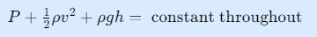
Figure 5-1 ~ Bernoulli's equation (Johnson, 2020)
Where P is the static pressure, ρ (pronounced ‘row’) is the density, g is acceleration due to gravity, and h is the height or depth. This equation may be easily derived from the principle of conservation of energy. Also, this equation is commonly written as:
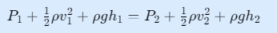

Figure 5-2 ~ Modified Bernoulli equation
Where the subscript 1 and 2 represent two different chosen points in a system.
This is very useful in many applications, but here is an example:

Bernoulli’s principle
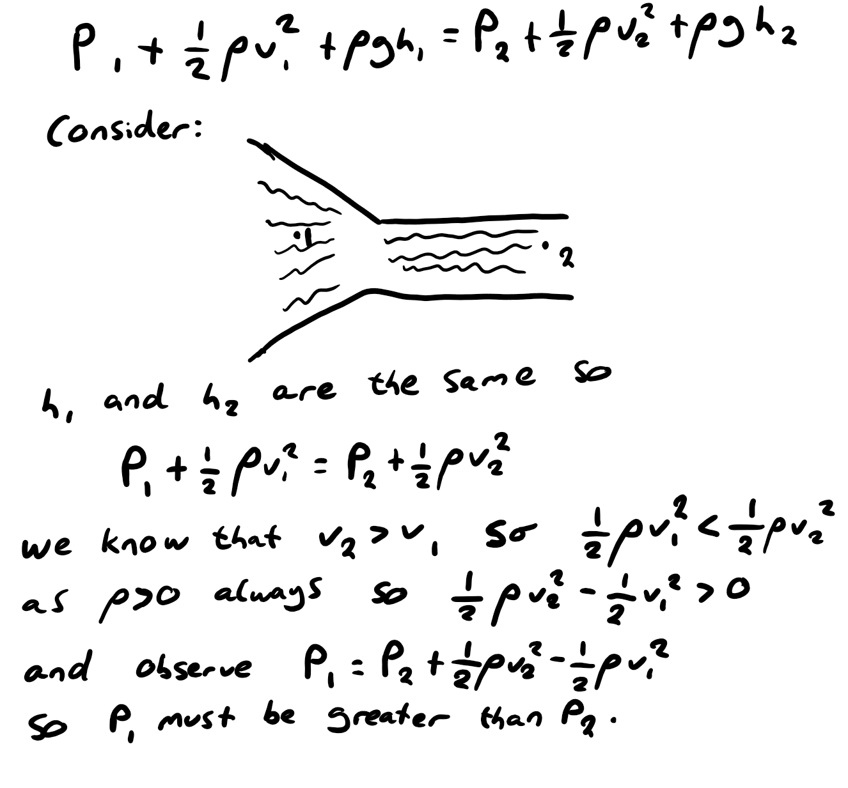
Figure 5-3 ~ Bernoulli’s principle
Since, from the venturi effect, the speed of flow increases, the pressure in the constriction is less than that before the constriction. This is known as Bernoulli’s principle and is the dominant principle in Formula 1 aerodynamics.

The parts of the car

The rear wing:
The rear wing, as the name may show, is responsible for producing downforce at the back of the car. It is used for cornering, but also used to force the rear wheels into the ground so that they grip to the floor and allow for maximum acceleration with no wheel spin. This is crucial to be able to exit corners with utmost traction, something that will contribute significantly to average lap times. Let’s explore how the rear wing produces its downforce. The car may be modelled as stationary and have the air flowing into the car at the speeds a car should be driving. This model is accurate as this is, in essence, what a wind tunnel is.

Modelling the rear wing & how downforce is produced
Consider the cross-section of the rear wing of an F1 car:
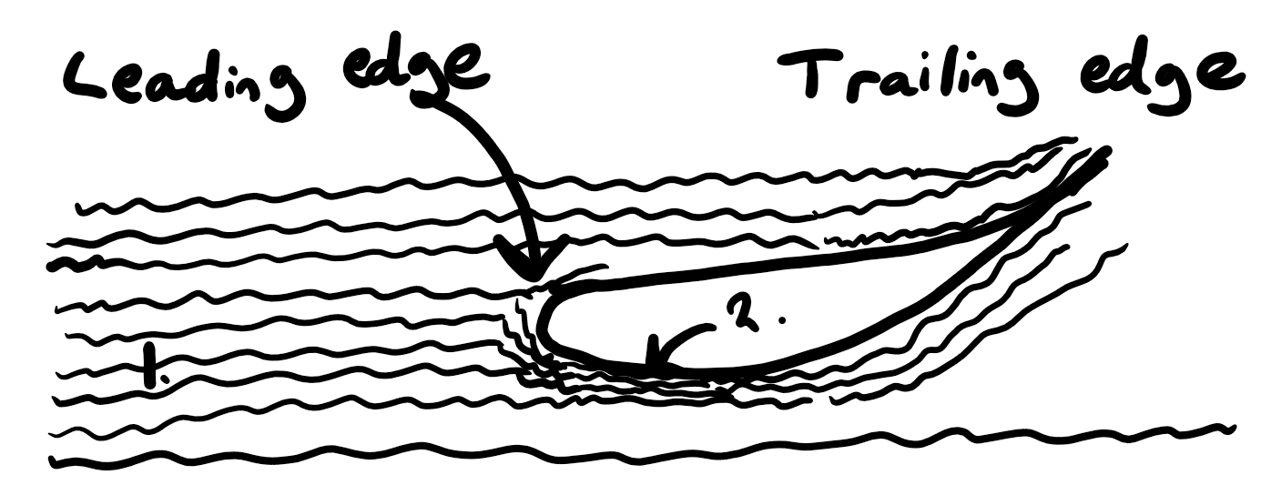
Figure 6-1 ~ Cross section of a rear wing
(The wavy lines represent the air)
As the air hits the leading edge of the wing, the wing will force the air upwards, and by Newton’s third law, the air will also push back with equal force on the wing causing it to be pushed downwards aka downforce. Also, Bernoulli’s principle will come into play here. Like before, a constriction is created near the point 2 between the wing and the layer of air below, meaning that the velocity of the air here must be greater than that at point 1:
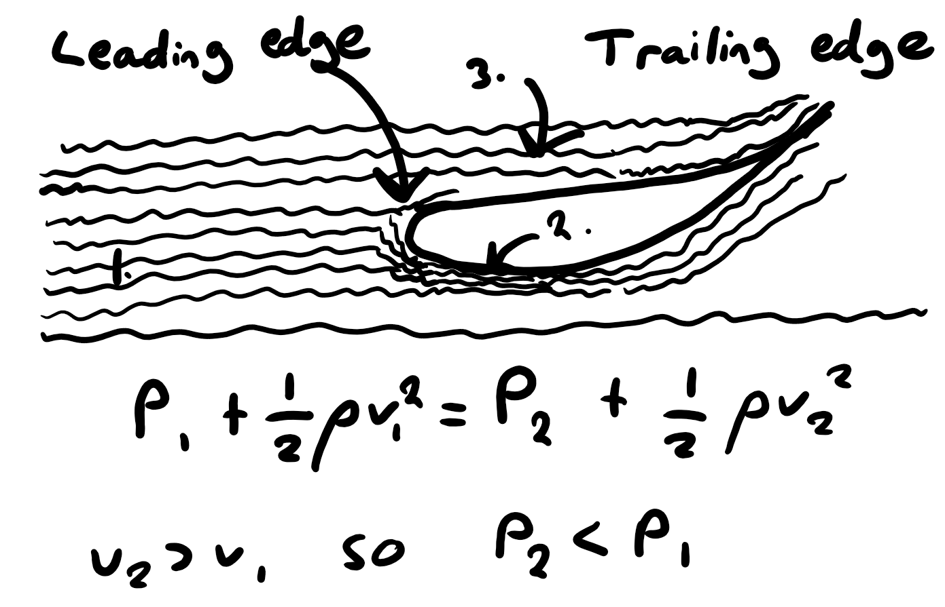
Figure 6-2 ~ How the wing produces downforce
Consider another point 3 that lies directly above the rear wing. P₃ must equal P₁ so the pressure above the wing is greater than the pressure below the wing, resulting in a net downwards force – contributing to even more downforce.

An example of a moving F1 car
In a specific example demonstrating the car ‘moving’ at 75m/s (roughly 167.8 mph) then v₁ = 75ms⁻¹, the density of air is 1.225 kgm⁻³ (reference?) so ρ = 1.225, atmospheric pressure is 101,325 pascals so P₁ = 101,325 Pa
Therefore, the rate of flow, given by Q = Av where A is the cross-sectional area of the ‘container’ being travelled through, can be calculated if the length of a rear wing is 1.3 metres and if the height of the ‘container’ is 0.5 metres, assuming the height after constriction is 0.1 metres, then:
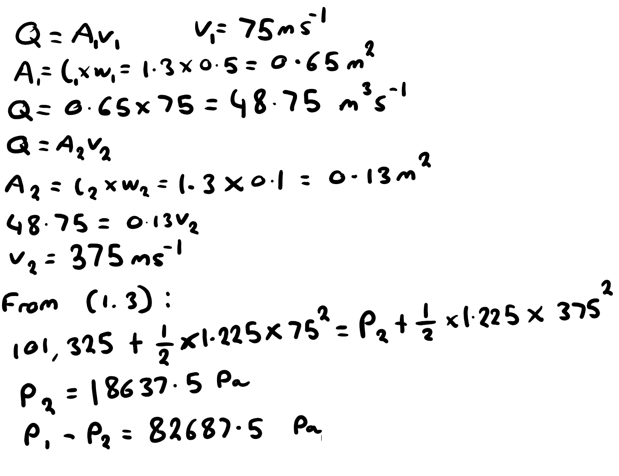
Figure 6-3 ~ Specific example
So, the difference in pressure above and below the wing in this example is 82687.5 pascals. That’s a huge amount of force since the force can be found from F = PA.

Further engineering challenges & Wing Tilt
All of this may beg the question: how much should the wing be tilted?
This is a question that F1 engineers will spend months calculating. We don’t want the tilt to be too small; it would produce little downforce, but if the tilt is too high then, as seen on [Figure 6-2], there will be an area of empty space created since the momentum of the air overpowers the frictional forces keeping the layers of air compressed together. This is called air separation. Whilst this could create a very low-pressure area and suck the wing down, it will actually mean that the average direction of the air after the wing will be less steep than it would be if the layers of air stayed compressed – leading to less downforce from Newton’s third law. Also remember that downforce comes at the cost of drag, so there is a balancing act trying to find the optimal tilt (F1 Aerodynamics - 2: Turbulence, Drag and Vortices, 2018, 2:05 – 2:45).
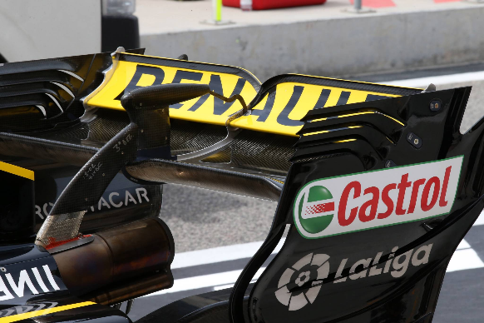
F1 teams will aim to produce downforce as efficiently as possible; the most downforce with the least drag. F1 rear wings have plates on the wing with slits in the side, these are called endplates and they help to reduce the difference in pressure between the air moving along the wing and the air moving next to it. This is important because a difference in pressure will cause the air to rush rapidly into the lower pressure area causing turbulence or ‘turbulent flow’. Any air separation will also cause turbulent flow, this is undesirable on any point on the car as it causes lower downforce. Therefore, there is a need to keep the same steepness of parts but have the air not separated. This leads us quite nicely into vortices which are covered in [Vortices].
Figure 6-4 ~ Renault rear wing endplates

The front wing
The front wing of an F1 car is arguably the most important part of the car, since it decides the way that air moves around the car, thus setting up every other part to be as great as possible. This also means they are the most complex part on the car and have many functions to go over. The front wind is shaped similarly to the rear wing, in the sense that they both curve upwards slightly, this means the top of the wing is higher pressure then the bottom, so the high pressure will move towards the low pressure if it can – so as seen in Figure 6-5 ~ Front wing wingtip a circular motion will start at the wing tip. As the front wing has many different wingtips, they will all work together to produce larger vortices. Creating this by design makes the front wing essentially a vortex generator.
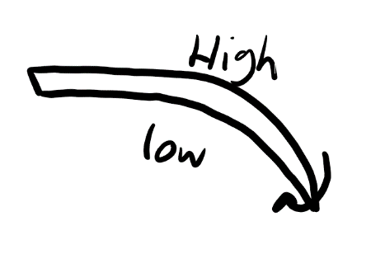
Figure 6-5 ~ Front wing wingtip

Why must the front wing produce vortices?
The front wing creates vortices at its wingtips, then pushes these towards the outside of the car. This creates a wall of air that cannot be easily broken through. This means that the turbulent air that emerges from the wheels, which are not allowed to be covered by aero parts, is blocked by the vortices so will not interfere with the other parts of the car and ruin the aero everywhere else.

The other functions of the front wing:
The front wing also directs all the air around the car so that the engineers know exactly where the most airflow should be so that they can create designs along the car in order to make as much downforce as they can, it also directs air inside the car to cool of the engine which produces lots of waste heat energy that needs to be cooled or the car will break down very quickly.

The Diffuser:
With the 2022 F1 regulation last year, a much greater emphasis on the shape of the floor of the car was created since the impact of ground effect was made much more potent. This is when the floor of the car, shaped once again like a wing, speeds air up underneath it and thus decreases the pressure – creating suction which forces the car to the surface of the track producing lots of very efficient downforce. This is called the ground effect, and a creative concept named the ‘double diffuser’ won Jenson Button the championship in 2009 and the floor has played a key role in every car design ever since.

The bargeboard:
The bargeboard is essential to a car and greatly improves the effectiveness of the front wing. As stated earlier, the vortices generated need to be pushed around the side of the car so as to not interfere with the aero but can still keep the turbulent flow generated by the tyres away. The bargeboard will help with this as it pushes the vortices out to the side of the car where they can carry out said purpose. Also, bargeboards have their own vortex generators on them, which aid the initial vortices from the front wing with their purpose – but also, they create an air seal to keep air rushing under the floor from spilling out the sides which makes the diffuser much more effective (F1 Aerodynamics - 3: Slots, Diffusers, Bargeboards, S-duct, 2018).

Changes made in the 2022 F1 season:
Many new regulations were put into place for the 2022 F1 season, most of which were made in order to promote close racing as this will make things more interesting. The most notable difference is the changes to the rear wing as the endplates were removed. This means that the pressure difference from on the wing to off the wing is much lesser, resulting in less vortices. This means that any car following close by another car will not be affected as heavily by turbulent flow from the car ahead.

Thermoregulation of F1 cars:
Whilst F1 cars must produce lots of downforce, more importantly to finish the race they must have methods of cooling the inside mechanical parts of the car. This is mainly done through tubes that run through the car that let hot air particles inside the car dissipate into the fast-moving air traversing the car. However, these tubes are not very aerodynamic meaning that they cause a lot of drag for the car. F1 teams must make sure they are doing the best of both worlds here, so it is easy to see how complicated everything gets in the F1 scene.

Conclusion
Aerodynamics is highly influential in determining which car will be the fastest, and will most likely then win the constructors championship; one of the F1 teams’ primary sources of income. For these reasons the teams must spend the majority of their time during and before seasons to optimise their car to beat the competition.

References
Dourmashkin, P. (2020) 28.1: Ideal Fluids. Available at: 28.1: Ideal Fluids - Physics LibreTexts (Accessed: 10 March 2023).

F1 Aerodynamics - 1: The Basics (4 March 2018) YouTube video, added by Chain Bear [Online]. Available at: F1 Aerodynamics - 1: The Basics - YouTube (Accessed: 8 March 2023).

F1 Aerodynamics - 2: Turbulence, Drag and Vortices (10 March 2018) YouTube video, added by Chain Bear [Online]. Available at: F1 Aerodynamics - 2: Turbulence, Drag and Vortices - YouTube (Accessed: 8 March 2023).

F1 Aerodynamics - 3: Slots, Diffusers, Bargeboards, S-duct (17 March 2018) YouTube video, added by Chain Bear [Online]. Available at F1 Aerodynamics - 3: Slots, Diffusers, Bargeboards, S-duct - YouTube (Accessed: 8 March 2023).

Holm, L. (2022) This is Downforce in F1 (Formula 1) – Easy explained. Available at: This is Downforce in F1 (Formula 1) - Easy explained (formulapedia.com) (Accessed: 10 March 2023).

Johnson, L. (2020) Bernoulli's Principle: Definition, Equation, Examples. Available at: Bernoulli's Principle: Definition, Equation, Examples | Sciencing (Accessed: 11 March 2023).

Ting, L. (1991) Viscous vortical flows. Berlin: Springer-Verlag.

Venturi effect and Pitot tubes | Fluids | Physics | Khan Academy (1 September 2014) YouTube video, added by Khan Academy [Online]. Available at: Venturi effect and Pitot tubes | Fluids | Physics | Khan Academy - YouTube (Accessed: 10 March 2023).

