Linear Algebra Approach

To

Quadratic Sequences & Generalisation

Ka Hoi Conrad Ho

Overview
I
n this essay, I shall demonstrate an alternative method for solving a general Term n equation of a quadratic sequence and the further application of using the matrix.

I will start off by introducing sequences in general, followed by quadratic sequence and a so-called ‘Textbook Method’ for solving for the equation of T_{n}. After that, I shall demonstrate and prove the ‘Linear Algebra Method’ as well as its generalisation and application towards the end.

Acknowledgement
This discovery would not have been possible without my Mathematics teacher, Mrs. Smith, who once set a homework containing few questions in relation to sequence which made me come up with an alternative method for solving the equation of Term n for completing my homework. The due day of my homework was coincidentally the same as the day when I started this essay. I would like to give credit to my father for proof-reading the use of language of this paper as well.

I am utterly delighted to discover this approach as opposed to the textbook method, and I hope you shall find it interesting as much as I do.

Introduction
A sequence is where a collection of number, known as a set, that are formed followed by a pattern in a particular order and each number formed by the pattern is called a term.

Examples of a linear sequence could be:
$${\left(2n\right)}_{n∈N}$$
such that,
T₁ = 2(1) = 2
T₂ = 2(2) = 4
T₃ = 2(3) = 6
T₄ = 2(4) = 8
T₅ = 2(5) = 10
⸽

A quadratic sequence is a subset of sequence where it follows a general equation of
$${\left(An^{2}+Bn+C\right)}_{n∈N}$$
where A, B and C are real numbers.

An example of a quadratic sequence could be:
$${\left(n^{2}-5n+10\right)}_{n∈N}$$
such that,
T₁ = (1)²-5(1)+10 = 6
T₂ = (2)²-5(2)+10 = 4
T₃ = (3)²-5(3)+10 = 4
⸽

Another example of a quadratic sequence could be:
$${\left(5n^{2}+10n-3\right)}_{n∈N}$$
such that,
T₁ = 5(1)²+10(1)-3 = 12
T₂ = 5(2)²+10(2)-3 = 37
T₃ = 5(3)²+10(3)-3 = 72
⸽

Solving Term n Equation - Traditional Method
In the previous chapter, we have encountered two examples of a quadratic sequence. To find a general equation for any given set of a sequence, traditionally we use a method similar to the one below:
The value of the first 5 terms of the sequence:
T₁ = 6
T₂ = 4
T₃ = 4
T₄ = 6
T₅ = 10
Firstly, one must work out the ‘first difference’ of the result of each term.
T_{2 –} T₁ = 4-6 = -2
T_{3 –} T₂ = 4-4 = 0
T_{4 –} T₃ = 6-4 = 2
T_{5 –} T₄ = 10-6 = 4
Then, we have to work out the ‘second difference’ which is the difference between the ‘first difference’.
0-(-2) = 2
2-0 = 2
4 – 2 = 2

The ‘second difference’ can be represented as the sum of 2A where term A is the term A from the general form of a Term n equation of a quadratic sequence, such that
$$2A=2$$
By rearranging,
$$A=1$$
By substituting $A=1$ into the general form, we get:
$$n^{2}+Bn+C$$
By substituting the term number as n, we get:
T₁ = 1 + B + C = 6
T₂ = 4 + 2B + C = 4
T₃ = 9 + 3B + C = 4
⸽
To solve A, B and C, we just have to solve the any 3 equations above as a simultaneous equation.
However, for the purpose of this essay, I will not demonstrate the steps of doing so. One might also notice that this is the 1st example of a quadratic sequence from the previous chapter where:
A = 1
B = -5
C = 10
Solving Term n Equation – Linear Algebra Method
An alternative approach, or a rather linear algebra approach is to use the following matrix, one that could compute the answer to the term A, B and C, as given in the following and to be proven in the next chapter:
$${\left[\begin{matrix}1 & 1 & 1 \\ 4 & 2 & 1 \\ 9 & 3 & 1\end{matrix}\right]}^{-1}\left[\begin{matrix}T_{1} \\ T_{2} \\ T_{3}\end{matrix}\right]=\left[\begin{matrix}A \\ B \\ C\end{matrix}\right]$$
Using the example from the previous example,
T₁ = 6
T₂ = 4
T₃ = 4
⸽
Substitute the values of the first three term into the matrix,
$${\left[\begin{matrix}1 & 1 & 1 \\ 4 & 2 & 1 \\ 9 & 3 & 1\end{matrix}\right]}^{-1}\left[\begin{matrix}6 \\ 4 \\ 4\end{matrix}\right]=\left[\begin{matrix}1 \\ -5 \\ 10\end{matrix}\right]$$
Substitute A, B and C as 1, -5 and 10 respectively into the general equation and simplify,
$$T_{n}={\left(n^{2}-5n+10\right)}_{n∈N}$$
Comparing to the result we get in the previous, we know that the answer we get from using this linear algebra approach is indeed correct.

Proof For the Linear Algebra Method
To prove that:
$${\left[\begin{matrix}1 & 1 & 1 \\ 4 & 2 & 1 \\ 9 & 3 & 1\end{matrix}\right]}^{-1}\left[\begin{matrix}T_{1} \\ T_{2} \\ T_{3}\end{matrix}\right]=\left[\begin{matrix}A \\ B \\ C\end{matrix}\right]$$

The general form for the equation T_{n} of a quadratic sequence:

$${\left(An^{2}+Bn+C\right)}_{n∈N}$$

where A, B and C are real numbers.

By substituting the term numbers into the general form as given above,
T₁ = $1A+B+C$
T₂ = $4A+2B +C$
T₃ = $9A+3B+C$
which can be represented by,
$$\left[\begin{matrix}1 & 1 & 1 \\ 4 & 2 & 1 \\ 9 & 3 & 1\end{matrix}\right]\left[\begin{matrix}A \\ B \\ C\end{matrix}\right]=\left[\begin{matrix}T_{1} \\ T_{2} \\ T_{3}\end{matrix}\right]$$

By multiplying both side with the inverse matrix,
$${\left[\begin{matrix}1 & 1 & 1 \\ 4 & 2 & 1 \\ 9 & 3 & 1\end{matrix}\right]}^{-1}\left[\begin{matrix}1 & 1 & 1 \\ 4 & 2 & 1 \\ 9 & 3 & 1\end{matrix}\right]\left[\begin{matrix}A \\ B \\ C\end{matrix}\right]={\left[\begin{matrix}1 & 1 & 1 \\ 4 & 2 & 1 \\ 9 & 3 & 1\end{matrix}\right]}^{-1}\left[\begin{matrix}T_{1} \\ T_{2} \\ T_{3}\end{matrix}\right]$$

Simplify and get,
$${\left[\begin{matrix}1 & 1 & 1 \\ 4 & 2 & 1 \\ 9 & 3 & 1\end{matrix}\right]}^{-1}\left[\begin{matrix}T_{1} \\ T_{2} \\ T_{3}\end{matrix}\right]=\left[\begin{matrix}A \\ B \\ C\end{matrix}\right]$$
Q.E.D.

Generalisation
A similar approach of polynomial sequence to any degree which conventionally are denoted by the following form,
$$\sum_{k=0}^{∞}{a_{k}x^{k}}$$
However, for the purpose for this essay, in accordance with the variables shown earlier, we shall use other symbols to represent, so that we get a general equation of:
$$An^{k}+Bn^{k-1}+Cn^{k-2}…+c$$
Where c is some constant of the polynomial equation and where $k∈N.$
To solve each coefficient of the T_{n} of the polynomial equation:
$${\left[\begin{matrix}{(1)}^{k} & {(1)}^{k-1} & & 1 \\ {(2)}^{k} & {(2)}^{k-1} & & 1 \\ {(3)}^{k} & {(3)}^{k-1} & ⋯ & 1 \\ ⋮ & ⋮ & & ⋮ \\ n^{k} & n^{k-1} & & 1\end{matrix}\right]}^{-1}\left[\begin{matrix}T_{1} \\ T_{2} \\ T_{3} \\ ⋮ \\ T_{n}\end{matrix}\right]=\left[\begin{matrix}A \\ B \\ C \\ ⋮ \\ c\end{matrix}\right]$$

This generalised equation could then be used to solve any polynomial sequence. This might be useful in predicting or estimating, for example, growth in such pattern. More on this will be discussed in the next chapter.
Real-Life Application
An obvious example of application is to estimate or predict a polynomial sequence of certain system, such as growth in interest rate or population as mentioned in the previous chapter. The matrix shown is generalised for all polynomial sequence and it can thus be used in applied mathematics such as optimising a program that requires identifying a polynomial sequence.
Comparison of both methods in computation time using Python:
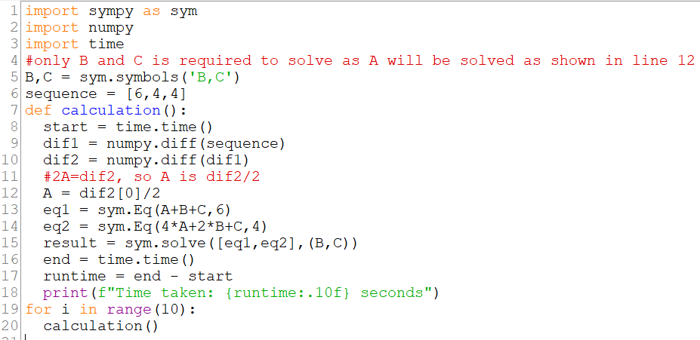
Figure 1: The code for the ‘Textbook Method’
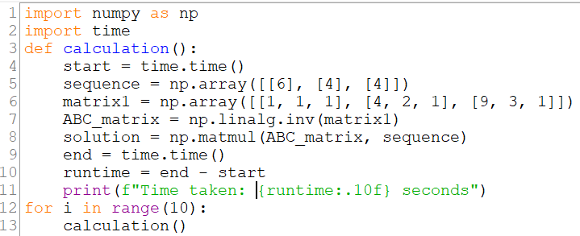
Figure 2: The code for the ‘Linear Algebra Method’
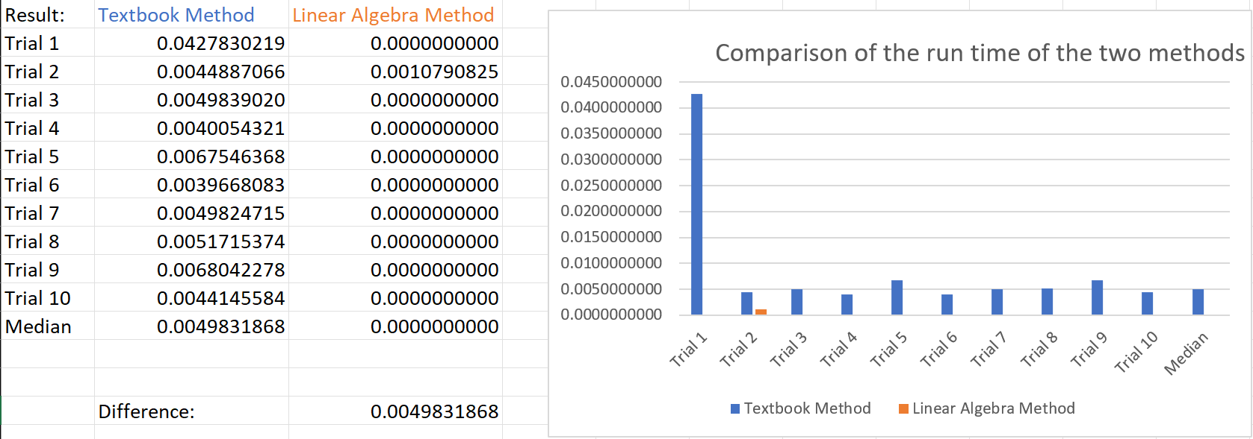
Figure 3: The results in the comparison of the run time of both methods
It is evident that the ‘Linear Algebra Method’ is relatively faster by 0.0049831868 seconds when comparing the average speed of the two respective methods. Although this might seem like a small advancement, the difference could be significant in a larger scale program.
Other Examples
Polynomial sequence is also used along with Ordinary Differential Equation (O.D.E.) in computing for optimisation in order to find, for example, maximum volume of an object with the least surface area. This might be used for companies trying to produce a container with the most volume for storage while having the least surface area, meaning least material cost.
This is often used in Physics and approximation theory. Some notable examples include Laguerre polynomial, Chebyshev polynomial etc.

References
- Harvard ‘Mathematical Sequences’ https://people.math.harvard.edu/~engelwar/MathS305/Sequences%20An%20Introduction.pdf
- Jiwen He ‘Lecture 27 11.7 Power Series’ https://www.math.uh.edu/~jiwenhe/Math1432/lectures/lecture27_handout.pdf
- Wikipedia ‘Polynomial Sequence’
https://en.wikipedia.org/wiki/Polynomial_sequence

Harvard ‘Mathematical Sequences’ https://people.math.harvard.edu/~engelwar/MathS305/Sequences%20An%20Introduction.pdf
Jiwen He ‘Lecture 27 11.7 Power Series’ https://www.math.uh.edu/~jiwenhe/Math1432/lectures/lecture27_handout.pdf
Wikipedia ‘Polynomial Sequence https://en.wikipedia.org/wiki/Polynomial_sequence

