Making Money with Probability Distributions

Probability distributions are one of the most fundamental tools available to a statistician to analyse past data and predict outcomes in the future. This essay aims to explain probability distributions, their different forms and uses, focusing on continuous probability distributions and their applications in finance.

Overview of probability distributions
In statistics, a random variable is a variable whose value is unknown. Usually denoted by a capital letter, they can be either discrete (taking only specific values, such as a test score) or continuous (taking any value in a given range, such as temperature).
A probability distribution is a statistical function that describes all the possible values and probabilities for a random variable within a given range. They are used to visualise the distribution of outcomes in an experiment.
For example, let the random variable X be the outcome of rolling a die. X can only take integer values from 1 to 6, making X a discrete random variable. In this case, the probability distribution would be as follows:
X | 1 | 2 | 3 | 4 | 5 | 6
P(X = x) | 1/6 | 1/6 | 1/6 | 1/6 | 1/6 | 1/6

Note: P(X = x) means the probability that the random variable X takes a specific value x. In valid distributions, the sum of all the probabilities must always equal one.
Probability distributions, like random variables, also come in two forms: discrete and continuous (the difference between the two is the same as that between discrete and continuous random variables). Discrete distributions
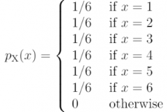
use probability mass functions, which give the probabilities of the variable taking a specific value. The probability mass function for rolling a die and its graph is below:
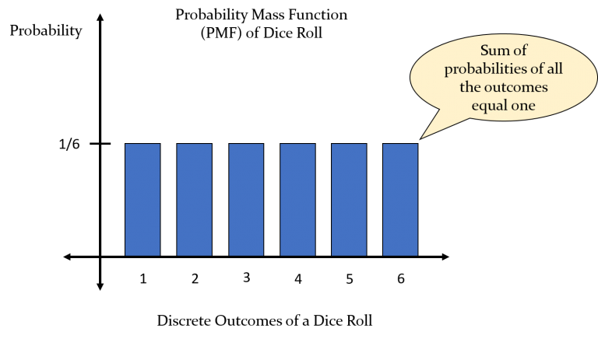
Continuous random variables use probability density functions. It returns the probability that the random variable will have a value in a given range.
By convention, for a continuous random variable P(X = x) = 0 (it is not 0 in reality, but it is infinitesimally small) because there is an infinite number of values that a continuous random variable could take in a given range. Therefore, if P(X = x) were positive the summation of all the probabilities would equal infinity, although it should be 1. This ‘paradox’ is why when referring to continuous random variables, P(a ≤ X ≤ b) is used rather than P(X = x).
Probabilities in graphs of PDFs (probability density functions) are equal to the area under the curve in an interval. The curve must be integrated between that interval to find the probability of the continuous random variable lying there.

Characteristics of a PDF
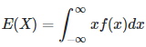
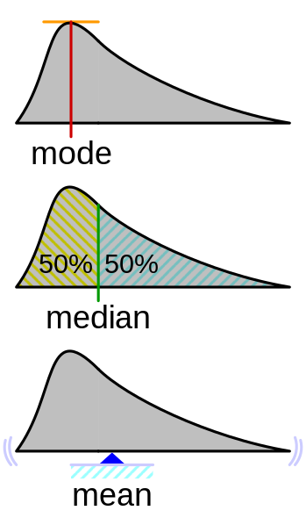
The mode of a PDF is the value of the highest point on the graph; the median is the value that splits the area under the curve in half; and the mean is the expected value of the random variable (must be calculated using the formula shown above and cannot be identified just using the graph).
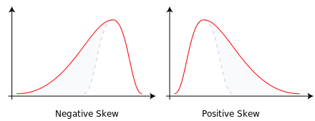
Skewness is the measure of the asymmetry of the PDF about its mean. The type of skew depends on which tail of the curve is longer: if the left is longer there is negative skew; if the right is longer there is positive skew. The probability distribution is concentrated on the side where the tail is longer.
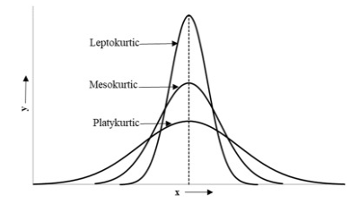
Kurtosis is a measure used to describe how 'fat' the tails of a probability distribution are relative to the normal distribution. Distributions with a kurtosis over 3 have more tail data than the tails of the normal distribution and are known as leptokurtic distributions. Distributions with kurtosis under 3 are known as platykurtic distributions. Distributions with the same kurtosis as the normal distribution (3) are known as mesokurtic. A high kurtosis means thinner tails; low kurtosis means fatter tails.

Normal Distributions
The normal distribution, or Gaussian distribution, is one of the most important probability distributions, appearing in many simple experiments. For example, the heights and weights of a group of people tend to be distributed normally.
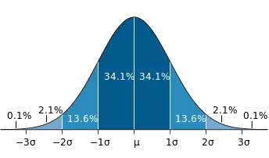
More commonly referred to as the 'bell curve', the PDF for the normal distribution has three key characteristics: the mean, median and mode of this distribution are all equal; the distribution is symmetric around the median; and the curve is asymptotic to the x-axis. There are many normal distributions, but the most used form is the standard normal distribution. For a standard normal distribution, the mean equals 0, the standard deviation equals 1, there is no skew, and it has a kurtosis of 3 (mesokurtic).
The normal distribution also must follow the empirical rule, which states that for all normal distributions, 68.2% of the observations will appear within 1 standard deviation of the mean; 95.4% will fall within 2 standard deviations; and 99.7% within 3 standard deviations.
Abraham de Moivre discovered the curve when he realised this distribution could estimate higher numbers in Pascal's triangle if the numbers in a row of the triangle were on the y-axis, and the x-axis represented the position of the number in the row.
Decades later, Carl Friedrich Gauss discovered that the normal distribution also describes the distribution of measurement error (the difference between a measured value of a quantity and its actual value). He came to this realisation while working on the problem of planetary motion after realising that the errors when measuring the size and velocity of large planetary objects followed a normal distribution. He tried to prove this hypothesis, but he was unable to do so successfully at the time.
Pierre-Simon Laplace later encountered Gauss’ work, eventually proving his hypothesis, known today as the Central Limit theorem.
The Central Limit theorem states that averages calculated from independent, identically distributed random variables will approximately follow a normal distribution, regardless of the type of distribution from which the variables are sampled, provided it has a finite variance. As the size of the sample increases, the more accurately the distribution of outcomes follows the normal distribution.
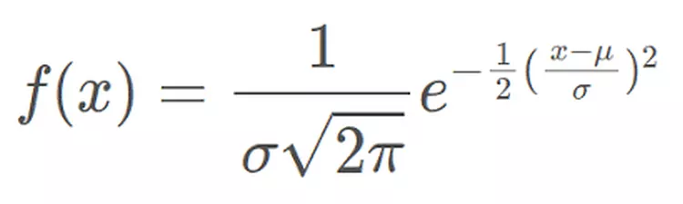
Note: x = value of the variable being examined, f(x) = PDF, μ = mean, σ = standard deviation
The formula for the PDF of the standard normal distribution (above) is complicated, but the general form is not too difficult to understand. Without the constants, the base equation is in the form e^-(x^2), which is responsible for the bell shape of the curve. The constant at the front is to ensure that the area under the curve is equal to 1, and the operation done to x in the exponent (subtracting the mean and dividing by the standard deviation) is simply there to transform the normal distribution into a standard one with mean 0 and standard deviation 1.

Log-normal distributions
Another famous distribution closely related to the normal distribution, log-normal distributions are created by taking the natural log of the random variable distributed normally (note that log-normal distributions can only come from a normally distributed set of values).
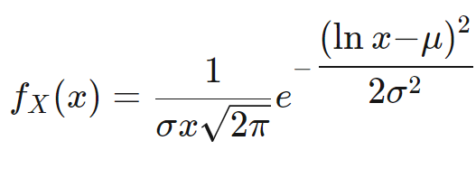
The formula for this distribution (above) is almost the same as the PDF for the normal distribution, the most notable difference being in the exponent, where ln(x) is used rather than x.
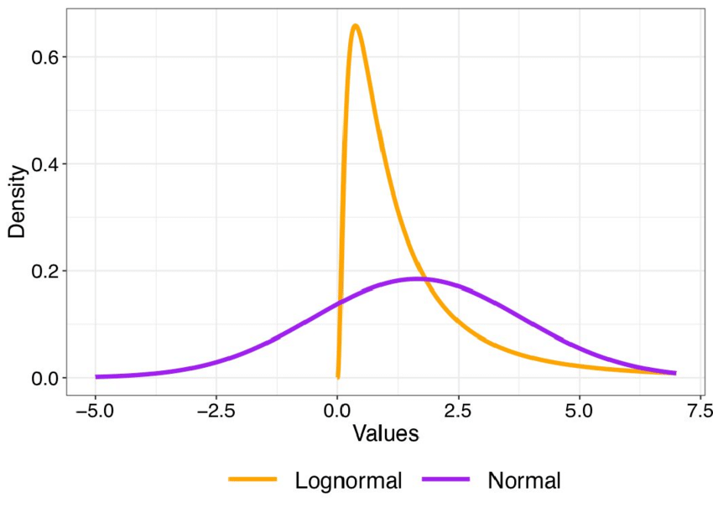
Log-normal distributions can model many events, such as milk production by cows and the size of rainfall droplets. These events have no outcomes that take negative values, which suits the log-normal distribution since it also cannot take any negative input values of X. Therefore, this distribution can be used as an alternative to the normal distribution in these cases since the normal distribution allows for negative random variables. This distribution suits events with a low mean value, a high variance and only positive outcomes.
Beta distributions
Beta distributions are another continuous distribution that is different from the others. It models data in the interval [0,1].
Given a set of outcomes, beta distributions find the actual probability of an event happening. For example, if a biased coin was flipped ten times and landed on heads eight times, the beta distribution examines the distribution of probabilities of the coin landing on heads. It is the 'opposite' of the binomial distribution, which gives the distribution of outcomes given an actual probability.
Beta distributions take two parameters: alpha and beta. Given a set of outcomes, they are used to create the PDF. The formula for calculating them is:
α = k + 1
β = n – k + 1
Note: k = number of successes, n = total number of trials
After obtaining additional information about the outcomes (e.g. flipping the coin a few more times) the values for alpha and beta can be updated. As the values for alpha and beta increase, the distribution narrows, reflecting the greater precision of the larger sample. For example, if a coin lands on heads 800 times out of 1000, the probability that the actual probability of the coin landing on heads is 8/10 is much higher than if the coin landed on heads only 8 out of 10 times.
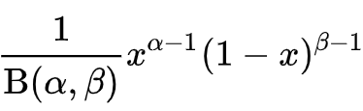
The formula for the PDF of a beta distribution is above. It is like the formula for a binomial distribution; the main difference is in the normalising constant at the front, which is the reciprocal of the beta function with parameters alpha and beta. This function has many uses, although in this case, it is there to ensure the area under to curve is 1.
The curve of a beta distribution can take many forms depending on the values for alpha and beta, as seen below.
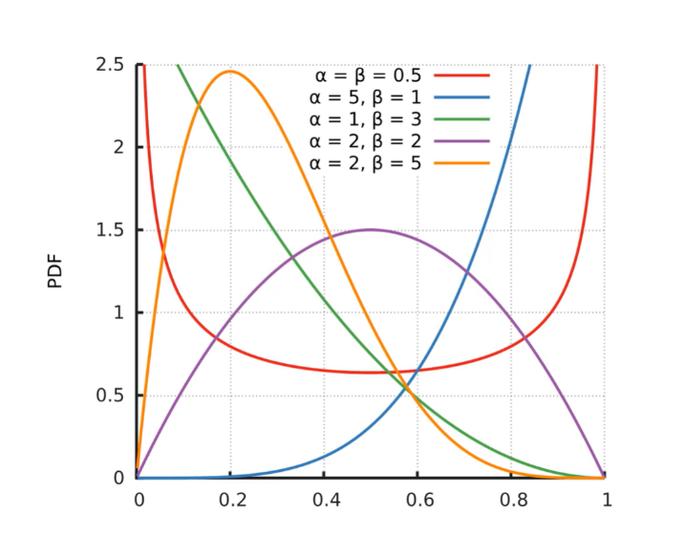
Applications in finance
Probability distributions can also model the performance of a financial asset when the asset is modelled as a random variable.
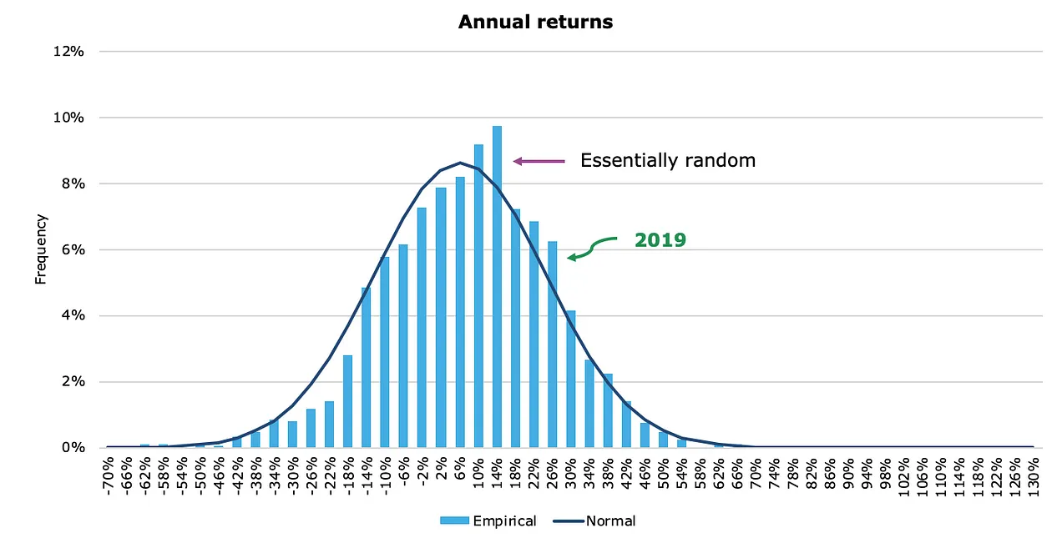
Normal distributions can model the annual returns of the stock market. The diagram above shows how returns of the S&P 500 follow a normal distribution, which is a result of the central limit theorem – many independent factors affect the performance of the S&P 500 index, such as the performance of individual companies listed in the index, most of which are in different sectors. Investors can use the rates of return given by the normal distribution to predict the most likely future prices of assets by considering the current asset price and the distribution of its returns. However, the use of the normal distribution in finance is limited, because asset performances do not often fit into this distribution, as they tend to have slightly 'fatter' tails (representing the volatile nature of financial markets).
Log-normal distributions often model stock prices, making it easier to identify the compound return that a stock can achieve over time. Investors can create log-normal distributions if they continuously compound the annual returns of an asset, allowing them to predict returns far into the future. Log-normal distributions have positive skew due to high variances and cannot take negative inputs, which suits most stock prices better than a normal distribution (stock prices cannot be negative, but the normal distribution allows this). Log-normal distributions are also the foundation for the Black-Scholes model, used for pricing options (another type of asset).
Beta distributions are not as widely used in financial markets as the other distributions. Bond recovery rates, however, can be modelled using beta distributions. Given parameters such as a team's productivity, managers also use them to estimate the time a team will take to complete a given project.
It is vital to understand that financial markets can be highly volatile, and there is no certainty that these models will provide an accurate picture of what is to come. There have been many circumstances where large banks have relied too heavily on these models (e.g. during the financial crisis of 2008) and did not realise the high degree of uncertainty that comes with using these models.

Probability distributions are undoubtedly one of the most important tools for statisticians, available in so many different forms that almost any experiment could arguably have its outcomes modelled by a probability distribution. Despite this, these distributions are only assumptions and can never provide a wholly accurate view of the future.

References:
https://www.newtechdojo.com/discrete-probability-distributions/
https://commons.wikimedia.org/wiki/File:Visualisation_mode_median_mean.svg
https://www.researchgate.net/figure/An-illustration-of-positive-and-negative-skewed-histogram-courtesy-of-Skewness_fig1_236096384
https://www.sciencedirect.com/topics/social-sciences/kurtosis
https://en.wikipedia.org/wiki/Standard_deviation
https://www.investopedia.com/terms/l/log-normal-distribution.asp
https://en.wikipedia.org/wiki/Beta_distribution
https://klementoninvesting.substack.com/p/the-distribution-of-stock-market
https://www.investopedia.com/terms/p/probabilitydistribution.asp
https://medium.com/magnimetrics/introduction-to-probability-distributions-in-financial-modeling-8804ac642647

