Reaching infinite: the Mandelbrot Set
A quick note: in this essay, I refer to “the universe” quite frequently. By this, I’m referring to the object which decides why things are the way are – why 1+1=2, why the speed of light is roughly 300 000kms⁻¹, why light refracting in the way that it does makes our sky blue rather than purple. When referring to the actual universe, as in the body in which the Earth happens to find itself, I’ll use other phrases like “our universe”, or “our world”.
The Mandelbrot set perplexes and awes ordinary people just as much as it does mathematicians. Once you've seen it, you become immediately intrigued, and the more you learn about it, the more intrigued you become. It appears to be incredibly obscure, being merely points plotted and coloured in by a computer, and yet it can make you question you’re understanding of reality, of the universe as we know it. Hopefully you learn a little about the history of how we discovered this mathematic painting, what it is, and why it is so mind-bendingly cool!
To fully understand the Mandelbrot set is, we must first look a little bit at fractals. A fractal is an image where similar patterns occur at progressively smaller scales, and the term was coined by Benoit Mandelbrot himself, the creator and namesake of the Mandelbrot set. You can see fractals everywhere you look, from snowflakes to coastlines to ancient African architecture, and maybe even on the wall of your maths classroom.
Below you can see two instances of my penultimate point. The left shows ruins of a palace in Cameroon, and the right shows a royal insignia. Both include iterations of scales rectangles, an example of fractals.
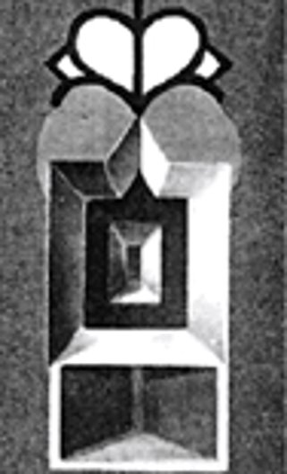
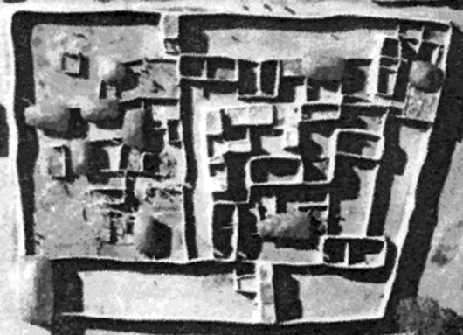
Left, an aerial photo of the palace of an ancient Cameroonian chieftain.

Right, the chief’s royal insignia, showing a good example of fractals, with iterations of scaled rectangles.

Moving onwards through history, a German mathematician and philosopher called Gottfried Leibniz was one of the first to evidence thought surrounding the concept of fractals. He thought about “recursive self-similarity” and referenced “fractional exponents” in his work, a term not used in mathematics up until that point. He also considered whether a straight line is self-similar, something we now believe not to be true, but it’s the thought that counts! Sadly, there wasn’t much more interest in fractals after this point for a while, with the study of such an idea being deemed a “mathematical monster”.
However, things started to get serious when two Frenchmen, called Anson Fatou and Gaston Julia, stepped into the scene in the early 1900s. Although they did not live long enough to see the beauty that their work helped to create, their exploration of complex dynamics laid the groundwork not only for Mandelbrot, but for the study of complex dynamics and chaotic/tame systems as a whole. Complex dynamics is the study of functions which describe iterations or sequences on the complex plane.
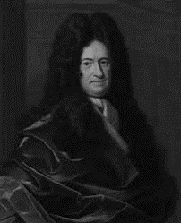
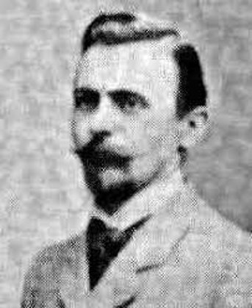
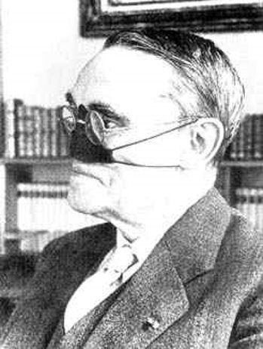

Above, from left to right: Gottfried Leibniz 1646-1716, Anson Fatou 1878-1929, Gaston Julia 1893-1978. Julia lost his nose during WWI.
Then, Benoit Mandelbrot begins to emerge in the early 1980s. Mandelbrot was a young Polish immigrant working at the IBM research centre in New York when he was tasked with a problem – to figure out and get rid of the white noise phone users were hearing when they made a call. Being a visual thinker, he decided to try to visualise recordings of this white noise and see if he noticed anything interesting. Thankfully, he did! In these white noise graphs, he noticed patterns which reminded him of work he’d seen before, specifically the work of Fatou and Julia. Forgetting about the problem at hand, Mandelbrot began exploring these patterns with the computing power provided for him by IBM. He began looking into the complex functions in which Fatou and Julia had found such interest, in particular this function:
$$f\left(z\right)=z^{2}+c$$
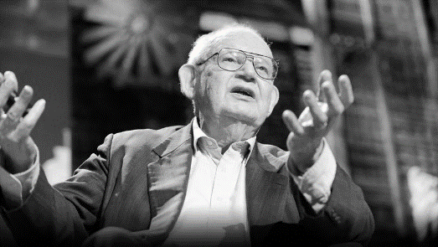
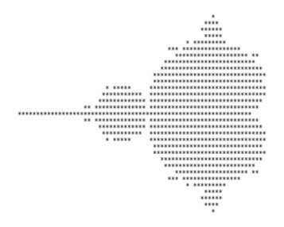
where c is any complex number. Mandelbrot put in certain numbers, iterated the function, and noticed that funky things started to happen. He programmed a computer to plot the points on a complex plane that made the above function stable (basically not shoot off to infinite) and print out the results. You can imagine how long this must’ve taken, printing out dots on a sheet of paper, but he kept going, and started noticing strange and wonderful patterns.

Above, Benoit Mandelbrot 1924-2010 and an image depicting what he would have originally seen coming out the printer.
What were these patterns? Well, other than points plotted by a computer, they are the universe’s artistic genius, with man and computer acting merely as tools. The computer is told to colour a point on the complex plane which, when it replaces c in the above function, and $x_{0}=0$, causes the function to blast off to infinite in one colour, and in a different colour if it doesn’t. We then tell the computer that if number causes the function “bounce around” a bit before blasting off to infinite, the computer should plot different numbers of bounces in different colours. For example, if we do the sequence $z_{n+1}={z_{n}}^{2}+\left(0.11-0.68i\right)$, there will be ten iterations of varying values before the function begins to grow exponentially. Mandelbrot managed to figure out the location of and the key to the safe which contained this secret, and as technology progress it was this final action, of colouring the various iterations, which made the Mandelbrot set as stunning as we know it.
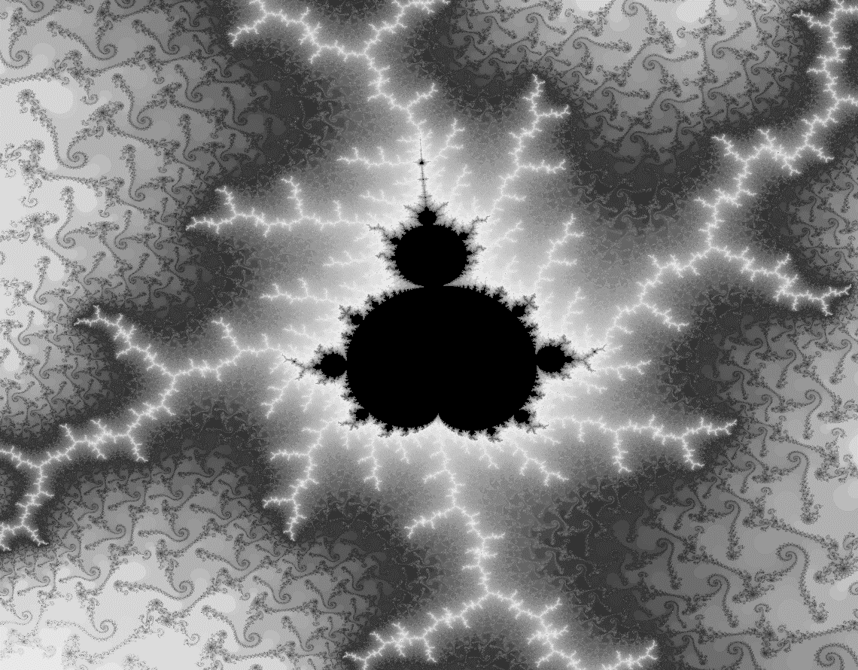
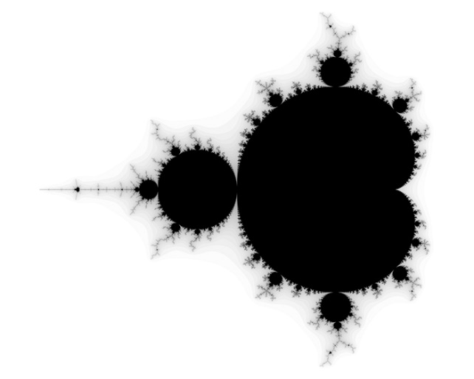
The entire Mandelbrot is infinitely vast, yet it is contained within a circle of 2 units diameter. It is not size that its enormity comes from, but instead from specificity. You can zoom into the Mandelbrot set forever and see infinitely complex patterns (if you had a powerful enough computer), each new one similar but not the same as the last. The funny thing is that if the computer didn’t colour in the different parts according to our input, we’d just be zooming into incredibly specific numbers with no meaning. The complexity and beauty come from the fact that it is impossible to predict whether a number will have a different result when input into our function compared to a number that is directly next to it (differences of 10^{-lots}), and the differences between numbers get infinitely smaller as we keep zooming in, meaning we get an infinite zoom of complex patterns.
Above, and image of the Mandelbrot set and a cool fractal from it.
Now I’m going to try to get you to question reality a little bit (if you haven’t already). Say you were trying to measure the length of a coastline; you might choose to do so with a ruler that is a metre long. You measure the coastline like this, but then you realise that your measured length isn’t quite long enough, as it doesn’t account for the jagged edges smaller than a metre. You then repeat the process with a 30cm ruler and realise that this measurement is also slightly shorter than the real length, due to the complexities within those 30cm. If you were to follow this train of thought to its logical conclusion, you would realise that we technically have an infinitely long coastline in a finite area, as you could theoretically keep measuring smaller and more specific distances forever.
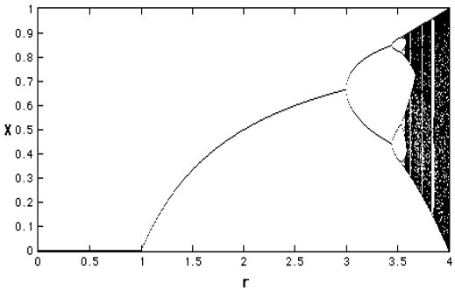
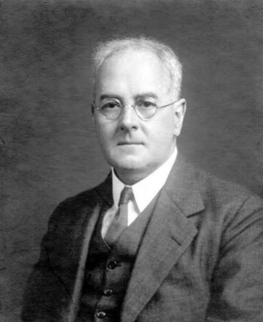

This is a thought experiment first posed by English mathematician Lewis Fry Richardson in the early 1900s, and it gives us an insight into why fractals and the Mandelbrot set aren’t just seemingly obscure and irrelevant mathematical constructs – in fact they are all around us. Fractals can be found across the natural world, in snowflakes, trees, lightning, clouds, crystals, river systems and many more. However, the connection to the real world doesn’t stop at the visual. It turns out that if you plot the Mandelbrot set in a slightly different way, and instead show the number at which a stable sequence ends up at, you will discover something called the bifurcation diagram. This diagram universally plots all sorts of data, including rabbit populations over time, the drips of a dripping tap, and convection currents. So, we’ve somehow gone from a weird but wonderful set of numbers coloured in to look pretty to very much real world and important phenomena.

Above, from left to right: Lewis Fry Richardson, a river system showing fractals in the natural world, and a simple version of the bifurcation diagram.
I suppose it begs the question, “why does this all matter?” Other than the fact that we don’t really know why this occurs, which begs all sorts of questions of its own, it is intriguing because its calls into question most people’s fundamental understanding of the universe. As human’s, we like to think of things the way Euclid thought about geometry – lots of straight lines, right angles, and theoretically perfect shapes. However, Mandelbrot might have argued that our universe is in fact a whole lot more complicated than this. For example, I argue that the Mandelbrot set provides evidence that the universe has the capacity to provide an infinite amount of complex information, that there is no boundary on how much “stuff” the universe can come up with.
Now, many people would reply to Richardson with something like “but, if we could measure it, surely at some point we would start measuring atoms, or protons or neutrons, or even quarks! We must inevitably reach some fundamental particle.” This is a valid conjecture, but I would argue the Mandelbrot set provides the possibility for an equally valid answer – that there are particles which make up a quark, and particles which make up those particles, and therefore an infinite number of smaller particles, and no fundamental particles. The logic can also be applied the other way, providing in my eyes valid evidence that our universe could very much be infinitely large and complex (we kind of already know this but it’s still cool to think about!)
I conclude with this idea: humans naturally like boundaries, fine lines, categories, because they make the world we live in easier to understand and measure. However, those who choose to delve into it will find the idea of infinite, of things infinitely small, infinitely big, or infinitely complex, to be an infinitely fascinating prospect, and I would say that the Mandelbrot set is solid evidence that the world we live in is very much capable of this idea of infinite.
By Max Pritchard, Highgate School N6 4AY

