A Deep Dive into the Machinations of Neural Networks

Despite the recent exponential growth of interest into artificial intelligence, with massive media attention, the inner workings of the algorithms at play are still a mystery to much of the public. AI is ubiquitous; it has been used everywhere from self-driving cars to cheating on homework and its capabilities are only growing. Yet there is still a significant question mark over what processes it employs to do the incredible things it can do. It is hiding in plain sight, begging you to take a peek inside the black box.

To gain a solid grasp of the concepts underpinning, and terminology surrounding neural networks, it is best to scale everything down to its most basic elements. Let’s take an extremely simple network model and build from there.
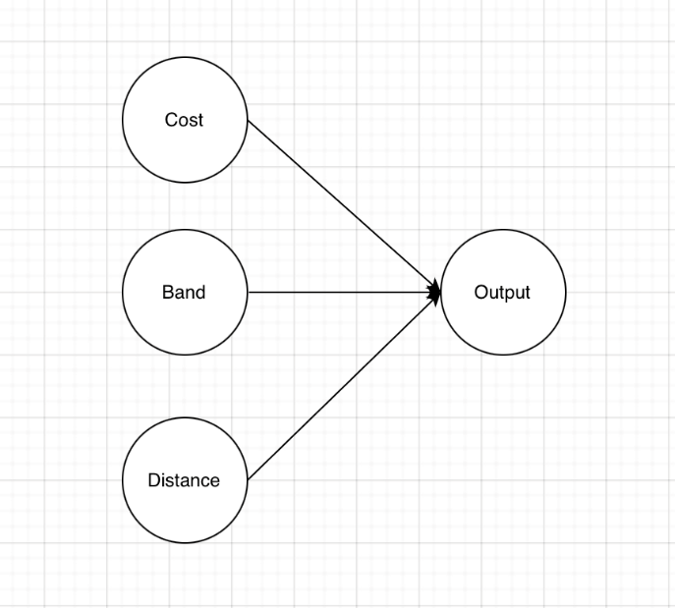
This model may be used to quickly determine whether you should go to a concert. It takes in 3 inputs (cost of a ticket, how much you like the band, and the distance you’d have to travel) and outputs a response for whether you should go to the concert (i.e., 0 if you shouldn’t and 1 if you should. The circles are called neurons, with input neurons on the left and an output neuron on the right. These neurons can take on any value from 0-1 i.e., 0.67 is valid. The connections between these neurons have a parameter called their “weight”. This weight is essentially how much impact the value of the neuron on the left side of the connection has on the one on the right This structure is meant to simulate that of a human brain although it is by no means a perfect comparison.

To aid in the conceptualisation of what the weight of a connection really means, let us examine the cost input neuron more closely. If the cost to see the event is high (assuming greater cost means greater value of the cost input neuron) then you’d probably be less likely to go. Therefore, we can assign a negative weight to the connection between the cost neuron and the output neuron. As well as assigning a negative weight we can also decide how negative we want the weight to be, as in the magnitude of the weight. In this case you can adjust it per individual. Someone who has no worries about money would presumably assign a small negative weight to the cost neuron and vice versa.

There is one other crucial parameter which influences the output of the network, which is the “bias” of each (excepting input neurons) neuron. To do this we shall add a small layer of complexity to our network. Introducing what is known as a “hidden layer” as is shown below.
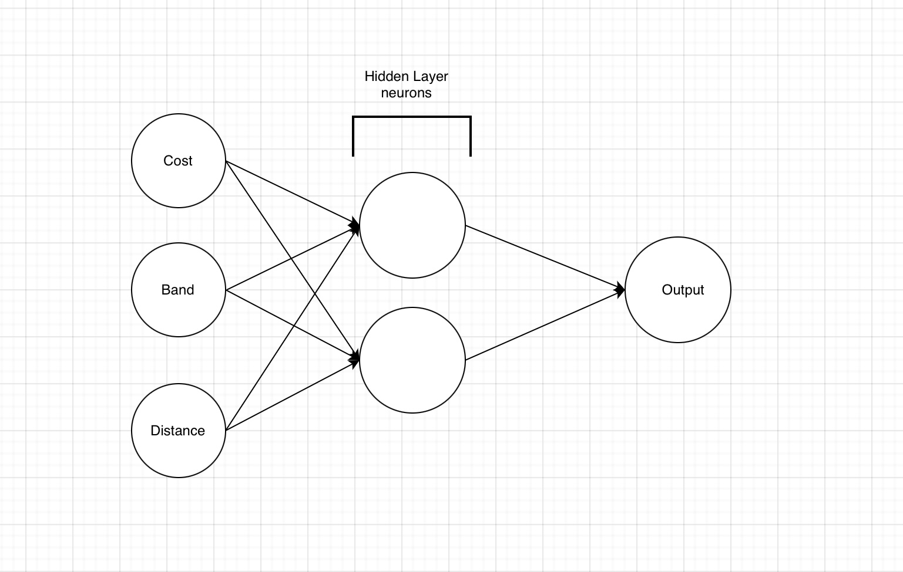
For this, we shall consider the distance input neuron and its connections. For most people, the further you would have to travel the less likely you would want to go to a concert; thus, a negative weight for its connection to neuron 1. The magnitude of the negative weight once again depends on personal preference/situation. This time, however, we will consider a network attempting to please an individual who likes concerts which are only nearby or very far away. They might enjoy getting out if it is to a new place far from home, for example, but anything between nearby and a far-off adventure is a dreary hassle. In this scenario we may utilise this added hidden layer. We can have the connections to neuron 1 be identical to the connections to the output neuron from the simpler model, but for neuron 2 we will have a positive weight for the distance. However, as we only want this neuron to trigger when the distance is very large so we can assign a bias to the neuron making it more difficult to cause it to “fire”. The larger the bias the more difficult it is for the neuron to fire and now we have two parameters which can be tweaked to improve the accuracy of our network.

Now that we have the basic model of a neural network in our minds and a conceptual understanding of weights and biases, we can look into how a neural network is actually trained. In a real-world neural network, you will have thousands of weights and biases which will all effect the final output of the network, and attempting to figure out what weights and biases can be assigned through logic becomes a laughably impossible task. Therefore, we introduce what is called the cost function. In the same way a function f(x) has one parameter and f(x,y) has two, the cost function has a parameter for each weight and bias in the network - which is a lot. The cost function takes the weights and biases of the network as inputs and outputs a number which is the average cost of the network. To get this cost, you give the network many training examples of whatever it is meant to recognise. If we take the classic case of handwritten digits, the “hello world” of neural networks, then you give the network thousands of images of manually labelled handwritten digits to identify. The network takes each pixel as an input neuron, with its value being the grayscale value of the pixel, and from there will give 10 outputs. These 10 outputs correspond with the numbers 0-9, and you then identify how wrong the network is by taking square of the difference between the value you want for the output neuron (0 if it’s not the number, 1 if it is) and the value the network actually outputs. Once the network does this for all the training examples, you can find the average cost of the network, with respect to the weights and biases assigned for that network.

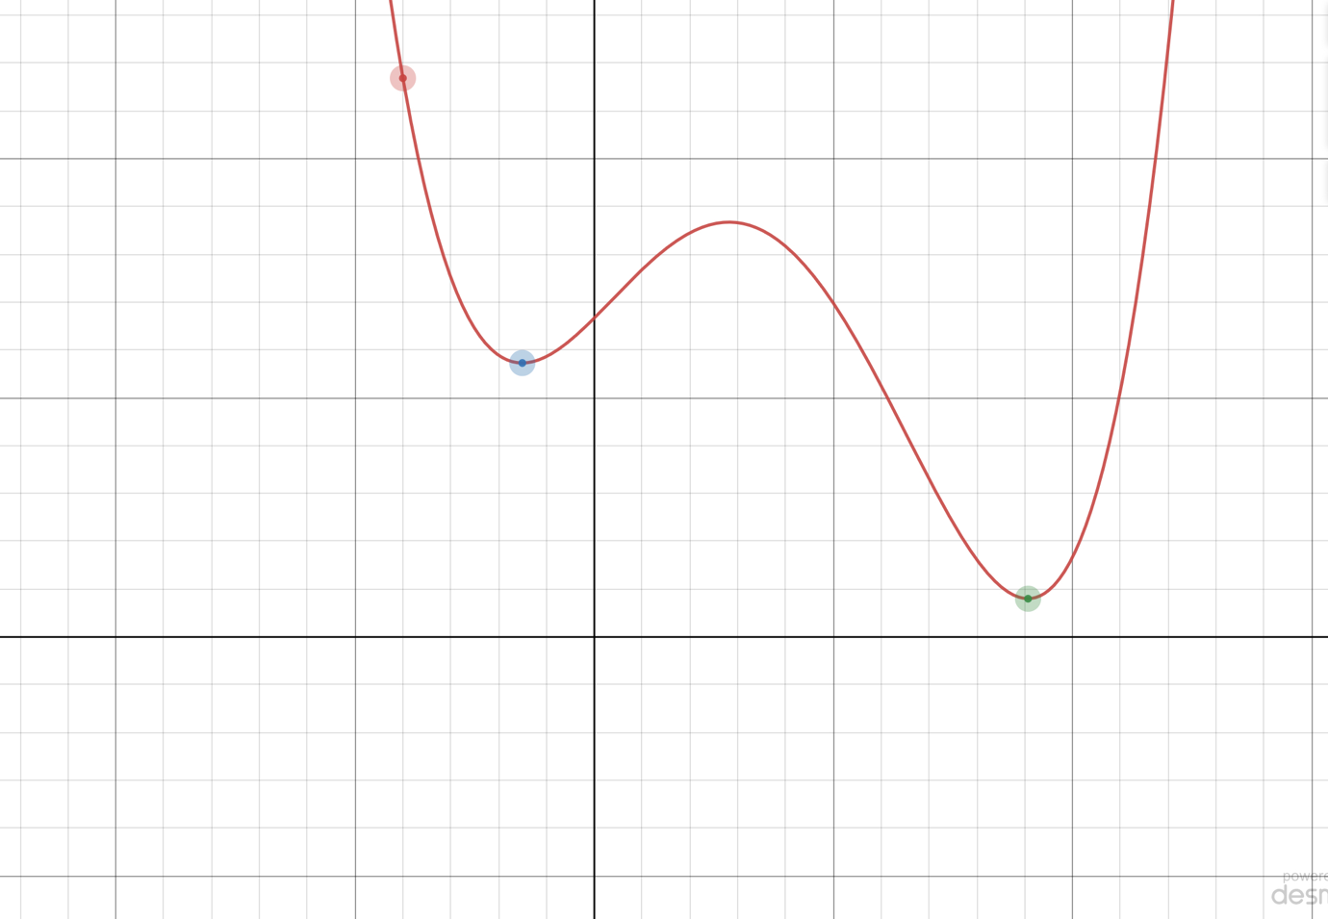
Now I do think I’m meant to include some maths in this essay at some point so here’s a pretty graph I prepared earlier. This is a simplified graph of the cost function as graphing >1000 dimensions might be somewhat inconvenient.

As is clear, there are two minima of this function, highlighted with the green and blue dots. We want to minimise this function so that the network is as accurate as possible and so the go to is calculus. Unfortunately, while it is fairly trivial to solve for the minima of a simple single input single output function as shown above, the same cannot be said for the monstrously complex cost functions of neural networks. Therefore, we will, for the sake of learning, pretend we cannot solve for minima analytically here. In that case how will we work out what they are?

Well for this you could take the derivative of our cost function with respect to the weights and biases. As each weight and bias is its own parameter, you would need to take the partial derivative of the cost function with respect to each weight and bias. Eventually you will end up with values which tell you whether to decrease or increase each weight and bias (i.e., if the value of the derivative at that point is positive or negative) and how much you should alter the weight or bias by (the magnitude of the derivative). With this information you can fine tune the neural network until it reaches a high accuracy. This process is called gradient descent. Unfortunately, there is a flaw with this method which can be demonstrated on the graph above. If you were to begin at the red point on the curve and attempt to minimise the cost function through gradient descent, then when you hit the blue point on the curve, the gradient will be equal to 0. Therefore, that is where you would stop changing the weights and biases as magnitude is 0 and that’s how much you want to change the parameters by. As you can see however, there is an even lower minimum at the green dot. The blue dot is called a local minimum whilst the green dot (assuming there are no lower minima) is called a global minimum. Thankfully, most networks will already be highly accurate when they have hit their local minimum and in fact some don’t even need to arrive at a local minimum to perform their given task proficiently.

Now you have your network set up, you’ve trained it on human-labelled examples and reconfigured its weights and biases accordingly, but what processes does it use to get to its result? What are the steps it takes? The logic it follows? This is the magic of it though; we don’t know. We’ve set up this machine and essentially taught it how to recognise these handwritten digits, and yet when you try to peer inside all you will see is an intriguing black box.

