Number of Numbers?
By: Andrew Chan
Introduction:

Numbers are more commonly used now than ever, to quantify data or to predict the future. But we often fail to consider its nature. “What is two? What comes after?” and inevitably “What is the largest number?”. In this essay, we will follow the development of numbers from the Egyptians to the modern-day definitions, including misconceptions to what lies at the end of the number line. We will then conclude the essay with a question to be ascertained by further work in mathematics.

Part 1 – Natural Numbers and Integers

“One, two, three, four…”. Probably the oldest mathematical skill, counting has proven to be useful starting from 3100 - 30 B.C. when the Egyptians roamed North Africa to our lives today. We extract a feature of physical objects and link them to a number. Then taking advantage of the well ranked property of numbers, we can do operations such as addition. The result could therefore be related back to the physical world. The Egyptians realised this and therefore developed a system representing numbers. This was one of the first numeral systems that we found evidence for, and it comprises mainly what we call “tallying” today. It is a type of unary number system, where a symbol is repeated as many times as the number it represents. Once the number becomes larger this system is no longer convenient. So, the Egyptians improved to a base-10 system, with a different hieroglyphic symbol for each multiple of 10. Such as 𓆼, a flower for 1000(see appendix 1). This is a numeral system representing numbers, and not a number itself. Other numeral systems have place values, where the order of symbols matter, thus reducing the number of symbols required to represent large values. Different bases also change the length of the representation, for example, in base-2, the number 162 is “10100010” while it is “A2” in hexadecimal (base-16). Numbers by themselves have no tangible or visible property, whereas a numeral system can be written, distributed or preserved on a physical medium. The numeral system most widespread today is the Hindu-Arabic Numerals, tracing back to the 10th century by Arabic speakers in Spain and North Africa. This may look different to the hieroglyphs, but the idea behind is unchanged by time.

Jumping back in the timeline, we arrive in India, in the 6th century A.D. Here a mathematician named Brahmagupta discussed the number zero. In his work Brāhmasphuṭasiddhānta, he even laid out rules for integers, such as:
- The sum of two positive quantities is positive
- The sum of two negative quantities is negative
- The sum of zero and a quantity will not change the quantity’s sign
- The sum of a positive and negative is their difference; Or, if they are an equal distance from zero then the sum is zero
- A number divided by zero will give a fraction with zero as the denominator
He defined properties of integers, and this was sufficient for the daily usage of positive and negative numbers at the time, as it provided a connection or relationship between positive and negative numbers. However, it fails to pin down what a number is.

This was solved in the 19th century when Giuseppe Peano proposed a set of axioms; except for zero, the first natural number, all other natural numbers can be defined by a successor function ($S:N→N$). This successor function can be visualised as the process of “adding one” to obtain the next natural number. Importantly, if the successor of two natural numbers is equal, then the two numbers themselves must be equal (it is an injective function). A technicality is that this isn’t a bijection as the natural number zero is not a successor of any other number in the domain. One way of implementing the axioms is Von Neumann’s ordinals. It defines numbers recursively where each number is the union of all previous numbers and zero as the null set or empty set (see appendix 2 for the proof in set notation). Ordinals denote the ordering of elements of a set, hence counting the same set two different ways would give rise to different results. A more practical use of ordinals is to define the cardinal numbers. These represent the size of a set, generated through collecting all ordinal numbers in the given set. Therefore, no matter how the set is counted, the cardinality stays the same. Then a one-to-one relationship (bijection) is established between the cardinal and the set. In other words, when you count that there are two apples in a box, you are linking each item in the set $\{∅,\left\{∅\right\}\}$ with each apple, labelling it “one” and “two” or “I” and “II” in the Egyptian case.

Following the natural numbers, integers can be defined as the natural numbers and the negated natural numbers with zero being at the centre. Today, these are represented by the difference between an ordered pair of natural numbers. For example, the ordered pair (4,3) would represent the integer 1 while (3,4) would represent -1. Note that for integers $\left(a,b\right)$ and $(c,d)$, $(a,b)≡(c,d)⟺a+d=b+c$. This equivalence relation defines a class of ordered pairs that represent the same integer, such as (3,2) and (4,3). These ordered pairs should remind you of the cartesian coordinate system, and they can indeed be written in that form (see appendix 3).

Part 2 - Real Numbers

Nearly as soon as the concept of natural numbers was identified, it gave rise to the rational numbers through dividing one whole item into multiple. The Egyptians represented the result of this process through putting a hieroglyph for the “unit fraction” on top of another number to represent the reciprocal (see appendix 4 for examples). The downside was that this was limited to reciprocals of natural numbers. However, with today’s Hindu-Arabic numeral system, the decimal expansion of a number became more related to rational numbers. A number is rational if the decimal expansion was either finite or repeating the same finite pattern. Or in a more succinct way, the fact that it can be represented as a ratio of two integers, hence “rational”.

As always in mathematics, we see a recurring theme, an ordered pair of numbers from a subset used to define the larger set. For an ordered pair of integers representing a rational $\left(a,b\right)=\frac{a}{b}$ and $\left(c,d\right)=\frac{c}{d}$ where $b≠0$, $d≠0$, $(a,b)≡(c,d)⟺ad=bc$. This is another equivalence relation that shows this class of ordered pairs of integers representing the same rational number.

The other major component of real numbers are the irrational numbers. They cannot be represented by a ratio of two integers as the name suggests, and have been discovered as early as the Ancient Greeks, namely Pythagoras at around 500 B.C. His famous Pythagoras’s theorem led to the discovery of $\sqrt{2}$, the first irrational. His proof is as follows:
- In an isosceles right triangle where the ratio of hypotenuse to base is at its simplest form, ie they are coprime,
- The hypotenuse $c^{2}=a^{2}+b^{2}=2b^{2}$,
- This implies $c^{2}$ and $c$ are both even and $c^{2}=4x^{2}$ for another integer $x$,
- It follows that $4x^{2}=2b^{2}⇒2x^{2}=b^{2}$,
- Implying that $b$ is even and divisible by 2, like $c$,
- We reach a contradiction as they have a common factor of 2
Therefore, the ratio $\frac{c}{b}$ cannot be rational, and $\sqrt{2}$ (the hypotenuse when the base is 1) is not a rational number. At the present, a similar proof relying on $a$ and $b$ being coprime can be used to prove that the root of all primes are irrational. Moving into the 18th century, $π$ was introduced by William Jones and $e$ by Leonard Euler, both being famous examples of irrational numbers used in a range of applications. Dedekind in the 19th century gave a definition of real numbers, the set of all cuts on a number line such that every other point either lies to the left or right of itself.

Part 3 - Counting Numbers

“Infinity” is often suggested as the largest number, but this implies that “infinity” is a number itself, which is not always true. Shifting our perspective, it becomes clearer when we think of the largest number as the size of the set of positive real numbers. This is the cardinality of the set as mentioned in Part 1 and represented by the vertical bars on either side of the set. For example, $\left|N\right|$ is the cardinality of the set of natural numbers. Counting is done by establishing a bijection with a natural number, so it is logical to start off with the size of the natural numbers. The German mathematician Georg Cantor introduced the Hebrew letter $ℵ_{0}$ (aleph-null or aleph-nought) to represent this. It is an example of a transfinite number, a number that is infinite, but also not.

To put that into perspective, let's try counting the set of integers. Upon first sight, there are double the number of integers than natural numbers, as integers include the negation of natural numbers. Paired with $±1$ on top of that depending if you include zero in the natural numbers. However, consider the function$f\left(x\right)=\left\{\begin{aligned}-2x, &x≤0 \\ 2x-1, &x>0\end{aligned}\right.$,$f\left(0\right)=0,f\left(1\right)=1,f\left(-1\right)=2,f\left(2\right)=3,f\left(-2\right)=4$. This creates the required bijection with the positive integers corresponding to the odd natural numbers, and negative integers mapped to the even. This suggests that integers and natural numbers have the same cardinality as its members can be mapped in a one-to-one relation. These are what we call countably infinite sets, where it is countable with natural numbers, but also infinite. Similar sets include the rational numbers which can be counted in a zig-zag pattern starting in the corner (see appendix 5). This gives us a very weird result, somehow $N⊂Z⊂Q$ and yet $\left|N\right|=\left|Z\right|=\left|Q\right|=ℵ_{0}$. In this sense $ℵ_{0}$ is “infinite” because it is larger than any finite quantity you can name.

But $ℵ_{0}$ isn’t absolute infinity either as there are proven values larger than $ℵ_{0}$, thus capping its magnitude. For example, the set of real numbers is uncountable, in other words strictly larger than the set of natural numbers regardless of how the bijection is formed. This proof relies on Cantor's Diagonal Argument when real numbers are represented by their decimal expansions. Whatever way the real numbers are ordered, you can always construct another real number, where the nth digit is different to that of the nth number (see appendix 6). So that this real number will never be encompassed by the list which corresponds to the natural numbers, and hence $\left|R\right|>\left|N\right|$. Other examples include the power set of the integers, which includes all the possible subsets in the integers. Using a similar diagonal argument, we can show that the power set has a strictly larger cardinality than the original(see appendix 7). In reality $\left|R\right|=2^{ℵ_{0}}$, but we are not sure where this value fits in the transfinite hierarchy. The Continuum Hypothesis, which states that there are no cardinalities strictly between that of integers and real numbers, is also shown to be independent of current mathematical infrastructure and ZFC set theory axioms, meaning either $2^{ℵ_{0}}{=ℵ}_{1}$ or $2^{ℵ_{0}}{>ℵ}_{1}$ are equally reasonable.

This is demonstrating how $∞+1=∞$ and $∞-1=∞$. It makes no mathematical sense because infinity is not a number and therefore cannot lie at the end of our number line. When we limit a variable to infinity, what we are saying is not “the variable is getting closer and closer to the end of the number line” but actually “the value of the variable is increasing without bound”. However this is not without its exceptions, where treating $∞$ as a number has it’s advantages, such as in Measure Theory where for simplicity intervals can sometimes be written as $[a,∞]$.

Conclusion:
In this essay, we have established that numbers are just mathematical objects, an abstract concept not to be confused with the numeral system or language used to represent them. These mathematical objects can be more rigorously defined through sets. With natural numbers being the foundation, they can be extended onto integers and rational numbers. Interestingly, the set of integers is smaller and yet the same size as the set of rational numbers. “Infinity” is not a number and should also be thought of as “value without a bound” rather than the ultimate largest number.
Numbers play a large role in the modern world and are deeply rooted into daily life where people rarely consider its roots. This essay hopes to challenge the obvious and remind us of the unanswered questions. My thoughts can be summarised by a quote of Albert Einstein – “Two things are infinite: the universe and human stupidity.”

Appendix 1: Egyptian Numerals
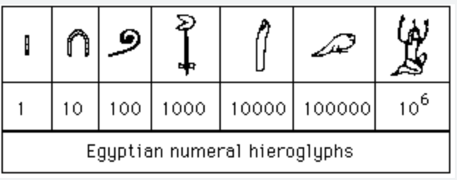

Appendix 2: Von Neumann’s ordinals definition
- Define $0=∅$, the null set or empty set.
- Define a successor $S(a)$ of $a$ by $S:N→N$, $S\left(a\right)=a∪\{a\}$,
It follows that:
- $0=∅$,
- $1=0∪\left\{0\right\}=\left\{∅\right\}$,
- $2=1∪\left\{1\right\}=\left\{0,1\right\}=\{∅,\left\{∅\right\}\}$ ,
- $etc.$

Appendix 3: Diagram for Integers
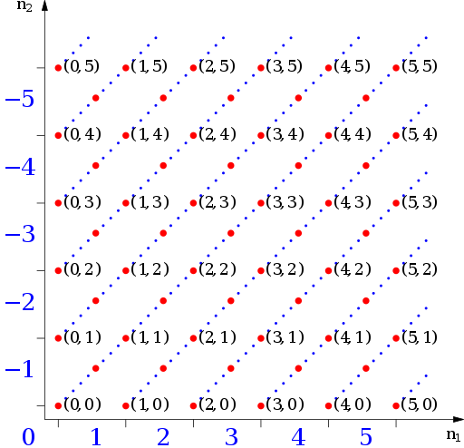

The dotted lines go through all ordered pairs in the same class satisfying the equivalence relation.

Appendix 4: Egyptian Fractional Notation
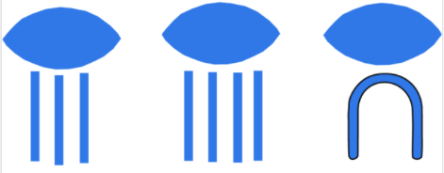
This image shows $\frac{1}{3}$, $\frac{1}{4}$ and $\frac{1}{10}$ from the left.

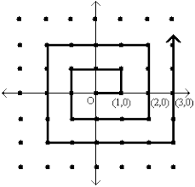
Appendix 5: Diagram for Rational Numbers
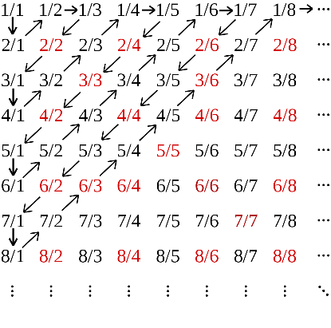
(Left:)The image shows how rational numbers can be written in the same grid format like integers, hence there are the same number of integers and rational numbers.

Figure SEQ Figure \* ARABIC 2 - Rational Numbers on a grid
(Right:) Including the negative rational numbers, it can be counted in a spiral pattern, still forming a bijection with the natural numbers.
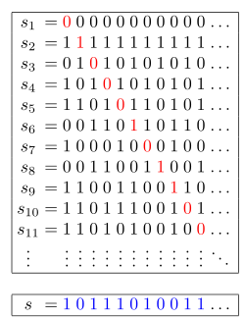
Appendix 6: Cantor’s Diagonal Argument
The nth digit of the constructed number is always different to the nth digit in the nth number in the list, so it is never equal to a real number in the list.

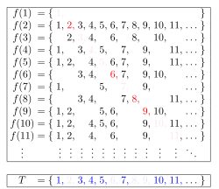
Appendix 7: Diagonal Argument in Power Sets
Let the function $f:S→P(S)$ and define $T=\{s∈S, s∉f(s)\}$. For the $s∈f(s)$, $s∉T$ therefore, $T≠f(s)$. On the other hand, if $s∉f(s)$, then $s∈T$, again, $T≠f(s)$. Like above, this proves that no matter how the bijection between $s$ and $f(s)$ is formed, there will always be more elements in $p(x)$.

