Mathematically modelling electrocardiograms

Pythagoras once said, “Number is within all things” and this indisputable truth is demonstrated all around us whether we choose to notice or not. So here I am going to demonstrate how mathematics can be used in the medical field, specifically in electrocardiograms also known as ECGs. Using ECGs, we can record electrical signals to measure the human heartbeat. We can also mathematically express the movements of the heart, allowing us to assess cardiovascular health and model healthy and unhealthy heartbeats.
Mathematically we would describe the heartbeat as periodic this means regular repetition, providing it is a healthy heartbeat. Here is an ECG recording of a healthy heart:
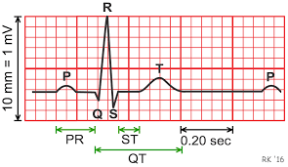

This diagram demonstrates one complete pulse cycle, which we will describe as a period, the wave labelled P is the contracting of the right and left atrium, the top two chambers of the heart. The QRS wave is when most of the heart muscles are in heart action, which is why the amplitude is highest. Finally, the T wave is the polarization of the ventricles which are the two chambers at the bottom of the heart.
A healthy heartbeat is between 60 and 100 beats per minute, for simplicity we will assume a heartbeat of 60 beats per minute, which would be one beat every second and thus the cycle above, p to the next p would repeat each second, which is ever 1000 milliseconds. For this mathematical expression we will model the R wave of a healthy heartbeat which represents ventricular depolarization.
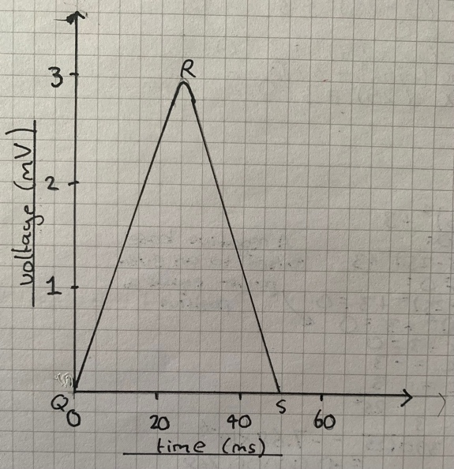
To model this R wave, despite it looking triangular, we cannot assume QR and RS are linear, as the wave must be continuously differentiable as it is a continuous function itself. The most appropriate function would be to base it on a quartic which is a polynomial function with a power of 4 as this would give the closest shape, you may wonder why not a parabola, so a power of 2, this is because a power 4 will give us a narrower shape, which is more appropriate for the narrow shape of wave R.
Placing our curve of R on a new axis would allow us to start the curve at the origin with a starting coordinate of (0,0), this will make it easier to model, so here I have drawn curve R on a set of axes, with the curve beginning at the origin:

We can observe that this curve begins at the origin, and thus inside our quartic brackets we can have t – 25, this t – 25 is because we can observe two roots are at t = 0 and t = 50 as the curve meets the x axis at both (0,0) and (50,0) so the R wave is 50 ms long, and one of the turning points is when t = 25, we subtract the 25 from t for the equation as it has to be moved over to the right by 25 ms, using our transformation rules, we must subtract inside the bracket to transform to the right.
This gives us the equation: f(t) = x(t-25)^4 + c
Our + c constant will come from the amplitude of our R wave; in this case the amplitude is 3mv thus our + c will be 3.
Finally, the constant x can be calculated from making t = 0:

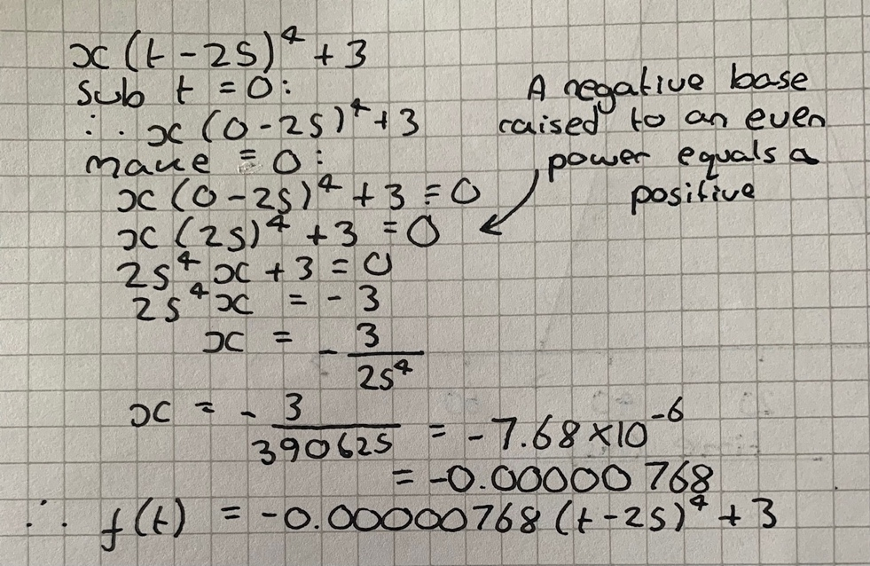

Here is the equation graphically represented:
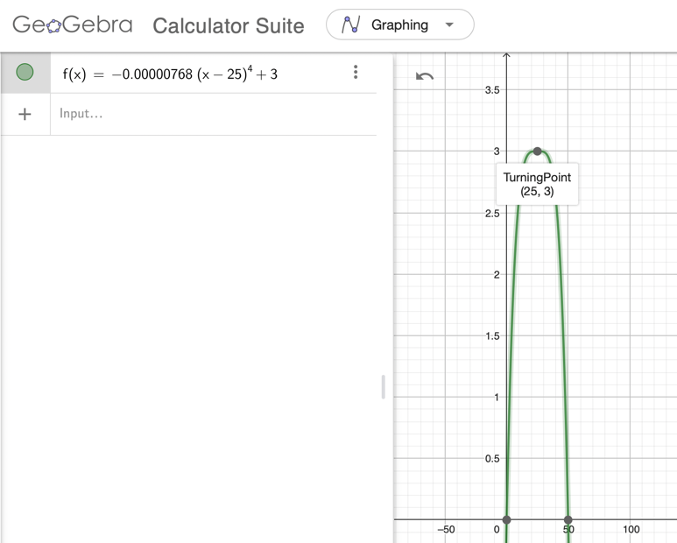

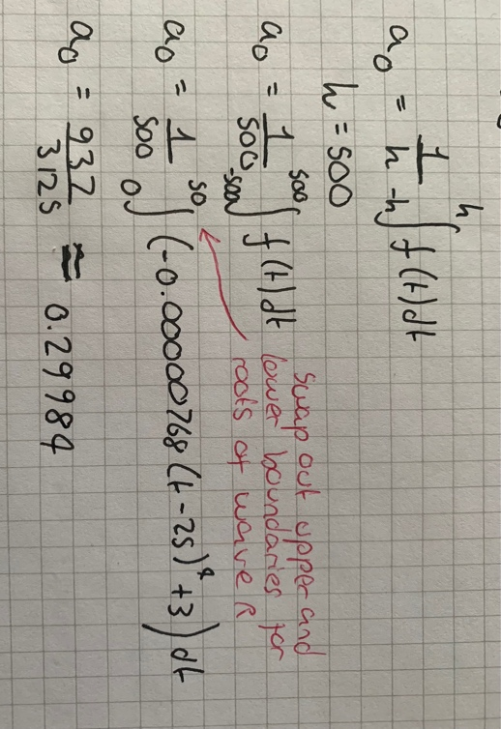
As we can see graphically, this is just one pulse, however we want a graph and equation that repeats this pulse at regular intervals, to solve this problem we will use the Fourier series. The Fourier series is an expansion of a periodic function in terms of an infinite sum of sines and cosines and the theory of this series is that anything periodic can be exactly reproduced almost as if changing the domain (x-axis) of a signal from time to frequency. To get the Fourier series we need the mean value which we can call a0 and two coefficient expressions which involve n which we will call an and bn, these are then multiplied by trigonometric terms and added so n = 1 up to infinity.
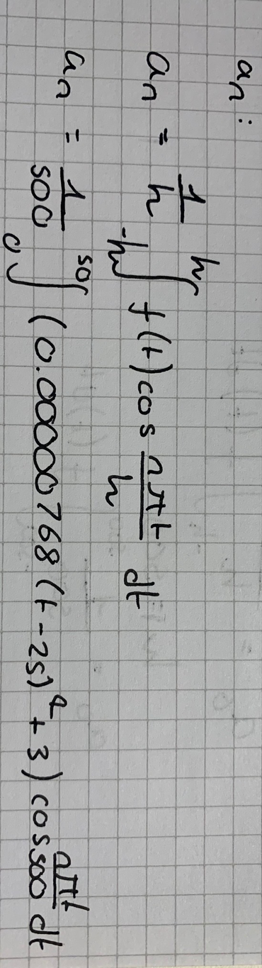
To work out the mean a0 we can use integration using limits of half the period. Our period in this case was 1 second so 1000 ms. Meaning half of our period is 500ms and an upper limit of 500 and lower limit of -500 would give us a range of 1000ms which is the total period of 1 second. If we let h = 500 our integration would allow us to calculate the mean as 0.29984, therefore a0 = 0.29984 We chose our limits for integration to be 0 and 50 as the section of curve R required is between t = 0 and t = 50.

The next steps of the Fourier series require the first coefficient term (an) and second coefficient (bn). a and b both being coefficients and n representing integers (1,2,3…). an is known as the Fourier cosine coefficient and bn is known as the Fourier sine coefficient.

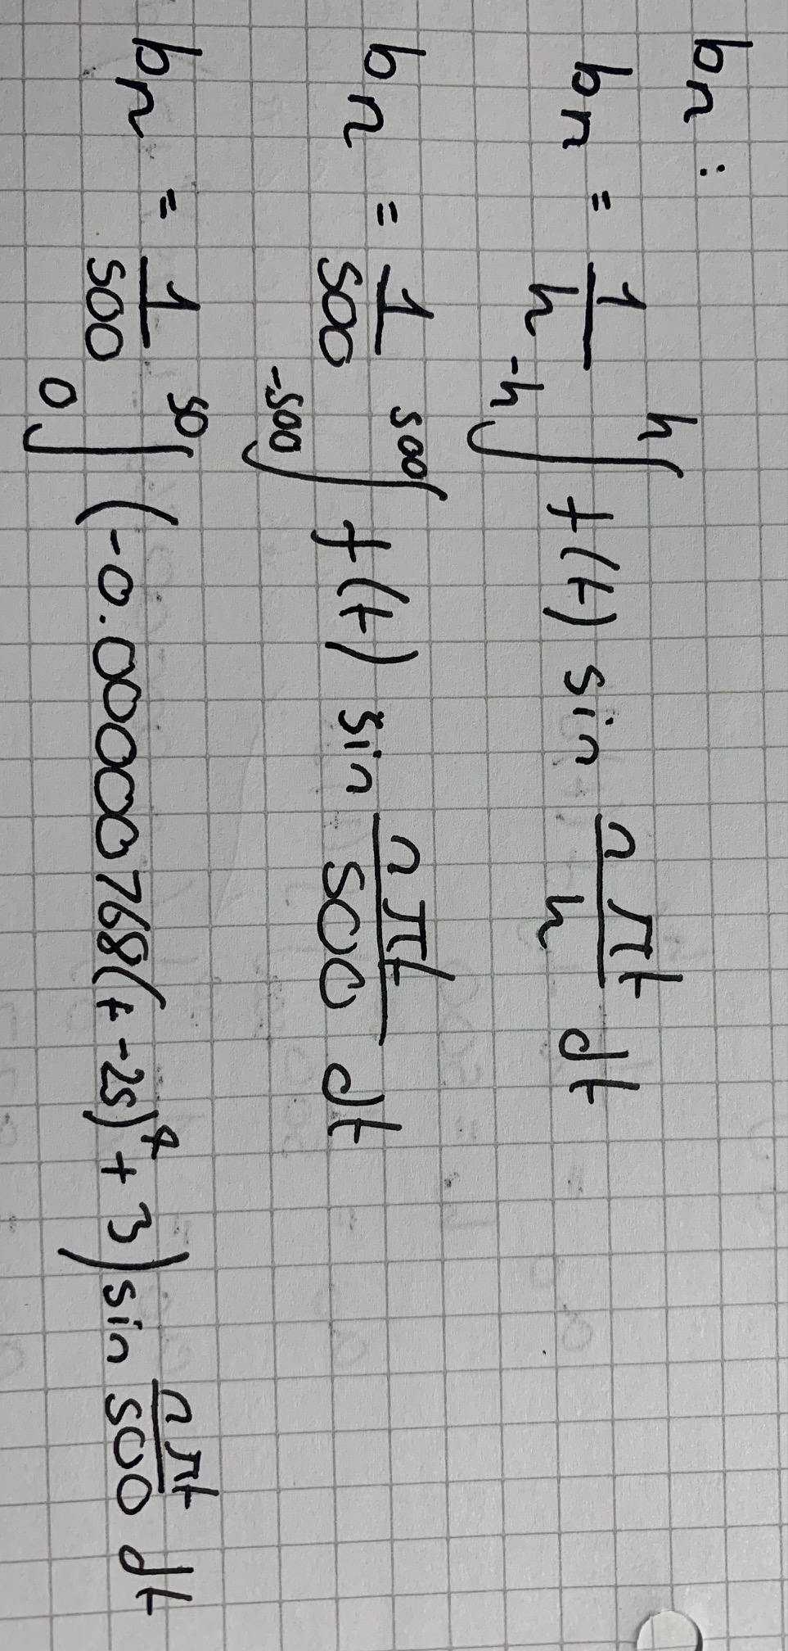

Both integrals can be solved to be then implemented into the Fourier equation:
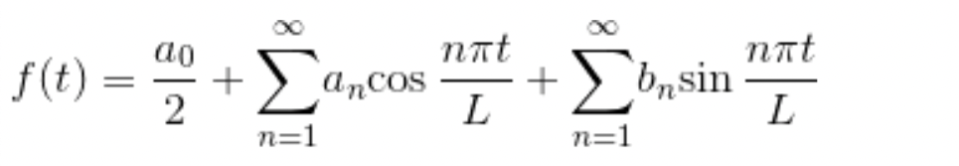
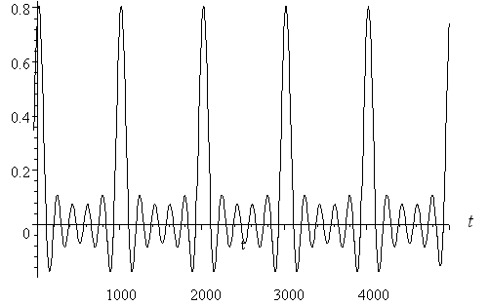
Graphically the Fourier equation will model a heartbeat, and have a similar shape to this graphical representation on the right which models the first 3 terms (n= 1 to 3) which are the beginnings of a regular 1 second heart beat and the more terms of n added gives us an even better approximation for our R wave.
This same mathematical process with the Fourier series can be applied to the P, Q, S and T waves obtaining an accurate model of the repeating heartbeat, so using the Fourier series we can take a single spike on the waves in a heartbeat and repeat them at regular time intervals. This repetition can be demonstrated with f(t) = f(t+1000) meaning repeat the curve every 1000 milliseconds.

The Fourier series is used in applied mathematics, particularly in physics and electronics where waves need to be expressed as functions such as in signal waveforms and is a useful tool in analyzing periodic functions such as the electrical signal produced by an electrocardiogram. Many instrument sound recordings such as violin, piano and drums can be represented as the sum of a collection of sine and cosine waves with varying frequencies and amplitudes, and too can be modelled by the Fourier series.
I hope I have convinced you that number has the power to model and replicate to high levels of accuracy, even the continuous beat of your own heart right now. As I said at the beginning Pythagoras claimed “number is within all things” and we have proved that number is within us.

By Olivia Fordham – Canford School

Bibliography:
https://prezi.com/ggggqthozssx/the-math-of-the-ecg/
https://en.wikipedia.org/wiki/Fourier_series
https://www.intmath.com/blog/mathematics/math-of-ecgs-fourier-series-4281
https://www.cvphysiology.com/Arrhythmias/A009
https://mathworld.wolfram.com/FourierSeries.html
https://www.electronicshub.org/fourier-series/
https://www.hopkinsmedicine.org/health/treatment-tests-and-therapies/electrocardiogram

Pictures (not hand written) from:
https://www.intmath.com/blog/mathematics/math-of-ecgs-fourier-series-4281
https://www.intmath.com/blog/mathematics/math-of-ecgs-fourier-series-4281
https://www.geogebra.org/?lang=en-GB

