The Complex Simplicity of Graph Theory
By Joe Gallagher

“Geometric diagrams are to geometers what board and pieces are to chessmasters: visual aids, helpful but not indispensable.”
– Richard J. Trudeau. Introduction to Graph theory
Here, Richard J Trudeau concisely highlights the importance of graph theory. Sometimes, we can be overwhelmed by a flurry of information and data in a variety of complex ways. By compressing detailed data into a minimalist diagram, graphs provide a fresh perspective from which information can be viewed, allowing analysts to uncover hidden connections between ideas. So, what is graph theory?

Graph theory is one of the most rapidly growing subsets of Mathematics, which Wikipedia defines as ‘the study of graphs, which are mathematical structures used to model pairwise relations between objects.’ Put simply, it is investigating how things relate to each other. These ‘things’ can be locations, values, code, people, and many other points of interest. In graph theory, these points of interest are referred to as ‘nodes’ or ‘vertices’ and the pathway which connects each node or vertex is called an edge.
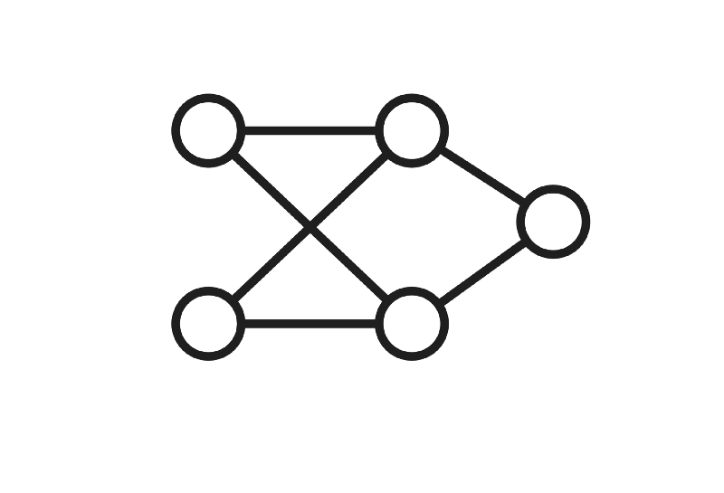

An example of a graph, where the circles are vertices and the lines are edges.

Leonhard Euler, one of the most influential Mathematicians to have lived, is often referred to as the pioneer of graph theory, introducing it in the late 18th century with the famous ‘7 Bridges of Königsberg’ puzzle, which we will explore later. Today, the study is used in a myriad of ways. In computer science, data structures are used to represent chains of code as working like vertices and edges; as a user navigates a coded piece of software, they move between each vertex (accessible piece of information) via edges (the code binding everything together). Like an explorer mapping undiscovered territory, each node unlocks a new feature of the software program as the users traverse their way along edges. On the topic of navigation, graph theory is also widely used by apps such as Google Maps to determine the shortest route, the route with the least turns, and the quickest route between 2 destinations. As you can see, our nodes can take on several different forms from the realm of code to the world of finance. So far, this strain of maths seems relatively straightforward – a visual display of logic – but it’s time to start adding some complexity.

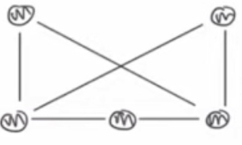
One key feature of a graph is that we can redraw and mould it to our own liking, and it still represents the same key data, as long as no edges are broken and no new edges are made. This is known as isomorphism, and basically allows us to move vertices around or stretch edges but keep the same graph. To show this, take the graph on the right and imagine moving the top left vertex to the top middle and the top right vertex down to the very bottom middle.

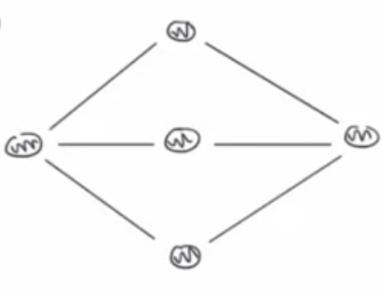
Hopefully, you are picturing a graph that looks like this:
What we have done here is create two graphs which are isomorphic to one another.

Moving forward with this knowledge, we are going to cover 5 main types of graph – each with its own unique applications. The first of these classifications are bipartite graphs. For these graphs, all of the vertices must be able to be placed into one of two sets, with each edge connecting a vertex from one set to a vertex from the opposite set. A vital application of bipartite graphs is in cancer detection, with their analysis being used to predict links between tumours (one set of vertices) and genes (the second set).

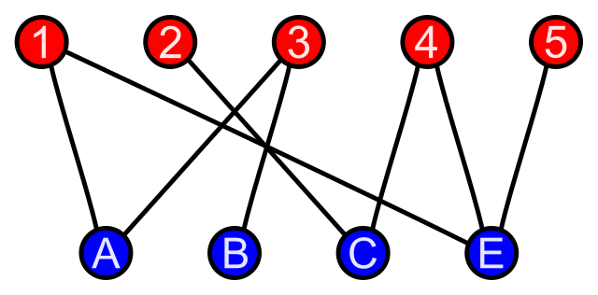

A bipartite graph with one set of vertices for numbers, and another set of vertices for letters. Each edge goes from number to letter (none from number to number nor letter to letter)

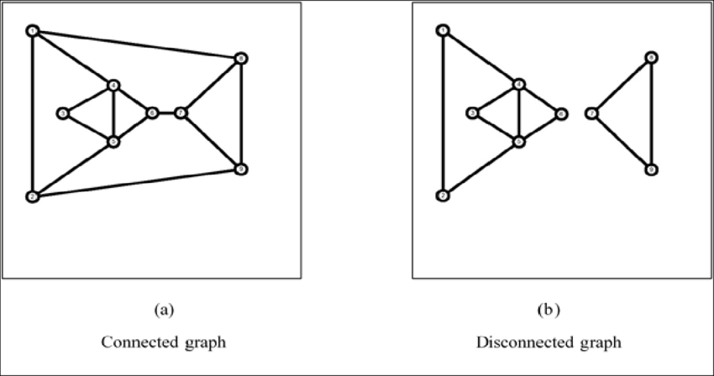

Our second type is a connected graph, which is quite simply where the is a set of edges connecting each vertex. This means that there will be at least one route to travel from any vertex to any another. Here we have an example of a connected graph and a disconnected graph:

Next, we have directed and undirected graphs. These graphs are opposites of each other; where with directed graphs you can only travel along an edge in one given direction, undirected graphs allow you to travel in any direction along an edge. We can describe directed graphs (digraphs) as asymmetrical and undirected graphs as symmetrical. These graphs are particularly useful in navigation and route planning.

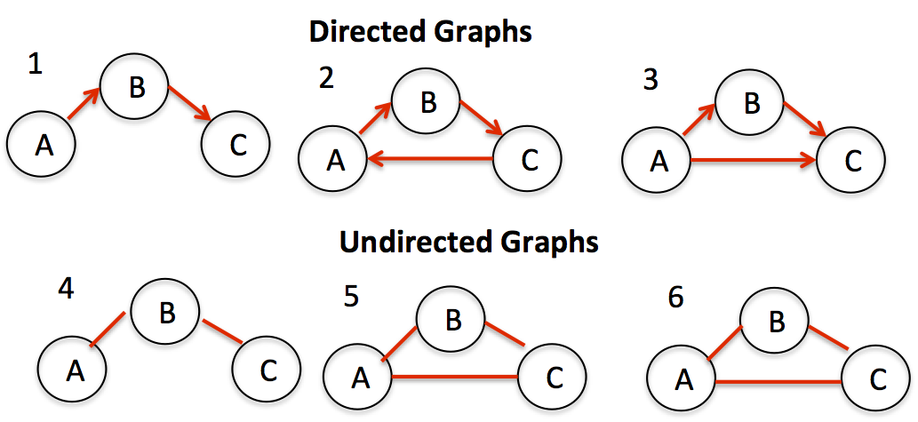

In graph 1, let e = the the edge linking vertex A to vertex B [e=(A,B)]. This means that A is referred to as the initial vertex of e and B is the terminal vertex of e.

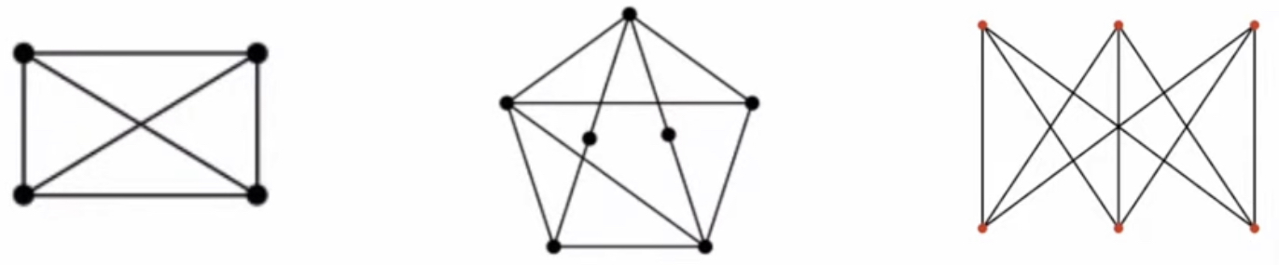
Finally, the most interesting graph to the mind of a mathematician and the one we will be mainly focusing on is a planar graph, where edges only intersect at their endpoints (vertices) and hence they do not overlap. A graph is planar if it can be drawn with no overlapping edges (isomorphic to a graph with no edges overlapping). Consider these 3 graphs and challenge yourself to decide whether or not they are planar:
If we begin with the graph on the left, you might note that stretching one of the diagonal edges to curve outside of the rectangle creates an isomorphic graph like this:
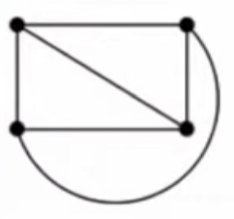

Here, none of the edges overlap, and so the left graph is planar.

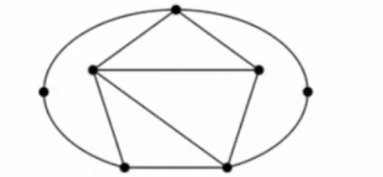

Moving onto our middle graph, taking the two middle vertices and pulling them outwards creates an isomorphic graph with no overlapping edges (pictured below) and so the middle graph is also planar.

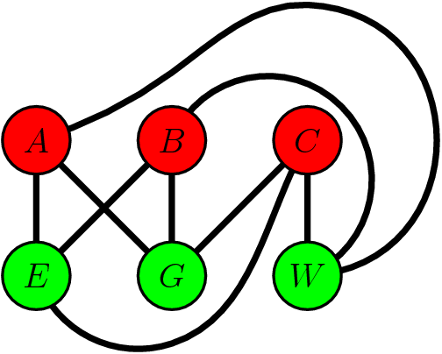
You might have become stuck with the graph on the right. This is because this graph is actually the first famous puzzle that we will be looking at, known as the Three Utilities Problem, which has a solution that uses graph theory. The problem is set up as follows: suppose we have three houses – A, B and C – and each house needs to be connected to three companies – gas (G), water (W) and electricity (E) - with a separate line from each house to each company, is there a way to set up all 9 connections without any lines crossing each other? To put it simply, and remove unnecessary words as we mathematicians love to do, the problem is asking: is our third graph planar? I invite you to attempt to answer this yourself before I go on to explain the maths behind our solution.
In order to find our solution, we need to learn about Euler’s formula. As I mentioned, Euler is a pioneer of graph theory and his formula states that for a connected graph with no overlapping edges, where V = number of vertices, E= number of edges, and F = number of faces, V – E + F = 2. Firstly, let us define the number of faces as the number of regions that we divide a piece of paper into when we draw a graph.
For example, this graph on the left from earlier has 5 faces: 4 within the rectangle and one surrounding the shape. It also has 4 vertices and 6 edges. Substituting these values into Euler’s formula, V – E + F = 2, we get 4 – 6 + 5 = 2, which simplifies to 3 = 2, obviously an incorrect statement. This is because the graph has overlapping edges. If, however, we draw an isomorphic graph with no overlaps, it now has 4 edges as pictured on the right. Now, using Euler’s formula, we get 4 – 6 + 4 = 2, or 2=2 a true statement which tells us that this graph is planar.

So, how do we apply this to the Three Utilities Problem? Well, we now know that if our bipartite graph, with 3 houses and 3 companies, is planar then it must be possible to draw the graph in a way that V - E + F = 2. Let us first assume that such an isomorphic graph does exist. We already know by counting our graph from earlier, that the Three Utilities Problem has 6 vertices and 9 edges. Using this in our formula gives 6 - 9 + F = 2 and so if the graph is planar then F must be equal to 5. We also know that the graph is bipartite, so there is no edge from company to company nor house to house. This means that if we pick a specific face, it cannot be bound by only 2 edges as there is just one line joining each house to each company (see figure 1 below). A face also cannot be bound by only 3 edges because this would require an edge from company to company or hose to house so that a triangle shape would be formed (see figure 2 below). Therefore, we may deduce that the minimum number of edges a face can be bound by in our ideal graph is 4 edges (see figure 3 below). Our next task is to construct a shape with 5 faces, which we know our graph must have, in the most edge-efficient way possible, which we know is 4 edges per face (see figure 4 below). Now, this shape we have constructed has a total of 10 edges, and so we can infer that the minimum number edges possible on a shape with 5 faces (each bound by 4 edges) is 10. This does not work with our Three Utilities graph which has 9 edges, which means that, after some complex geometric manipulation and slightly prolonged reasoning, we have shown that the Three Utilities Problem has no valid solutions as using Euler’s formula tells us that the graph is non planar.
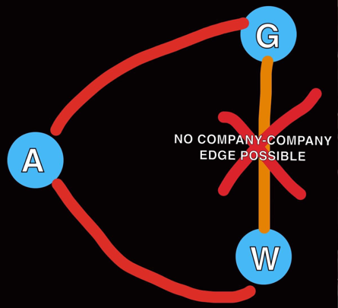
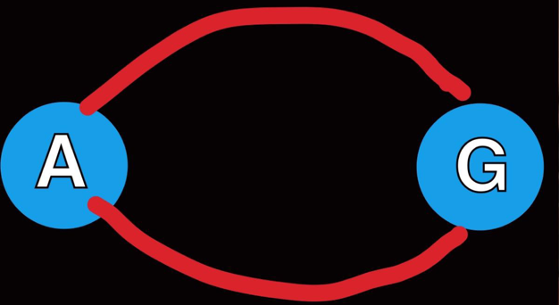
Figure 1
Figure 2

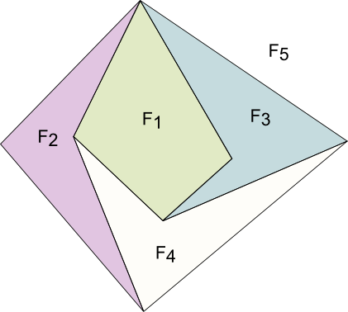
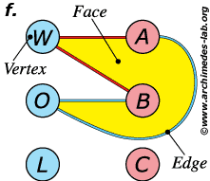
Figure 4
Figure 3

As is so often the case in Mathematics, the work of Leonhard Euler has proved essential in solving a complex problem, so I believe it is important to understand the origin of Euler’s formula, which coincides with the origins of graph theory. In the 18th century, a puzzle that gripped the world was to do with the historic German town of Königsberg and its bridges. The challenge, known as the 7 Bridges of Königsberg, is to plan a route around the town where you cross every bridge once and only once. Many had tried to solve the problem and failed by studying a map and attempting to plot their own unique route. Nobody could do it, but equally no one could prove why. No one except for Leonhard Euler. He approached the problem from a new angle - by representing each bridge as a vertex and each route between bridges as an edge, the question became whether or not that graph was planar. Armed with this new perspective, Euler was able to Mathematically prove that this puzzle was impossible to solve if the number of bridges was odd, and thus from this arose the discipline of graph theory when Euler later developed his infamous formula V - E + F = 2.
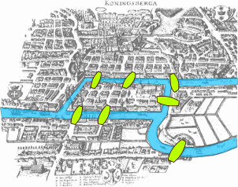

Whilst I’m sure you can appreciate this work of Mathematical intricacy; you may also be left asking why does this all matter? The answer is that Euler’s formula provides us with a new perspective from which problems can be approached and a simple response to the question: is this graph planar? This matters because planar graphs - despite the opinion of Richard J Trudeau in the quote I opened with - are truly indispensable in the design of complex radio electronic circuits, railway maps, chemical molecules and in so many other applications. It is thus clear that the elementary appearance and design of graphs is heavily contrasted by their advanced applications and detailed geometry. This is why the complex simplicity of graph theory is so enticing, and why it will continue to be one of the most rapidly growing subsets of Mathematics.

References

Introduction to Graph Theory, Richard J Trudeau (Dover Books on Mathematics published 2003)
https://www.youtube.com/live/71fz2F7UNIg?feature=share
https://prinsli.com/application-of-graph-theory-in-real-life/

