The Mystery of Pascal Blaise
and his inventions

While considering remarkable characters that contributed to Maths’ growth it is inevitable to mention Pascal Blaise who was the French mathematician, physicist, inventor and philosopher. His impact on the development of mathematics and its applications cannot be overstated and his contributions continue to be recognised to this day. Additionally, Pascal’s work also had a profound influence on the development of computer science, making him pivotal figure in the history of technology, in spite of the fact that he lived in the 17th century. What made him so recognisable?

The most remarkable and broadly known Pascal’s involvement is Pascal’s Triangle. When discussing the origins of Pascal’s Triangle, it is commonly believed that it was created by Pascal Blaise himself. However, a closer examination of the historical record reveals that this mathematical construct has a much longer and more complex history than the common misbelief. In fact, evidence of the triangle dates back to the 10th century, where it was mentioned in Persian now-lost literature. Over the centuries, it was discovered independently in various regions around the world, including Iran, China and Italy. As such, Pascal’s Triangle is not solely the product of a single individual, but rather the cumulation of a rich and diverse tradition of mathematical inquiry spanning multiple cultures and time periods. What about Pascal then? Did he know about the existence of the triangle beforehand?
“Let no one say that I have said nothing new… the arrangement of the subject is new. When we play tennis, we both play with the same ball, but one of us places it better.”
~Blaise Pascal

In his quote, Pascal acknowledged the existence of Pascal’s Triangle before his own contributions to its properties. More significantly, he recognised the endless potential for improvement within the fields of mathematics. Pascal’s dedication and perseverance have led to the flourishing of domains such as probability, combinatorics and algebra. As a result of his contributions to the study of this geometric structure in Western Europe, the triangle now is named after him. However, it is worth noting that in other regions, such as Iran, the triangle is alternatively referred to as the Khayyam Triangle, while in China it is commonly known as Yang Hui’s Triangle. Similarly, in Italy, the triangle is referred to as Tartaglia’s Triangle in recognition of the work conducted by various mathematician on this mysterious structure. Anyway, what is the Pascal’s Triangle and what is its usage?
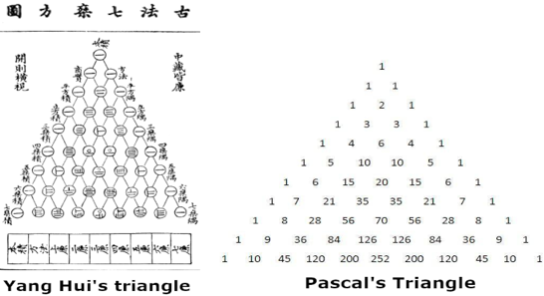

When it comes down to explaining Pascal’s Triangle, it seems not to be something that complex. To construct it, one begins with a single 1 at the top of the triangle. Each subsequent row is then created by adding the two adjacent numbers in the row above it. If a row begins or ends with 1, then additionally 0(s) can be imagined to complete the row. What is the size of this triangle?
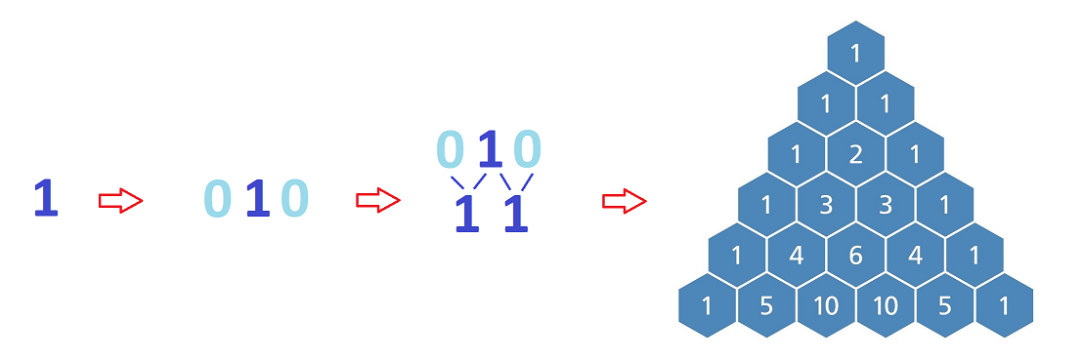
Construction of Pascal’s Triangle
One of a distinctive property of the Pascal’s Triangle is that the rows are characterized by an infinite progression, which means that it never ends. It is worth mentioning that while there is no theoretical limit to the number of rows that can be constructed, the practical limit is determined mostly by the ability of computers to handle increasingly large numbers. Thus, the largest known number of rows reaches a remarkable 184 of them.

Beyond both those numbers and its shape there are lots of patterns and properties of the triangle. Undoubtedly, the most familiar to most people is fact that it contains a relationship to binomial theory. Apparently, numbers in each row represent the binomial coefficients, which are basically coefficients of each term in the expansion of the binomial. It can be represented by the formula (x + y)^{n}, where n is an index of a row, counted from 0.
For example, given n = 3:
(x + y)³ = (x + y)(x + y)(x + y) = x³ + 3x²y + 3xy² + y³ = 1x³ + 3x²y + 3xy² + 1y³
Which corresponds to the values of 4th row of the Pascal’s Triangle
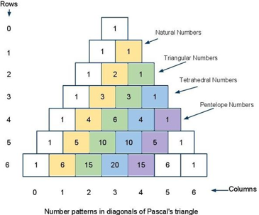
There are several other patterns that can be observed in the triangle, including consecutive Natural numbers, Triangular numbers, Tetrahedral numbers and Pentatope numbers. Presumably, the most familiar to everyone is pattern of Natural Numbers, which are basically positive whole numbers. Triangular numbers (also referred to as triangle numbers), are another pattern found in this geometric structure. They represent the count of objects arranged in an equilateral triangle, where each triangular number is equal to the total number of dots in the arrangement. We can visualize these triangular numbers as a sequence of equilateral triangles with increasing numbers of dots.

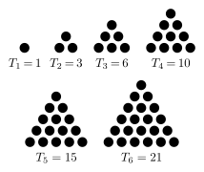

While exploring figurate numbers – numbers that can be visualized as dots arranged in geometric patterns e.g. triangular numbers, it is worth mentioning two notable examples of them: Tetrahedral and Pentatope numbers. Tetrahedral numbers represent a pyramid with a triangular base and three slides, whereas pentatope numbers represent a five-dimensional pyramid. (More in further reading)
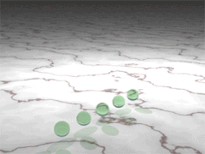
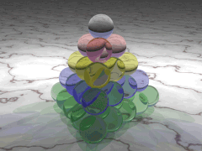

Tetrahedral numbers Pentatope Numbers
It goes without saying that Pascal’s Triangle is well-known for containing many mathematical identities, one of which I will cover in this essay – “Hockey-stick identity”. The extraordinary name of the identity stems from its graphical representation on Pascal’s Triangle. The Hockey-stick identity is a principle, which describes distinct pattern emerging from the progressive summation of values along a diagonal beginning at the top of a given row (starting from 1) and extending down to a specified element, equals the value of the element located a fixed distance to the right/left of the diagonal, mostly depending on its starting point. This pattern resembles the shape of a hockey stick, which is the main reason of its name.
For example:
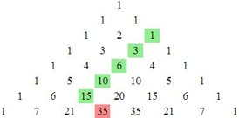
If we start a diagonal from the 2nd row [right side of the triangle] and turn once we’ve reached 15, the result will be following:
1 3 6 10 15 35
1 + 3 + 6 + 10 + 15 = 35
35 = 35

To this point, we have covered the salient concepts related to the properties and patterns of Pascal’s Triangle. Building on this knowledge, I shall shift focus to the transformations of this geometric structure. Specifically, consider the application of a mod-2 operation to each value within a given row. Notably, such an operation results in the substitution of all odd numbers (e.g. 1,3,5,7, …) with 1, while all even numbers (e.g. 2, 4, 6, 8, …) are replaced with 0. (Possibly, for some people it is more convenient to replace those numbers with different colours/shades than numbers – it ought to work in the same way)
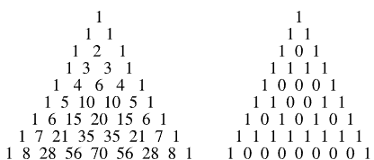

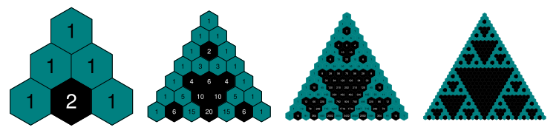
Noticeably, with each subsequent row, we can discern a certain relationship amongst those numbers. Within Pascal’s Triangle, successive figures emerge that resemble upside-down equilateral triangles. (Graphical visualization)

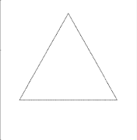
As we can see with each successive iteration, the triangles and their amount become more apparent, making it a fascinating example of fractal geometry – branch of mathematics that deals with the study of self-similar and irregular shapes or patterns, found also in nature phenomena such as clouds, snowflakes. (More in further reading) The figure that was created in this process is called Sierpiński Triangle, also known as Sierpinski’s Triangle, which can be created through a recursive process. This fascinating mathematical construct has applications in various fields of mathematics such as probability and combinatorics. Interestingly, there is more than one way to construct this triangle. Except using Pascal’s Triangle there is a method which involves starting with an equilateral triangle and then dividing it into smaller ones by removing subdivided triangles. (Graphical visualization). Are there any properties with mod-2 Pascal’s Triangle?
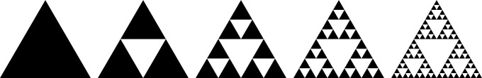

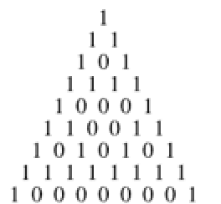
It is worth noting that in addition to its design and construction, the Pascal’s Triangle mod-2 exhibits an intriguing property related to the binary number system. If we observe the triangle mod-2, each row generates a sequence of binary digits, consisting solely of zeros and ones. The binary sequences generated by the rows of the mod-2 Pascal’s Triangle exhibit a remarkable similarity to the binary representation of numbers in the base-2 number system. Therefore, it would be interesting to convert these sequences into the decimal number system and explore their property further. Here are the results of this conversion.
1
3 – Prime number
5 – Prime number
15 – 5 x 3, not prime
17 – Prime number
51 – 17 x 3, not prime
85 – 17 x 5, not prime
255 – 17 x 15, not prime
257 – Prime number
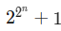
With that being said, we can see a pattern looking at those numbers and whether they are prime or not. Every time we observe a prime number, we take a step back and multiply by numbers before. It can be represented by the formula:

where n = index of row, counted from 0.
Surprisingly, it is not the only pattern seen in which there are prime numbers involved. If we take a look at the diagonal with consecutive Natural Numbers from the previous part of the essay, we can notice that in each row, where the prime number exists, every other number [except ones] is multiplication of the prime numbers.
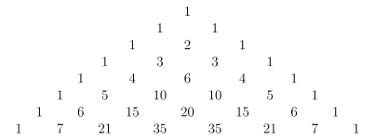

For example one of the prime numbers is 7. As we can see both 21 and 35 are multiplication of this number as described before.
With both knowledge and excitement about the topic we can move to the part of Computer Science. As mentioned, Blaise Pascal made significant contributions to the fields of computer science and technology. His ground-breaking work in this area laid the foundation for the development of modern computers, programming languages and computer architecture. In 1642, Pascal invented the digital calculator, also known as the Pascaline, which was a major milestone in the history of computing. It is said that Pascaline was the first calculator that had been made. The device utilized gears and wheels to perform addition and later subtraction operations. Despite being widely used by professionals, mostly accountants, the Pascaline was not commercially successful due to its high cost. However, it undoubtedly paved the way for the future innovations in computing technology, including future programming languages.
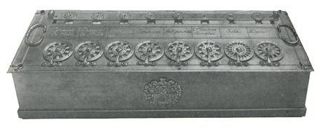

Pascaline
Pascaline utilized a series of dials to input numbers and Pascal developed a notation system for the dials that was similar to the notation used in modern programming languages. Interestingly, one of the first programming languages used Pascal’s notation as the basis, which is the main reason of its name – “Pascal”. Another significant contribution of Pascal to computer science was his work on the theory of algorithms. Pascal emphasized the importance of breaking down complex problems into smaller, more manageable parts, an idea that is fundamental to modern computing. Today, algorithms are used to solve a wide range of problems, from complex mathematical calculation to processing vast amounts of data – e.g. progressing rows in Pascal’s Triangle.
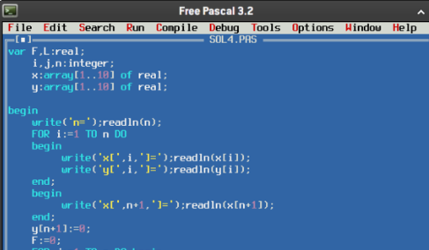

Pascal’s work on the nature of knowledge and certainly in philosophy also had a significant impact on the field of computer science. His views on the importance of logical reasoning and empirical evidence influenced the development of AI – Artificial Intelligence and other fields of computer science dealing with the representation and manipulation of knowledge.

In conclusion, Blaise Pascal was a brilliant mathematician and scientist, whose contributions to the field of mathematics have had a profound impact on modern science. Thanks to his devotion to the philosophy and technology by constructing algorithms theory and first calculator, Pascal made significant contributions that continue to shape our understanding of the world and allow our generations to simplify activities and processes we used to struggle with in the past. Pascal’s legacy is a testament to the power of interdisciplinary thinking and the potential of individuals to make lasting contributions to human knowledge. As he once said:
Look for the truth, it wants to be found.
~ Blaise Pascal

This quote embodies Pascal’s dedication to the pursuit of knowledge and his belief in the importance of seeking truth in all aspects of life.

Oskar Krawczyk

References:
- Pascal ‘s Triangle - YouTube
- Pascal 's triangle - Wikipedia
- Blaise Pascal - Wikipedia
- Sierpiński Sieve -- from Wolfram MathWorld
- „Computer Science, An Overview, 13th edition” - J. Glenn Brookshear, Dennis Brylow
- Sources of images: Sierpiński Sieve -- from Wolfram MathWorld, Search media - Wikimedia Commons
- OOMC – Oxford Online Maths Club
Further Reading:
- Tetrahedral numbers, Pentatope numbers - Tetrahedral number - Wikipedia, Pentatope number - Wikipedia
- Fractal geometry - Introduction to Fractal Geometry
- Pascal’s contribution to technology and computer science - How the Pascaline Works - YouTube, https://en.wikipedia.org/wiki/Mechanical_calculator
- More properties of Pascal’s Triangle - https://www.livescience.com/51238-properties-of-pascals-triangle.html

