What is the shape of space?

Let’s start by thinking back to the Big Bang and its initial conditions so that we can predict the behaviour of the expansion. Initially, the universe was extremely hot and extremely dense. It then expanded outwards in all directions with uniform acceleration. Or did it? In this scenario, we have not accounted for dark energy or dark matter, which makes up 71.4% and 24% of our universe respectively, meaning that atoms and ‘normal’ matter only makes up 4.6%. The first evidence for dark energy was discovered in 1998 hence before that, the existence of a flat universe could not be explained. This situation was aptly named the flatness problem. Today scientists have had to adapt the big theory for the so called flatness problem to allow for dark energy and dark matter. The existence of the flatness problem can tell us something crucial about the expansion of space-time and has also caused some us to adapt the Big Bang theory to allow for “flattening” of the universe.
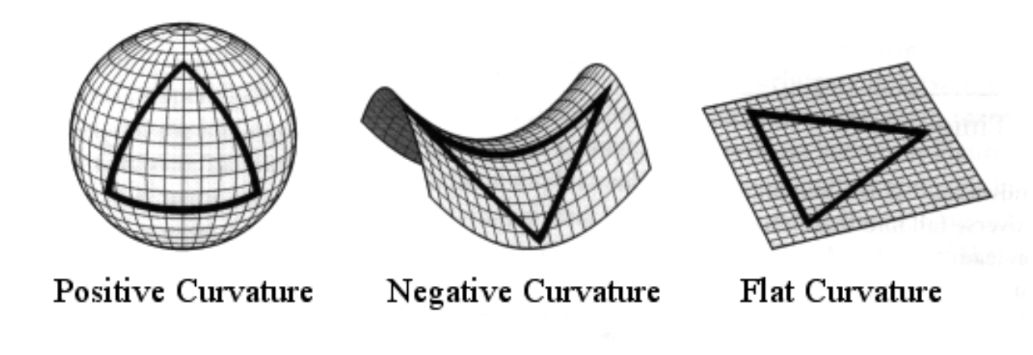
Space can either be positively curved like a ball, negatively curved like a saddle or flat, the image above visualises this. Here, it is important to make the distinction between the curvature of space (positive, negative or flat) and its topology (the shape it makes through its connections e.g a torus). If space is positively curved than this means that it is finite and closed. If space is negatively curved or flat than it is infinite and open.

Let’s take a look at one indicator of the shape of space - whether the density of space (actual density) matches the critical density. Density measures how much stuff is in a given amount of space so, density = mass/volume. The critical density is the density that would stop the expansion of the universe (nor would the universe start collapsing). The density parameter (Ω) is used to model the relationship between the actual density, ρ and the critical density, ρ_{c} such that Ω = ρ/ρ_{c}. If the actual density is larger than the critical density ( therefore Ω > 1), than the gravitational forces will overcome the momentum left over from the Big Bang and dark energy, so the universe will eventually collapse - this is called a closed universe model. But what is dark energy? It was first considered a property of space by Einstein in 1917 but very little is known about it. Scientists only found out about its existence through the effects of gravity because the universe was expanding and accelerating faster than predicted so scientists knew that there must be something else at play in the form of dark energy. But back to the density parameter - if the actual density is smaller than the critical density (therefore Ω < 1) then the universe will continue expanding up to a point where the gravitational forces are negligible. In this case, the expansion rate will approach, but never reach a constant rate - this is an open universe model. However, if the actual density is the same as the critical density (therefore Ω = 1) then the universe will continue to expand forever, with the expansion rate reaching an asymptote towards zero (will constantly become closer to but will never reach zero).
(1)
$$\left(H^{2}-\frac{8}{3}πGρ\right)R^{2}=-kc²$$

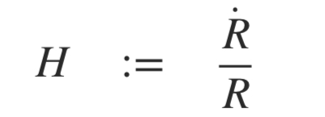
The density of the universe and the curvature are linked by the Friedmann equation, which is shown in (1) above. The actual density is represented by ρ and the curvature is represented by the dimensionless constant k, whose value is either -1 for negative curvature, 0 for zero curvature or 1 for positive curvature. R is a scaling factor, G is the gravitational constant and c is the speed of light. The Hubble constant, H, tells us how fast the universe is expanding and can be linked to R as shown in (2) below:
(2)
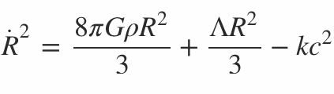
(3)

The Friedmann equation can also be written as shown above in equation (3). You’ll notice that equation (3) contains an extra parameter, Λ, in addition to six parameters shown in equation (1). The extra parameter, Λ, is called the cosmological constant was first seen in the Friedmann equation in Einstein’s 1917 paper. Its purpose was to make a static universe possible within the equation. However when the universe was irrefutably found to be expanding, Einstein called adding in Λ “the worst mistake I have ever made”! Now Λ can be used to represent the observed acceleration of the expansion as a result of dark energy. Although there is still debate as to whether Λ is necessary, with many versions of the Friedmann equations abandoning it.

Another way in which the Friedmann equation (4) can be used is to calculate the critical density that we have previously talked about. This can be done by setting the curvature constant (k) to zero such that the actual density equals the critical density as shown in equation (5). This also simulates the density parameter (Ω) equalling 1.

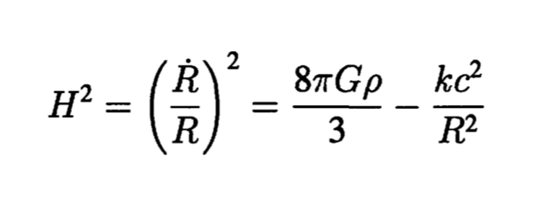
(4)
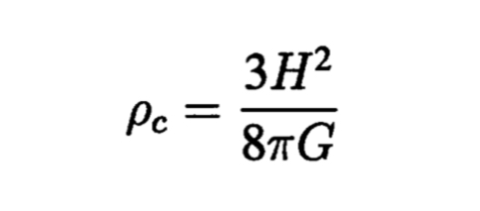
(5)

As the Hubble constant can be estimated to be 69.8 km/sec/Mpc ¹, and G can be estimated to be 6.67 x 10⁻¹¹ N m²/kg² ² the critical density today is roughly 9 x 10⁻²⁷ kg/m³. This value for the critical density includes of all the mass and energy in the universe, including dark mass and dark energy which remains a mystery.

¹According to NASA’s 2019 value, https://www.nasa.gov/feature/goddard/2019/new-hubble-constant-measurement-adds-to-mystery-of-universe-s-expansion-rate
²According to NASA’s 2018 value, https://imagine.gsfc.nasa.gov/educators/programs/swift/classroom/law_grav_guide.html

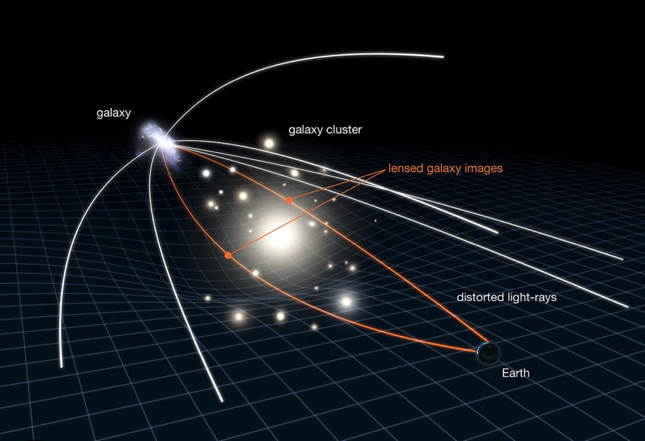
Illustration of gravitational lensing (Image: NASA/ESA)

Studies have been undertaken to try to collect data to tell us what the curvature of the universe is using Cosmic Microwave background (CMB) radiation. CMB radiation is the remnants of radiation that appeared immediately after the Big Bang. One such study has been undertaken by the Planck collaboration using the Planck space telescope. The study, conducted in 2018, found a larger than expected gravitational lensing effect resulting in the direction of the CMB photons being slightly altered from their original direction due to the photons encountering matter, such that the more matter they encounter the more lensing occurs. The gravitational lensing effect is illustrated in the image above. The larger than expected lensing effect could be attributed to another finding of the Planck mission - a larger than originally thought proportion of dark matter in the universe. For a flat universe, the curvature measurement should fall within one standard deviation (σ) of zero to allow for statistical fluctuations. However, the CMB radiation information differs from zero by 3.4σ. Some cosmologists argue that this could be due to a fluke in the data. If you roll a dice a hundred times and at some point you roll four sixes in a row and you wouldn’t think too much of it. However, if you only rolled the dice four times and it landed on a six four times, then the chance of this happening is 0.00077..% or (1/6)⁴ and therefore, this series of rolls would seem quite remarkable in isolation. A similar line of thought has been put forward to explain the fluke in the data - we must have encountered that remarkable series of rolls - or in this case that series of variation in CMB radiation. This is called the “look elsewhere effect” by physicists. Cosmologists have also postulated that there must be something unknown and/or something unaccounted for that is interfering with the results, mimicking extra matter. However if you run with the assumption that the universe really is closed and therefore spherical then other anomalous results from the CMB radiation are resolved. One such example of this was that the variation in the colour of CMB light was different when large areas and small areas were compared. However, when you look at these values, assuming a spherical universe, these values are consistent. Those who don’t believe in a spherical universe have chalked up these results to the same statistical fluctuations that caused the curvature measurements to differ by 3.4σ from zero, or they say that it could be due to the same unknown and/or unaccounted for thing that caused the blurring of CMB light. So as you can see, the arguments for each situation cannot be easily differentiated.

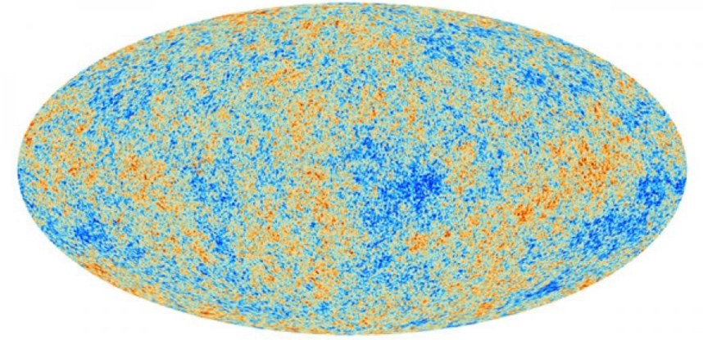
Credit: ESA and the Planck Collaboration

The image above maps the thermal fluctuations of the CMB radiation in the universe. The temperature fluctuations relate directly to the density of that region, with denser areas appearing hotter (red in the above image). As CMB radiation is the remnants of radiation that appeared immediately after the Big Bang, if the universe expanded outwards uniformly in all directions, then surely there should be some symmetry in this image as acceleration should be the uniform in every direction. However there is not, therefore it could be said that the universe is not spherical or closed and instead must be open and infinite. This means that the shape of the universe could either be flat or hyperbolic. Herein a problem arises – how can you be sure of the shape of the universe if you don’t know how big the universe is? For example, if the data says that the universe is flat then how can we be sure that a big enough portion of space was measured for this to be true? It is also worth noting that the measurements provided by the Planck space telescope have an accuracy set by the fundamental astrophysical limits, meaning that you could never take measurements of CMB radiation to a higher degree of accuracy than this.

In conclusion, there are many ways in which we try to determine the shape of our universe including: the density parameter which tells us whether the universe is expanding or collapsing; the Friedmann equations that link many factors together including actual density, the curvature parameter and the Hubble constant (but not the cosmological constant as the universe isn’t static, sorry Einstein!); the Planck space telescope whose statistical fluctuations have lead to arguments for both an open and a closed universe; or using CMB radiation which showed us that the universe must be open as a result of asymmetry, but did not tell us whether it was flat or hyperbolic. Ultimately, we cannot observe the dark energy making up 68% of our universe, meaning that currently we can only go as far to say that the universe is open and quite possibly flat. I believe that this conclusion can only result in exciting research possibilities for the future as we endeavor to know more about our universe.

Bibliography:
https://www.quantamagazine.org/what-shape-is-the-universe-closed-or-flat-20191104/

https://s3.cern.ch/inspire-prod-files-b/b11715bd3ecff0e22e0fdf99d5005ca0

https://www.aanda.org/articles/aa/full_html/2020/09/aa33886-18/aa33886-18.html

https://www.esa.int/Science_Exploration/Space_Science/Planck_overview

https://www.oxfordreference.com/display/10.1093/oi/authority.20110803095648446;jsessionid=4F09419B91C0C42A9EBBC8A4E96DFFA4

https://wmap.gsfc.nasa.gov/universe/uni_matter.html

https://www.cam.ac.uk/research/news/planck-captures-portrait-of-the-young-universe-revealing-earliest-light

http://hyperphysics.phy-astr.gsu.edu/hbase/Astro/fried.html

https://academic.oup.com/mnras/article/495/4/3571/5824652

Stuart, C 2021, Numbers: 10 Things You Should Know Seven Dials

