You Are Made of Maths – And Here’s Why…
Have you ever looked at history’s greatest mathematicians and wondered: What is the difference between them and me? Heroic figures like Pythagoras, Euler and Hypatia, with their innovative thinking and infinite wisdom - they must eat, sleep, and breathe maths to be as bright as they are! Well, although they did immerse themselves in the subject, the biology of their bodies is just the same as you and I. And, like them, we have maths coursing through our arteries creating the beautiful structure that is the human body. Think about the composition of you. A walking bag of bones, blood, lymph, neurons, cells, electrical impulses; all of which are regulated and carefully monitored by the supercomputer that is your brain. Our temperature is regulated around 37°C; the sugar levels in our blood are monitored and controlled and hormones are secreted at regular intervals, all to keep the human machine functioning to perfection. So, how could all this relate to mathematics?
The Vitruvian Man
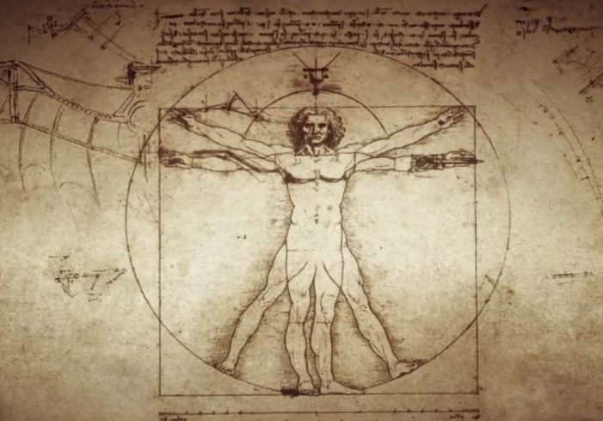
It turns out that the idea of relating humans to mathematics has been explored for millennia, perhaps most famously by Da Vinci’s ‘Vitruvian Man’ (Fig 1). For years mathematicians had been trying to solve equating the area of a circle to the area of a square, a construct which is not possible due to the nature of Pi. However, Da Vinci’s out of the box thinking enabled him to calculate areas in terms of the human body. How did he do it? By assuming the naval is the direct centre of the body, it is possible to construct a near perfect circle with the circumference touching the tips of the fingers and the toes. For the same body, since arm span approximates height, a near perfect square can also be constructed. By overlaying these two bodies using mankind as the template, the square of a circle could be constructed.

Fig 1: Da Vinci’s Vitruvian Man
Human Rivers
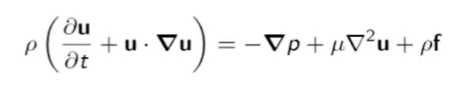
Where there is liquid, there is fluid dynamics. And what’s more important than blood? To begin with, let’s understand the Navier Stokes equations - the fluid equivalent of Newton’s second law of motion. Applying this equation to a fluid where the volume is continually decreasing, we can express the rate of change of the momentum of the fluid in terms of three values: the forces acting on the fluid due to pressure, the viscosity of the fluid and any other forces acting on the liquid. By dividing these three variables by the volume of the liquid, and allowing the liquid’s volume to slowly tend to 0, equation (1) can be formed:

Equation (1)
Where ρ = the density of the fluid; u = the velocity of the fluid; μ = viscosity of the fluid; p = pressure of the fluid; and f = other forces (e.g. gravity).
On the left-hand side of equation (1) is the fluid’s density (ρ), multiplied by the rate of change of velocity (acceleration, $\frac{du}{dt}$) and corrective terms to account for molecular interactions between the particles within the fluid ($u∙∇u$).
There are numerous examples of fluids in the body, (vitreous / aqueous humors, mucus, pleural fluid, urine). To take the simplest example of this, let’s look at the movement of blood within arteries (Fig 2). For context, the arteries distribute oxygenated blood to the body from the heart.
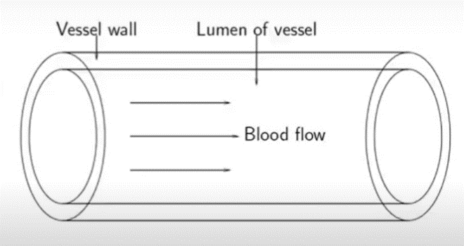

Fig 2: Diagram of a human artery
To unpack the fluid dynamics of blood in the artery we must make a few assumptions. Firstly, we assume that the blood travels at a constant velocity; secondly, that the artery walls are inelastic; and thirdly, that the artery has a regular cylindrical shape. To start with, we also assume that each particle of blood flows in a straight line down the artery, however we will relax this later. This allows a numerical calculation for the rate of change of momentum of the blood. As the speed is constant, the rate of change of momentum is also 0. Setting equation (1) to 0 and rearranging for velocity of the blood, u, you can derive equation (2):
0

$Q= \frac{P_{1}-P_{2}}{R}$ Equation (2)
This means that the rate of flow of the blood is determined by a pressure gradient, the change in pressure (P) divided by the resistive forces which in this case are the viscosity of the fluid.
The resistance, R, to the laminar flow through the artery can be described as $R=\frac{8μl}{πr^{4}}$ where: μ is viscosity; l is the length of the cylinder and r is the radius. Combining these two equations we form Poiseuille’s Law, this describes laminar flow through a tube (equation 3).
$Q= \frac{(P_{1}-P_{2})πr^{4}}{8μl}$ Equation (3)
As we know that the flow of blood is determined by a pressure gradient, lets apply this to more real-world conditions: your heartbeat. While it obviously has numerous incredible functions, one of the key roles of your heart is to set up this pressure gradient within your arteries by pumping blood constantly into the aorta, your main artery. This creates an increased volume of blood to be pushed through the aorta increasing the pressure, causing a pressure gradient which allows for laminar flow as we just calculated. However, your body is far more complex than this.
Meandering Rivers
As we know, the arteries are not simply long straight drainpipes that penetrate your body, instead they have curves and bends. Arteries are the rivers of humankind. With their numerous meanders and fatty deposit point bars, the modelling of laminar flow can be somewhat disrupted. To account for this, we must understand the idea of centrifugal force around a bend. As the tube curves, a second laminar flow take precedence, one running from the inside of the bend to the outside of the bend (Fig 4).

Fig 3: Direction of laminar flow in a bend
This offsets the Poiseuille flow as the predominant flow is not in the centre of the artery, but closer to the outer wall of the bend. Therefore, there is a difference in pressure exerted by the blood, with a higher pressure on the outside of the bend and a lower pressure on the inside. When we apply this to realistic situations, it helps us to understand why fatty deposits build up on the inside of an artery rather than the outside, much like how a slip off slope is formed on the inside of a meander in a river. Whilst the dominant laminar flow is closer to the outer wall, there is a secondary flow forward through the bend - these two directional flows create a swirling vortex of blood that barrels through the arteries, twisting and turning (Fig 4). Although there is this difference in stress between the inside and outside of an artery, this is accounted for by the swirling nature of the Poiseuille flow, preventing excessive strain on the artery’s walls.
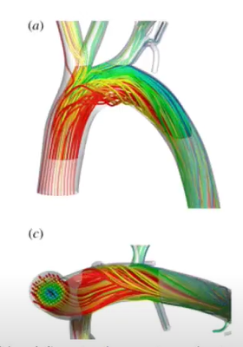
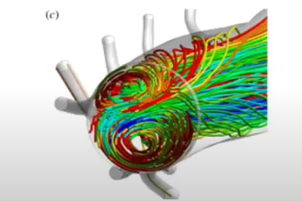

Fig 4: Poiseuille flow offset by two directional laminar flow.
How can this help us?
By understanding the rate of laminar flow through the artery, and the fact the blood is swirling constantly, scientists have designed a new type of stent with a helical structure to force the artery to coil into a winding state, evening out the stress of the pressure from the two differing currents of laminar flow. Hence, the number of regions that can develop disease and opportunity for build ups of fatty acids is reduced.
Using Fluid Dynamics in the Eye
Another example of using fluid dynamics to aid medical research in relation to the body is in your eye. Picture the eye: a ping pong ball with vitreous humor at the back and aqueous at the front. Albeit the fluid dynamics in this scenario are a little more complicated. Think back to secondary flows within arteries. Though the two structures are vastly different, the eye has two flows of its own as well. The primary flow is caused by forcible rotations of the eye when you look around, causing the vitreous humor to spin around an imaginary horizontal axle through the middle of your eyeball (Fig 5).
centre of rotation

Fig 5: The oscillating primary flow as the eye rotates.

Fig 6: The steady secondary flow
The reason for this movement is due to inertia in the middle of the eye and the non-slip membrane that surrounds the vitreous humor, dragging the fluid around as it moves. This rotation leads to a centrifugal force, giving rise to a secondary flow. The particles of humor are pulled towards the centre of the eye due to the centrifugal force caused by the eye rotating constantly. When they reach the middle of the eye, they hit a region of high pressure as fluid cannot build up in the centre of the eye. So they are driven sideways then back around the outside, to repeat the process again, (Fig 6). If you imagine this in a 3D plane, movement around the centre of rotation will lead to two taurus’ of flow, one on the left, one on the right.
Comparing these two flows the primary flow changes direction depending on the forced movement of the eye, whereas the secondary flow always remains consistent at a steady pace.
What does this mean for medicine?
Many diseases to do with the eye require patients to undergo injections monthly, where a fluid is inserted into a patient’s eye, targeting the retina. For years, doctors thought the process of moving the fluid to the back of the eye was caused by the movement of the eye, however it is this secondary flow which leads to an even distribution of the drug. It is breakthroughs like these that can aid medical technology as doctors can better predict where to inject patients for the highest chance of success at recovery.

Conclusion
To conclude, there are numerous different approaches to applying mathematics to the human body, the most prevalent one being fluid dynamics. We have explored its uses within the context of the arteries and the eye, while applying the real-world benefits of this knowledge to medicine. While history’s most brilliant and best mathematicians may have been out of the box innovative problem solvers, their physiology used the same intricate mechanics and daedal dynamics as those operating in your body and mine. So, next time someone says Isaac Newton was ‘just built different’, think back to Navier Stokes and his equations proving that whilst geniuses eat, sleep and breathe maths, you eat, sleep and breathe because of maths.

Bibliography:
Tweedy, J. Going with the flow: Why fluid dynamics are important for understanding how the body works. Institute of Mathematics. Available at:https://ima.org.uk/8629/going-flow-fluid-dynamics-important-understanding-body-works/ [Accessed on 26/03/2023]
OpenStax. Viscosity and Laminar Flow; Poiseuille’s Law. LibreTexts, Physics. Available at:https://phys.libretexts.org/Bookshelves/College_Physics/Book%3A_College_Physics_1e_(OpenStax)/12%3A_Fluid_Dynamics_and_Its_Biological_and_Medical_Applications/12.04%3A_Viscosity_and_Laminar_Flow_Poiseuilles_Law [Accessed on 24/03/2023]

