Thinking – a deep dive into artificial intelligence

“Of course a machine can’t think as people do. A machine is different from a person. Hence they think differently.” – Alan Turing.

As if cracking the German Enigma was not intellectually taxing enough, Turing would spend his downtime pondering the possibility that computers could one day think like us. The prospect of man and machine becoming intellectual equals seemed a long way off back in the 1940s. “At that time, the advent of such machines was often placed some twenty years into the future,” wrote Oxford University professor Nick Bostrom in his book ‘Superintelligence’. “Since then, the expected arrival date has been receding at a rate of one year per year.”

Like Turing, Bostrom too contemplated the existence of machines harbouring human level intelligence, and the aftermath upon which such a machine surpasses the very humans who designed it. It is definitely an interesting thought experiment, however, human level artificial intelligence still remains a fiction.

But by no means does that mean the art has failed us; there have been countless “weak” artificial intelligence systems that have exceeded expectations. Google’s PageRank algorithm sifts through billions of pages in seconds, and DeepBlue’s chess engine defeated the legendary Gary Kasparov in 1997. Building “strong” AI however, is a problem that has yet to be solved, though machines are continuously getting smarter, and this essay will explore some well-known algorithms and probabilistic models that allows for somewhat ‘intellgent’ machines.

Search algorithms
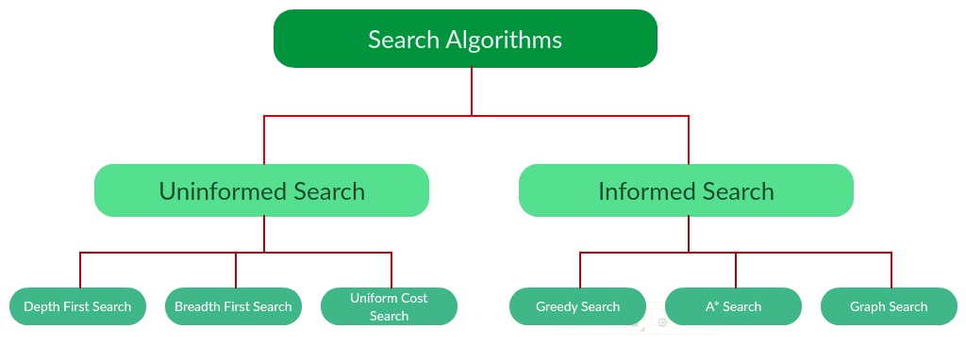
As shown in the above diagram, there are two sub categories of search algorithms, uninformed and informed search. As suggested by their names, uninformed methods of searching do not take into account external informations, whereas informed methods of searching do. For simplicity, only DFS, BFS, greedy search and A* search will be explored.

Uninformed search
With all methods of search, a “frontier” is necessary, which will keep track of all the different states to be searched (states are the environments of an AI agent). The frontier starts off containing the initial state i.e., the starting position or the root node. That initial state node is removed from the frontier and checked against a goal state. Intuitively, if the node matches the goal state, a solution has been found to the search problem and it is returned. Otherwise, the node is added to an ‘explored’ set, and then is expanded, in other words each of its neighbours are retrieved and added to the frontier for searching. This process repeats until the goal state is eventually reached.

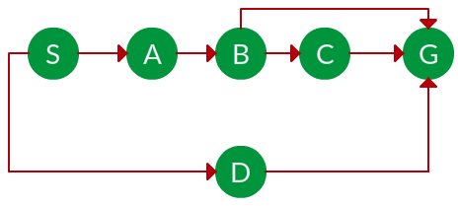
Take this example:

The S node is the root node, or the initial state. The arrows indicate the paths or actions that can be taken from one node to the next. Let’s say we want to find a solution from S to G. Upon analysing the graph above, one should notice that there could be different solutions to such a problem, as some nodes diverge off to others forming branch structures.

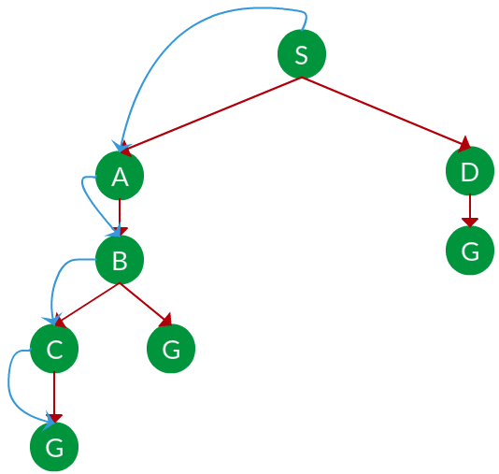
Depth first search explores each branch fully before backtracking, hence it uses a stack, or LIFO (Last In First Out). You could imagine a scenario with a maze, where DFS would pick a route and explore it fully, all the way to the end. When it hits a dead end, only then will it backtrack, hence the name “depth” first search. Here’s how this search problem would be solved using DFS:

The solution found is shown in blue. At the start, once the S node is expanded there are two options, to expand the A node or D node. (This is where DFS falls behind in comparison to other methods of search, as unluckily the A node was expanded resulting in the longer solution to G, compared to a much shorter solution if the D node was explored instead.). The A node is expanded, then B, which adds two node to the frontier, C and G. Again, sadly the algorithm unknowingly picks the longer route, eventually reaching G.

Now let’s look at Breadth First Search. BFS uses a queue over a stack for expanding nodes from the frontier, or FIFO (First In First Out). Hence, it will explore the shallowest node first, taking a very different approach compared to the more brutish and stubborn DFS. Here’s the solution to the same problem using BFS:
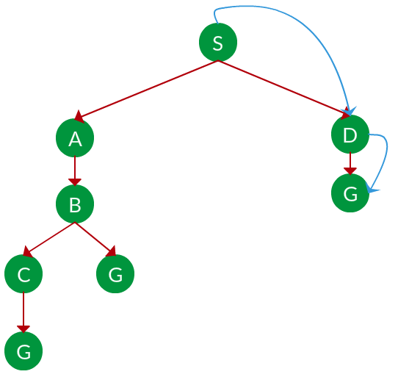

The solution is shown in blue. Like before the S node is expanded, and A and D are added to the frontier. The difference this time is that, a queue is used. This means that when say A is expanded and the B node is added to the frontier, instead of venturing deeper down that branch, the First In First Out data type meant that the D node was explored first. This makes BFS much more efficient, as it doesn’t commit to searching any branch, and will therefore find the most optimal solution.

What about informed search?
Uninformed search can be costly, as the agent is essentially ‘blind’; there is no way of determining an optimal solution.

Informed search however, provides the agent with more information alongside the goal state. This is called a heuristic, a function that estimates the distance to the goal. Examples include Manhattan distance and Euclidean distance, each used in different situations.

Greedy search will always choose the node closest to the goal state, the ‘closeness’ evaluated by a heuristic function h(x). The lower the value of h(x), the closer to the goal state. Take this example, where the root node is still S, and the goal is G.
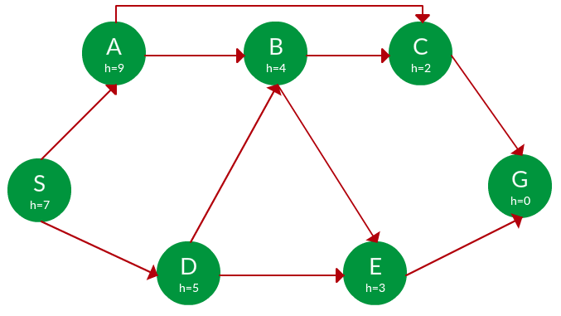

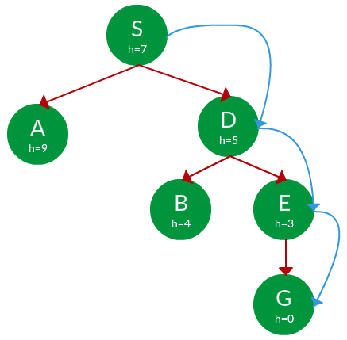
Upon expanding our initial node S, we must choose between A(h=9) or D(h=5). Greedy search chooses D, as its heuristic cost is lower. Then E is explored, as 3 < 4. Then we finally reach G (note the heuristic cost of G is 0 as it is the goal state).

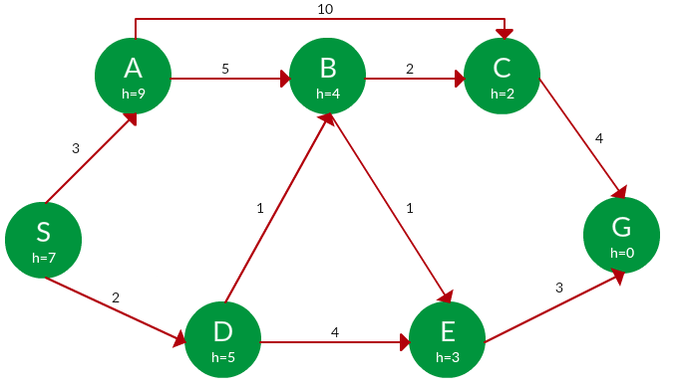
A* search combines 2 values: f(x) = g(x) + h(x), where g(x) is the cumulative cost to reach current node from root node, and h(x) is the estimated cost to the goal. Start from S, the value of f(x) is calculated at each step, with the node with the lower value being chosen.
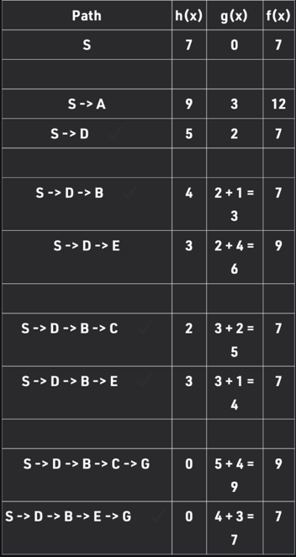
Steps shown below:
Adversarial Search
Unlike a classical search problem, adversarial search takes into account an adversary, take chess and tic tac toe as examples. What do they have in common? They have outcomes based on choices, and there is an ‘adversary’ whose goal is to ‘minimise’ your position, and your goal is to ‘maximise’ your position. Hence the minimax algorithm was born. In game theory, minimax is a decision rule used to minimize the worst-case potential loss; in other words, a player considers all of the best opponent responses to his strategies, and selects the strategy such that the opponent's best strategy gives a payoff as large as possible. Its foundation is based on creating an overall ‘score’ so the agent is able to perceive who’s ‘winning’ at any given position. Although most games don’t have an explicit score system (only a winner and loser at the end), creating a score system is not too difficult. Let’s take chess as an example, we can give each piece a certain score (e.g. pawn=1, knight/bishop = 3 points, rook = 5 points and queen = 9 points) and then sum up the scores of the pieces on the board for both players at a given point in time, and then subtract player 2’s score from player 1’s score. If the final value is positive, then player 1 is winning, but if it is negative, then player 2 is winning. If the score is 0 then the position is equal.

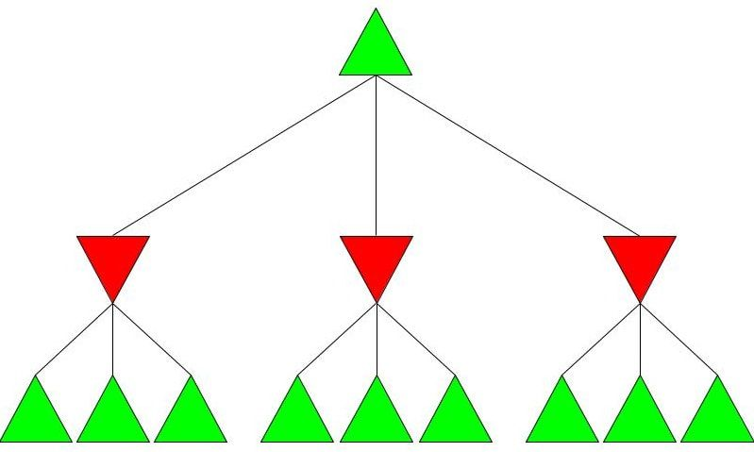
Imagine a game where each player has only three decisions. As seen before, player 1 wants to maximise the evaluated score, so they are the ‘maximising player’ or ‘max player’. On the contrary, player 2 wants to minimise said score, so they are the ‘minimising player’ or ‘min player’. Look at the Minimax tree diagram shown below:

The green and red triangles represent the max and min players’ moves respectively. The top trainable is the root node, and since it’s the max player’s turn first, the goal is to find a move that maximises the overall score for the max player. In this imaginary scenario, each player has three possible moves they can make, and the max player is deciding on a move based off of looking 2 moves ahead. Some arbitrary values are assigned to the nodes since this isn’t a real scenario:
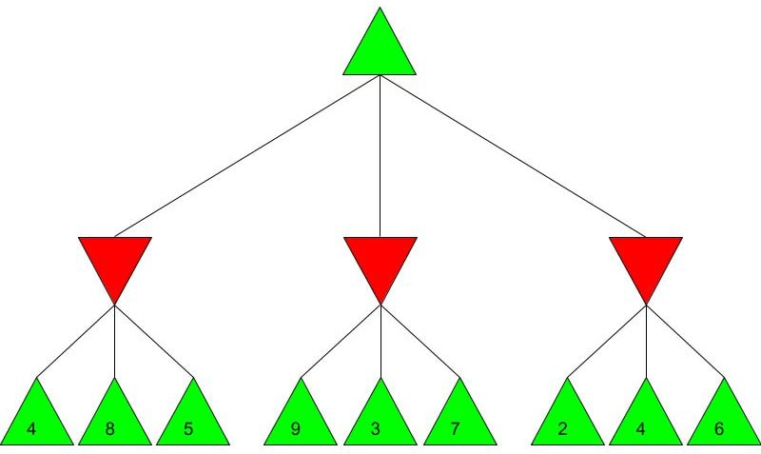

Minimax assumes both players play optimally, so the max player can evaluate the min player’s most optimal moves that minimise the score:
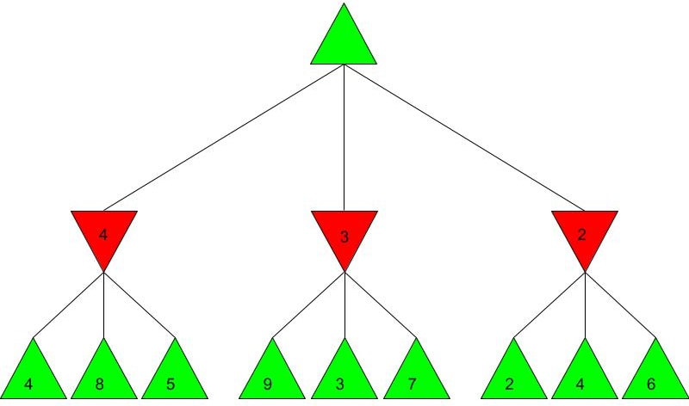
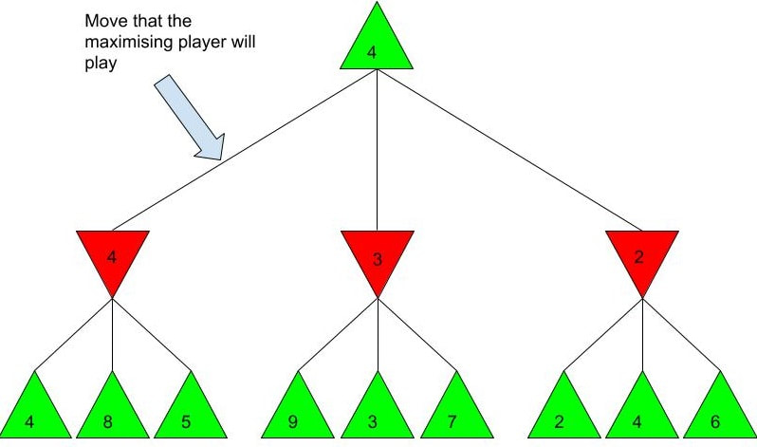
4, 3 and 2 were the minimum values of each branch of moves. Using this information, the max player can decide on an optimal move that will maximise the score, which would be 4:

The above scenario is an example of depth limited minimax, as the max player explored a limited number of moves. Without a limit, minimax would simply take far too long due to the sheer number of decisions that must be computed. The depth in this case was 2, as the max player evaluated all the possible positions 2 moves ahead. This is a repetitive process where the score for the positions less than x moves away are used to evaluate the score for the position x-1 positions away, until we reach the current position and therefore evaluate the best move. Because of this property, the minimax function is recursive. Minimax is widely used to create game engines, however, for complex games like chess, depth limits above 3 can take a huge amount of time with minimax. To counter that, alpha-beta pruning can be used to drastically reduce the amount of time to evaluate positions:
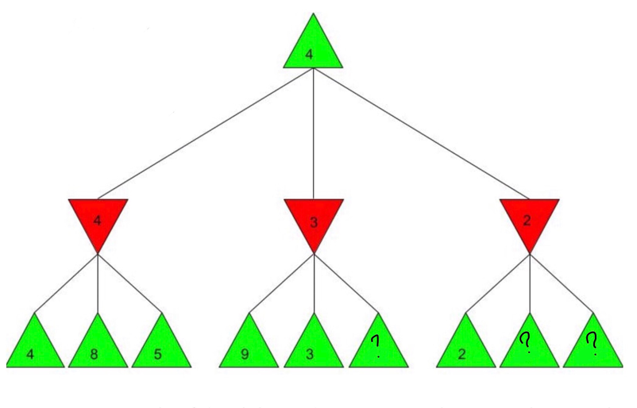
In the above diagram, alpha beta pruning was used to rule out the need to consider some of the positions, as a minimum could already be determined with what is already known; the min node on the far right can yield values of <=2, so there is no need to evaluate any further positions as 2 is already the minimum resulting score out of min player’s 3 possible moves.

Therefore, alpha-beta pruning, used along with minimax, can be used to create game engines that are capable of ‘intelligent’ decision making.

Conditional probability and Bayes’ Theorem
As people sought to apply artificial intelligence to the real world, they began developing systems using ‘domain specific’ knowledge.

However this failed to take conditional probability into account. “AI had some early success by ignoring probabilities…but once we started to run up against the real-world, we had to re-tool and move away from logic towards probability, statistics, and game theory.”, said Peter Norvig.

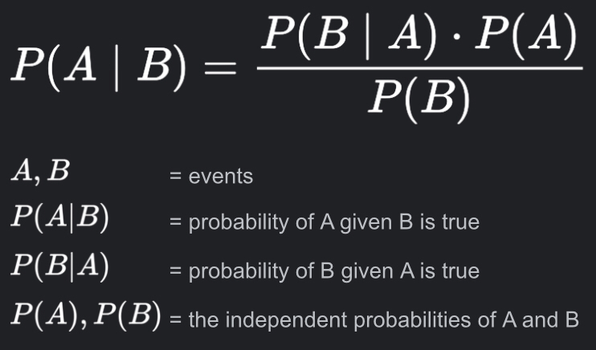
Take a chess engine for example, it relies on logic, and a starting point of logic made sense in this context of microworlds; for any specific move, we know with logical precision what the outcome of the board state is going to be. “But in the real world that doesn't work,” said Norvig; if you apply the brakes on your car, you don't have a definitive outcome, but rather a probability distribution over several possible outcomes. Unconditional probability is a degree of belief in a proposition in the absence of any other evidence. However in the real world, events are often dependent on others, introducing the idea of conditional probability, a degree of belief in a proposition given some evidence. Conditional probability can be calculated using Bayes’ Theroem:
(The equation can be read as: the probability of A given B occurred, is equal to the probability of B given A occurred multiplied by the probability of A occurring, all over the probability of B.)
Bayes' Rule lets you calculate the posterior probability, P(A|B), is a conditional probability. It is the probability of the hypothesis being true, if the evidence is present. Think of the prior probability, P(A), as your belief in the hypothesis before seeing the new evidence. If you had a strong belief in the hypothesis already, the prior probability will be large.

The prior is multiplied by a fraction. Think of this as the "strength" of the evidence. The posterior probability is greater when the numerator is big, and the denominator is small. The numerator is the likelihood, P(B|A). This is another conditional probability. It is the probability of the evidence being present, given the hypothesis is true. Note, this is not the same as the posterior! I.e., P(A|B) does not equal P(B|A).

Now look at the denominator, P(B). This is the marginal probability of the evidence. It is the probability of the evidence being present, whether the hypothesis is true or false. The smaller the denominator, the more "convincing" the evidence.
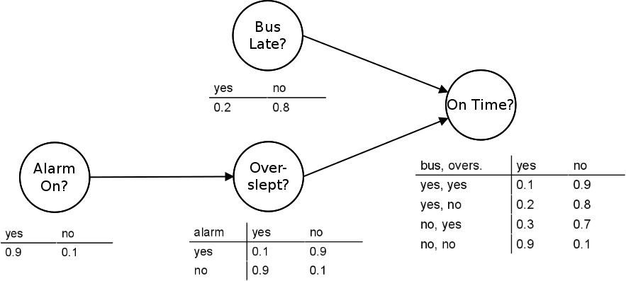
For AI to develop, and continue down the path towards human-level intelligence, machines needed to develop capabilities for dealing with the complexity and uncertainties of life outside the microworlds they had become accustomed to. This realisation led to Judea Pearl’s invention of Bayesian networks. Bayesian networks are probabilistic graphical models that measure the dependencies between random variables.
The nodes in the example graph represent random variables and the edges that connect the nodes represent the relationships between the random variables.
Central to the Bayesian network is the notion of conditional independence. Independence refers to a random variable that is unaffected by all other variables. A dependent variable is a random variable whose probability is conditional on one or more other random variables. Conditional independence describes the relationship among multiple random variables, where a given variable may be conditionally independent of one or more other random variables. This does not mean that the variable is independent per se; instead, it is a clear definition that the variable is independent of specific other known random variables. A probabilistic graphical model, such as a Bayesian Network, provides a way of defining a probabilistic model for a complex problem by stating all of the conditional independence assumptions for the known variables, whilst allowing the presence of unknown variables.

Bayesian networks have played a great part in the development of AI, and have helped machines get better at modelling knowledge and handling uncertainties. Though reaching human level machine intelligence is still a long way away. Essentially, machines need to get better at solving problems that they have not yet encountered. If we want general purpose human-level intelligence, the AI has got to be able to work with something that hasn't had a programmer spend hours figuring out. The system has to do that on its own; it's got to be making the inferences.

