Finding an nth term of the Fibonacci sequence and an introduction to the shift operator.

$0,1,1,2,3,5,8,13,21$ What comes next?
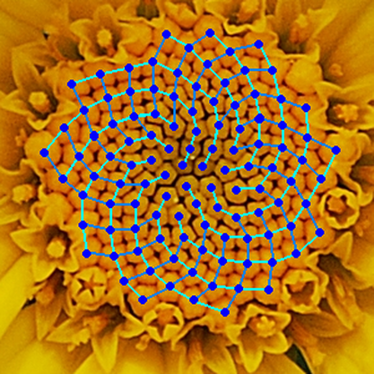
Of course, in maths it could be anything, but the neat answer would be we sum the last two terms every time, so the next one should be $13+21=34$.
The Fibonacci sequence is famous for arising in nature.
The Fibonacci numbers are a really famous sequence in maths, their connection with the golden ratio is often talked about and how they show up in nature in the number of petals on flowers etc. sometimes that goes a bit far. Nevertheless, the Fibonacci and recurrence relations in general are quite fascinating.
Here we’re going to investigate how to find an nth term formula for the Fibonacci sequence. First, looking at how we may set out this problem mathematically, and then look at a standard approach to solving this problem. But being somewhat unsatisfied with this method, I will present what I believe to be a more intuitive way of achieving using something called the shift operator.

Recurrence relations
Recurrence relations are tools we can use to define sequences. They relate terms after to terms behind for instance.
$$u_{n+1}=3u_{n}$$
What this tells us is that the $n+1$th term in the sequence is obtained by multiplying last term by $3$. So, what does this sequence look like? Given that I haven’t given you a single term there is no knowing what it could be. It could be:
$$1,3,9,27,81…$$
But we could also start with 5 so it could be:
$$5,15,45,135…$$
Which seems like we multiplied the first sequence by$5$.

There are many it could be, so to decide between these sequences we need an extra piece of information, the value to one of the terms, such as $u_{0}=2$, now we know our sequence looks like
$$2,6,18,54,162…$$
Multiplying by a constant each time, that is an exponential. In this case $u_{n}=2⋅3^{n}$. In general, if we start with $u_{0}=A$ our sequence becomes $u_{n}={A⋅3}^{n}$ and generalising even further we could replace the $3$ with an $x$ to get that if
$$u_{n+1}=xu_{n}$$
Then
$u_{n}={Ax}^{n}$
What about for the Fibonacci Sequence?
For the Fibonacci sequence we always sum the last two terms so our relation for this looks like:
$$F_{n+2}=F_{n+1}+F_{n}$$
For the Fibonacci sequence we needed to actually specify two initial conditions $F_{0}=0$ and $F_{1}=1$, we had to specify two of them otherwise how could we calculate $F_{2}$ with only knowing one term before it.
Writing out the first few terms:
$0,1,1,2,3,5,8,13$
It isn’t clear how to work out the nth term.
Well, there is a closed form for the Fibonacci numbers which is:
$$F_{n}=\frac{1}{\sqrt{5}}\left[{\left(\frac{1+\sqrt{5}}{2}\right)}^{n}-{\left(\frac{1-\sqrt{5}}{2}\right)}^{n}\right]$$
Which at first glance seems not so pretty. However, you might recognise that $\frac{1+\sqrt{5}}{2}$ is actually the golden ratio, and $\frac{1-\sqrt{5}}{2}$ is its closely related conjugate. If we write $\frac{1+\sqrt{5}}{2}$ as $φ$ as it often is then we may make it look a bit neater, and after simplifying:
$$F_{n}=\frac{1}{\sqrt{5}}φ^{n}-\frac{1}{\sqrt{5}}{(-φ)}^{-n}$$
This is known as Binet’s formula. After the fact it is straightforward (but a bit long) to check that this indeed works, we verify that this formula indeed gives $F_{0}=0$ and $F_{1}=1$ when we put in $n=0$and $n=1$, and that this formula satisfies $F_{n+2}=F_{n+1}+F_{n}$ by doing algebra.
But how do we come up with the formula in the first place?
There are some ways that are used to derive this, such as using generating functions, using Matrices and Eigenvalues. However, let’s look at probably the simplest and most common method of solving recurrence relations of this type in general. This uses a technic known as ansatz, in which we try to make educated guesses.
We have $F_{n+2}-F_{n+1}-F_{n}=0, { F}_{0}=0, F_{1}=1$let’s just guess that we have a solution that looks like
$$F_{n}= Ar^{n}$$
for some numbers $A$ and $r$ putting this back to the relation in we get
$$Ar^{n+2}-Ar^{n+1}-Ar^{n}=0$$
dividing through by $Ar^{n}$ which will never be $0$ to get$r^{2}-r-1=0$ solving this we get
$r=\frac{1±\sqrt{5}}{2}$. Then putting this back in we get general solutions:
$F_{n}=A{\left(\frac{1+\sqrt{5}}{2}\right)}^{n}$and $F_{n}=B{\left(\frac{1-\sqrt{5}}{2}\right)}^{n}$
and we can combine them to give:
$$F_{n}=A{\left(\frac{1+\sqrt{5}}{2}\right)}^{n}+B{\left(\frac{1-\sqrt{5}}{2}\right)}^{n}$$
to work our $A$ and $B$ we make use of the initial conditions $F_{0}=0={A\left(\frac{1+\sqrt{5}}{2}\right)}^{0}+B{\left(\frac{1-\sqrt{5}}{2}\right)}^{0}$ and $F_{1}=1={A\left(\frac{1+\sqrt{5}}{2}\right)}^{1}+B{\left(\frac{1-\sqrt{5}}{2}\right)}^{1}$ and after solving the simultaneous equations we will yield that $A=\frac{1}{\sqrt{5}}$ and $B=\frac{-1}{\sqrt{5}}$. Delivering us with our formula.
$$F_{n}=\frac{1}{\sqrt{5}}{\left(\frac{1+\sqrt{5}}{2}\right)}^{n}-\frac{1}{\sqrt{5}}{\left(\frac{1-\sqrt{5}}{2}\right)}^{n}$$
This method works for (nearly) all recurrence relations of the form $g_{n+2}+{ag}_{n+1}+bg_{n}=0$ which may be formally known as known as homogeneous 2nd order linear recurrence relations with constant coefficients and if you know about them this method may remind you of the method for solving homogeneous 2nd order linear differential equations. That we guess a solution that looks like an exponential and then fill in the gaps, and hopefully by the end we will see that actually the reasoning behind why this works is the same for both. Personally, I find something unsatisfying here, why is it that we after guess a solution of the form
$F_{n}= Ar^{n}$ it all works out really nicely? Another interesting pattern is the quadratic
$r^{2}-r-1=0$ that we get; to me at least it kind of look like we took $F_{n+2}-F_{n+1}-F_{n}=0$ got rid of all the $n$, and then made the indexes into powers. This quadratic is known as the characteristic equation, its importance goes beyond just this method.

The shift operator
Now let’s take a look at a more abstract argument which will hopefully allow us to understand why this method works in the way it does.
First of all, lets introduce something we will call the shift operator $T$. An operator is literally defined as a mapping from a space to another space, that is quite abstract, but in our context this operator will take in one sequence and give us out another with the following rule:
$$Ta_{n}=a_{n+1}$$
So for instance $T\left(n^{2}\right)={\left(n+1\right)}^{2}$ or $T\left(r^{n}\right)=r^{n+1}$.
$T$ is also what we call a linear operator, this is because it satisfies some rules that you might expect from something that is “linear”.
$$Tca_{n}=ca_{n+1}=cTa_{n}$$
Where $c$ is some constant, and
$$T\left(a_{n}+b_{n}\right)=a_{n+1}+b_{n+1}=Ta_{n}+Tb_{n}$$
Linear operators are actually quite common, other familiar operators are linear, for instance the derivative $\frac{ⅆ}{ⅆx}$ because $\frac{ⅆ}{ⅆx}cf\left(x\right)=c\frac{ⅆ}{ⅆx}f(x)$ and $\frac{ⅆ}{ⅆx}[f\left(x\right)+g\left(x\right)]=\frac{ⅆ}{ⅆx}f\left(x\right)+\frac{ⅆ}{ⅆx}g\left(x\right)$ the same is true of the integral, also all matrix’s are linear operators.
Using $T$ we can rewrite some of our relations from earlier, for instance take
$$u_{n+1}-3u_{n}=0$$
we can rewrite this as
$$\left(T-3I\right)u_{n}=0$$
here we just think of $I$ as the identity or “do nothing” so $I(u_{n})=u_{n}$. Using this our Fibonacci recurrence relation becomes $TTF_{n}-TF_{n}-IF_{n}=0$ using a shorthand we will write $T^{2}=TT$ or $T$applied two times. So, we get:
$$\left(T^{2}-T-I\right)F_{n}=0$$
now we can see how to factorise our operators using $x^{2}-x-1=\left(x-\frac{1+\sqrt{5}}{2}\right)\left(x-\frac{1-\sqrt{5}}{2}\right)$ or $\left(x-φ\right)\left(x+\frac{1}{φ}\right)$ to simplify our expression to $\left(T-φI\right)\left(T+\frac{1}{φ}I\right)F_{n}=0$

So now let’s solve $\left(T-φI\right)\left(T+\frac{1}{φ}I\right)F_{n}=0$ we either have:
$\left(T-φI\right)F_{n}=0$ or $\left(T+\frac{1}{φ}I\right)F_{n}=0$
(Although this fact we won’t be proved rigorously) which gives us
$F_{n+1}=φF_{n}$ and $F_{n+1}=-\frac{1}{φ}F_{n}$
But we know how to solve these recurrence relations, they are just exponentials $F_{n}=Aφ^{n}$ and $F_{n}=B{\left(\frac{-1}{φ}\right)}^{n}$ giving us a complete solution of
$$F_{n}=Aφ^{n}+B{\left(-φ\right)}^{-n}$$
and like the first method we use $F_{0}=0$ and $F_{1}=1$ to find that $A=\frac{1}{\sqrt{5}}$ and $B=\frac{-1}{\sqrt{5}}$ so
$F_{n}=\frac{1}{\sqrt{5}}φ^{n}-\frac{1}{\sqrt{5}}{(-φ)}^{-n}$.
We can apply this method to all recurrence relations whose characteristic polynomial has distinct roots, and it justifies in the first method why we find the solution by solving the characteristic equation like we do.
While admittedly I didn’t show here totally rigorously that this method is justified, I think that it gives a much better and elegant reason as to why we solve linear recurrence relations the way we do. What is also interesting is that this reasoning works in other areas as well, replace the shift operator $T$ with another linear operator like our differential operator $\frac{ⅆ}{ⅆx}$ (sometimes also written in shorthand as just $D$) and we can apply the same logic to solve linear differential equations. Of course, there are still things not addressed here like what if our characteristic polynomial has double roots? Or what if instead of $g_{n+2}+ag_{n+1}+bg_{n}=0$ we wanted to solve something like $g_{n+2}+ag_{n+1}+bg_{n}=c$ (a non-homogeneous linear recurrence relation), but I believe that this reasoning can provide a basis to solve these and also to explain some of the otherwise quite mysterious similarities between finding solutions to differential equations and finding solutions to recurrence relations.
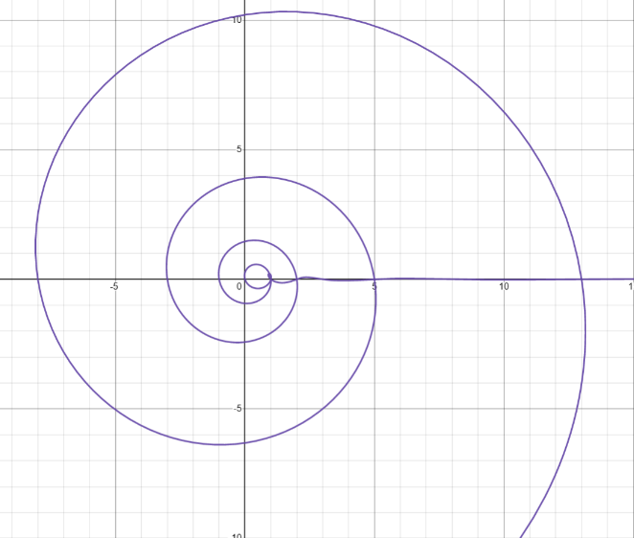
Using Binet’s formula we can extend the nth Fibonacci number to all complex numbers, here plotting just the real values in the complex plane gives a nice spiral.
Afterword on Matrix algebra
For those who know about Matrices and perhaps have seen the Matrix algebra method to solve this problem, I think it is interesting to briefly look at how the shift operator connects with this method. The method itself goes like this. We first consider a new sequence:
$${\vec{F}}_{n}=\left(\begin{aligned}F_{n+1} \\ F_{n}\end{aligned}\right)$$
with ${\vec{F}}_{0}=\left(\begin{aligned}1 \\ 0\end{aligned}\right)$ then we know ${\vec{F}}_{n+1}=\left(\begin{aligned}F_{n+2} \\ F_{n+1}\end{aligned}\right)$ using matrix algebra we can rewrite this as
$$\left(\begin{aligned}F_{n+2} \\ F_{n+1}\end{aligned}\right)=\left(\begin{aligned}F_{n+1}+F_{n} \\ F_{n+1}\end{aligned}\right)=\left(\begin{matrix}1 & 1 \\ 1 & 0\end{matrix}\right)\left(\begin{aligned}F_{n+1} \\ F_{n}\end{aligned}\right)$$
so, we have ${\vec{F}}_{n+1}=A{\vec{F}}_{n}$ where $A=\left(\begin{matrix}1 & 1 \\ 1 & 0\end{matrix}\right)$
we already saw how to solve $u_{n+1}=xu_{n}$ and here it is similar we just replace the $x$ with $A$. Giving us ${\vec{F}}_{n}=A^{n}{\vec{F}}_{0}$, we now need to find ${\left(\begin{matrix}1 & 1 \\ 1 & 0\end{matrix}\right)}^{n}$.
Undergoing a process in which we find the Eigenvalues to the matrix and do something called eigen-decomposition, after which we can write:
$A^{n}=\frac{1}{\sqrt{5}}\left(\begin{matrix}φ & -φ^{-1} \\ 1 & 1\end{matrix}\right)\left(\begin{matrix}φ^{n} & 0 \\ 0 & {\left(-φ\right)}^{-n}\end{matrix}\right)\left(\begin{matrix}1 & φ^{-1} \\ -1 & φ\end{matrix}\right)$ and putting this back in and doing more algebra we get
$${\vec{F}}_{n}=\frac{1}{\sqrt{5}}\left(\begin{aligned}φ^{n+1}-{\left(-φ\right)}^{-\left(n+1\right)} \\ φ^{n}-{\left(-φ\right)}^{-n}\end{aligned}\right)$$
remembering that ${\vec{F}}_{n}=\left(\begin{aligned}F_{n+1} \\ F_{n}\end{aligned}\right)$ we read of the bottom line to get $F_{n}=\frac{1}{\sqrt{5}}φ^{n}-\frac{1}{\sqrt{5}}{(-φ)}^{-n}$.
This method is quite impressive when worked out in full, but it is very long and involved. Looking at ${\vec{F}}_{n+1}=A{\vec{F}}_{n}$, it seems reminiscent of another statement $TF_{n}=F_{n+1}$, $A$ is actually acting as a shift operator for this sequence ${\vec{F}}_{n}$, and when we do calculate the eigenvalues we would find that $A$ has a characteristic equation of$λ^{2}-λ-1=0$ the same characteristic equation as $F_{n+2}=F_{n+1}+F_{n}$. What is cute about this is that using a nice theorem called the Cayley-Hamilton theorem, we know that $A$ satisfies its own characteristic equation, that is $A^{2}-A-1=0$ which links up nicely because we needed our shift operator to satisfy
$\left(T^{2}-T-I\right)F_{n}= 0$ which will be satisfied by $T^{2}-T-I=0$. So actually, the connections found in characteristic equation of $\left(\begin{matrix}1 & 1 \\ 1 & 0\end{matrix}\right)$ are by no means coincidence but actually deeply connected to the idea of the shift operator; in a way this method with matrices is actually taking back a layer of abstraction from the shift operator.

We can confirm this result by putting it back into the formula $u_{n}=Ax^{n}$ and $xu_{n}=x\left(Ax^{n}\right)=Ax^{n+1}=u_{n+1}$
We can check this is the same thing by expanding $\left(T-φI\right)\left(T+\frac{1}{φ}I\right)F_{n}=\left(T-φI\right)\left(TF_{n}+\frac{1}{φ}IF_{n}\right)=T\left(TF_{n}+\frac{1}{φ}IF_{n}\right)-φI\left(TF_{n}+\frac{1}{φ}IF_{n}\right)=T^{2}F_{n}+T\frac{1}{φ}IF_{n}-φI{TF}_{n}-φI\frac{1}{φ}IF_{n}$ now we simplify, remembering $I$ means do nothing so $IT=T$ gives $T^{2}F_{n}+T\left(\frac{1}{φ}-φ\right)F_{n}-F_{n}=T^{2}F_{n}-TF_{n}-F_{n}$ ($φ^{2}-φ-1=0$will rearrange to give $\frac{1}{φ}-φ=-1$).

