Fractals: The Infinite Beauty of Chaos
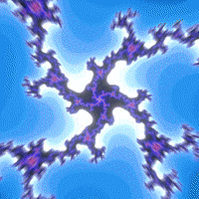
What is a fractal?
Fractals are a non-regular geometric shape that has the same degree of non-regularity on all scales.
They are referred to as being infinitely complex because you can zoom in and out of them forever. They also have infinite self-similarity, which essentially means that they repeat the same patterns at different scales an infinite number of times.
The image on the right shows an example of a fractal showing similarities at different levels of zoom, and go on for an infinite amount of time.
This essay will discuss some of the most famous fractals, including the Mandelbrot set, Fibonacci spiral and Koch’s snowflake. Some of the great uses of fractals include how they can inspire biologists to understand nature, such as new plants, as well as physicians to understand dimensions and infinity, through chaos theory.

The Mandelbrot Set
Fractals were first introduced by the mathematician Benoit Mandelbrot in the 1970s, who used the term to describe objects or shapes that have a non-integer dimension.
The most famous example of a fractal is the Mandelbrot set, which defined by the set of complex numbers for which the complex numbers of the sequence remain bounded in absolute value. It is generated by iterating a simple equation:

This formula looks relatively simple, however it forms a never-ending pattern, filled with details and information.
To understand this fractal, we first need to understand complex numbers. A complex number is a number of the form a + bi, where a and b are real numbers, and i is an imaginary unit, which satisfies i^2 = -1.
In the Mandelbrot set formula, Z(n) is a complex number and c is a constant complex number. Each consecutive number – Z(1), Z(2), Z(3)… - therefore, is a complex number.
If we continually iterate (a computational process in which a series of operations is repeated a number of times) each number in the sequence for different values of the complex number c, it diverges to a number, often 2. Diverge (of a series) means to increase indefinitely as more of its terms are added. If the sequence does not diverge to infinity, the value of c belongs to the Mandelbrot set.
The Mandelbrot set is usually visualized as a fractal in the complex plane. The x and y ranges determine how much magnification occurs in the sequence and each pixel of the grid represents the complex number c. We can determine whether c belongs to the Mandelbrot set or not and assign a color to each point. If the set diverges to a non-infinity number, we use the color black, representing the value of c to belong to the Mandelbrot set. However, if it diverges to infinity, we can assign a color based on how quickly it diverges.
The following images are parts of the pattern which is formed. The never-ending pattern shows similarities at different levels of magnification.
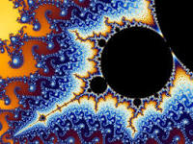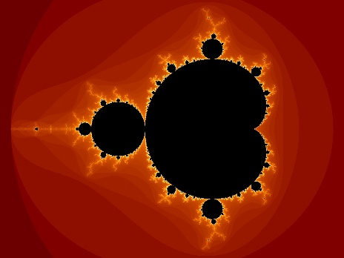

Fractals in nature
So how are fractals useful? Well, they can be discovered in many things in everyday life, such as in nature.
One of the most famous examples of a relationship between nature and fractals is the Fibonacci Spiral. This is based on the Fibonacci sequence, as well as golden ratio.
The Fibonacci sequence is a series of numbers, which add the previous two numbers of the series, starting from 1. This series is infinite and begins with the following numbers:
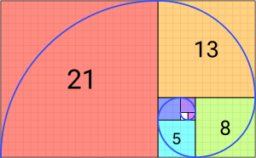
1, 1, 2, 3, 5, 8, 13, 21, 34, 55, 89, 144, 233, 377, …
The Fibonacci Spiral is a simple logarithmic spiral based upon Fibonacci numbers. It is formed by drawing a series of squares with dimensions based on the Fibonacci sequence and connecting their corners with a curved line. The resulting spiral appears the same at different levels of magnification, and so can be considered a fractal.
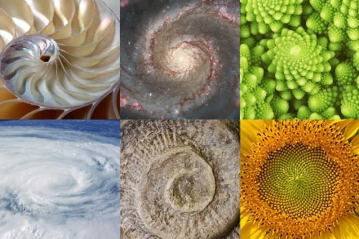
The golden ratio is closely linked to the Fibonacci series. It is derived by dividing each number of the Fibonacci series by the previous one. In mathematical terms, if F(n) describes the nth Fibonacci number, the quotient F(n)/ F(n-1) will approach the limit 1.618... for increasingly high values of n. This limit is better known as the golden ratio.
This fractal can be studied through nature, for example in the branching of trees, the shape of clouds, and the contours of mountains. Understanding fractals help us to understand how plants produce leaves, shoots and flowers, as many grow in spiral patterns. This image shows some of these examples.
Fractal patterns can be generated using iterative algorithms and mathematical formulae, creating complex and intricate patterns. The Fibonacci sequence and golden ratio are often used in these algorithms to create these fractal patterns.

Chaos theory
Chaos theory is field in which mathematicians study recursion and dynamic systems, and so fractals can be studied in this field due to their unpredictability and complex systems. In fact, fractals are often used as models for chaotic systems because they share many of the same characteristics.
Chaos theory is defined as the branch of mathematics that deals with complex systems whose behaviour is highly sensitive to slight changes in conditions, so that small alterations can give rise to strikingly great consequences.
This is essentially the butterfly effect, based on the idea that a small butterfly flapping its wings could, hypothetically, cause a typhoon. In a similar way, the butterfly effect is the sensitive dependence on initial conditions in which a small change in one state of a deterministic nonlinear system can result in large differences in a later state (according to Wikipedia).
This idea is closely related to fractals because they exhibit sensitivity to initial conditions. For example, if you change a single factor in the Mandelbrot set equation, you will get a completely different fractal. This sensitivity to initial conditions is what makes fractals and chaotic systems interesting for mathematicians to study.
By studying fractals in chaos theory, we can also understand the concepts of dimensions.

Dimensions
Fractals have a close relationship to the study of dimensions, as they are not defined by the standard geometric and dimensional laws. Unlike regular Euclidean geometry, which have integer dimensions such as 1, 2, or 3, fractal dimensions can be fractional or even irrational. For example, they could have a fractal dimension of 1.5. This is because the dimension of a fractal is based on how much space the fractal takes up.

An example which demonstrates this is the famous Koch’s snowflake. This is shown in the image on the right, where it begins with a standard equilateral triangle, and new equilateral triangles are added to each side. Each new triangle is a third of the area of the previous one and is placed in the middle of each side of the previous one.
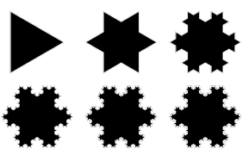
As you zoom in further, you can observe that it repeats the same feature, making it a fractal. Unlike the Mandelbrot set, the infinite boundary encloses a finite area.
Its area is approximately 1.2619. Therefore, Koch’s snowflake takes up more space than a 1-dimensional shape, but less than a two-dimensional one.
Analyzing Koch’s Snowflake is particularly useful in understanding the formation of snowflakes and crystals.
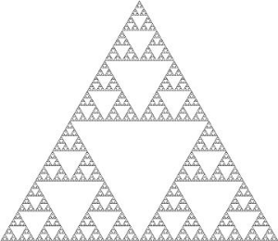
The Sierpinski’s Triangle is another example of a fractal with a non-integer fractal dimension. Its dimension is approximately 1.58, which is more than a line, but less than a plane.
The triangle is formed from an equilateral triangle again. However, this time central triangles are removed at each iteration.
Like Koch’s snowflake, an infinite series is enclosed by a boundary.

Tech Target (2016) - https://www.techtarget.com/whatis/definition/fractal#:~:text=A%20fractal%20is%20a%20non,of%20as%20never%2Dending%20patterns.
CodinGame - https://www.codingame.com/playgrounds/2358/how-to-plot-the-mandelbrot-set/mandelbrot-set
Wikipedia - https://en.wikipedia.org/wiki/Complex_number
Merriam-Webster - https://www.merriam-webster.com/dictionary/iteration#:~:text=Kids%20Definition-,iteration,repeated%20a%20number%20of%20times
Oxford Languages
https://stackoverflow.com/questions/53658296/mandelbrot-set-color-spectrum-suggestions
https://www.codingame.com/playgrounds/2358/how-to-plot-the-mandelbrot-set/mandelbrot-set
Oxford Languages
Farnam Street - https://fs.blog/the-butterfly-effect/#:~:text=The%20butterfly%20effect%20is%20the,wings%20cannot%20cause%20a%20typhoon.
http://datagenetics.com/blog/january12016/index.html
https://gifer.com/en/gifs/sierpinski

