MATHEMATICS AND MORALITY- THE HEDONIC CALCULUS

ORDER OF ARGUMENTS OF ESSAY
- What is the Hedonic Calculus?
- What does P(x,t) look like, and how is it graphed?
- The formation of: $\frac{∂}{∂t}P=α\frac{∂^{2}}{∂x^{2}}P$ and why it is necessary for finding P.
- Why use sine, cosine, and e?
- The Boundary Conditions.
- The formation of the pleasure function using a cosine wave.
- How can we use the step function to fulfil our initial premises?
- So, can we find the value of a discrete persons sum of pleasure at a specific point in time?
WHAT IS THE HEDONIC CALCULUS?
Quantitative Utilitarianism is an ethical theory within moral philosophy that argues that the seeking of pleasure and avoidance of pain are the ultimate ends of humanity, and that the greatest quantity of pleasure for the greatest number of people should be fulfilled. Thus, the seeking of pleasure and avoidance of pain for the individual person should be sought to the greatest extent.

‘The greatest happiness of the greatest number is the foundation of morals and legislation.’ - Jeremy Bentham

Jeremy Bentham’s Hedonic Calculus was a way of affirming his Quantitative Utilitarianism. Bentham proposed that by finding the sum of prospective pleasure and subtracting the sum of prospective pains resultant of a course of action, one can use this ‘Calculus’ to obtain an objective numerical value of this course. Furthermore, if multiple numerical values are formed for multiple courses of action, one can find the objectively more valuable course, and thus the morally correct course as the course of action with the highest corresponding numerical value is superior to its alternatives.
However, one of the main objections to the quantitative ethical theory was that it was sheerly impossible to carry out the summation of prospective pleasures in the first place. Bentham offered seven different factors that contribute to the quantification of a course of action (two of which being duration and intensity), how can one predict how intense a pleasure will be, or how long it will last? If one cannot affirm that their prediction is reliable or correct, one also cannot affirm that the numerical value they have generated, nor the course of action they have taken follow the principles of Quantitative Utilitarianism. And thus, one is forced to question: how can we find this objective value? Can we find the objective sum of pleasure or pain received by a person at a point in time? If so, can we create a function of pleasure so we can find this summation at any point in time?
WHAT DOES P(x, t) LOOK LIKE AND HOW IS IT GRAPHED?
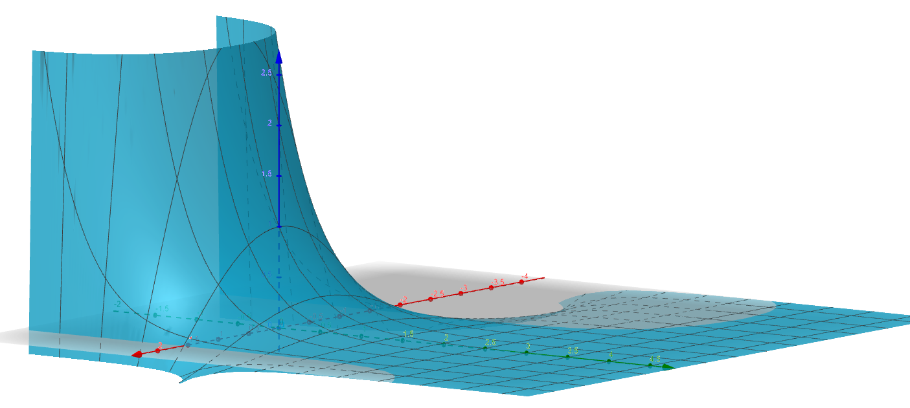
To find a function of pleasure we require two variables, position, and time. Position being a person x’s class(indicative of some form of societal bias or wellbeing in comparison to others in society), where the higher the value of x, the lower ‘class’ they are. Each person is represented by interval [β,β+1] on the x axis, where β is smaller than the total population, and β is a positive integer. Our population is represented as a rod of length L, such that every single person is present within this rod. After the initial pleasure distribution of our rod, pleasure moves as heat would within a metal, where each person receives and spreads pleasure such that they are conductive of pleasure (just like that of a metal with heat). Once our pleasure distribution flattens such that all values of pleasure for all people are equal, our initial pleasure distribution then starts again as if it were at t=0. My theory of the movement of pleasure is that pleasure is concentrated as a step at interval [0, L/2] and is then dispersed across society as time surpasses, such that the middle ‘class’ receives pleasure before the lower ‘class’.

THE FORMATION OF $\frac{∂}{∂t}P=α\frac{∂^{2}}{∂x^{2}}P$ AND WHY IT IS NECESSARY FOR FINDING P:
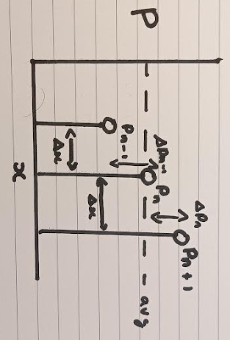
Picture 3 distinct points, $P_{n}$, $P_{n-1}$ and $P_{n+1}$, each of 3 distinct pleasures of equal distance from each other. From our understanding of heat, $P_{n}$’s temperature varies in relation to its neighbours, such that if the average of $P_{n-1}$and $P_{n+1}$’s temperature is higher than $P_{n}$, its temperature increases.
$\frac{P_{n-1}+P_{n+1}}{2}-P_{n}$ >0 P increases.
$\frac{P_{n-1}+P_{n+1}}{2}-P_{n}$ <0 P decreases.
$1/2(\left(P_{n-1}-P_{n}\right)-\left(P_{n}-P_{n+1}\right))$→1/2($∆P_{n-1}-∆P_{n})$
Also, from our understanding of heat, the greater the difference between the average and $P_{n}$, the faster the rate at which $P_{n}$ changes to assimilate its adjacent points. And thus, one can deduce that the rate at which pleasure changes in respect to time for a fixed point is proportional to the average of neighbouring pleasures, minus the fixed points’ pleasure itself. Thus, in the language of derivatives, the partial derivative (the derivative of a function in respect to one of multiple variables) of the pleasure function in respect to time is proportional to the average of neighbouring pleasures, minus the fixed points’ pleasure itself.
w/2($∆P_{n-1}-∆P_{n})$= $\frac{∂}{∂t}P\left(x_{,}t\right)$ where w is some proportionality constant
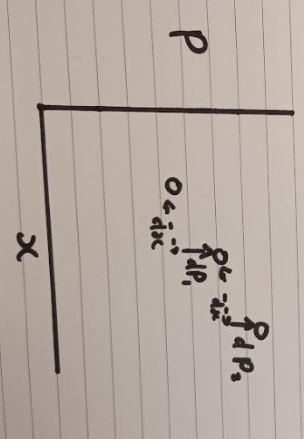

The above shown equation shows the difference of two differences equidistant from $P_{n}$. If these are both of distance dx from $P_{n}$. The first change in dx cause a vertical change dP1, and the second change in dx causes a vertical change of dP2. The difference between these two differences can be expressed as d(dP) and this change has taken place over an interval dx^2, and thus this change in P over the axis can be expressed as the second partial derivative of P in respect to x (for a fixed t), as dx approaches 0.

$$\lim{ⅆx}→0\frac{ⅆ\left(dP\right)}{ⅆx^{2}}=\frac{∂^{2}}{∂x^{2}}P(x,t)$$

If this is not a satisfying explanation, one can also look at this from the perspective of first principles. The gradient at $P_{n}$ is equal to P’(x)=$\lim{h}→O\frac{P\left(x+h\right)-P\left(x\right)}{h}$. And thus to find the second derivative, we take the derivative of the derivative. Thus P’’(x)=P’P’(x)=$\lim{h}→O\frac{(P\left(x+2h\right)-P\left(x+h\right))-(P{\left(x+h\right)}^{-}-P\left(x-h\right))}{h}⋅\frac{1}{h}$
=$\lim{h}→O\frac{\left(P\left(x+2h\right)-P\left(x+h\right)\right)-(P\left(x+h)-P\left(x\right)\right)}{h^{2}}$. This is quite explicitly the difference of the differences between $P_{n+1}$ and $P_{n}$, as well as $P_{n}$ and $P_{n-1}$, over an interval dx or h squared. And so, we can conclude that:
$$α\frac{∂^{2}}{∂x^{2}}P\left(x,t\right)=\frac{∂}{∂t}P\left(x_{,}t\right) where α is some proportionality constant$$

WHY USE SINE, COSINE, AND E?
The first step to solving our differential equation and finding our pleasure function is to look at a generalised, trivial scenario. What if our initial pleasure distribution was sin(x), thus P(x,0) =sin(x). We are now tasked with finding G(t).
If we separate our pleasure function into two separate functions of position and time, we can now express P(x,t)=F(x)G(t). Using our PDE, we also know that αF’’(x)G(t)=F(x)G’(t). If F(x)=sin(x), we can now take the partial derivative of the function in respect to time and let G(t) act as a constant.
Thus: αF’’(x)G(t)=-αsin(x)G(T). If such is equal to F(x)G’(t), -αsin(x)G(t)=sin(x)G’(t). Dividing both sides by sin(x), we now find that -aG(t)=G’(t). This shows us that the derivative of some function of time is proportional to itself. This is indicative of the presence of e as $\frac{ⅆ}{ⅆt}ⅇ^{kt}=kⅇ^{kt}$and so we can conclude that G(t) is an exponential $ⅇ^{-αt}$, as G’(t)=$-aⅇ^{-at}$, which fulfils the above requirements.
And thus if P(x,0) =sin(x), we can deduce that P(x,t)=sin(x)$e^{-at}$. To check that this conclusion makes sense, we know that, $\frac{∂}{∂t}P(x,t)$=-αP(x,t). And so, for values of x where t=0, each point changes its pleasure at a rate proportional to the value of pleasure itself. So, for each time step, every point scales down by the same factor.

THE BOUNDARY CONDITIONS
If we accept that our points X on the rod of society exist upon the interval [0,L], at both X=0 and X=L each end of the rod has only one immediate neighbour to either its’ left or right. And thus, the flow of pleasure is changed. Looking at the discrete model, $P_{n}$ does not increase/decrease in accordance with the average of its’ neighbours, but rather it tends towards only its’ immediate neighbour to either the left or right at a rate proportional to the difference of the two’s pleasure. Thus, as the distance between the two tends to zero, the difference between the two points decreases so much so that the gradient at point P(0 or L, t>0) in respect to x is equal to zero.
Thus, for x=0 and using our previous function:
$F^{'}\left(x\right)G\left(t\right)=\cos\left(x\right)ⅇ^{-αt}$ → $F^{'}\left(0\right)G\left(t\right)=1⋅ⅇ^{-at}≠0$
Hence our previously found function does not adhere to the boundary condition at x=0.
So, if we let F(x)=cos(x), $α\frac{∂^{2}}{∂x^{2}}P\left(x,t\right)$= $-αcos⁡(x) e^{-at}$ and $\frac{∂}{∂t}P\left(x_{,}t\right)$=$-αcos⁡(x) e^{-at}$= -αP(x, t)
This shows that without the boundary conditions, cosine is adept at carrying out the same function as sine.
However, $F^{'}\left(x\right)G\left(t\right)=\sin\left(x\right)ⅇ^{-αt}$→$F^{'}\left(0\right)G\left(t\right)=0⋅ⅇ^{-at}=0$, and thus does fulfil our boundary conditions at x=0. However, for any value L, we cannot ensure that sin (L) will be equal to zero. Consequently, we must introduce some coefficient inside of cosine to ensure that sine of such equals 0. 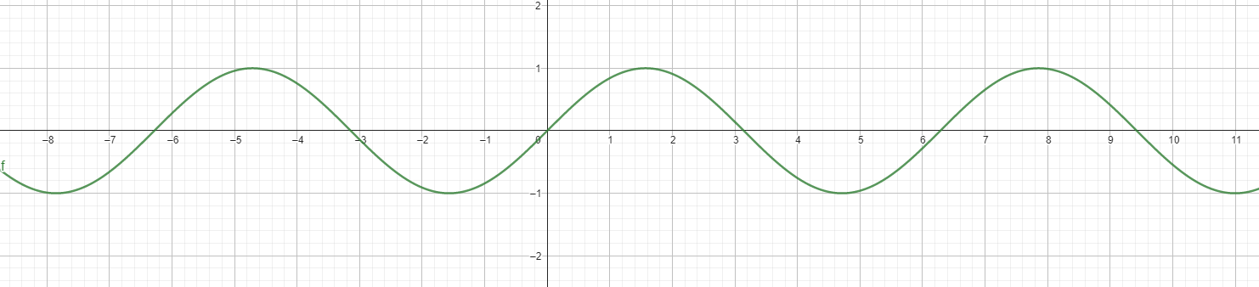

Sine is a periodic function, where for every $x=nπ (where n∈Z$), the function equals 0. And thus, for some coefficient C: CL=n$π$, C=n$π$/L. And so $α\frac{∂^{2}}{∂x^{2}}P\left(x,t\right)=-α({\frac{nπx}{L})}^{2}cos\left(\frac{nπx}{L}\right)G(t)$. Thus, our exponential instead of having just -α in its exponent, instead has $-α({\frac{nπx}{L})}^{2}$ so that $α\frac{∂^{2}}{∂x^{2}}P\left(x,t\right)=\frac{∂}{∂t}P\left(x_{,}t\right)$. And so, we can now argue that our pleasure function for a cosine wave =$\cos\left(\frac{nπx}{L}\right)e^{-a{\left(\frac{nπx}{L}\right)}^{2}t}$.
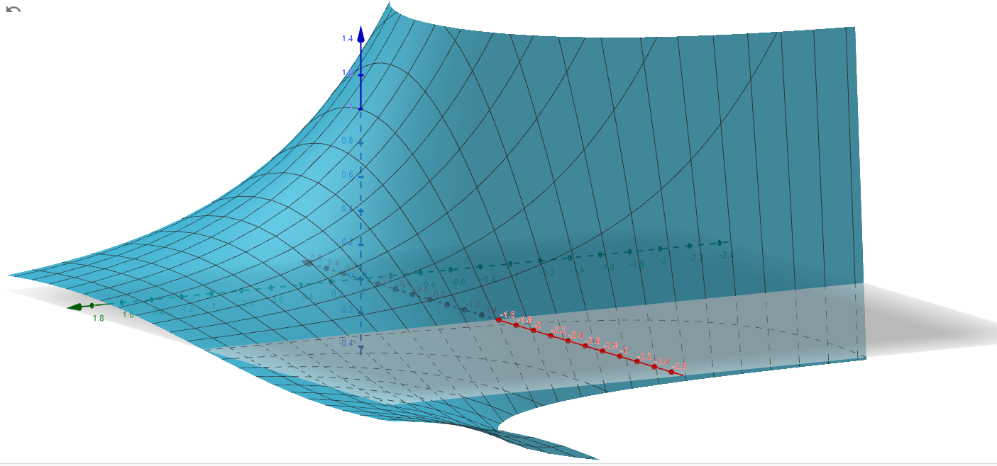
However, this is still under the assumption that the initial distribution of pleasure is equal to a simple cosine wave. Under this initial framework, can we express our initial premises as a sum of cosine waves?

HOW CAN WE USE THE STEP FUNCTION TO FULFILL OUR INITIAL PREMISES?

The pleasure distribution of a cosine wave is an ideal distribution, in accordance with our initial premises set out, we know that the initial distribution is one within which mimics that of a step. To find such a distribution, we need to understand and apply the Fourier Series, an infinite sum of sines and cosines to form a seemingly discontinuous function.
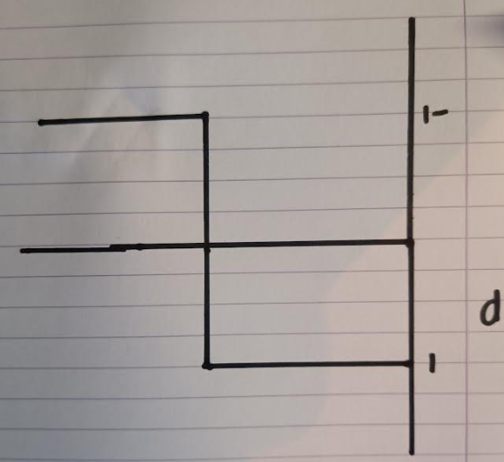
To do as such the idea of orthogonality comes into effect. The identities discussed in this essay will not be proven for worry it’ll be too long. $L_{δ_{mn}}$is shorthand for the expression that when $m≠n$, $L_{δ_{mn}}$ equals zero, and when $m=n$, $L_{δ_{mn}}$ equals $L$, where both m and n are positive integers.
$$\int_{-L}^{L}{\sin\left(\frac{nπx}{L}\right)\sin\left(\frac{mπx}{L}\right)ⅆx}=L_{δ_{mn}}$$
$$\int_{-L}^{L}{\cos\left(\frac{nπx}{L}\right)\cos\left(\frac{mπx}{L}\right)ⅆx}=L_{δ_{mn}}$$
$$\int_{-L}^{L}{\sin\left(\frac{mπx}{L}\right)\cos\left(\frac{nπx}{L}\right)ⅆx}=0$$

$$f\left(x\right)=\sum_{n=0}^{∞}{a_{n}\cos\left(\frac{nπx}{L}\right)}$$
When n=0, our first term simply equals $a_{0}$, and thus if we express this constant as ½ $a_{0}$, we can now start the summation from one to infinity. We can only integrate an infinite sum by taking the integral of the general sum inside sigma if the series converges, as this is the case: we can now put our orthogonality rules to use.
$$f\left(x\right)=\frac{1}{2}a_{0}+\sum_{n=1}^{∞}{a_{n}\cos\left(\frac{nπx}{L}\right)}$$
Here we integrate our function f from -L to L, and thus take the integral of both our constant term and infinite sum. When integrating the sum, we use the reverse chain rule and multiply our new sine function by the reciprocal of x’s coefficients so that if we were to take the derivative of our integral, we would be given the exact same expression we had originally. Our constant term simply integrates to itself multiplied by length L, and our infinite sum converges to 0 as both our sine terms equal zero as they are a multiple of pi. And so, we are left with only our constant term.
$\int_{-L}^{L}{f\left(x\right)ⅆx}=\frac{1}{2}\int_{-L}^{L}{a_{0}ⅆx}+\sum_{1}^{∞}{\int_{-L}^{L}{a_{n}\cos\left(\frac{nπx}{L}\right)}}$=${\left.\frac{a_{0}x}{2}\right|}_{-L}^{L}+\sum_{1}^{∞}{{\left[\frac{a_{n}L}{nπ}\sin\left(\frac{nπx}{L}\right)\right]}_{-L}^{L}}$=
$a_{0}L+\sum_{1}^{∞}{{\left[\frac{a_{n}L}{nπ}\sin\left(\frac{nπx}{L}\right)\right]}_{-L}^{L}}=a_{0}L+\sum_{1}^{∞}{\frac{a_{n}L}{nπ}(\sin\left(\frac{nπL}{L}\right)-sin}\left(\frac{-nπL}{L}\right)$) = $a_{0}L$+$\sum_{1}^{∞}{0}$

By dividing both sides by L, we are given an expression for our constant term dependent upon our original function f.
$$\frac{1}{L}\int_{-L}^{L}{f\left(x\right)ⅆx}=a_{0}$$
We can now continue to utilise our orthogonality rules again by multiplying function f by $\cos\left(\frac{mπx}{L}\right)$. What happens next is fascinating. Our constant value simply acts as a coefficient for the integral of $\cos\left(\frac{mπx}{L}\right)$, which equals zero as it is an even function that is periodic every 2L. Our infinite sum however equals zero for all value of n $≠$m, except for when n=m. This has the surprising effect that the only term remaining from our integrated sum is $La_{m}$.
$$\int_{-L}^{L}{f\left(x\right)\cos\left(\frac{mπx}{L}\right)ⅆx}=\frac{1}{2}a_{0}\int_{-L}^{L}{\cos\left(\frac{mπx}{L}\right)ⅆx}+\sum_{n=1}^{∞}{\int_{-L}^{L}{a_{n}\cos\left(\frac{nπx}{L}\right)}}\cos\left(\frac{mπx}{L}\right)dx=La_{m}$$
Through such we are shown that for any given m, we can find its corresponding coefficient. And thus, for all n, the formula we have found for $a_{m}$ applies forever.
$$\frac{1}{L}\int_{-L}^{L}{f\left(x\right)\cos\left(\frac{nπx}{L}\right)dx=a_{n}}$$
And thus, we can now attempt to tackle our step function. $f\left(x\right)=\left\{\begin{aligned}1, &0<x<L/2 \\ -1, &L/2<x<L\end{aligned}\right.$
$$\frac{1}{L}\int_{-L}^{L}{f\left(x\right)ⅆx}=a_{0}$$
Through such, we understand that this integral of an even periodic function over 2Lis equal to zero. To check that this is the case, the average value of the function for all x between 0 and L is zero, and so it makes sense for cosines waves to oscillate directly from the x axis.
$$\frac{1}{L}\int_{-L}^{L}{f\left(x\right)\cos\left(\frac{nπx}{L}\right)dx=a_{n}}$$
Here as we have an even function periodic every 2L, the integral from bounds -L to L equal the two times the integral from bounds 0 to L. And so we can now find our coefficients from as f(x) is defined from points $0<x<L/2$ and $L/2<x<L$.
$$\frac{1}{L}\int_{-L}^{L}{f\left(x\right)\cos\left(\frac{nπx}{L}\right)dx=\frac{2}{L}\int_{0}^{L}{f\left(x\right)\cos\left(\frac{nπx}{L}\right)dx=\frac{2}{L}\int_{0}^{L/2}{f\left(x\right)\cos\left(\frac{nπx}{L}\right)dx+\frac{2}{L}\int_{L/2}^{L}{f\left(x\right)\cos\left(\frac{nπx}{L}\right)dx}}}}$$

And so, we can now find our coefficients from as f(x) is defined from points $0<x<L/2$ and $L/2<x<L$.
$$\frac{2}{L}\int_{0}^{L/2}{f\left(x\right)\cos\left(\frac{nπx}{L}\right)dx+\frac{2}{L}\int_{L/2}^{L}{f\left(x\right)\cos\left(\frac{nπx}{L}\right)dx}}=\frac{2}{L}\int_{0}^{L/2}{1.\cos\left(\frac{nπx}{L}\right)dx+\frac{2}{L}\int_{L/2}^{L}{-1.\cos\left(\frac{nπx}{L}\right)dx}}$$
Taking this integral again we find: $\frac{2}{ππ}\sin\left(\frac{nπ}{2}\right)--\frac{2}{πn}\sin\left(\frac{nπ}{2}\right)=\frac{4}{πn}(\sin\left(\frac{πn}{2}\right))$
This is our changing coefficient $a_{n}.$

SO, CAN WE FIND THE VALUE OF A DISCRETE PERSONS’ SUM OF PLEASURE AT A SPECIFIC POINT IN TIME?
If we take our infinite sum of F(x) multiplied by G(t), we can finally find our ever evolving function of pleasure.$P\left(x,t\right)=\sum_{n=1}^{∞}{\frac{4}{π}\sin\left(\frac{nπ}{2}\right){\cos\left(\frac{nπx}{L}\right)ⅇ}^{-a{\left(\frac{nπx}{L}\right)}^{2}t-ln⁡(n)}}$
And thus, to find the sum of pleasure, we need to take the double integral in respect to both pleasure and time to find the volume encompassed by the curves. And so, you can ask me a question about Bentham’s Hedonic Calculus that I can answer that he could not: can we find the objective sum of pleasure minus the sum of pain over any given time?

My answer would be: $ΣP=\int_{t1}^{t2}{\int_{β}^{β+1}{\sum_{n=1}^{∞}{\frac{4}{π}\sin\left(\frac{nπ}{2}\right){\cos\left(\frac{nπx}{L}\right)ⅇ}^{-a{\left(\frac{nπx}{L}\right)}^{2}t-ln⁡(n)}}dxdt}}$
REFERENCES
This essay was particularly inspired and aided by the following videos:
https://youtu.be/ly4S0oi3Yz8- Building the heat equation
https://youtu.be/ToIXSwZ1pJU - Solving the heat equation
https://youtu.be/LEonZYoW6sk - Deriving the Fourier Series
https://youtu.be/r6sGWTCMz2k - Building a Fourier Series

