The Point of Pythagoras

And

The Purpose of Pi

Foreword
If you’re reading this, you either thought that it was two separate articles or that the writer was stupid in thinking that there’s a relationship between a TRIANGLE and the most famous irrational number.
Okay, you say, obviously this “lunatic” has found some link between the two and wants to tell us about this pointless fact that I will never use again.
Well tough, because that’s exactly what this is about. Welcome to the Point of Pythagoras and the Purpose of Pi

Why Py?
Pythagoras was… is one of the most famous mathematicians of all time. Yet, Pythagoras didn’t spend his entire life in triangles. Of course, he got bored and built a prank cup.
Got you now haven’t I?
Ha! We’re going to save that one for last. So Pythagoras of Samos was a Greek philosopher and the founder of the cult “Pythagoreanism”. Yes, he had a cult. He became vegetarian and believed that “every soul is immortal.” One could say he’s a perfectionist… hmmm…
Besides his “questionable” personality, he’s made great mathematical breakthroughs. His most famous Pythagorean Theorem is his claim to fame, he proposed the Theory of Proportions, Pythagorean Tuning and the “sphericity” of the Earth…
He also claimed that there were “5 regular solids” that the entire universe was composed of: the sky, fire, water, earth and the Universe as a whole. Of course, we all know that the cube would be earth, the icosahedron is water, the octahedron is sky, the tetrahedron is fire and the dodecahedron is the universe. What else could they possibly be?
Anyway, let’s get into triangles.

Let’s Try Angles (geddit? Triangles…try-angles… Never mind)
So Pythagoras created the famous formula: a²+ b²= c². This only works with Right-angle triangles. This means that when you “Try angles” you must make sure you’ve got the right angles!
Come on guys... that was a good one…
Anyway side “a” is usually the shortest side and side “c” is the longest. Sides “a” and “b” are generally the ones that form a right angle. This means that side “c” is always opposite the right angle, no matter how you draw a right angle triangle.
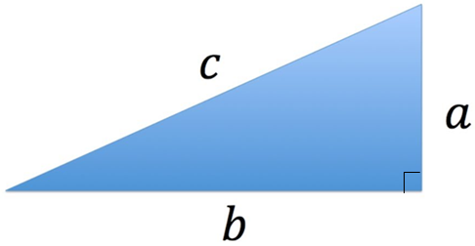
From now on, side “c” will be referred to as the Hypotenuse. Why? Well not only is it the Official Mathematical Term it also sounds super posh. Go show off to your friends.
We’re going to cover two crucial things about the Pythagorean Theorem. One helping you to understand how it works, the other saves more time than Pot Noodles. Yup, you can find the hypotenuse in less than 4 minutes.
However, the fun stuff has to come after the formalities, even if no one pays any attention.

Proof of Pythagorean Theorem.
So the most famous Pythagorean proof is creating a square with four triangles.
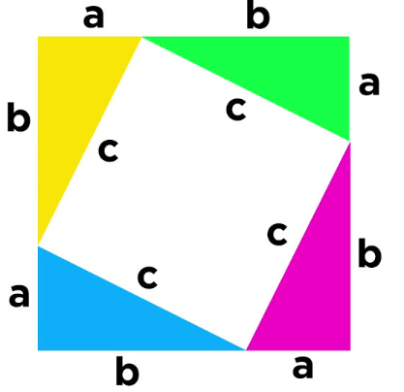
The area of the entire thing=(a+b)²=(a+b)(a+b)=a² + 2ab + b² .
The area of the smaller square=c²
Whilst the area of one triangle=(a+b) * ½
Putting this all together
a² + 2ab + b²=4(½ab) + c²
a² + 2ab + b²=2ab + c²
a² + b²=c²

The problem with this is that it’s a little difficult to get your head around.
A second proof says by drawing squares on each side of the right angle triangle, you will find that the area of the two smaller squares is equal to the area of the third.
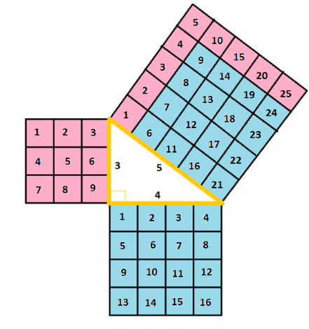

However, there is no simple way to give a mathematical formula why this works... except that it does. So understanding the first solution is better.
What?
You want to know the complicated method of why proof 2 works?
Okay… if you insist:
To understand what we’re looking at we need another image:
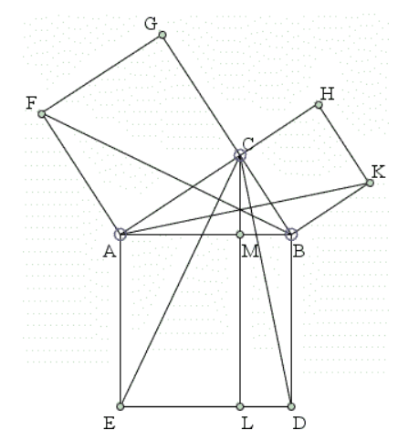

Okay so this method is known as the Bride’s Chair. Firstly, our right-angle triangle is ΔABC. We need to understand that ΔABF ≅ ΔAEC (because of ASA).
ΔABF has the bas AF and the height of B, but B is the same height as AC. Therefore ΔABF’s area is just AF*AC/2. As we can see AF*AC is the area of the square ACFG. So ΔABF is just half of AC². Similarly, ΔACE has the bas of AE and its perpendicular height is just AM (because AE∥LC and M lies on CL). Therefore, the area of ΔAEC=AE*EL/2.
Confused? Well we have to do it again now…
Since ΔABF=ΔAEC, we can put our two equations together and get AC²⁼area of rectangle AEML.
Applying the same thing for the other side, we see that ΔCBD≅ΔABK. Then, ΔABK=CB² and ΔCBD=MB*BD.
Look back at the earlier step to see how we got this
So now AC²=AE*EL and CB²=MB*BD and MB*BD+AE*EL=AB².
So AC²+CB²=AB².

Now, that took way too long… so now we have satisfied your curiosity, we can get onto some of the fun stuff…
Oh wait, we need to beat Pot Noodles first…
Let’s do that, and then we can move onto the Pythagoras Prank cup…

Pythagorean Triples
One of the fastest ways to do maths is when a number/sum has a pattern and you can instantly see the next one. How does this happen in triangles? Introducing… Pythagorean Triples!
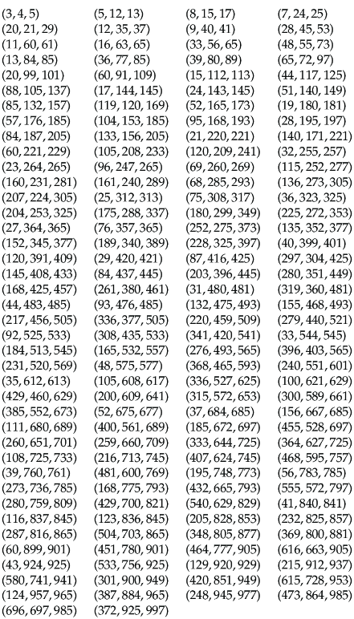
Does anyone see the purpose of these numbers? Well what if I told you that each triplet of numbers is the side lengths of a right-angle triangle? Let’s look at the first three numbers: 3, 4, 5. This is the most famous Pythagorean triple (but the top row is the row you want to memorise). The 3 and the 4 are the lengths of the legs. They can be any length as long as the ratio is 3:4. It can be 3cm, 4cm or 3km, 4km or 6mm, 8mm (2*3:2*4=3:4). And the 5 is the length of the hypotenuse. Again, it can be any length as long as the ratio remains 3:4:5.
Note: a 6-8-10 triangle is also 3-4-5 triangle because the lengths are multiplied by 2.
1.4-2-2.5 is also a 3-4-5 triangle because the lengths are divided by 2.
Okay so now if we had a stopwatch, and I told you to find the missing side of the following triangle. How long would it take you?

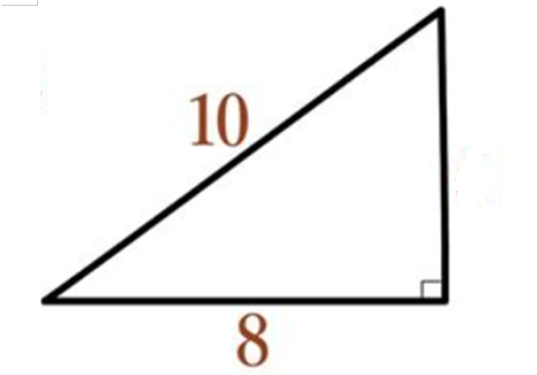
Less than 4 minutes? Less than 4 seconds I’d hope!
Now, onto the fun stuff…

Pythagoras the Prankster
Now Pythagoras is a human, and we all need a good laugh every now and then. So take easy when I tell you that he made a cup that leaks when you get greedy.
Pythagoras made this cup, and gave it to all of his students (yes he had students). And the ones who wanted to pour a cup full of wine or drink a lot of it at once would suddenly find that all their wine has spilt on the floor. Meanwhile, the ones that drank it in controlled amounts would be able to finish their cup.
So the cup looked like this:
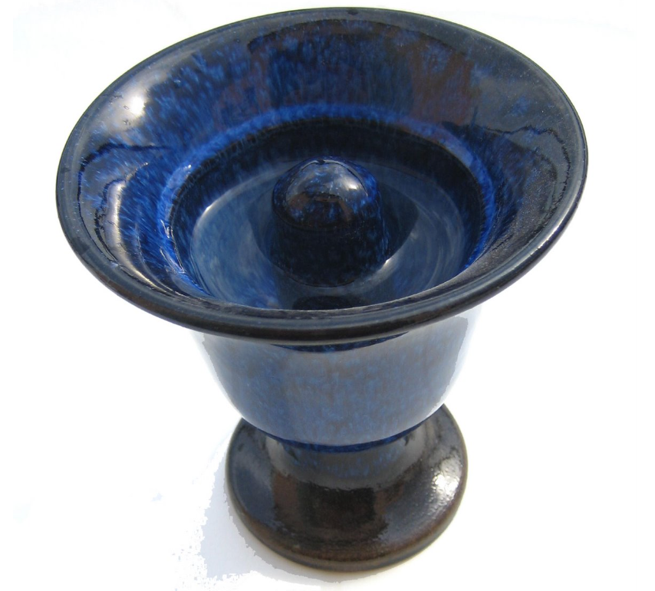
Notice anything weird? It’s pretty conspicuous: the “knob” in the centre. But how does this make the cup only drain at a certain level? Well the trick is inside the “knob”. Inside the little undulation, there’s a clever hole. It goes from the bottom of the cup, to the top of the knob then down to the hole at the bottom. Yet, you may ask, why does the wine not go straight down to the bottom? And if the cup empties itself, why does it not empty itself earlier or later?
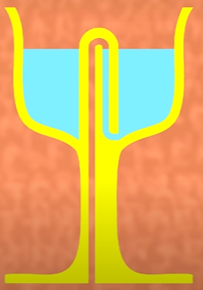
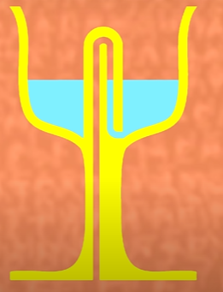
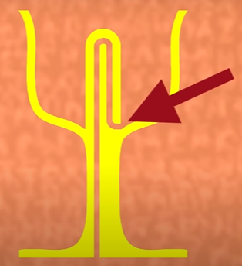
Maybe this comic strip will help:

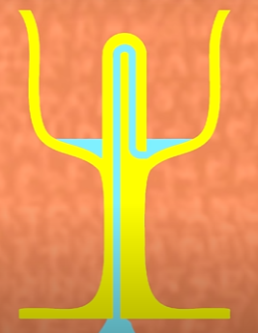
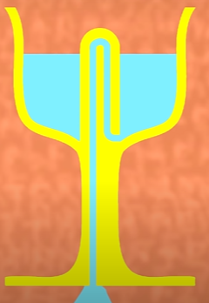
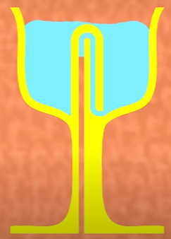

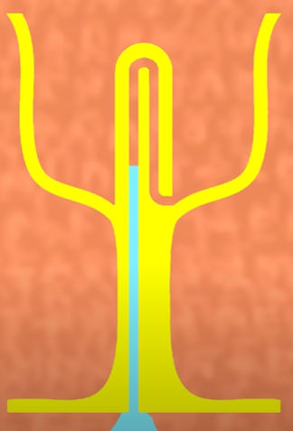
- Cross section of the Pythagoras Cup
- Glass fills up and the U-tube fills up to. Note: the left side is filled but the right side is not.
- Glass fills up more, liquid in U-tube fills up more
- This happens either when the liquid is too high (as shown) or if the cup is tilted to an extreme (when the student is “chugging”)
- Liquid gets sucked out from the cup. Note: the right side now has liquid, this causes the air pressure to be able to pull on the wine and the wine will push itself out (due to its own weight).
- + 7. Wine drained
Fun huh? Well sorry because, that’s all from Pythagoras (or is it?), let’s move onto Pi…

Why Pi?
Now, pi (π) is not just used in circles, it’s used in electronics to solve problems with electricity, it’s used to track population, fluid ripples, areas of skin of an aircraft, signal, processing analysis… what? Bored already?
Well basically, my point is that pi is used everywhere… even if we’re going to be focusing on circles today. Here are good rules to remember about circles:
- Pi multiplied by the circle’s radius squared (πr²)
- Pi multiplied by the diameter gives the circle’s perimeter – known as the circumference (πd)
- If you have 2 points, you can create multiple circles (with the points on the circumference)
- If you have 3 points, you can either create one circle or no circles
Expanding on this last point, it means that if you draw a triangle, you can draw a single circle that touches all of its edges and there would only be one possible circle. This’ll be important for later…
Great, now let’s go straight to the fun stuff. What does NASA do with Pi?

What does NASA do with Pi?
Yeah… I just said that. Silly editor.
- The Paratrooper Rover
  - So far, all Mars landings use parachutes. Slowing down the rover is essential so it doesn’t crash or damage any equipment. Pi helps engineers to design a parachute large enough to slow the rover down, but also small enough to be tucked away in the rover.
- What the Saturn
  - 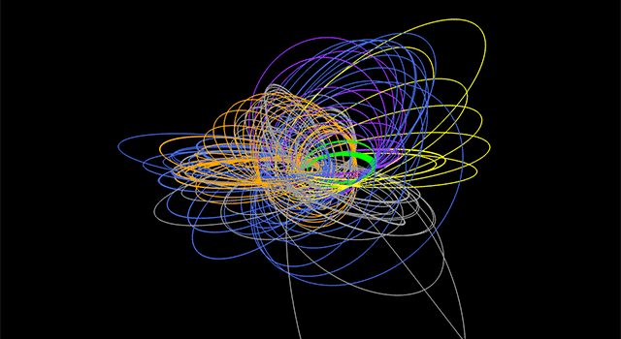
  - Saturn being fun and that has loads of seas and ice on its moons. Oh yeah and it has rings. Π has been used twice to change the orbit of a spacecraft – to flip it 180 degrees.
  - Yeah I forgot to mention… π=180º in trigometry. It’s to do with sin, cos and tan.
- Rover Wheels
  - Rovers have special wheels that leave marks in the ground as they turn, by measuring the distance between the two marks (and using πd on the wheels) operators can determine whether or not the wheels are slipping.
- Alien Ice
  - Ice is everywhere in the solar system: moons of Jupiter and Saturn, comets, Neptune etc. To take tests, scientists use lasers in labs to explode the ice and study the reaction. to blast the ice, they use π to calculate the beam’s width

Right! It’s time for the super exiting stuff that ties up everything together:
Now, entering the stage… it’s the area of a triangle using Pi!

The Grand Finale: An Alternate Formula in terms of Pi to find the Area of a Triangle – Atomic Energy Commission Method
On March 1998 people wanted to identify π as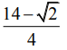≈ 3.14644660942 the reason was this:
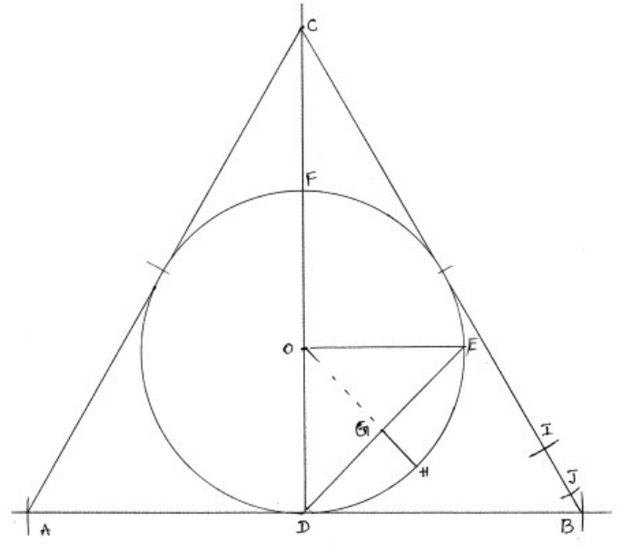
Doesn’t say much does it… must be stage fright. Looks like I’ll have to explain it myself:
- Circle:
  - Centre=O
  - Radius=OD=OE=D*½
  - Diameter=DF=d
- Triangle:
  - Triangle=ABC
  - Side=AB=BC=AC=sqrt(3)*d
  - Altitude = DC
- Both:
  - Radius=OE=OD=d*½
  - Hypotenuse=Chord=DE=d/2*sqrt(2)=(sqrt(2))*d/2

Original Area formula: AB/2
New Formula:
(4*perimeter-of-ABC-triangle)/14*Diameter-of-circle – 2*chord
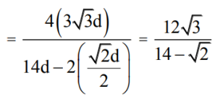

Confused? I certainly am. It doesn’t explain where it gets the “times 14” or anything… it just says: DO IT
Circle’s Area: πd²/4

Triangle’s area:
[area of circle]*(12sqrt(3))/(14-sqrt(2))
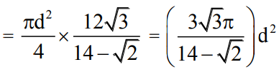
Voilà! The area of a triangle using π.

Extro Show

I know it didn’t have much to do with Pythagoras… but oh well. Maybe it really was two separate articles…

At least, you can now forget all this purposeless facts about π but this pointless essay will be remembered as The Document Written By a “Lunatic”.
Ah never mind, at least we can now both get on with the rest of our day.
Good day.

‘Till we meet Again.

Sources and thanks:
Many thanks to Miss Metcalfe, my maths teacher.

Pythagorean trigonometric identity
https://en.wikipedia.org/wiki/Pythagorean_trigonometric_identity#:~:text=The%20Pythagorean%20trigonometric%20identity%2C%20also%20called%20simply%20the,basic%20relations%20between%20the%20sine%20and%20cosine%20functions

Alternate formula in terms of Pi to find the area of a triangle
https://iosrjournals.org/iosr-jm/papers/Vol10-issue4/Version-3/C010431317.pdf

Most common proof of Pythagorean Theorem
https://www.math-only-math.com/proof-of-pythagorean-theorem.html#:~:text=The%20proof%20of%20Pythagorean%20Theorem,of%20c%20(c2).

Pythagorean Theorem and its many proofs
https://www.cut-the-knot.org/pythagoras/

18 ways NASA uses Pi
https://www.jpl.nasa.gov/edu/learn/list/oh-the-places-we-go-18-ways-nasa-uses-pi/#:~:text=Scientists%20use%20pi%20to%20locate,it's%20in%20the%20habitable%20zone.

25 surprising facts about Pi
https://r.search.yahoo.com/_ylt=AwrEoLtBAB5k29MoO8APxQt.;_ylu=Y29sbwNiZjEEcG9zAzIEdnRpZAMEc2VjA3Ny/RV=2/RE=1679716546/RO=10/RU=https%3a%2f%2fwww.piday.org%2fpi-facts%2f/RK=2/RS=hLrZ_FFD1jYrXRhrkUE3VsJ2L9w-

How is Pi used in everyday life?
https://r.search.yahoo.com/_ylt=AwrEoLtBAB5k29MoPcAPxQt.;_ylu=Y29sbwNiZjEEcG9zAzMEdnRpZAMEc2VjA3Ny/RV=2/RE=1679716546/RO=10/RU=https%3a%2f%2fwww.reference.com%2fworld-view%2fpi-used-everyday-life-12e3a3045de687c6/RK=2/RS=J.qoN0z6B8Vxgr5ttzC.lwFXtbU-

What is Pi and what is it good for?
https://r.search.yahoo.com/_ylt=AwrEoLtBAB5k29MoQ8APxQt.;_ylu=Y29sbwNiZjEEcG9zAzUEdnRpZAMEc2VjA3Ny/RV=2/RE=1679716546/RO=10/RU=https%3a%2f%2fwww.zmescience.com%2fscience%2fwhat-is-pi-feature-82359724%2f/RK=2/RS=.4s3E4jGTQGalnPAf_BGUD1.XAg-

Real life applications of Pi
https://amazingarchimedes.weebly.com/real-life-application-of-pi.html#:~:text=Using%20pi%2C%20it%20can%20measure,using%20a%20series%20of%20circles.

50 surprising Pythagoras facts you never knew
https://facts.net/pythagoras-facts/

The Greeky Greedy cup
https://youtu.be/ISfIT3B4y6E

1973 words

