Predicting the Unpredictable
Dion Gurung

- Prerequisite Knowledge
To understand concepts later in the essay let’s look at phase space.

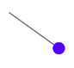
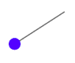
We have a pendulum that’s swinging in a dynamic system that has no friction acting on it as shown in Figures 1 and 2. We’ve seen distance/time graphs, where we can see how far an object has travelled in a certain amount of time. We’ve seen velocity/time graphs, where we can see how fast an object is moving at any time. But what if we wanted to plot every state (all the information you need to fully describe what the system is like at a particular moment) of our swinging pendulum; everything that our pendulum can do in one graph. We can map every possible state of the pendulum on a graph if on the graph we plot the angle of the pendulum along the horizontal axis and the velocity of the pendulum along the vertical axis.
Figure 2: Same pendulum swinging (without friction)
Figure 1: Pendulum Swinging (without friction)

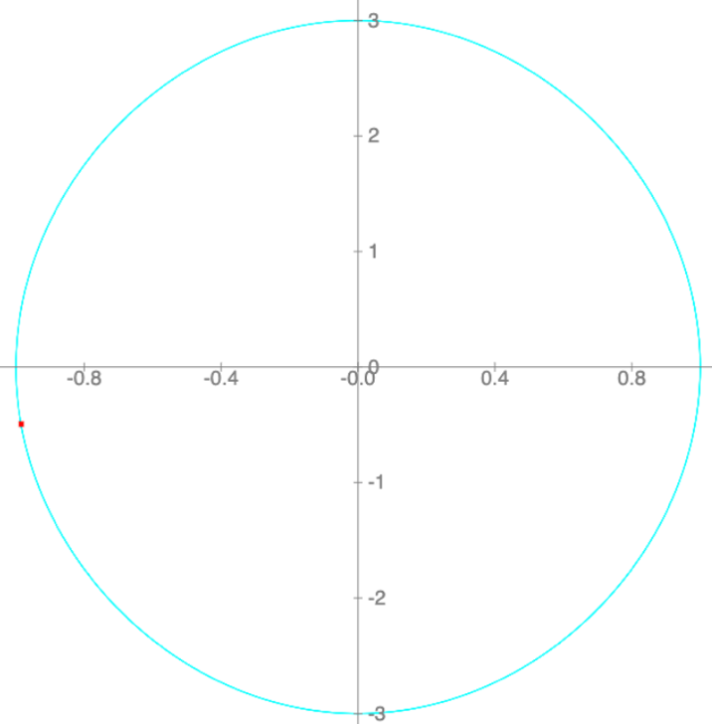
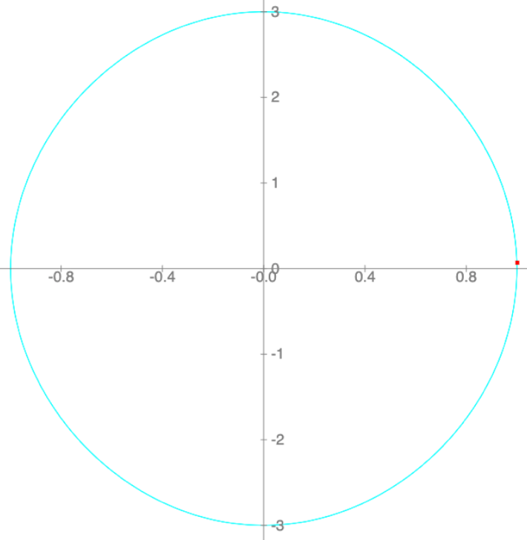
This space where all possible states of the pendulum are shown is called phase space: the space in which all possible states of a system are represented, with each unique point in the phase space corresponding to each possible state. Figures 3 and 4 show the phase space of the pendulum that is swinging which is the blue line making a circle on the plot. Both plots in Figures 3 and 4 have a red circle which shows the position in phase space of the pendulum in Figures 1 and 2.
Figure 4: The phase space of the pendulum with the red dot being the position of the pendulum in Figure 2.
Figure 3: The phase space of the pendulum with the red dot being the position of the pendulum in Figure 1.
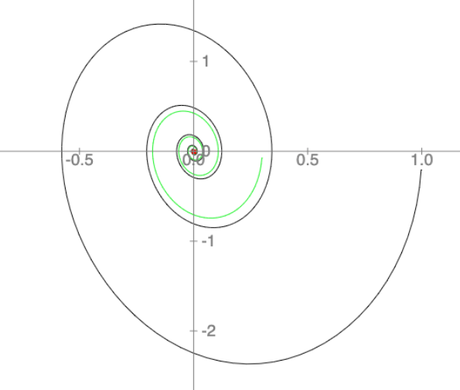

The phase space of the pendulum, in Figures 3 and 4, is a circle as there is no friction acting on the pendulum, so it doesn’t lose energy and swings back and forth with constant amplitude. However, if friction was acting on the pendulum, the pendulum will begin to lose energy and return to its rest position, which is shown in Figure 5, where the graph is spiralling inwards to a fixed point.
Figure 5: The phase space of the pendulum swinging starting from two different points with the different coloured lines being two different phase spaces (with friction)
In Figure 5, the pendulum has been released at two different points and is spiralling inwards towards the origin (the rest position of the pendulum). On the graph, it looks like the system is “attracted” towards the origin, which is a fixed point in that system, hence it is called a fixed-point attractor: a point in phase space which the system will tend to over time, regardless of its initial conditions.

- Introduction

You’ve probably heard of the butterfly effect before; the idea is that small causes such as a flap of a butterfly’s wings in Brazil can lead to large and possibly devastating outcomes, for example setting off a Tornado in Texas. The butterfly effect has since become a widely recognised concept in pop culture, often to describe the idea that seemingly, meaningless choices can have large, unintended consequences later. The rise in popularity of the butterfly effect probably arises from the fact that it’s an interesting concept that your everyday choices can lead to something disastrous, but it all boils down to a question that has probably crossed your mind before: How good are we at predicting the future?

The future is a subject, which human imagination is captivated by. A realm of endless possibilities and opportunities that lie beyond the horizon of our current existence. Most have wondered what’s going to happen in the future. Perhaps you had an exam and wondered what score you’re going to get? Maybe you’re worried about job security? The future seems like an entanglement of infinite possibilities; impossible to navigate around and seemingly unpredictable. Or is it?

- A Man sent by God
“If this intellect were vast enough to submit the data to analysis, it could condense into a simple formula the motion of the great bodies of the universe and the lightest atom; for such an intellect nothing could be uncertain and the future, as well as the past, would be present before his eyes.”

– Pierre Simone Laplace

The “intellect” referred to by Laplace is called Laplace’s Demon: a being that knows everything about the universe, down to the precise locations and motions of each atom and with that knowledge can calculate the future values for any given time using the laws of classical mechanics, thus being able to “predict the future”. This is called total determinism: the view that the future is predetermined, where everything that has occurred, is occurring and will occur, has been predestined and cannot be altered.

The quote from Laplace came during a golden era of physics after Newton discovered his laws of motion and universal gravitation, where everything was considered predictable; from predicting the projectile motion of a ball that’s been thrown to the motions of celestial objects. Newton was seen as a gift given by God: you plug in values into his equations and predicting the motion of anything is a breeze. Have enough information, and you’re able to predict the future. However, a problem arises, as these equations are only able to predict the motions of two objects that have significant mass and are subject to gravity; Newton realised that not all problems would fit into his equations.

Newton in his magnum opus “Philosophiae Naturalis Principia Mathematica” applied his theory of gravitation to the Sun-Earth-Moon system and was unable to find a general formula to predict the motions of the three objects. Newton spent years trying to solve what we now call the “N-Body Problem”: a problem of predicting the individual motions of a group of celestial objects interacting with each other via gravity. Unfortunately for Newton, it’s virtually impossible to find a full solution to this problem.

In 2009, an experiment was run by Laskar and Gastineau: they took everything that we knew about the planets of the solar system and calculated where every planet would be up to 5 billion years in the future. The scientists ran over 2000 numerical simulations with the same initial conditions, except they changed one thing: the distance between the Sun and Mercury was modified by less than a millimetre from one simulation to the next. You’d think a millimetre when compared to the massive distances between the planets and the Sun seems incredibly minuscule and obsolete changing the distance by that much, however, in 1% of their simulations, Mercury’s orbit changed so drastically that it would plunge into the Sun or collide with Venus. This property of gravitational systems is referred to as the “N-Body Problem”.

As stated previously, we have equations that can completely predict the motions of two gravitating masses, however, when there are three or more gravitating objects, it is impossible to write down all the terms of a general formula to describe their motion. This is a problem that Henri Poincaré, who was a French mathematician in the 19th century, came across. In the late 19th century, Henri published a paper on the three-body problem (predicting the motions of three celestial objects), where he found out that small changes within the system led to drastically different outcomes, meaning that predicting the future of the system is impossible. This is also what Laskar and Gastineau saw as well, as only the distance between the Sun and Mercury was changed by a millimetre, yet Mercury sometimes flew into the Sun because of that tiny change in distance. This is called sensitive dependence on initial conditions, which is a key aspect of chaos theory: a theory which completely upended Newtonian determinism as we knew it.

- Unveiling the Mystery of Chaos

Have you ever wondered why weather forecasts are often so difficult to get right? Despite advances in technology and the use of sophisticated computer models, weather forecasting remains inherently unpredictable. This is due to chaos: a branch of mathematics that studies systems that are highly sensitive to their initial conditions.
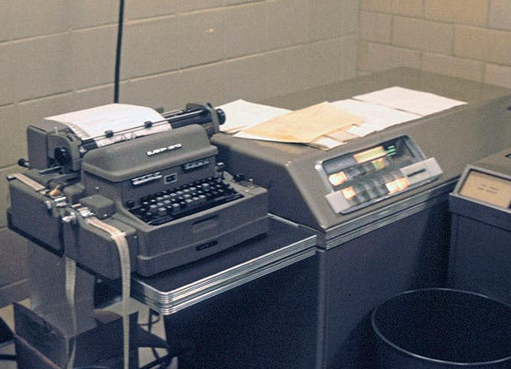
In the 1960s, Edward Lorenz, an American mathematician and meteorologist, installed an LGP-30 computer in his office at MIT and began to try using it to make weather predictions. He had lots of equations and variables, and the computer would print out each time step as a row of the variables, so you could see how they evolved as time progressed. One day, Lorenz had to interrupt a sequence that he had already run once before. When he resumed, he manually typed back in all the three-decimal place numbers that were in place when he stopped and went to grab a cup of coffee. When he returned, to his astonishment, he found the predicted weather diverged substantially from the previously predicted patterns, which is shown in Figure 7.
Figure 6: LGP-30 Computer courtesy of Wikipedia

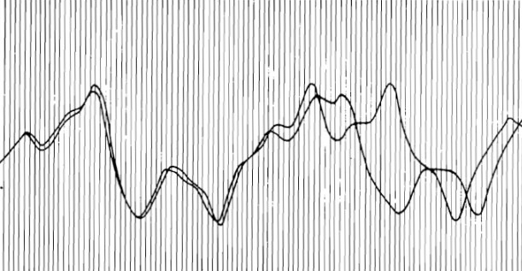
Initially, the two lines started at the same point, but as time progressed the lines diverged from each other revealing completely different weather patterns.

Lorenz later found out that the
Figure 7: Ed Lorenz’s graph showing chaos.

computer printed out three-digit decimal places, but kept six decimal places in memory, so the numbers Lorenz put into the computer were slightly different (off by less than a thousandth) from the numbers used previously. Despite finding the answer to his problem, it only led to more questions. How did such a minute and insignificant change by a thousandth lead to a big change in the weather? Lorenz then came up with the idea that tiny or large changes in initial conditions lead to even larger changes in the system. He proposed this idea to his colleagues and wrote about this in a paper titled the “Essence of Chaos”, where he also brought up the question “Does the Flap of a Butterfly’s Wings in Brazil Set off a Tornado in Texas?” Accidentally, he had created something beautiful: the butterfly effect.

So how do we understand chaos theory without using a lame example such as the weather, but something more mathematical and in turn more beautiful? Lorenz used differential equations. Differential equations aren’t your standard, traditional algebraic equations: algebraic equations have number solutions, whereas the solutions to differential equations are a function itself. Differential equations describe how a function changes as time progresses.
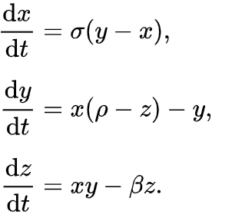
Lorenz simplified his equations that he used to model the weather down to three differential equations (called Lorenz’s system), which modelled convective fluid flow: air is heated up, becomes less dense and rises and then cools down becomes denser and descends. σ, ρ, and β are all constants, and x, y and z represent the temperature of air in the atmosphere, the velocity of air in the atmosphere, and the density of air in the atmosphere respectively. ‘t’ is also a value that represents time so “dx/dt” is a function that describes how temperature changes over time, “dy/dt” is a function that represents how velocity changes over time (which is just acceleration) and “dz/dt” is a function that represents how the density changes over time.

We’ve seen how phase space can represent all possible states of a system, so what if we were to plot the phase space of these functions? With our pendulum, the phase space looked like a circle or a spiral, tending to the origin, but how different would it be compared to the Lorenz System? If we plotted Lorenz’s System, we’d get something called the Lorenz attractor:
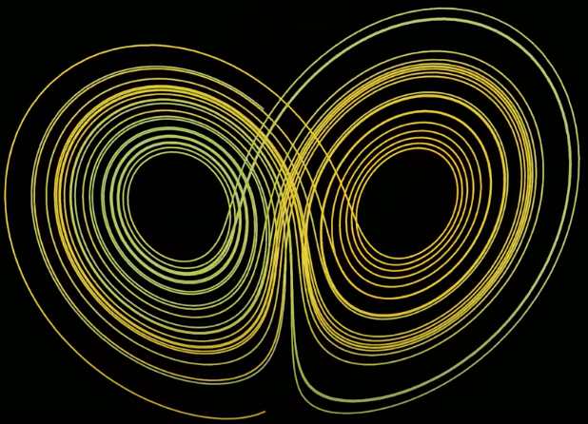

Figure 8: The Phase Space of Lorenz’s System courtesy of imPrgrmr on YouTube

In Figure 8, the phase space of Lorenz’s attractor starts with the initial state of the system shown as the red circle and the final state of the system as the yellow circle.

Note that nothing about this is random. This system as with the pendulum, is deterministic, meaning that the future state of the system is completely determined by its present state and the laws governing its behaviour. The difference between the Lorenz system and the system of the pendulum I had earlier is that a single pendulum system is not chaotic; meaning that if you do not enter the exact correct initial conditions for the Lorenz system, you will get a completely different final state. This technically makes the Lorenz system and chaotic systems in general “unpredictable”, since you can never perfectly know the initial conditions up to an infinite number of decimal places.

“So, we’ve seen that weather is an example of chaos; we’ve seen the Lorenz attractor, but what other examples of chaos are there?” You may be wondering. Well, we’ve seen people attempt to predict the weather and the motions of planets, but what about if someone were to predict the population growth of a species?

- Chaos is Everywhere

What if we tried to predict the population growth of cats over several years? Let’s use x as our number of cats and r being the growth rate/fertility of our population. This will leave us with an equation:
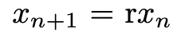

(For notation’s sake x_{n} is the initial population and x_{n+1} is the population after one year)

If for example, r was 2, then the population would double every year. However, there’s a problem with this model as it would mean that the number of cats would grow exponentially forever. For example, if the initial population was 2, after 10 years, the cat population would be 2048. In my opinion, there’s nothing wrong with that, but unfortunately, this is unrealistic: if this were true cats would be everywhere, and again there isn’t anything bad with that; we just don’t live in an ideal world.

Instead of seeing x_{n} as our value for the initial population, let’s think of it as a percentage of the theoretical maximum population and multiply rx_{n} by (1-x_{n}) leaving us with the equation:
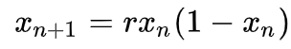

This equation is called the logistic map: a mathematical function used to model the growth of populations, in this case, the population of cats. Since 0 < x_{n} < 1, as x_{n} gets larger and larger, the expression (1-x_{n}) gets smaller and smaller, approaching the value 0 and constraining the population.

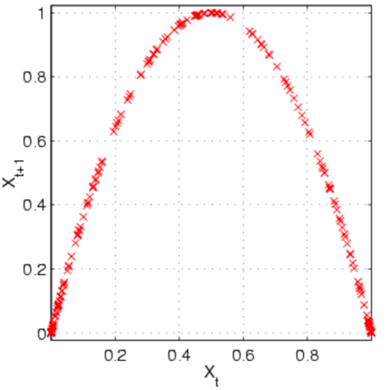
If we plot a graph of x_{n+1} (the population the next year) against x_{n} (the population this year), we get a negative parabola. This is a prime example of a negative feedback loop, which is when the output of a process or system is used to counteract its own activity. In our example of populations, this is shown when the population of cats begins to rise, but the expression (1-x_{n}) causes the growth rate to decrease, which eventually will cause the population to decrease. This is often reflected in real life, where the cat population would rise a lot if there’s plentiful resources, however as time progresses and with more cats, there would be less food and more competition for food leading to the growth rate decreasing and the population slowly declining.
Figure 9: Graph showing x_{n+1} against x_{n} courtesy of Wikipedia.

Let’s test a couple of different values and see how x_{n+1} varies as time progresses:
For example, let’s say that x is 0.5 and the cats are “active” with a growth rate of 2.5. If we substitute those values into the formula and keep on resubstituting the values, we’ll notice something:

(2.5)(0.5)(1 - 0.5) = 0.625
(2.5)(0.625)(1 - 0.625) = 0.5859375
(2.5)(0.585…)(1-0.585…) = 0.6065368652
(2.5)(0.606…)(1-0.606…) = 0.5966247409
(2.5)(0.585…)(1-0.585…) = 0.6016591486
(2.5)(0.585…)(1-0.585…) = 0.5991635437
…
(2.5)(x_{n})(1- x_{n}) = 0.6

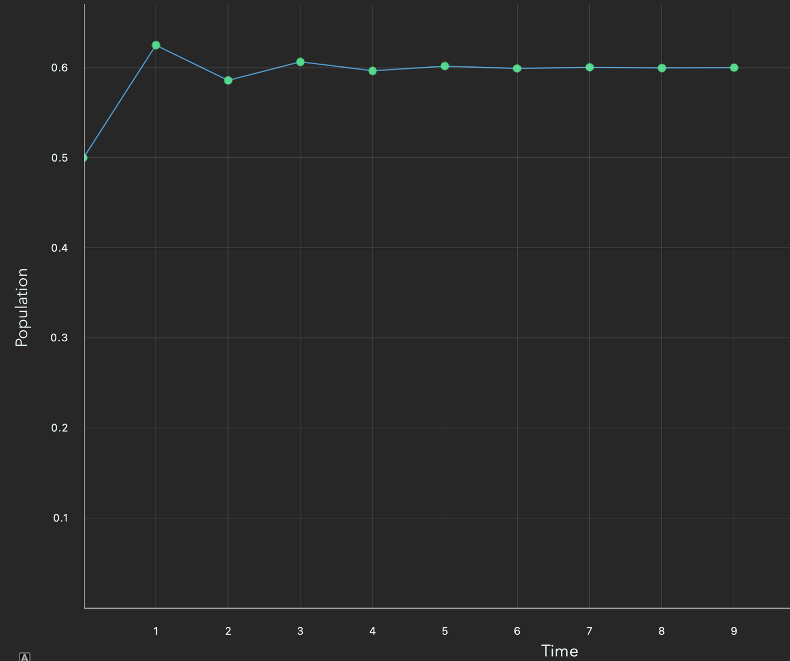
We eventually get to a point where the new population is at 0.6, and it settles there.
Figure 10: Population vs Time graph, when x_{n} = 0.5 and r = 2.5

As you can see the graph in Figure 10 fluctuates a bit going up and down, but settles at an equilibrium value, which resembles real life where populations tend to stay the same. But what if we changed the initial population? Would the population at which the graph reaches an equilibrium be the same or would it differ? With an initial percentage population of 0.3 and the same growth rate of 2.5, the graph looks like this:
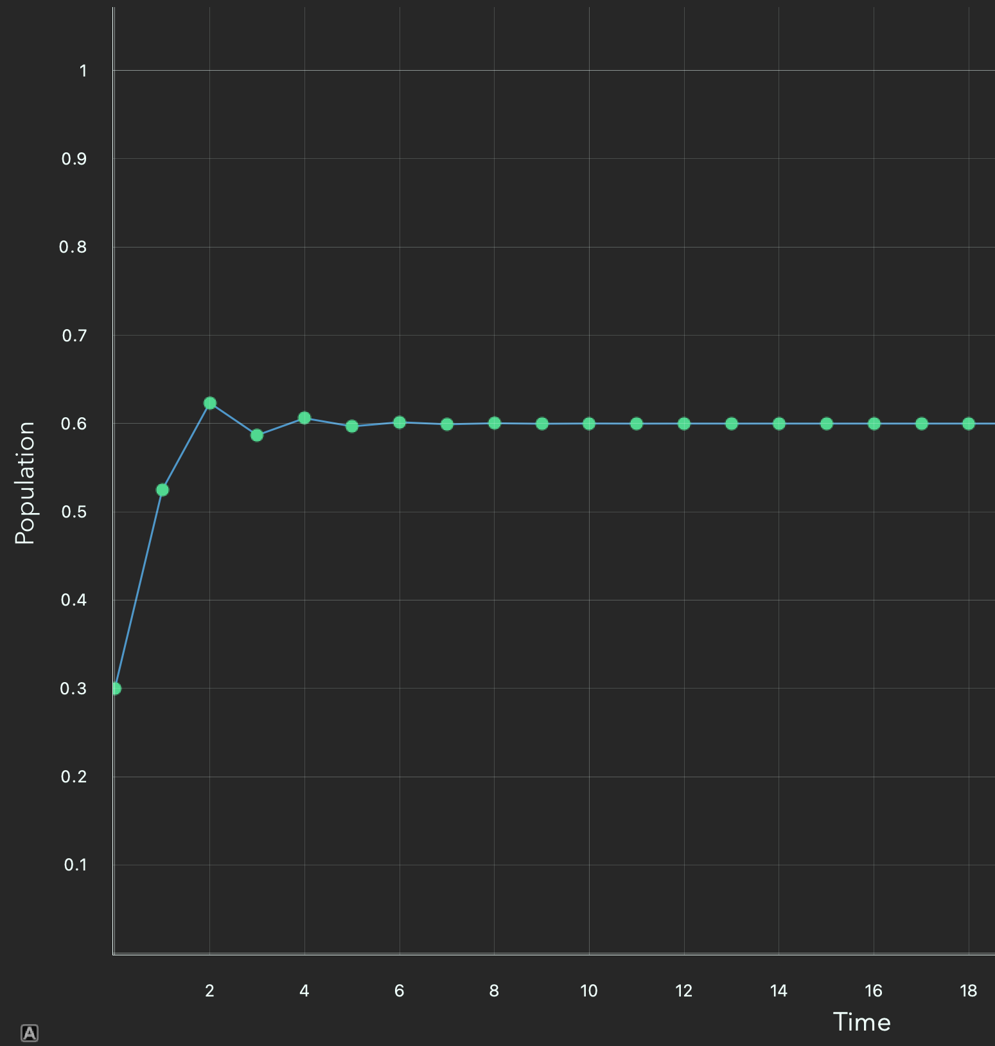
Figure 11: Population vs Time graph, when x_{n} = 0.3 and r = 2.5

No matter the starting population, it will always tend to the same equilibrium for the same growth rate. But what if we changed the growth rate? If we decreased the growth rate, then the population would begin to decrease and for any populations that had r < 1, then the cats would go extinct.

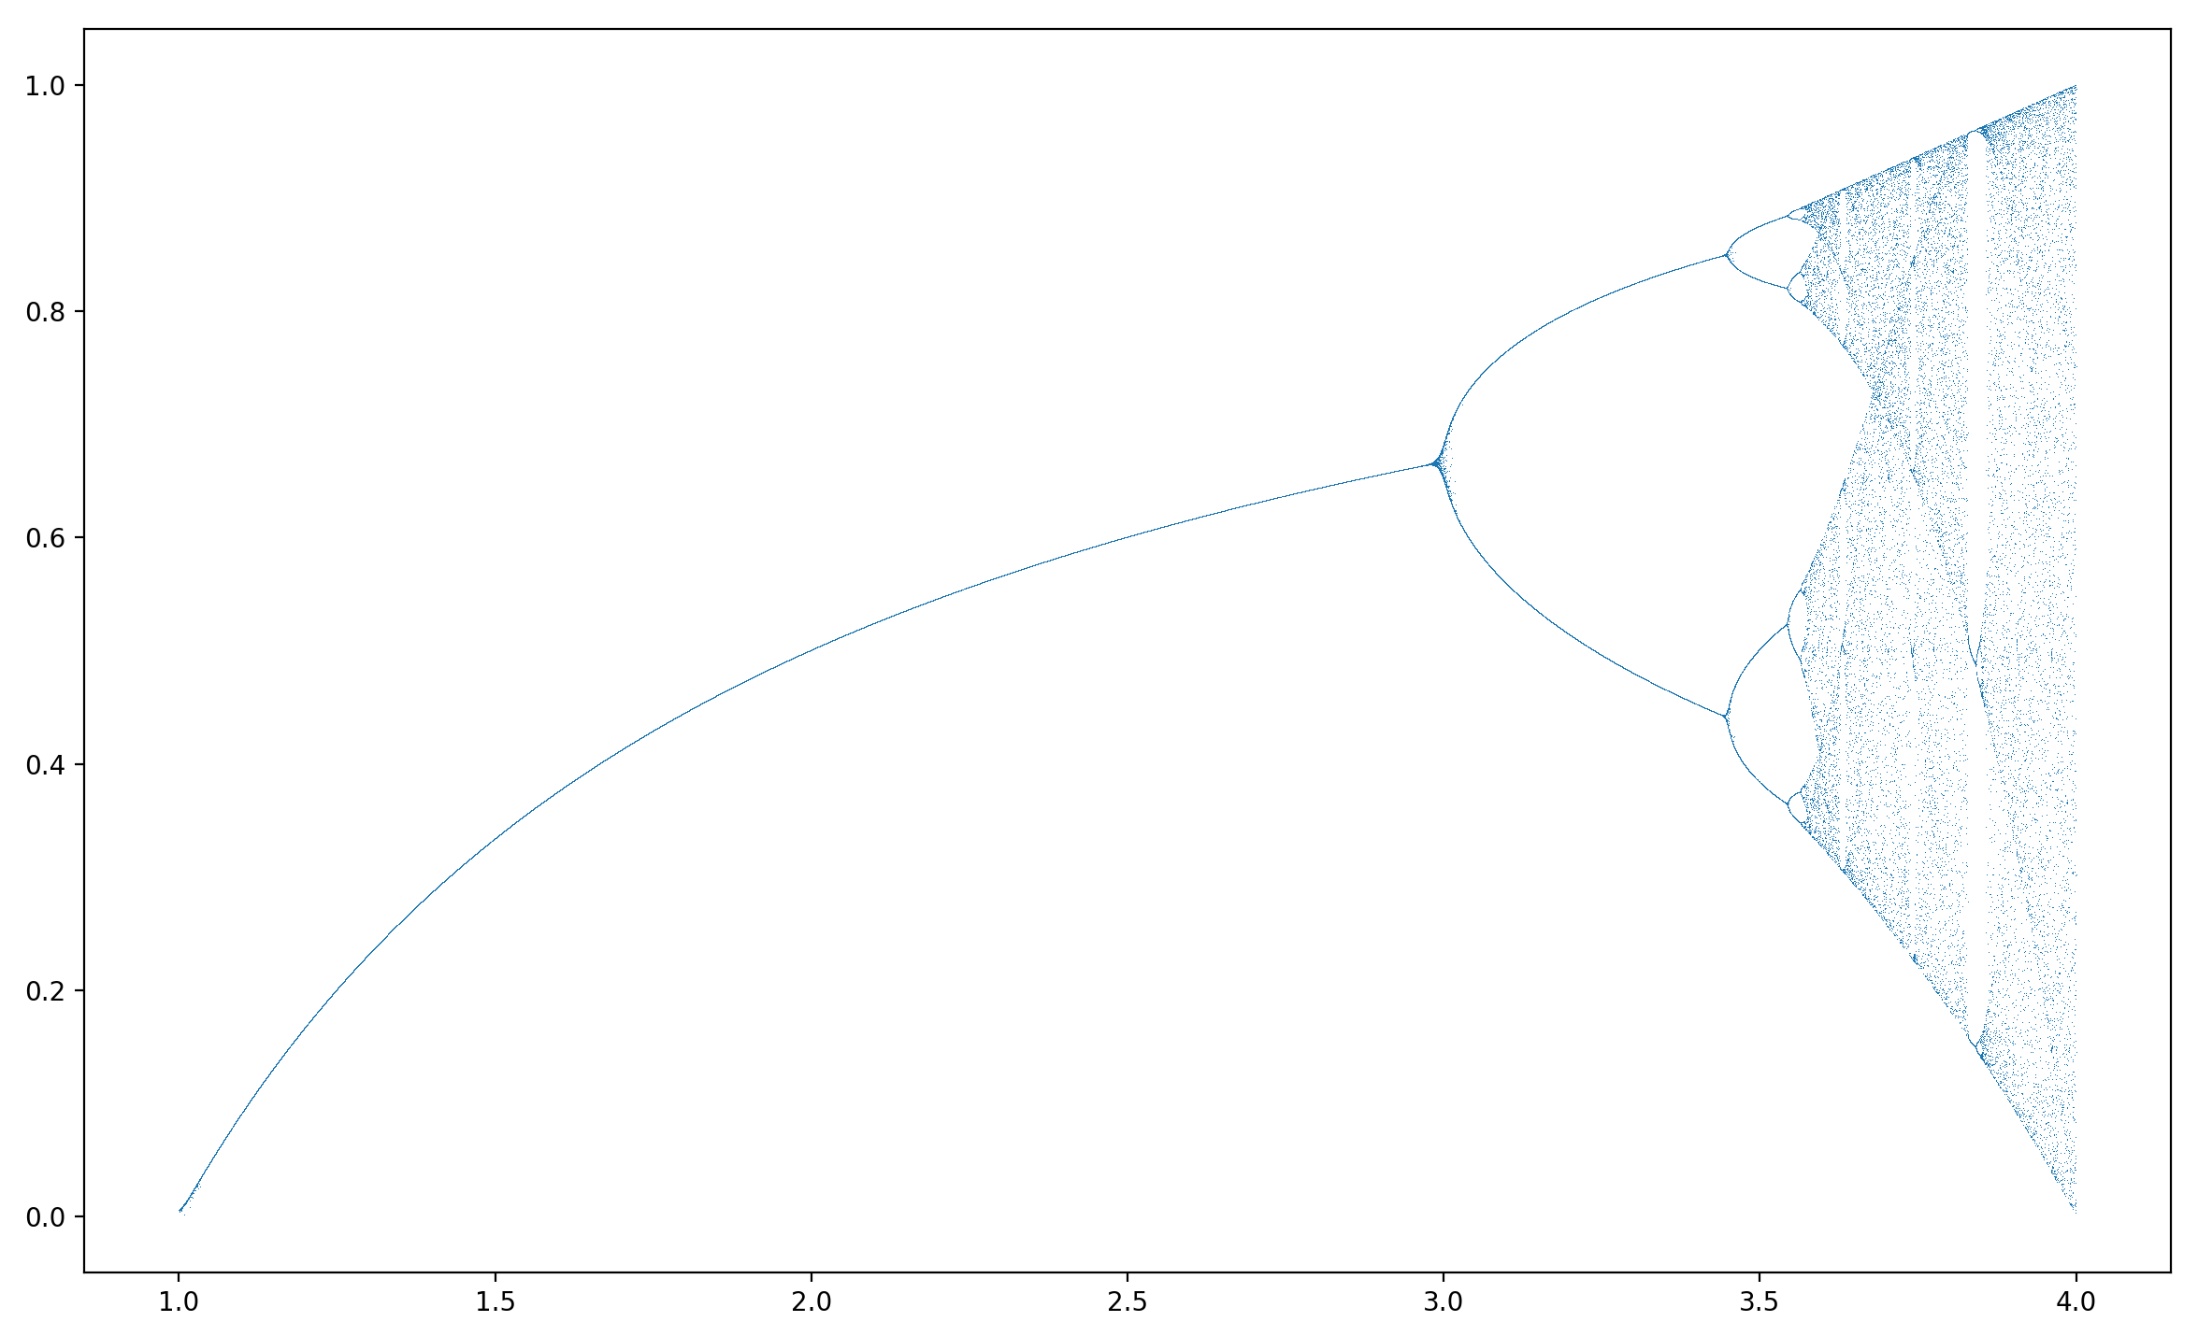
Things get more interesting when we plot the equilibrium population (the population after many generations) against the growth rate.
Equilibrium Population
Growth Rate
Figure 12: Equilibrium Population vs Growth rate (Bifurcation Diagram)

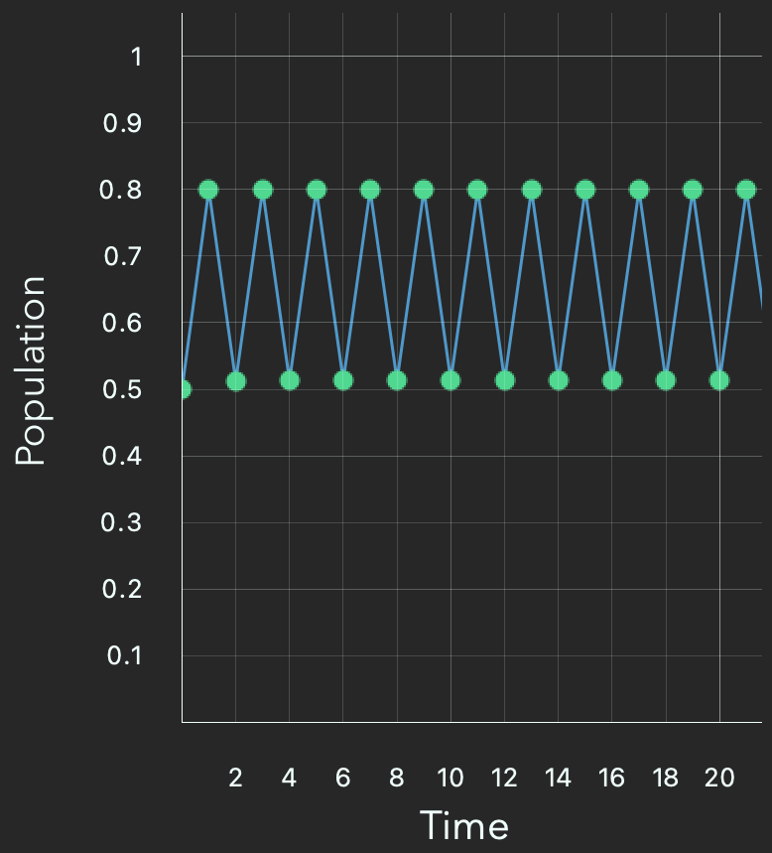

Looking at Figure 12, initially, the graph looks normal: it’s increasing at a decreasing rate. However, when the growth rate increases, the graph does something weird: once r reaches 3 the graph splits in two! If we take a small portion of Figure 14, when r reaches 3 and look at the population vs time graph for it, we can see that the population doesn’t find an equilibrium, rather it fluctuates between two different values, where one year the population of cats is high and the next year it is lower, shown in Figure 13.
Figure 13: Population vs Time graph, when r = 3

As the growth rate increases further, Figure 12 shows the graph splitting again, leaving 4 different lines. Rather than the previous Population vs Time graph in Figure 13, oscillating between two different points, it now oscillates between four different points. As the length of the cycle has doubled, these are referred to as period-doubling bifurcations.
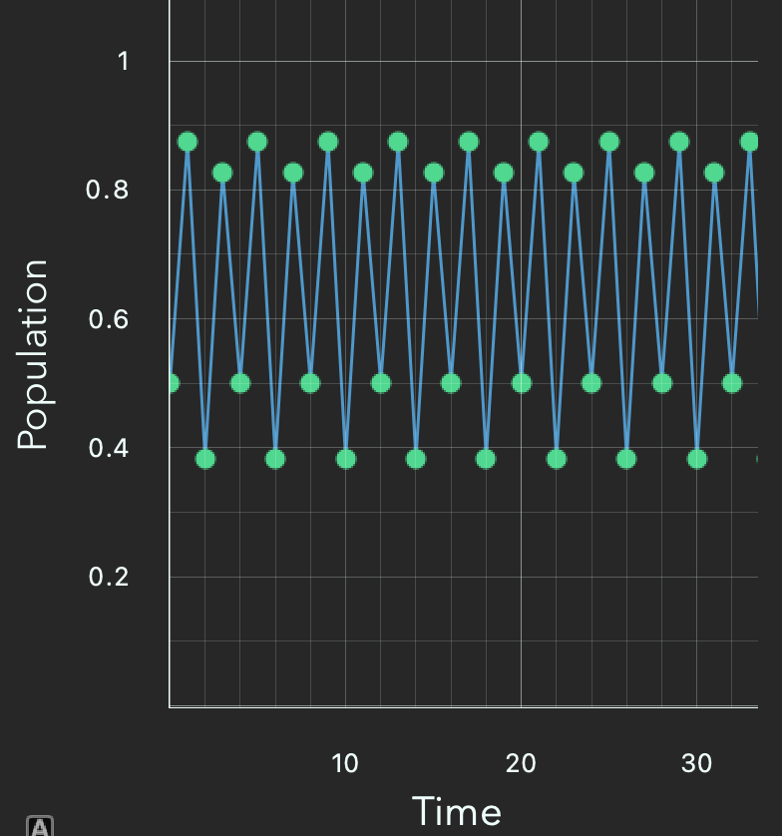

Figure 14: Population vs Time graph, when r = 3.5

In Figure 12, as the growth rate increases, the number of period-doubling bifurcations increases until r = 3.57, where chaos occurs: the population never settles down or oscillates between multiple populations, rather as time progresses the population is sporadic and “random”.
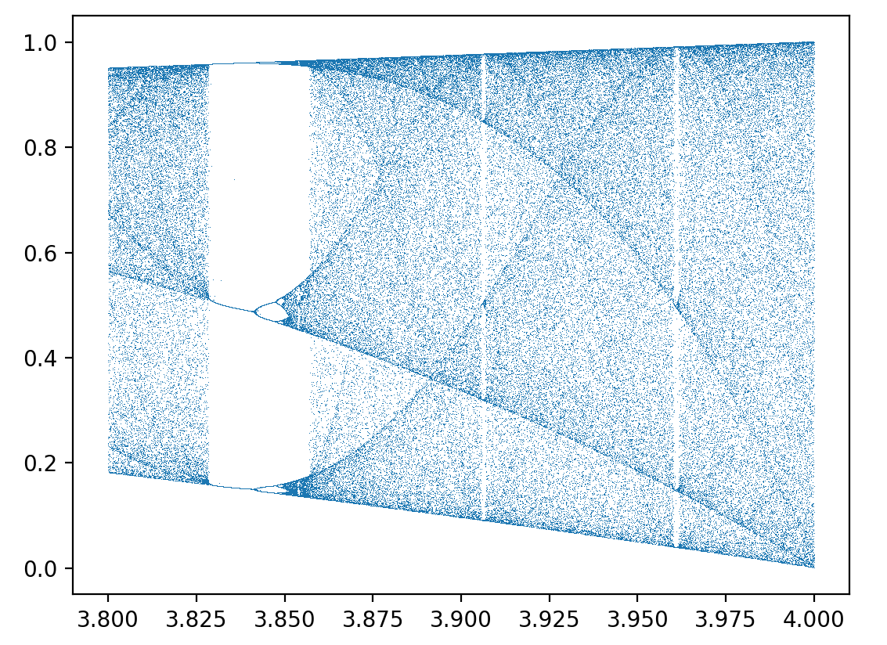

Figure 15: The Bifurcation diagram seen in Figure 12 but magnified.
If we look at a magnified image of the bifurcation diagram when 3.8 < r < 4, we see that the graph in Figure 15 isn’t always chaotic after r = 3: there’s periods of stability. If we continued zooming into the bifurcation diagram you will soon realise that it’s a fractal: a pattern that repeats at different scales i.e., if you zoom in or out of the pattern you will still see the same pattern.

It’s fascinating how chaos is pretty much everywhere, but such systems exhibit unpredictable behaviour, as I’ve discussed previously, so it does beg the question I asked at the start of this essay: “How good are we at predicting the future?”.

- Predictions in an Unpredictable World

When it comes to chaotic systems, our ability to predict the future isn’t great. For example, a double pendulum (a pendulum attached to another pendulum) exhibits chaotic behaviour: you can never release a double pendulum and make it behave the same way twice. I would bet my entire life savings that you will never be able to predict the motion of a double pendulum even with a supercomputer making calculations for you; albeit that if you win, you’ll only win £1.50.

The further into the future you try to predict the outcomes of a chaotic system, the harder it becomes, and it gets to a point where you’re trying to predict so far into the future that predictions are no better than guesses. Chaos theory has shown us that even seemingly simple systems can exhibit chaotic and unpredictable behaviour, and that minor errors or uncertainties in our measurements or models can have a significant impact on our predictions. Despite these challenges, there are still many techniques and approaches that can be used to make predictions about the future: for example, with the knowledge of chaos, meteorologists make “ensemble forecasts”, which is a type of forecast that uses multiple simulations to estimate the range of possible outcomes for a given weather event. This provides us with a more comprehensive and accurate picture of the potential weather conditions than a single model can. Then again, even if the weather forecast says it won’t rain, take your umbrella just in case: the world is more chaotic than it seems.

- References
  - Heavily Influenced By:
https://www.youtube.com/watch?v=Q8JZ4L6Ocic – Ted Talk on Chaos Theory by Samuel Won
https://www.youtube.com/watch?v=ETrYE4MdoLQ – Video about the Logistic map by Numberphile
https://www.youtube.com/watch?v=ovJcsL7vyrk – Video about the Logistic map and the Mandelbrot Set by Veritasium
  - Sources:
https://en.wikipedia.org/wiki/Phase_space#:~:text=In%20dynamical%20system%20theory%2C%20a,of%20position%20and%20momentum%20variables – Wikipedia Article on Phase Space
https://www.myphysicslab.com/pendulum/pendulum-en.html - Pendulum simulator, which I used for Figures 1, 2, 3, 4 and 5
https://www.stsci.edu/~lbradley/seminar/laplace.html#:~:text="Laplace%27s%20Demon"%20concerns%20the%20idea,be%20traced%20back%20to%20Socrates – Article on Laplace’s Demon, also where I got the quote from
https://ed.ted.com/lessons/newton-s-three-body-problem-explained-fabio-pacucci - TedEd Video on Newton’s three body problem and the experiment by Laskar and Gatineau in 2009
https://en.wikipedia.org/wiki/LGP-30 - Article contained image from Figure 6
https://www.lindahall.org/about/news/scientist-of-the-day/edward-lorenz - Article on the Discovery of Chaos
https://fractalfoundation.org/resources/what-is-chaos-theory/ - Article on What is Chaos Theory?
https://en.wikipedia.org/wiki/Chaos_theory - Wikipedia article on Chaos Theory
https://www.youtube.com/watch?v=r_5shyQGIeA – Video on Chaos Theory by Seeker
https://journals.ametsoc.org/view/journals/atsc/20/2/1520-0469_1963_020_0130_dnf_2_0_co_2.xml?tab_body=pdf – “Deterministic Nonperiodic Flow” one of Edward Lorenz’s most influential papers.
http://www.ex-tempore.org/little/little.htm - Music and The Logistic Map, and where I found the image for Figure 7
https://plato.stanford.edu/entries/chaos/ - Paper on Chaos by Stanford University
https://www.youtube.com/watch?v=dP3qAq9RNLg – Lorenz Attractor Simulation by imPrgrmr, which I used for Figure 8
https://en.wikipedia.org/wiki/Logistic_map - Wikipedia article on the Logistic map, which I got the image for Figure 9 from
https://github.com/jonnyhyman/Chaos - The code behind the graphs used in Figures 10, 11, 13, and 14 made by Jonny Hyman
https://www.youtube.com/watch?v=BcVLeYV7DGQ – Video that helped me make a program to create Figures 12 and 15 on the Logistic map by Chaos and Cryptography

